G PULLAIAH COLLEGE OF ENGINEERING AND TECHNOLOGY
DEPARTMENT OF COMPUTER SCIENCE AND ENGINEERING
C PROGRAMMING CONTEST WINNERS ORGANIZED BY C-CLUB
DATE: 28-10-2017
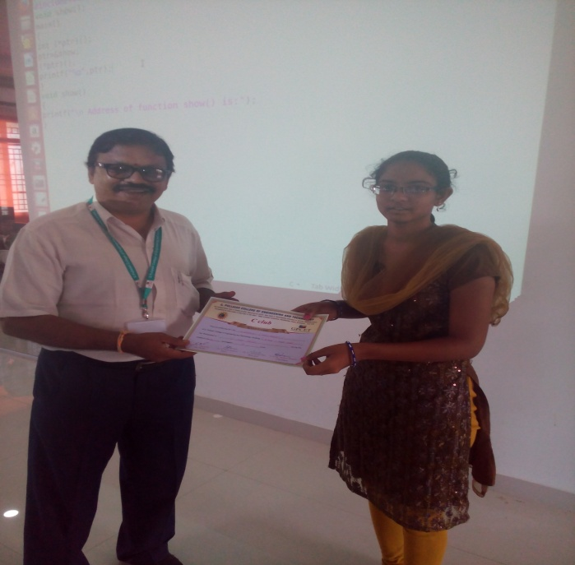  NAME: V.Sushma(17AT1A0275),I EEE-B | 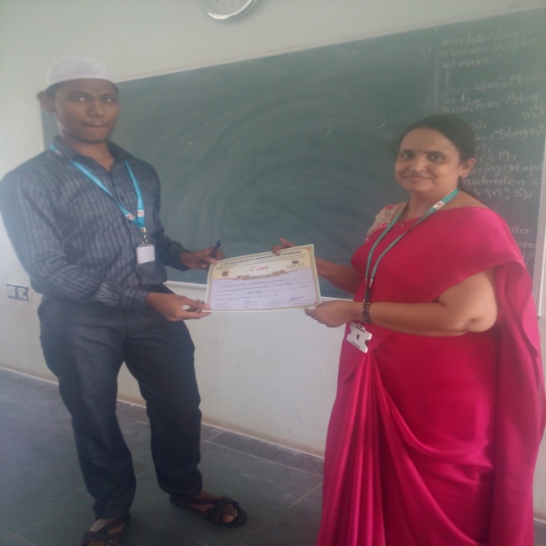  NAME: SMD Ziyaulhaq (17AT1A0227) I-EEE-A
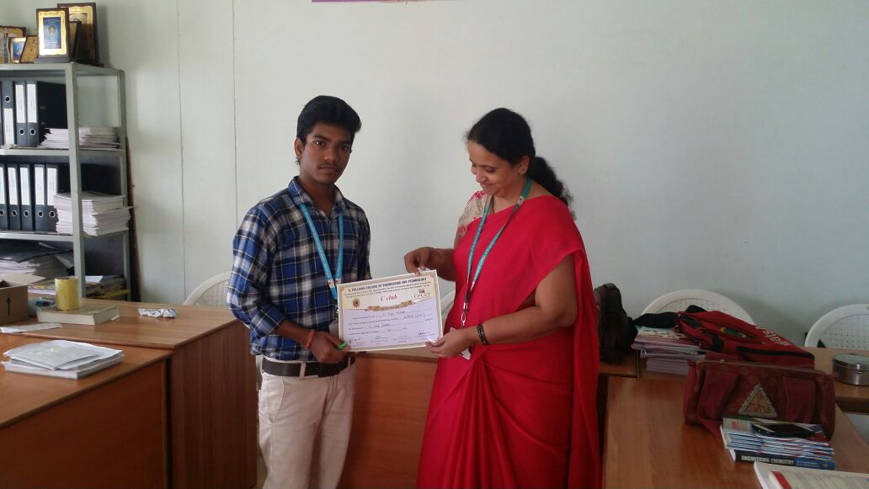  NAME: K.Yoga Mukesh(17AT1A0153)  I-CIVIL | 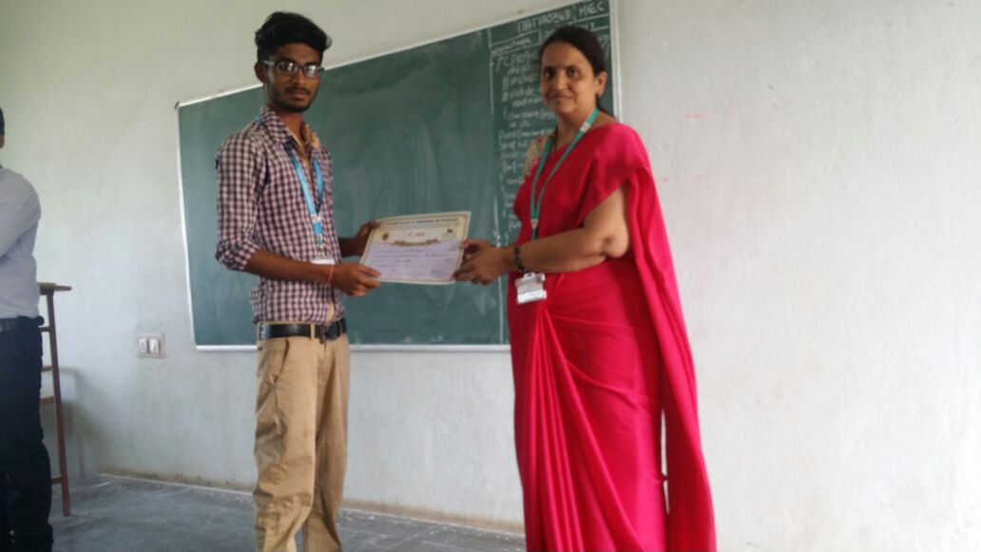  NAME: D.Siva Kumar(17AT1A0140)  I-CIVIL
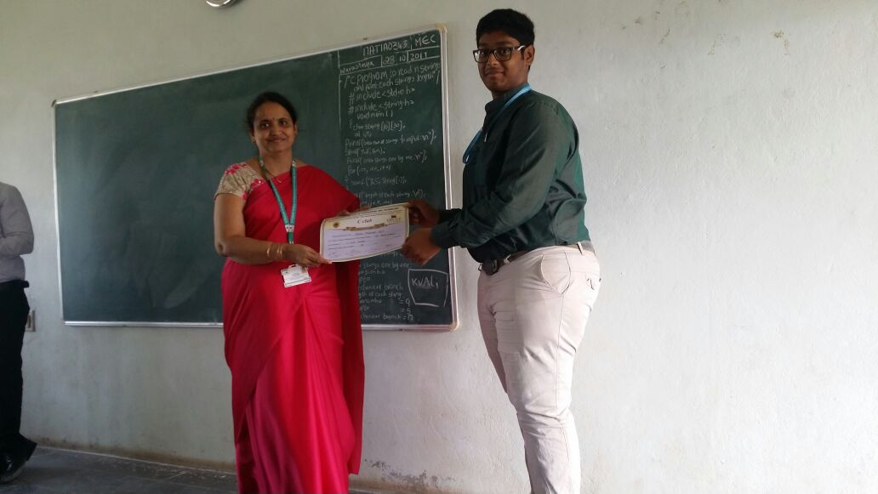  NAME: Shaik Mohammed saif (17AT1A0318)  I-MECH | 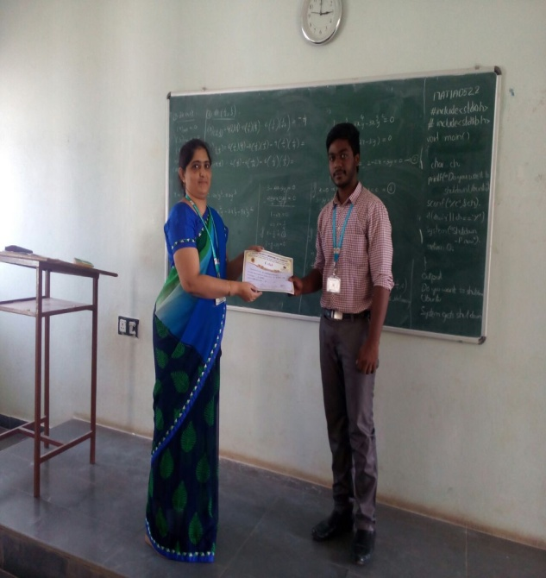  NAME: K.Harsha Vardhan (17AT1A0528)  I-CSE A
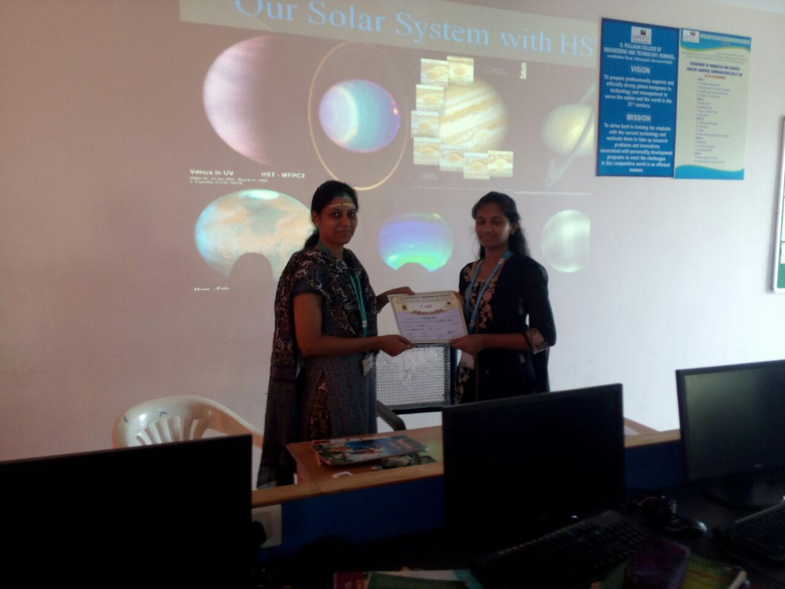  NAME: S.Ramya Sree(17AT1A0574) I-CSE B | 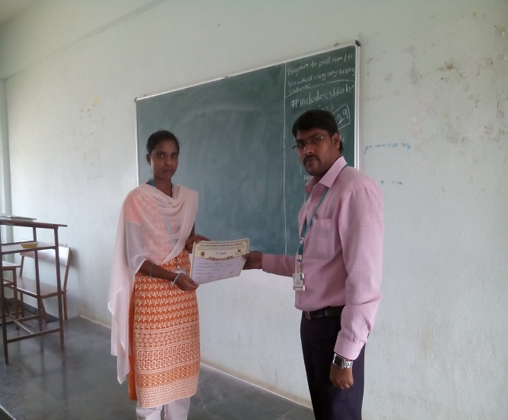  Name : P. Dharani (17AT1A0424) I-ECE A
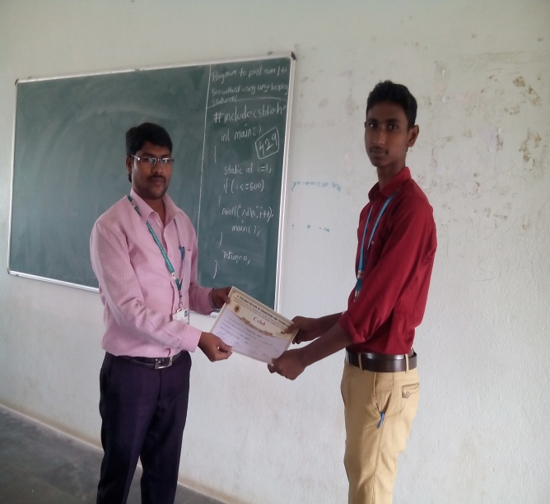  Name : V. Chendreswar Prasad(17AT1A0421)  I-ECE A | 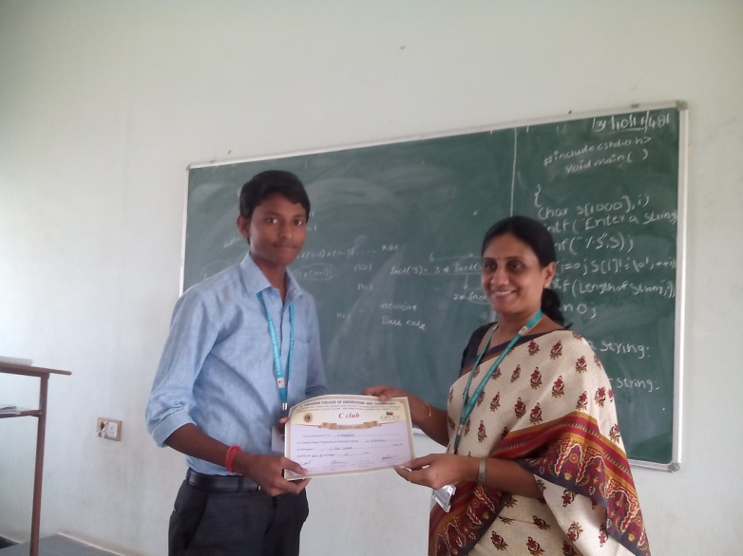  Name : M. Muralidas (17AT1A0478) I-ECE B

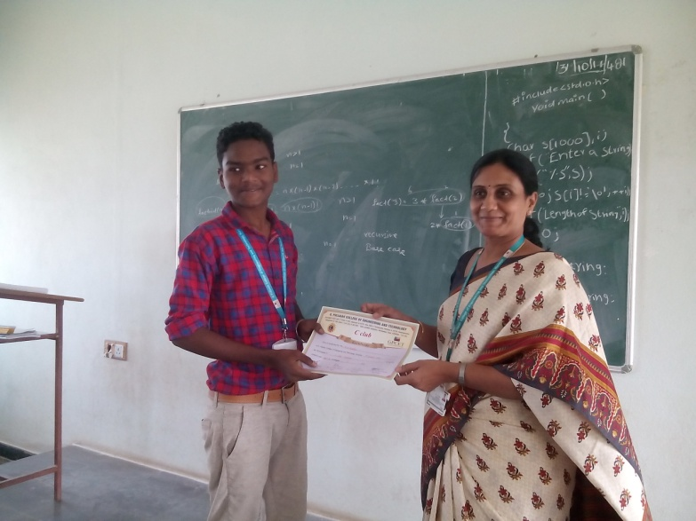  Name : B. G. Madhu (17AT1A0466) I-ECE B | 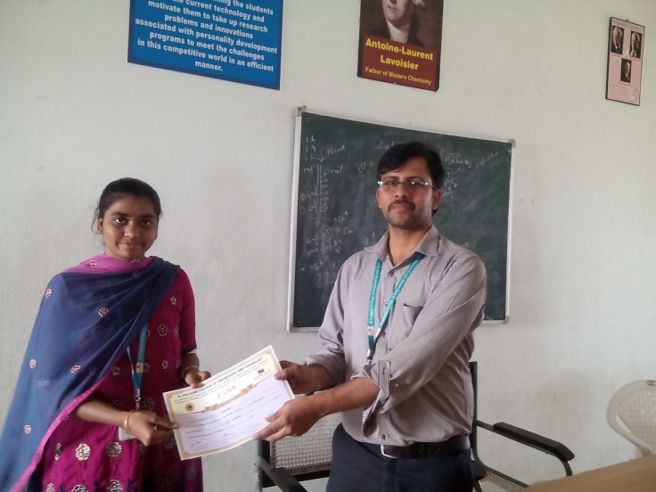  Name : R. Supriya (17AT1A04E6) I-ECE C

