G. Pullaiah College of Engineering and Technology, Kurnool
Department Of Electronics and Communications
CADENCE REPORT
Report on Workshop for VLSI Design using CADENCE
The Department of electronics and communication is organized VLSI Design Using CADENCE on 02nd & 03rd Dec, 2017 in GPCET. The speaker came from Vardhaman College of Engineering by name Dr.JVR Ravindr, Professor in Department of ECE. He has an industry and teaching experience of 17 years. He is expert in various fields like Modelling of Ultra Low power Interconnects, High-Speed and Low power Arithmetic Circuits, Low Power DSP Architectures, Hardware Security, Wireless Sensor Networks etc. The following faculty members attended for the Workshop.
S.No | Cadence Tool | Mobile No. | Department | College
 | B.Obulesu(In-charge) | 7702150437 | ECE | GPCET
 | A.Parvathi | 9440360352
 | M.A.Farida | 9885448606
 | M.Riyaz Pasha | 9642292457
 | T.Swetha | 9052057550
 | T.Lavanya | 8885155880
 | N Geetha Rani | 7416853998
 | K.Swarna Madhuri | 9505804217
 | P.Bindu Swetha | 9666930999
 | K.Vinod Kumar | 9700903036
 | K.Pushpakala | 9440119708
 | K.Uma Maheswari | 9177736675
 | G.Rama rao | 9014376053
 | K Abdul Munaf(In-charge) | 8121941023 | ECE | RCEW
 | G.Sivaiah | 9912125803
 | Y.S Goud | 9951860531
 | T.Kishore | 9949188060
 | B.Sulochana | 9010842923

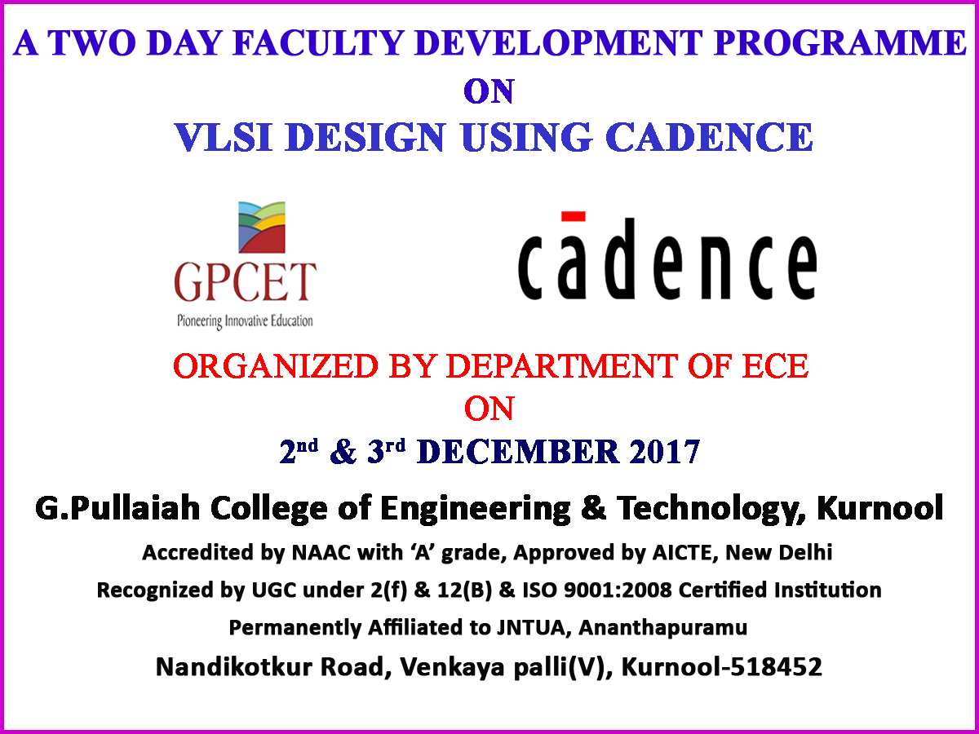

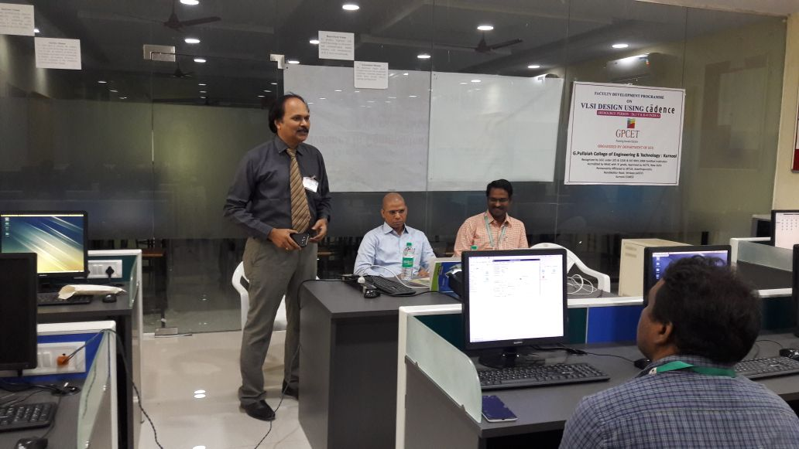
Dr.S.Prem Kumar, Prof&Dean GPCET along with Dr.K.E.Srinivas Murthy Prof& ECE HOD,Speaker Dr.JVR Ravindra , Professor ,Vardhman College of Engineering,Hyderabad.
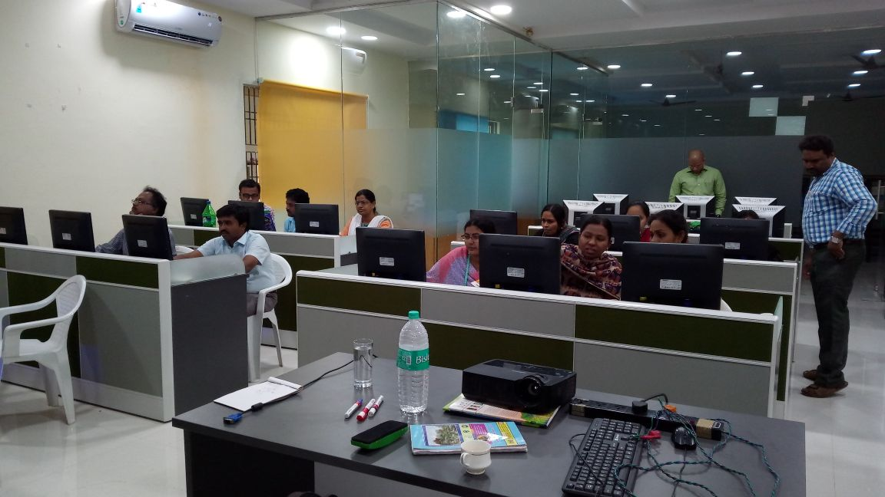
Faculty hands on cadence tool and practicing schematics with cadence VIRTUOSO Tool
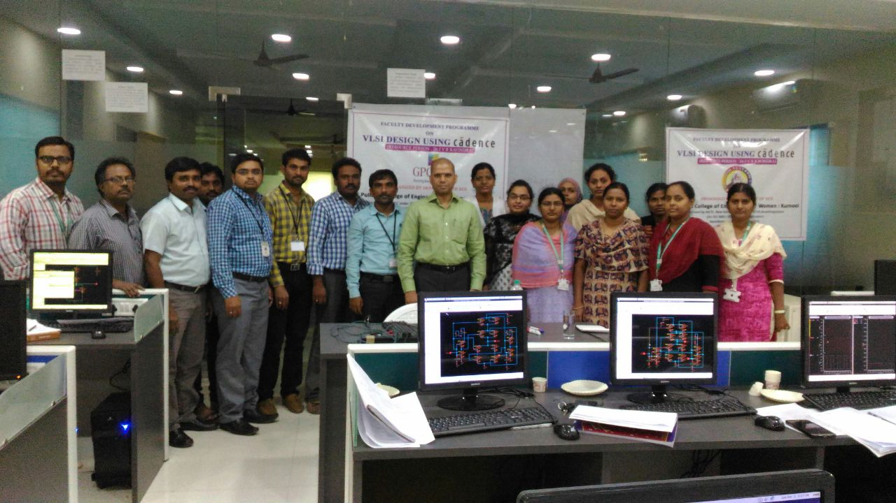
Speaker Dr.JVR Ravindra , Professor ,Vardhman College of Engineering,Hyderabad along with faculty members.

