G PULLAIAH COLLEGE OF ENGINEERING & TECHNOLOGY, KURNOOL
DEPARTMENT OF CIVIL ENGINEERING
Report on Faculty development program
Date: 09/12/2017
JNTUA organised Faculty Development Program (FDP) on Faculty Intelligence Learning Module at JNTUA on 08/12/2017. K Mallikarjuna Reddy, Assistant Professor, Dept of CE, GPCET, Kurnool, attended this FDP-2017. Faculty development program- 2017 is a unique program conducted by JNTUA in collaboration with CADD CENTRE at JNTUA campus, Anantapur on 08/12/2017.
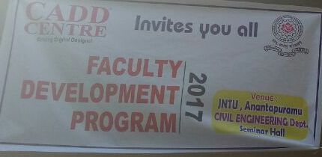
The program was inaugurated by Dr.C Sashidhar, Controller of Examinations, JNTUA & Dr. Aruna Kranthi, Associate Professor from Dept of CE, JNTUA.
The Speakers Mr.U.Jayaraman as Corporate trainer & Consultant Mr. Rajendra Nalluri, CADD Centre Training Services Pvt.Ltd. Arvind, CADD centre, highlighted on overview of faculty Intelligence Learning Module. The Speaker presented what is the expectation game between the teacher and the student, Improving the teaching styles, Mood Analysis of the student etc,. The speakers streesed on role of teachers in building strong society.
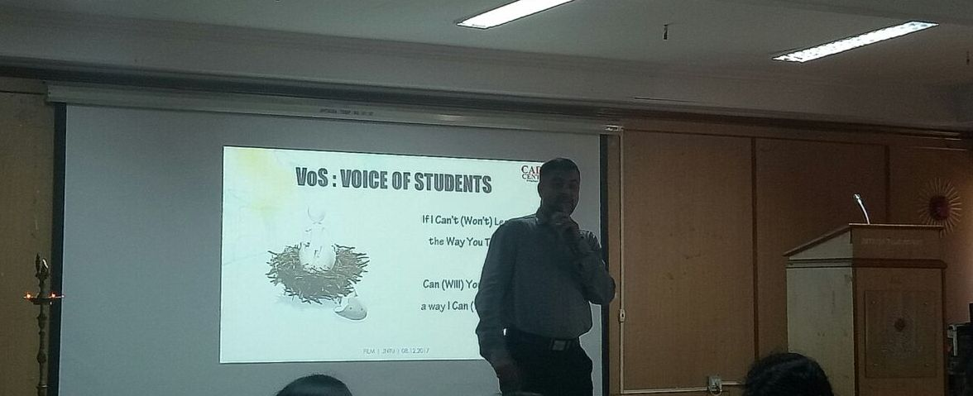
The faculty from various engineering colleges affiliated to JNTUA have participated in this FDP. Finally the program was wrapped up with valedictory & vote of thanks delivered by Dr.C Sashidhar, Controller of Examinations, JNTUA.
