G.PULLAIAH COLLEGE OF ENGINEERING & TECHNOLOGY
Accredited by NAAC with ‘A’ Grade of UGC, Approved by AICTE, New Delhi
Permanently Affiliated to JNTUA, Ananthapuramu.
(Recognized by UGC under 2(f) & 12(B) & ISO 9001:2008 Certified Institution)
Nandikotkur Road, Kurnool-518452.

GPCET/NSS/A21-2018
NSS UNIT
Date : 26-01-2018
Name of the Activity: NSS Unit Republic Day
The NSS Unit, GPCET celebrated India’s 69th Republic Day. Dr.C.Srinivasa Rao, Principal, GPCET hoisted the National Flag and accepted the salute. The Principal, Teaching & Non-Teaching staff and Students saluted the National Flag and pledged themselves to upholding the honour and integrity, diversity and uniqueness that is “India”.
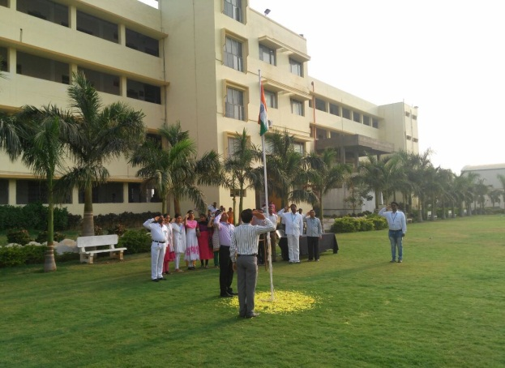
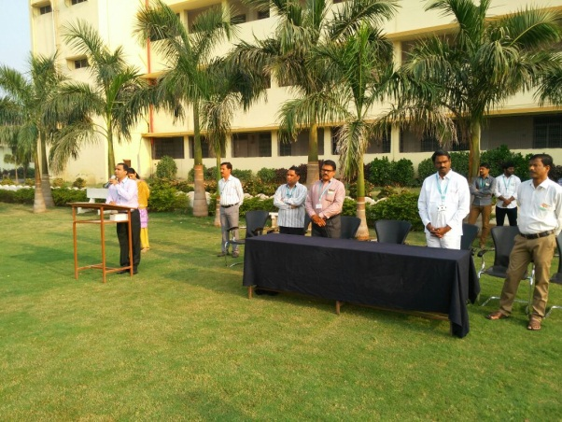

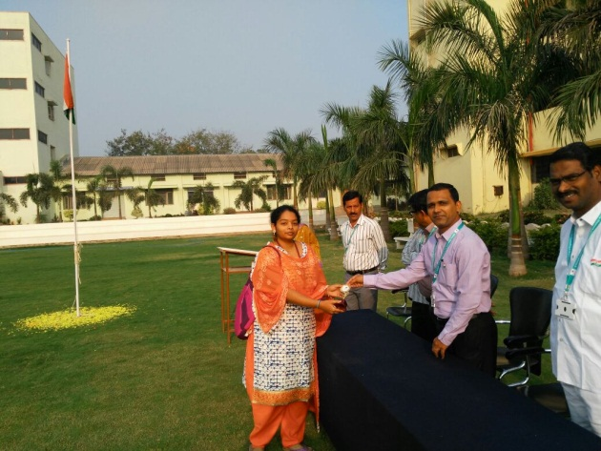
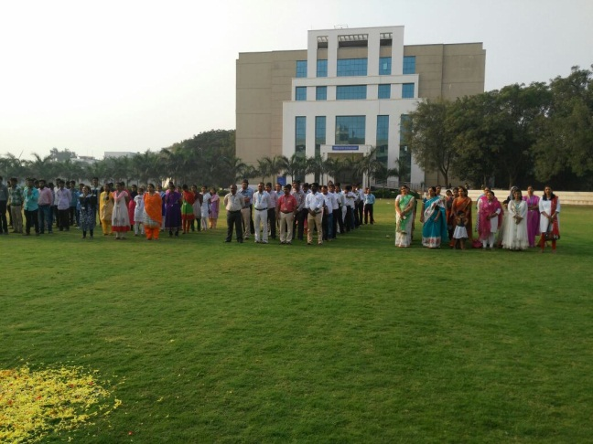

Program officer
NSS-Unit, GPCET.

