G. PULLAIAH COLLEGE OF ENGINEERING AND TECHNOLOGY, Kurnool

Report on the Kurnool District level Technical Fest
On
04 Jan 2018 at GPCET, Kurnool

Department of ECE, G. Pullaiah College of Engineering and Technology organized a prestigious event “Kurnool District Level Tech Fest 2018” on 4-Jan-2018 under ISTE and IEI students chapter. The program commenced with inaugural function at 9:30 am for which the college vice chairman Mr. G. Vamsidhar was the chief guest. In his message he insisted that “participating in such events make students a real engineers”.

The model exhibition commenced at 10 am for which there were representations from 11 engineering colleges of Kurnool district. The students from various colleges exhibited their models. Dr.K.E.Srinivasa Murthy, Professor & HOD-ECE and Mr.Sreenivasulu Goud, Professor, RECW, Kurnool were the judges for the tech fest. A total of 48 models were exhibited during the fest. Students of neighboring colleges witnessed the models, interacted with the exhibits creators and got their doubts clarified. A total of 140 students were participated in the mega event.

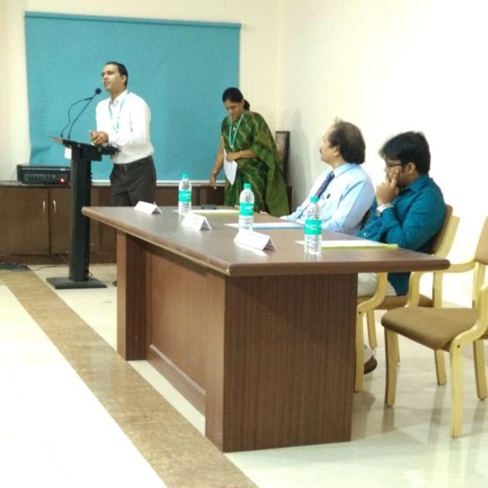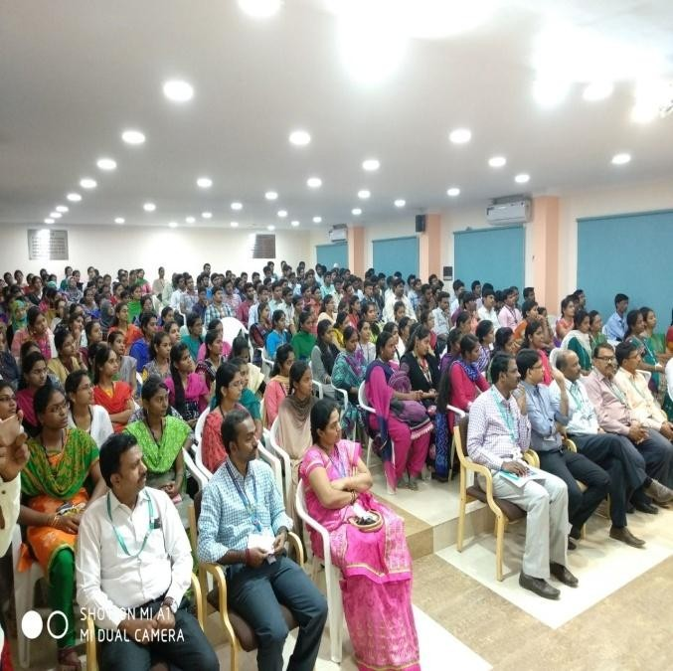The tech fest concluded with valedictory function at 4 pm for which the chief guest was Dr. P.Chenna Reddy, Director, Academic Audit, JNTUA, Ananthapuramu. The program concluded by giving away prizes for winners and runners.

Inaugural Function of Tech Fest 2018

Photo Gallery:

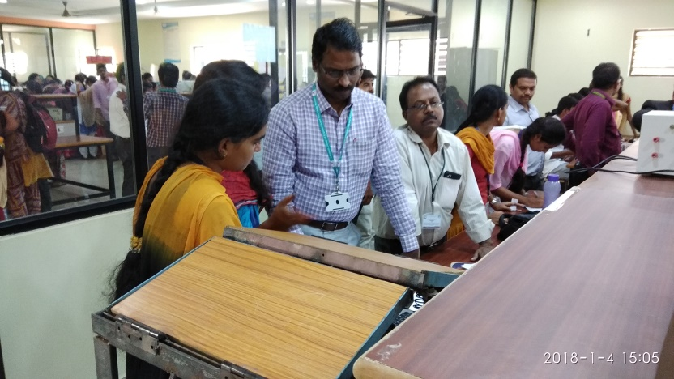

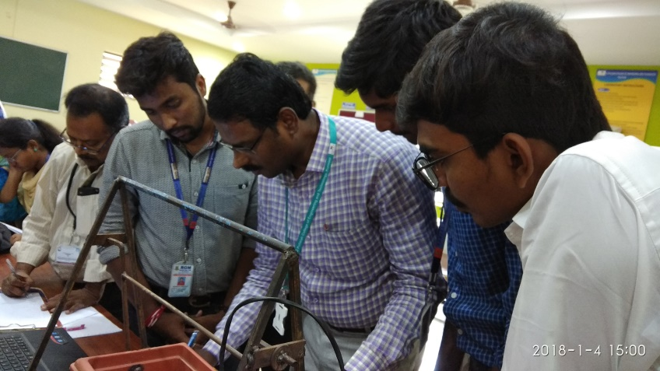

Models being exhibited by the students

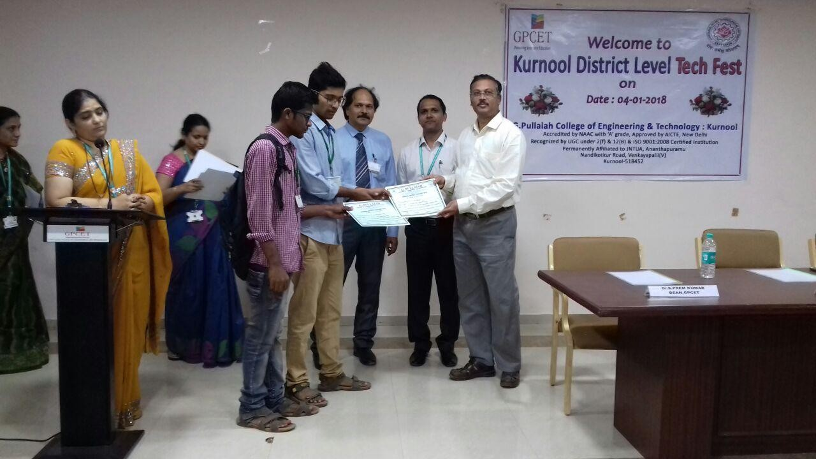

Valedictory function of Tech fest 2018

