G PULLAIAH COLLEGE OF ENGINEERING & TECHNOLOGY
KURNOOL
Report - Workshop on EPICS
- I K Mallikarjuna Reddy attended a workshop on EPICS is a unique program conducted by APSSDC & IUCEE at SVCE, Tirupathi on 29/07/2017.

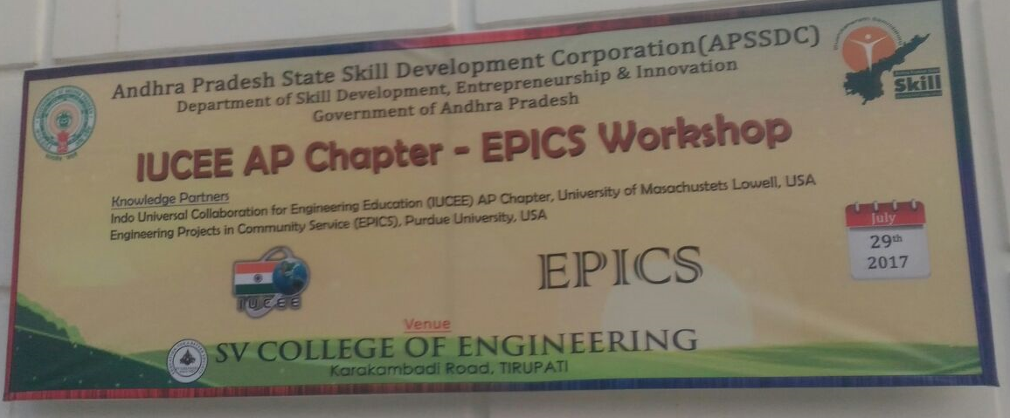

- The inaugural function conducted by SVCE & APSSDC. The chief guests are Dr. Willam Oakes (EPICS Programme, Prude University, USA), Ms. Maeve Drummand (Co-Ordinator, EPICS Consortium), Dr. N Sudhakar Reddy (SVCE, Principal) and Kantha Reddy (IUCEE Co-ordinator).
- The key speaker of the workshop on EPICS is Dr. Willam Oakes and he gave an overview of EPICS & vision for IUCEE – EPICS network in India.
- The Speaker presented how to be the professional’s preparation, Engineering responsibilities to educate future professionals and leaders.

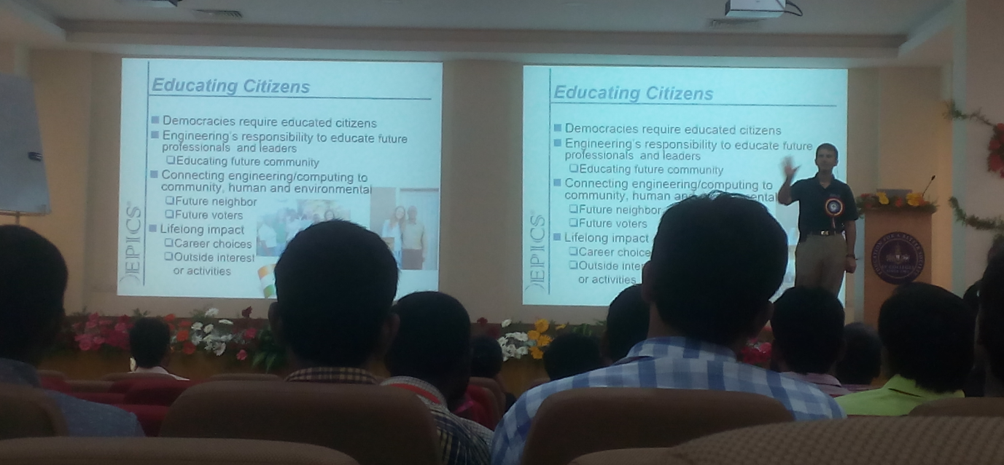
- Guidelines on the responsibilities associated with Project work for junior/senior level and on selecting the community partners for Internship programmes to students.
- Assessing the student learning in EPICS & Project Artifacts (Proto type) and about design process of thinking.
- Dr. Lakshmi from APSSDC announced that from every institute a representative has to give a speech about research in their institute and they suggested for every institute to adopt a village and develop that village.
- I K Mallikarjuna Reddy gave a speech about Producing Concrete by using Waste materials for few minutes.

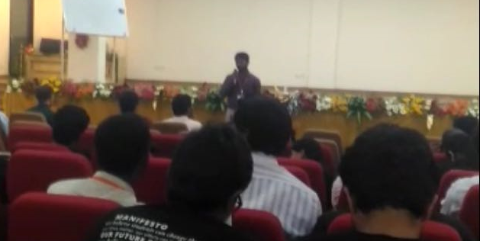

- APSSDC & IUCEE announced premier institutions in their chapter; out of 29 institutions they selected 19 institutions as premier, GPCET is one among them. The selection is done by speech of representative by Institution.
- Workshop ends with vote of valedictory function.
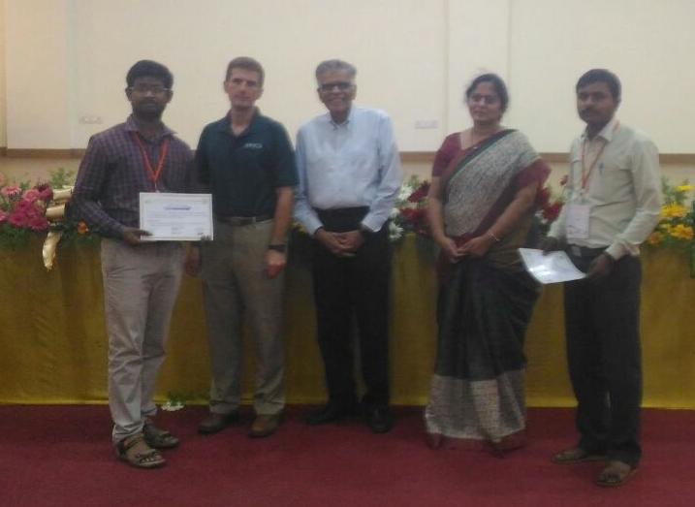

Regards
K MALLIKARJUNA REDDY Asst Professor, Dept of CE.

