G.PULLAIAH COLLEGE OF ENGINEERING & TECHNOLOGY
Accredited by NAAC with ‘A’ Grade of UGC, Approved by AICTE, New Delhi
Permanently Affiliated to JNTUA, Ananthapuramu
(Recognized by UGC under 2(f) &12(B) & ISO 9001:2008 Certified Institution)
Nandikotkur Road, Kurnool-518452
REPORT ON
A ONE-DAY INDUSTRIAL VISIT TO
“FM RADIO STATION”
FEB01-02-2018
(UNDER IEI &ISTE STUDENT CHAPTERS)

Department of ECE, G.Pullaiah college of Engineering & Technology, Kurnool, organized a one day industrial visit to “FM RADIO STATION” on 01-02-2018 under IEI & ISTE student chapters for the III B.Tech II semester students.
This visit was focused to know How Radio Signals were transmitted. All the students were divided into 3 batches and for each batch theory was explained with the block diagram of the entire station by the Deputy Director Sri Surendra Babu. Then they were taken into transmission booth where the students observed how the RJ will do live FM radio programs, how the feeders are connected and different types of Omni directional mikes were used. Then the students were taken to multipurpose studio room, where students were seen how the radio programs were recorded and the devices used. This was explained by the concern engineer. In control room, the transmitter and receiver sections were explained and finally students were taken to antenna and radio tower section. Here they observed and understood how the signal was sent from control room to antenna and the type of antenna they used for the purpose of transmission. The transmission frequency of Kurnool FM station is 102.4MHz. The range of transmission is 50KM and height of the antenna is 100m.
Total of 126 students visited FM radio station and gained some practical knowledge on FM radio signals transmission.

HOD ECE
Photo Gallery:
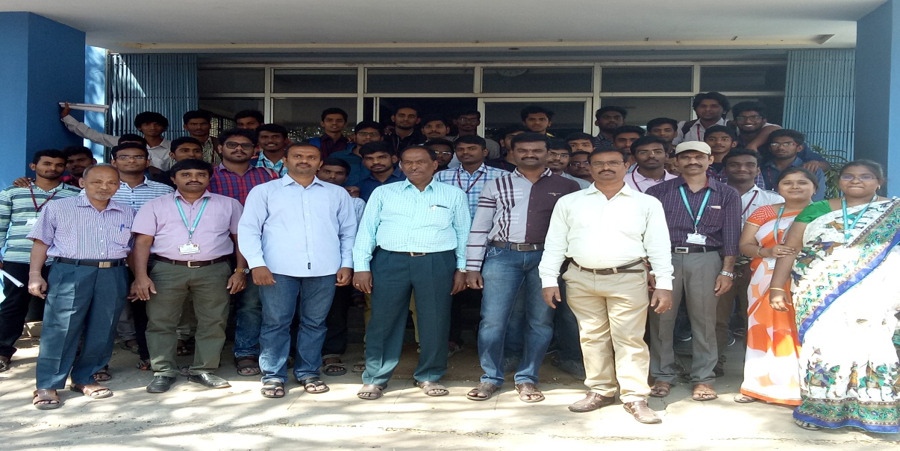

Basic theory class:

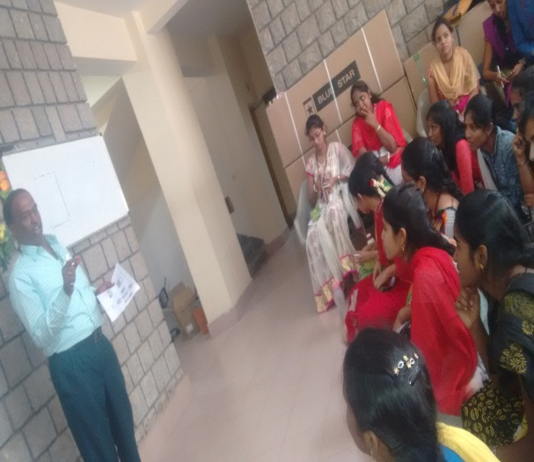

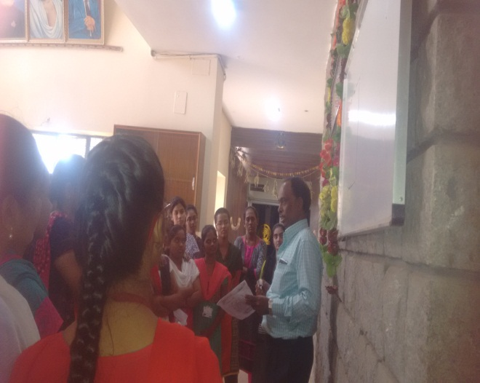

Transmission Booth:
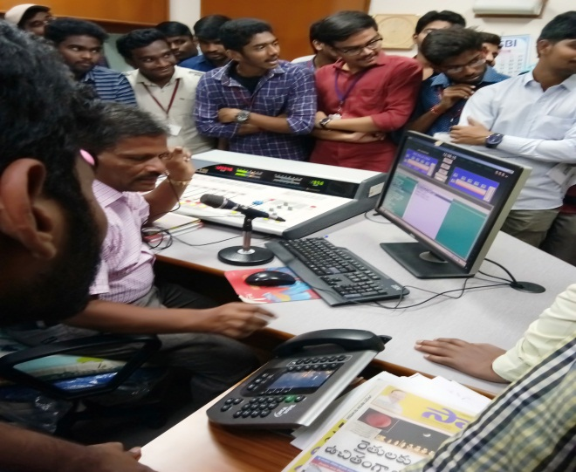

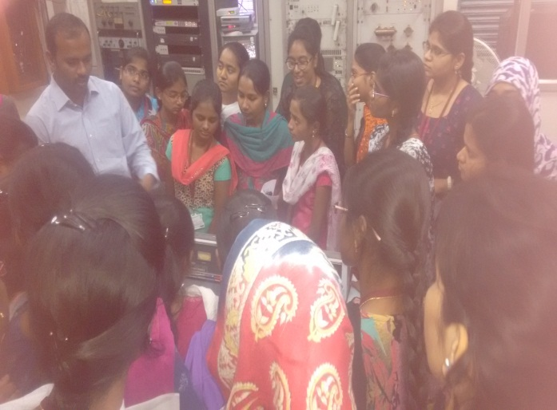
Control Room:

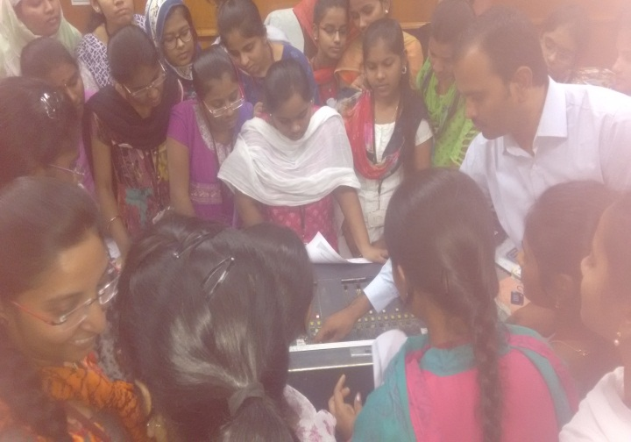

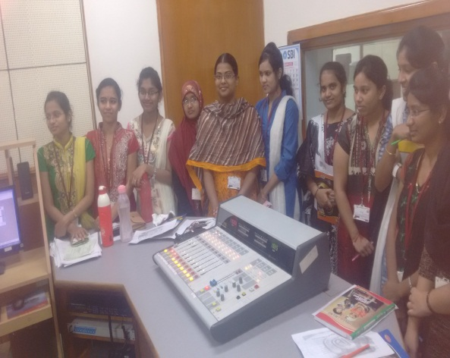
Multipurpose studio room:

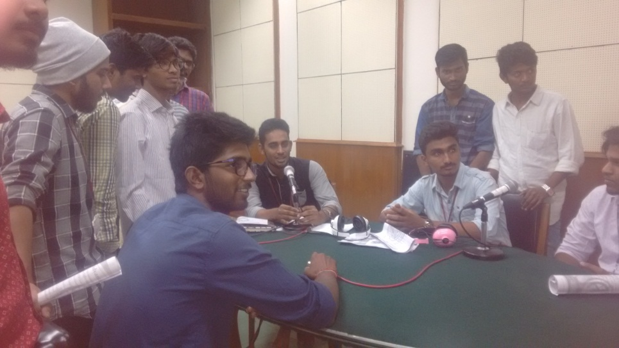

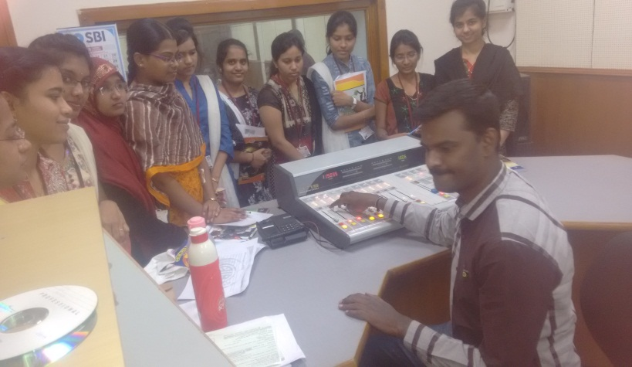

Transmission System:
