G. PULLAIAH COLLEGE OF ENGINEERING & TECHNOLOGY, Kurnool
Department of MBA
Report on “Kurukshetra-The Battle for Knowledge”
“Management meets provide useful tools to help you improve your leadership and management ability.”
With the above objective, the Department of Management Studies, G. Pullaiah College of Engineering and Technology has taken initiative and organized its first National level Management meet on 26th March, 2011 by name “Kurukshetra – The Battle for Knowledge”. Continuing its trend of organising the Management Meet, 6th National Level Management Meet was organized on 7th April, 2018.
Kurukshetra aims to provide a platform for sharing experiences and information to the budding managers from across the country. The overall objective of the event is to elucidate the major business activities through different events and to elicit diverse responses from the students of management.
Chief Guest for the Event: Dr. CH. KRISHNUDU, Assistant Professor, Sri KrishnaDevaraya Institute of Management, Ananthapuramu
EVENTS HOSTED:
- Biz Mavin – Business Quiz
- Patraparichay – Paper presentation
- Young Manager
B-QUIZ:
- Round 1 – Written test
The written test consists of 25 fill in the blanks related to current affairs, Business, Sports and etc., the duration of the written test is 30 minutes.
- Round 2 – Final round
The final round consists of 5 rounds again.
- Take a punch – Logos and punch lines
- Buzzer round
- Picture assembling
- Face the rival
- I’M nutty
- Winners of B-Quiz are Sandeep and Sindhoori from G. Pullaiah College of Engineering and Technology
- Runners of B-Quiz are Sreenivasulu and O. Madhumitha from G. Pullaiah College of Engineering and Technology
YOUNG MANAGER:
- Round 1- Written Test
The written test consists of 20 fill in the blanks related to current affairs, Business, Sports and etc., the duration of the written test is 30 minutes.
- Round 2- Unique Talent
The participants were asked to present their unique talent such as singing, dancing, mimicry etc
- Round 3- Stress Interview
Stress interviews" are an offbeat way to see how candidates react to unusual circumstances under pressure. Dr. CH. KRISHNUDU, Assistant Professor, Sri KrishnaDevaraya Institute of Management, Ananthapuramu acted as interviewer. The best performer won the title of “YOUNG MANAGER”.
- Winner of the Title “YOUNG MANAGER” is D. Saleem Basha from Dr. K.V. Subba Reddy College, Kurnool.
PATRAPARICHAY – PAPER PRESENTATION
Good number of papers were presented in the Paper Presentation contest held during the event. Dr. CH. KRISHNUDU, Assistant Professor, Sri KrishnaDevaraya Institute of Management, Ananthapuramu has acted as an adjudicator for Paper Presentation and given his valuable inputs to students.
- Winners of PPT are Lavanya and Kezia from G. Pullaiah College of Engineering and Technology.
- Runners of PPT are B. Raghunath Reddy and Shaik. Naazneen from G. Pullaiah College of Engineering and Technology.
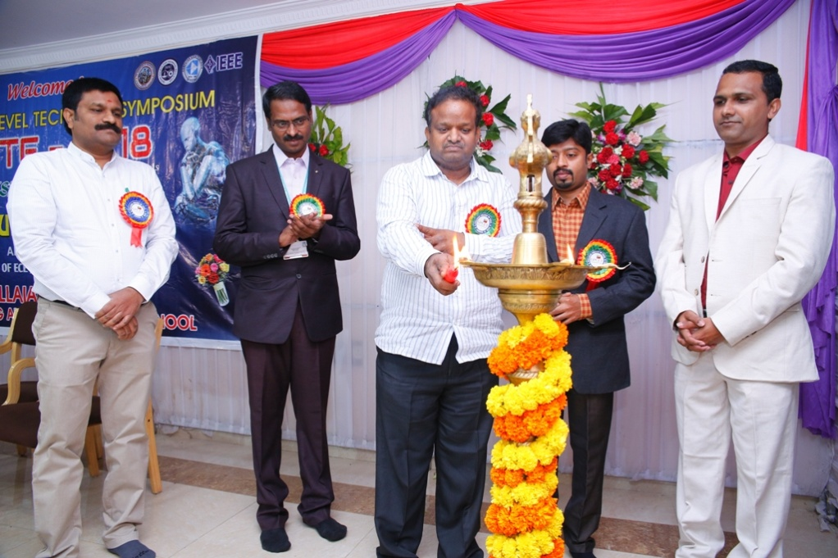

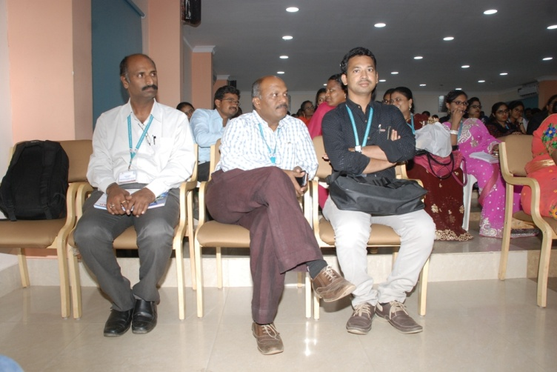
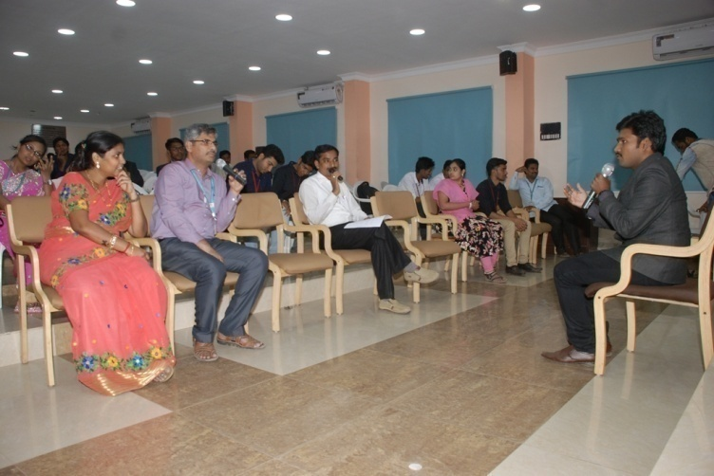

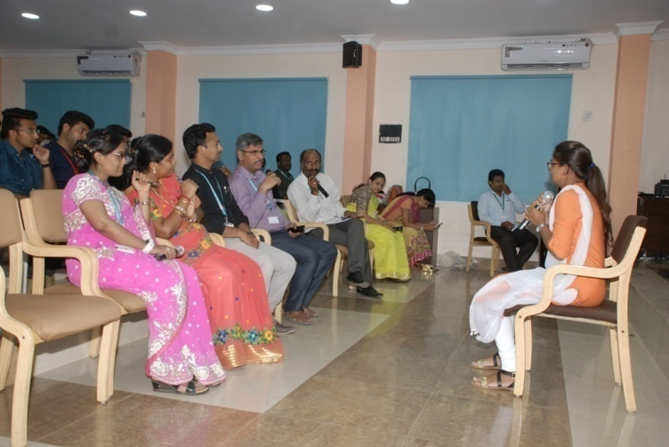
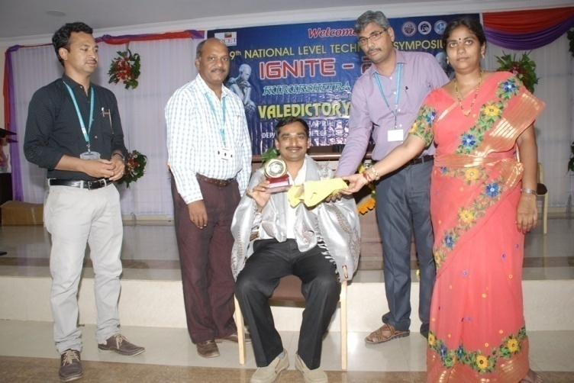

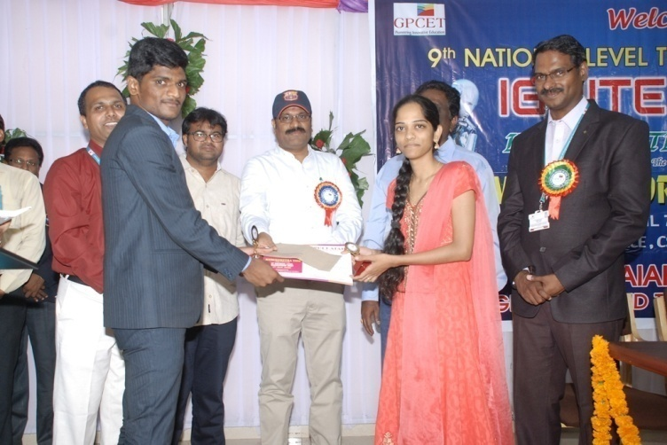
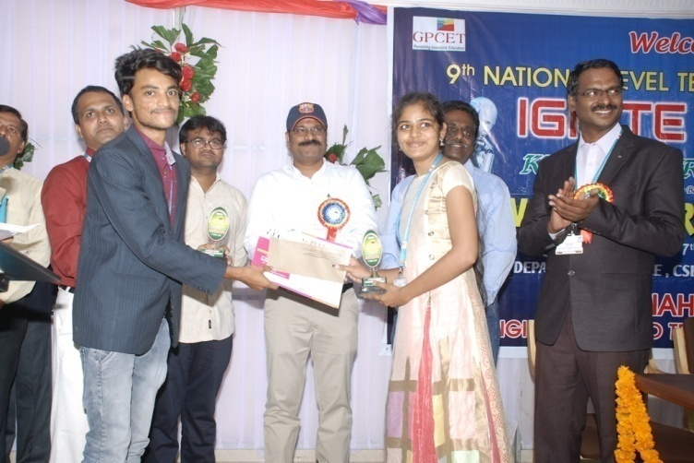

SNAPSHOTS OF THE EVENT AND PRIZE DISTRIBUTION
HOD-MBA

