UNIT-I
INTRODUCTION TO MANAGERIAL ECONOMICS

DECISION MAKING:
Decision is a process to select a particular course of action from among a number of alternatives
The decision makers should have good knowledge of those aspects of economic theory and its tools of analysis which are involved in the process of decision making
The managerial economics is concerned with those aspects of economics and its tools of analysis which are used in the process of decision making of business enterprises.
DEFINITIONS OF MANAGERIAL ECONIMICS:
- MC Crutgan and Moyer:-
“Managerial Economics is the application of economics theory and methodology to decision making problems faced by both public and private institutions”
- MC Nair and Meriam:-
“Managerial economics consists of the use of modes of thought to analysis business situations”.
- Spencer and Siegelman:-
“Marginal economics is the integration of economic theory with business practice for the purpose of facilitating decision making and forward planning by management”.
- Haynes mote and paul:-
“Managerial economics refer to those aspects of economic and its tools of analysis most relevant to the firm decision making process”.

- Joel dean:-
“Use of economic analysis in formulating policies is known as managerial economics”
- Edwin mans field:-
“Managerial economics is concerned with application of economics concepts and economics analysis to the problem of formulating rational managerial decisions”.
Thus managerial economics is the process of application of the principles, technical and concepts of economics to solve the managerial problems of a business and industrial enter price.

ANOTHER NAMES OF THE MANAGERIAL ECONIMICS

- Business economics
- Micro economics
- Economics of enterprises
- Applied economics
- Managerial economics
Managerial economics lies on the border line between economics and business management and services as a bridge between the two disciplines.
CHARACTERISTICS OF MANAGERIAL ECONOMICS
- Micro economics:- managerial economics is micro economics as it is concerned with smaller units of the economy it studies the problems or an individual industry it assist firm or an individual industry. It assists the management in forecasting and evaluating the trends of market.
- Normative economics:- managerial economics belongs to normative economics it is concerned with what management should do under particular circumstances. It determines the goal of the enterprise and then develops the ways to achieve these goals it deals with future planning, policy making, decision making and making full utilization of the available resources of the enterprise.
- Pragmatic:- managerial economics is pragmatic if tries to solve the managerial problems in their day to day functioning and avoids difficulty issues of econ9mic theory.
- Uses theory of firm:- managerial economics uses economic concepts and principles which are known as the theory of firm or economics of the firm thus its scope is narrower than that of pure economic theory.
- Takes the help of macro economics:- managerial economics takes the help of economics for business cycles, taxation policy of the government price and distribution policies, wage policy and anti monopoly policy etc…,
- Aims at helping the management:- managerial economics aims at helping the management in taking correct decisions and preparing plans and policies for future.

NATURE OF MANAGERIAL ECONOMICS

- Micro economics in character:- macro economics is concerned with whole economy while micro economics is concerned with smaller part of the economy such as affirm managerial economics falls within micro economics as it is concerned with the problems of the individual business firms.
- Normative science:- managerial economics is a normative science. It tells us what should be done under given circumstances. It is not concerned with what should be done to achieve the organization goals efficiently. It explains what the firm should do in order to get good result.
- Prescriptive rather than descriptive:- managerial economics is a normative and applied discipline.
- Pragmatic:- managerial economics avoids difficult extract issues of economics theory and tackles practical problems faced by the firms in their day to day functioning.
- A scientific art:- an art is a system of rules for the attainment of given ends it is the best way of doing the things managerial economics may also be called an art, because it is helps the management in the best and efficient utilization of scarce economic resources. It facilitates good and result oriented decision under the conditions of uncertainty.

SCOPE OF MANAGERIAL ECONOMICS
The scope of managerial economics includes following subjects:

- Theory of demand:- “According to science and siegalman, a business firm is an economic organization which transforms productivity sources into goods that are to be sold in a market”.
- Demand analysis:- demand analysis is analysis for demand fore casting which is an important part of managerial decision making because an estimate of future sales is essential before preparing production schedule and employing productive resource demand analysis helps the management in indentifying factors that influence the demand for the products of a firm. Thus demand analysis and fore casting is essential for business planning.
- Demand theory:- demand theory is the study of behavior of consumers, Regarding behavior of consumers, it anasers questions such as
- Why does the consumer buy the particular commodity?
- How much they purchase?
- What is the effect of the income, habit taste of consumer on the demand of a commodity?
- What is other factors influencing the demand of a commodity?
- Why and when does a consumer stop to consume a commodity?
- Theory of production:-
Production and cost Analysis is important for the smooth function of production process and project planning.
- Certain amount of goods has to be produced to earn a certain level of profit. To obtain such production same cost have to be incurred
- Here the problem before management is to determine the level of production at which cost of production may be minimum.
- Production theory helps in determining the size of firm and the level of production. It explains how average and managerial cost changes with the change in production.
- Under what conditions do the costs increase or decrease?
- How does the total production increase when input of one the factors of production is keeping other factors constant?
- How can one factor of production substitute another when all the factors are increased simultaneously
- How can optimum production be obtained?

- Theory of exchange (or) pricing theory:

- Theory of exchange is popularly known as price theory it explains
How the prices are determined different types of market conditions?
- How and what extend advertisement can be helpful in increasing sales of a firm in a market?
- Price theory is helpful in determining price policy of firm. Pricing is an important area managerial economics.
- The success of a business and industrial firm depends upon the accuracy and correctness of price decision taken by it. Policy depends affects the demand of products.
- It includes the determination of price under different market conditions, pricing methods, pricing policies, differential pricing, product line pricing and price fore casting.
- Theory of profit:-
- Every business and industrial enterprise aims at earning
maximum Profit.
- Profit is the difference between the total revenue and total cost. Because of the following factors profit is always uncertain:-

- Demand of the product
- Price of the factors of production
- Nature and the degree of competition in the market
- Price behavior under changing conditions.
Hence, profit planning and profit management are necessary for improving profit earning efficient of the firm. Profit management requires that the most efficient techniques should be used for predicting future. The possibility of risks should be minimized as far as possible.
- Theory of capital and investment:-
Theory of capital and investment explains the following important issues:-
- Selection of most suitable investment project
- Most efficient allocation of capital
- Assessing the efficiency of the capital
- Minimizing the possibility of under capitalization.
Capital is the foundation of a business like other factors of production; it is also scare and expensive. It should be allocated in most efficient manner.
- Environmental issues:- Certain issues of macro economics also form a part of managerial economics. These relate to social and political environment in which a business and industrial firm has to co-operative .

DEMAND ANALYSIS

DEMAND:-
The willingness to pay money for some quantity of a particular good
or performance of service.
Ex:- I want a car and I cannot pay for it there is no demand for it from
my side.
FEATURES OF DEMAND
- Desire on the part of the buyer to buy
- Willingness to pay for it.
- Ability to pay the specified price for it.

NATURE OF DEMAND
A product with more number of uses in naturally more in demand than one with a single use.

- Consumer goods Vs producer goods
- Autonomous demand Vs derived demand
- Durable Vs perishable goods
- Firm demand Vs industry goods
- Short run demand Vs long run demand
- New demand Vs replacement demand
- Total market Vs segment market demand

FACTOR DETERMINING THE DEMAND
- Price of the commodities or products:- There is an inverse relationship between price and demand of a commodity if the price increases demand will decrease and vice versa .
According to the law of demand “a fall in the price of a commodity causes the house hold to buy more of that commodity and less of the other commodity which complete with it, while a rise in price. Causes the house hold to buy less of this commodity and more of competing commodities”.

- Nature of commodity:-

- Necessities
- comforts
- luxuries

- Price of related goods:-
- Substitute goods:- These are the goods that can be used as substitute in the place of other goods with equal satisfaction.
EX:- coffee (or) tea.
- Complementary goods:- these are the goods that are demanded only when their related goods are available.
Ex:-ink is complimentary to the pen
- Income of the consumers:- If the income of the consumers increase the demand of commodity will increase the demand of the commodity will also increase because with the increase in income he can also spend more amounts on the purchase of commodity.
- Taste and preferences of the consumers:- Tastes and preferences along with fashion habit and customs of consumers affect the demand for example the demand of goods of fashion goes on increasing at the same price or even if the prices of these goods increase if a consumer is habitual of consuming he will purchase it on all the price levels.
- Size of the population:- The demand of almost all the commodities increases on an increase in the population and it decreases on a decrease in population.
- Government policy:- Government policy affects the demand of the commodity for example if heavy taxes are imposed on the commodity the demand of such commodity will decrease substantially conversely if the government announces the tax concession for certain commodity their demand will increase.
- Expectations regarding future prices:- Expectations of consumers regarding future prices of a commodity affects its demand for example if there is a hope of raise in price of a commodity in future, its demand will increase even at high price because the consumer would like to store such commodity conversely if there is hope of fall in the prices of a commodity in future, the demand of such commodity will decrease.
- Quality of the product:- Demand of the goods of better quality is more than of cheaper quality.
- Advertisement:-Advertisement creates increase and maintains demand of goods advertisement helps in increasing the demand.

DEMAND SCHEDULE
A demand schedule can be constructed to any commodity when the list of price and the quantities purchase at those prices and the quantities purchased at those prices are known demand schedule divided in to two categories. They are
- Individual demand schedule
- Market demand schedule

- Individual demand schedule:- An individual demand schedule is a list of the various quantities of a commodity which an individual consumer purchases at various levels of price in the market.

EX:-
PRICE OF THE MANGOES  RS. | QUANTITY DEMANDED
9 | 1
8 | 2
7 | 3
6 | 4
5 | 5
4 | 6
3 | 7
2 | 8

- MARKET DEMAND SCHEDULE:-
A Market demand schedule shows the total demand for a good at a particular time at different prices in the market.
Market demand schedule can obtained in the way by adding up all the individual demand schedule of all consumers in the market.

price of apples | Quantity demanded | Market demand
 | A B C
10 | 6 6 10 | 22
9 | 8 10 15 | 33
8 | 10 14 20 | 44
7 | 12 18 25 | 55
6 | 14 22 30 | 66
5 | 16 26 35 | 77

It is clear that above figure that adding up the individual curves A,B,C we can arrive at the market demand curve mm

TYPES OF DEMAND
- Price demand
- Income demand
- Cross demand

- PRICE DEMAND:- price demand refer to the quantity of a product or service demand at a given price.
- INCOME DEMAND:- Income demand refers to the quantity of a particular product or service demand at a given level of income of the consumer or the households.
- CROSS DEMAND:- Cross demand refers to the quantity demand for a particular product or service given the price of a related good the related good that may be complementary or substitute goods.

LAW OF DEMAND
The law of demand tells us a commodity and relation between the price of a commodity and its quantity demand in the market
As lower the price greater the quantity will be demanded the law of demand shows the inverse relationship between the price and quantity demanded.

OPERATIONS OF THE LAW OF DEMAND
The law of demand explains that with every fall in the price of a particular product its demand goes on increasing vice versa.

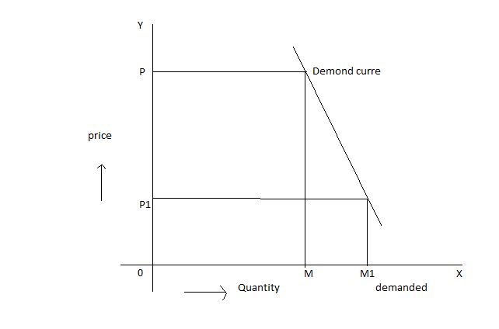

CHANGES IN DEMAND:-
- Increase in demand
- Decrease in demand
- Extension and contraction in demand

- INCREASE IN DEMAND:-
If the consumer is willing and able to buy more of the product or services at the same price the result will be an increase in demand the demand curve will shift o the right.

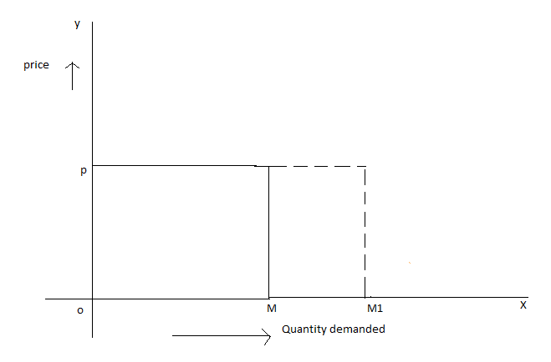
- DECREASE IN DEMAND:-
A decrease in demand occurs when buyers are ready to buy less of a product at the same price because of facts like fall income rise in price of complimentary goods and so on ment along a demand curve which indicates that a higher quantity is demand for a given fall in the price of the goods.
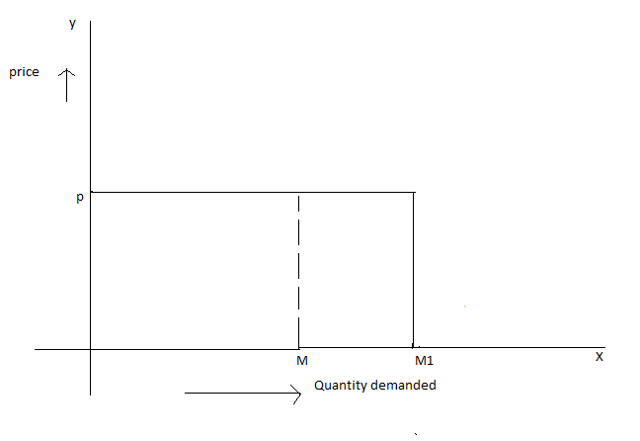
- Extension and contraction in demand:-
A contraction is the upward movement along a demand curve which indicates that a lower quantity is demanded for a given increase in the price of the goods.

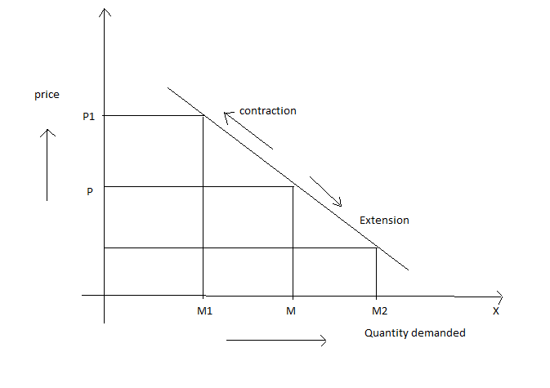
In the above figure we can see that at op is the price the quantity demanded is oq when the price decreases from op to op1 the quantity demanded extends from oq to oq1 this is called extension in demand.
Contraction refers to the movement upwards along the same demand curve when the price increases from op to op2 the demand contrast from oq to oq2 along the same demand curve this is called contraction in demand

EXCEPTIONS TO THE LAW OF DEMAND
The law of demand is only a general statement there are a few exceptions to this general statement they are as given here under.

- GIFFEN’S PARADOX:-
According to the law of demand when the price of a commodity increases its demand must decrease but in some rare occasions people may buy more when the prices are high this type of situation was first discovered by the British economist SIR ROBERT GIFFEN. Goods of this type are called as giffens goods most of the goods like jowar, Bajer and necessaries of life used but the lower—

- PRESTIGIOUS GOODS:-
Theorstein veblem is a nowregian American sociologist and economist he is most famous for his book “the theory of the leisure class”1899.
A commodity is sometimes Vought not because it has any intrinsic worth but because it possession confer a social status for example diamonds precious stones gold etc.
This exception is associated with the name of the orstein Veblen the law of demand may not apply to these goods.
- SPECULATION:-
Some times the price of the commodity might be increasing and it is expected to increase still future the consumers will buy more of the lower price thus an increase in price may not be accompanied by a decrease in its demand in its demand which is contrary to the law of demand
It is evident from the above that the law of demand will not hold good in cases of inferior goods prestigious goods and expectations about future price Changes.
ELASTICITY OF DEMAND
- Definition
- Types of elasticity of demand
- Measurement of elasticity of demand
- Signification of elasticity of demand
- Demand & forecasting
- Factors governing the demand forecasting
- Methods of demand forecasting

INTRODUCTION

The law of demand indicates only the direction of change in quantity demanded in resources to the change in the quantity demanded as a result of changes in the prize of the good differs from time to time, person the person and place to place
EX:- Incase to rice, vegetables, salt etc. there will not be significant changes in the quantity demanded even after a rise in the prize of these goods similarly there will be greater changes in quantity demanded of t.v sets, air coolers, DVD players etc. with a small fall in the prize.
The impact of prize changes is not always uniform on quantity demanded
The law of demand does not tell us by how much or to what extent the quantity demanded of a good will change in response to a change in its price. It will be explained by the concept of “ELASTICITY OF DEMAND”.

Definition of Elasticity of Demand

According to “Marshall” the elasticity of demand in a market is a great or small according as the amount demanded increases such as the amount demanded increase much or little for a given fall in prize”.
The elasticity of demand is defined as the rate of responsiveness in the demand of a commodity for a given change in price or any other determinants of demand.
In other words the degree of sensitiveness or responsiveness in the demand to change in price. However small or great is called as elasticity of demand

TYPES OF ELASTICITY OF DEMAND

- Price elasticity of demand
- Income elasticity of demand
- Cross elasticity of demand
- Advertising elasticity of demand
- Price elasticity of demand:-
It refers to the quantity demanded of a commodity in response to a given change in price. Price elasticity is always negative which indicates that the customer tends to buy more with every fall in the price. The relationship between the price and the demanded is inverse
Price elasticity of demand = proportional change in the quantity demanded/proportional change in the price.
It was developed by Alfred marshall the changes in the price of a particular good will never bring uniform changes in the quantity demanded.

- Income elasticity of demanded:-
Income elasticity of demand refers to the quantity demanded of a commodity in response to a given change in income of consumer
Income elasticity is normally positive which indicates that the consumer tends to by more and more with every increase in income
Income elasticity of demand = proportionate chage in the quantity demanded/ proportionate change in the income
Cross elasticity of demand; cross elasticity of demand refers to the quantity demanded of a commodity in response to a change in the price of a related good which maybe substitute or complement.

- Cross elasticity of demand:-
Proportionate change in the quantity demanded/proportionate change in the price of product
Complementary goods will have negative cross elasticity of demand where as substitutes will have positive cross elasticity of demand.
- Advertising elasticity of demand:-
It refers to increase in the sales revenue because of change in the advertising expenditure. In other words, there is a direct relationship between the amount of money spent on advertising and its impact on sales advertising elasticity is always positive
Advertising elasticity of demand=proportionate change in the quantity demanded for product/proportionate change in the advertising costs.

MEASUREMENT OF ELASTICITY OF DEMAND
- Perfectly elastic demand
- Perfectly in elastic demand
- Relatively elastic demand
- Relatively in elastic demand
- Unity elasticity of demand
- Perfectly elastic demand:- It is a situation where the smallest change in price causes the greatest change in the demand. This type of situation we rarely come across in real life
A slightly fall in price will lead to infinitive increase in demand and a slightly rise in price will the quantity demanded to fall to zero, which is equal to infinity.
In reallife , we will not come across any such commodity which has perfectly elastic demand implying that it remains as an imaginary concept.

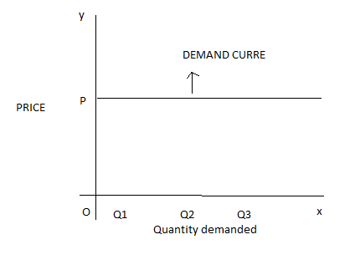
- Perfectly inelastic demand:-
When a significant degree of change in price leads to little or no change in the quantity demanded, then the elasticity is said to be perfectly inelastic.
In other words, the demand is said to be perfectly inelastic when there is no change in the quantity demanded even though there is a big change in price.

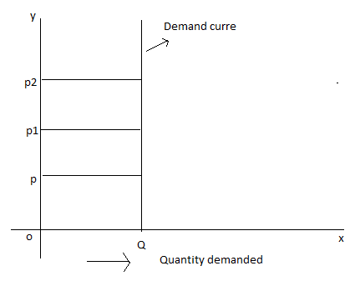
- Relative elastic demand:-
It is a situation when the proportionate change in quantity demanded is greater the proportionate change in the price of a product.
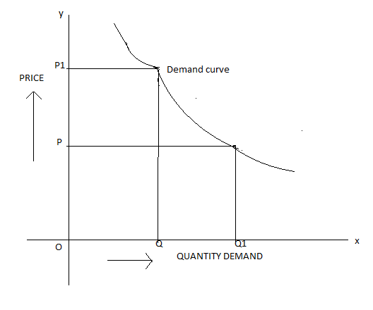
- Relative inelastic demand:-
The demand is said to be relative inelastic when the change in demand is less than the change in the price.
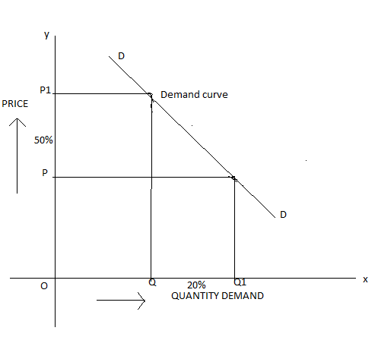
- Unity elasticity of demand:-
The elasticity in demand is said to be unity when the change in demand is equal to the change in price, it is a situation where the proportionate in quantity demand is equally proportionate to change in the price of the goods. Elasticity of demand here is said to be equal to unity or1.
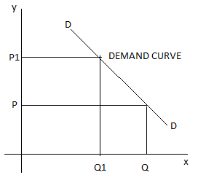
MEASUREMENT OF PRICE ELASTICITY OF DEMAND
Different methods have been devised by the economist to measure the degree of elasticity they are
- To total outlay method
- The point method
- The arc method
- The total out lay/Revenue method
Under this method we compare the total outlay of the buyer or total revenue of the seller before and after the change in price we can get total out lay.
P*q = price*quantity
P*q = total outlay=total revenue
According to this method, prince elasticity of demand is expressed in three forms, they are:
- Elastic demand
- Unity elasticity
- In elastic demand
- Elastic demand:- when the total amount spent on goods increases with a fall in price and decrease with a rise in price then elasticity is said to be greater than unity or elastic demand
- Unity elasticity:- when the total amount spent on goods remains the same before and after the price change, then it is called unity elasticity.
- Inelastic demand:- when the total amount spends on the goods decreases with a fall in price, then it is called inelastic demand.

price of product (p) | Q.D | Total out lay(PxQ) | Elasticity
9 | 40 | 360 | elasticity demand np>1
8 | 50 | 400
7 | 60 | 420 | elasticity demand np=1
6 | 70 | 420
5 | 80 | 400 | elasticity demand np<1
4 | 90 | 360

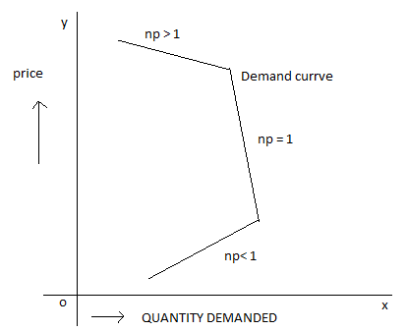
- Point method:-
This method helps us to measure the elasticity of demand at any point on the demand curve this method has also given by Alfred marshall and is known as “Geo-metrical method”.
According to this method, elasticity at any point is the ratio to the lower position of the demand curve to the upper positon.
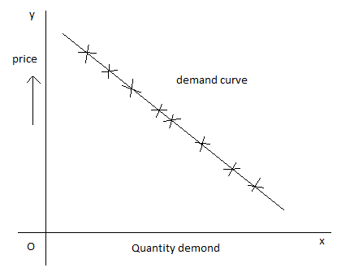
- Arc method:-The main drawback to the point method is that it can be used only when we have complete data on the changes in the price of the good and quantity demand but in real life, it is not easy to get and quantity this means that there will be gaps in the demand schedules in such cases, it is not possible to apply the point method to get the desired results.
In the arc method, the mid-points b/w the old and new data in the case of price and quantity are used.
This method studies a portion or segment (Arc) of the demand curve between the two points
Np=change in the quantity demanded/original quantity +new quantity/change in the price/old price + new price.
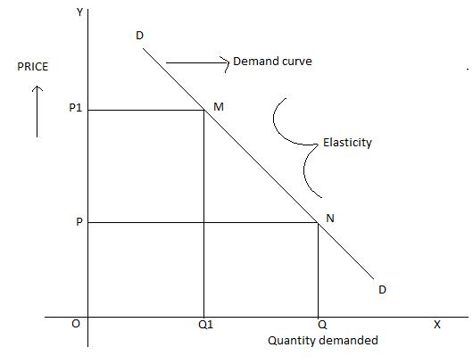

FACTORS GOVERNING THE ELASTICITY OF DEMAND
Elasticity is governed by number of factors charge in any one of these factors is likely to affect the elasticity of demand these factors are
- Nature of the product:- Based on the nature the products and services are classified in to necessities, comforts and luxuries. Necessaries imply the absolute or basic necessities such a food, clothing housing, comforts refer to T.V, refrigerator and so on. By luxuries, we mean sofa, marble flooring in the house and such others. The meaning and definition of these necessaries luxuries and comforts change from person to person time to time and place
EX:- A scooter may be a comfort or luxury for a student but when he does a part-time job, it may be a necessity for him.

- Time factor:- In general the demand is inelastic in the short period and more elastic in the long period, because there will be sufficient time for consumers to know the change in price.
- Degree of postponement:-Where the product consumption can be postponed, the product is said to have elastic demand and where it cannot be postponed, it is said to have inelastic demand. The consumption of necessaries cannot be postponed and hence they have in elastic demand.
- Number of alternative uses:- If the number of alternative uses is more, the demand is said to be highly inelastic, and vice versa. In the case of electricity or power. It is used for a number of alternative uses .
- Tastes and preference of the consumer:- where the customer in particular about his taste and preference, the product is said to be inelastic for the customer who are particular to certain brands such as colgate, Tata tea and so on price increases do not matter. They tend to by that brand in spite of the price changes.
- Availability of close substitutes:- where there are a good number of close substitutes, the demand is said to be elastic and vice versa. If coffee and tea core equally good for me, if there is an increase in price of coffee, I may tend to switch over to tea.
- In case of complementaries of joint goods:- In case of complementaries or good having joint demand, the elasticity is comparatively low.
- Level of prices:- If the price is very expensive such as diamonds or very cheap such as salt, then the product is likely to have an inelastic demand.
- Expectation of the prices:-When people expect a fall in the price, the demand for the product is likely to be inelastic.
- Durability of the product:-Where the product is durable in case of consumer durable such as T.V .The demand is elastic. In the case of perishable goods such as milk, the demand is inelastic.

SIGNIFICANCE OF ELASTICITY OF DEMAND
- Price determination:- The individual producer consider the elasticity of demand of his commodity before fixing the price when the commodity has inelastic demand he will fix a lower price to maximum his profit vice versa.
- Joint products:- In case of joint products, separate cost are not ascertainable. In such cases the product will be guided mostly by elasticity of demand. So a lower price is fixed in the case of goods having elastic demand and a higher price of inelastic demand.
- To government:- The concept of elasticity of demand also enables the government to decide as what particular industries should be declared as “Public utilities” to be taken over and operated by the state.
- International trade:- It is possible to calculate the terms of trade between two countries only by taking into account the natural elasticity of demand for each other products.
- To the finance minister:- The finance minister also takes in to the account elasticity of demand for goods when selecting the goods for taxation . When the government is in need of more revenue he choose those goods which has inelastic demand.
DEMAND FORECASTING
“Forecasting helps to assess the likely demand for product and services and to plan production accordingly. Demand forecasting is helpful not only at the firm level but also at the national level”
“Demand forecasting is an estimation of demand during as specified future period based on a proposed marketing plan and particular uncontrollable and competitive forces”.

ADVANTAGES OF FORECASTING
- Production scheduling
- Reducing cost of manufacturing
- Inventory control
- Determination of price policy
- Setting sales targets
- For suitable advertising
- Make a long term investment decision
- Manpower planning

FACTORS GOVERNINIG THE DEMAND FORECASTING

- Purchasing power of customers
- Price
- Substitutes
- Complementary
- Nature of the goods
- Degree of competition
- Socio-economic condition of the country
- Credit conditions
- Demography
- Time factors(long term or short term)

METHODS OF DEMAND FORECASTING
Forecasting demand is not any easy exercise it may be easy only in the case of a very few products or services.
Where the demand for the products does not change from time to time or competition is not significant. It may be relating easy to forecast demand for a particular product or services
There are many methods of forecasting demand some of them is
- Survey methods.
- Statistical methods.
- Other methods.
- Survey methods
- Survey of buyer intention
- Sale force opinion method

1. Survey methods.
A. Survey of buyer intention:- To anticipate what buyer are likely to do under a given set of circumstances. Most useful sources of information would be the buyers themselves. It is better to draw a list of all potential buyers approach each buyers to ask how much does he plans to buy of the given product of a given point of time under particular conditions.
B. Sales force opinion method:- The sales people are those who are in constant touch with the main large buyers of a particular market and hence they constitute another valid source of information about the likely sales of a product.
2. Statistical methods:-
For forecasting the demand for goods and services in the long run, statistical and mathematical methods are used condition ring the past data.
A. Trend projection methods:-
These are generally based on analysis of past sales patterns. These methods dispense with the need for costly market research because the necessary information is often already available in company files in terms of different time periods, that is a time series data.
B. Barometric Techniques:-
Under the barometric technique, one set of data is used to predict another set In other words, to forecast demand for a particular product or service, use some other relevant indicator which is known as barometer of future demand.
C. simultaneously equation method:- In this method, all variables are simultaneously considered, with the conviction that every variable influences the other variables in an environment. Hence the set of equations equal the number of dependent variable which is also called endogenous variables.
D. Correlation and regression methods:-
Correlation and regression methods are statistical techniques. Correlation describes the degree of association between tow variables such as sales and advertisement experiment. When the two variables tend to change together. Then they are correlated is measure by correlation co-efficient of these two variables one is a dependent variables and the other is an independent. If the high value of one variable are associated with the high values of another, they are said to be positively correlation.

3. OTHER METHODS:-
- Expert opinion method: well informed person are called expert. Experts constitute yet another source an expert is good at forecasting and analyzing the future trend in a given product or services at a given level of technology.
- Test marketing:- It is likely that opinions give by buyers, sales man or other experts may be, at times, misleading. This is the reason why most of the manufacturers favour to test their product or services in a limited market as test- run before they launch their products nationwide.
Based on the result of test marketing valuable lessons can be learnt on how consumer reacts to the given product and necessary changes can be introduced to gain wider acceptability.
To forecast the sales of a new product or the likely sales of an established product in a new channel of distribution or territory, it is customary to find test marketing in practice.
- Controlled experiment:- In this method the product is introduced with different package, different prices in different markets or same markets to asses which combination appeals to the customer most.
This method cannot provide better result, unless these markets are homogeneous in terms of, tastes and preference of the customers their income so on.
- Judgmental approach:- when none of the above the methods are directly related to the given product or services, the management has no alternative other than using its own judgment.

