THEORY OF PRODUCTION AND COST ANALYSIS
DEFINITION: Production is the conversion process of Input resources into Output.
Definition:-

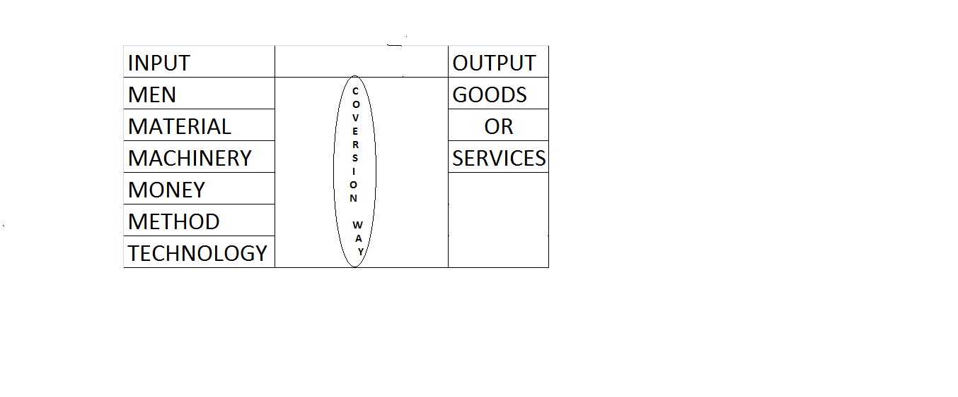

Production Purpose: to satisfy human wants.
Sectors:
- Agriculture
- Industry
- Mining
- Transportation
- Banking
Factors of production:-
- Land
- Capital
- Labour
- Technology

- Production is an economic activity it is to learn something and to satisfy the human wants
- Based on production with business part it may classified into two types of concern
- Manufacturing concern
- Trading concern
- Input resources are based on requirements to produce goods and services
- Finally the ultimate desire is to get the required output

To get profit :-
- To reduce costs
- To increase the price or maximize the revenue (increases)
- In production department to reduce the cost then automatically revenue may increases it was the procedure
PRODUCTION FUNCTION
A producer has to combine different factors or inputs to produce the certain outputs
Production function explains the physical relation between input used and output produced by the firm. This relation ship when expressed in the form of an equation is as follows
O=f (a, b, c, d)
Where o=quality of output produced
a, b, c, d=input resources
f=functional relationship between input and output
The quantity of input used and their combination depends upon the technology. further a producer changes the output by altering input in short run it is not possible to change all inputs ,particularly buildings ,machinery etc…… hence output changes are made by changing labourers.
In long run it is possible to change all inputs & to change the quantity of the output. It is also possible to substitute one factor for another to some extent.
ISOQUANTS
‘Iso’ means’ equal’ & ‘quants’ means ‘quantity’.
Definition: equal quantity is possible to produce as a output at different combinations of input resources.
combinations | capital Rs. In lakh | number of labourers
A | 1 | 20 -EX:20,000 UNITS
B | 2 | 15-EX:20,000 UNITS
C | 3 | 11- EX:20,000UNITS
D | 4 | 8 - EX:20,000 UNITS
E | 5 | 6- EX:20,000 UNITS
F | 6 | 5- EX:20,000 UNITS

NOTE: In short period the alternation is possible by the change the only capital & labourer as input resources.
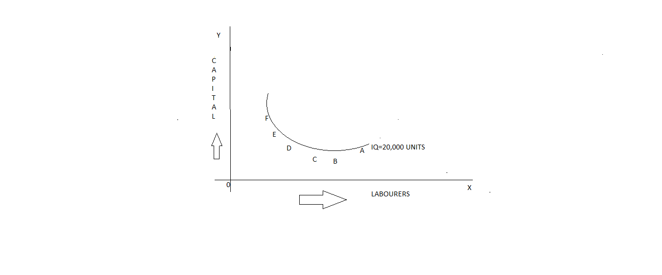
MARGINAL RATE OF TECHINAL SUBSTITUTION (MRTS)
Rratio of MRTS between capital and labour:
Combinations | capital Rs. In lakh | number of Labourers | MRTS
A | 1 | 20 - EX:20,000 UNITS | -
B | 2 | 15- EX:20,000 UNITS | 5:1
C | 3 | 11- EX:20,000UNITS | 4:1
D | 4 | 8 - EX:20,000 UNITS | 3:1
E | 5 | 6 - EX:20,000 UNITS | 2:1
F | 6 | 5- EX:20,000 UNITS | 1:1
- MRTS refers to the rate at which one input factor is substituted with the other to attain a given level of output. In other words the lesser units of one input must be compensated by increasing amounts of another input to produce the same level of output.
- MRTS is existed to produce the same level of quantity with the help of technical substitution.
Isocosts:

- Isocosts refers to that cost curve that represent the combination of inputs that will cost the producer the same amount of money. In other words each isocost denotes a particular level of total cost for a given level of production. If the level of level of production changes then total cost should changes &thus isocost curve moves upwards at in the same way downwards.

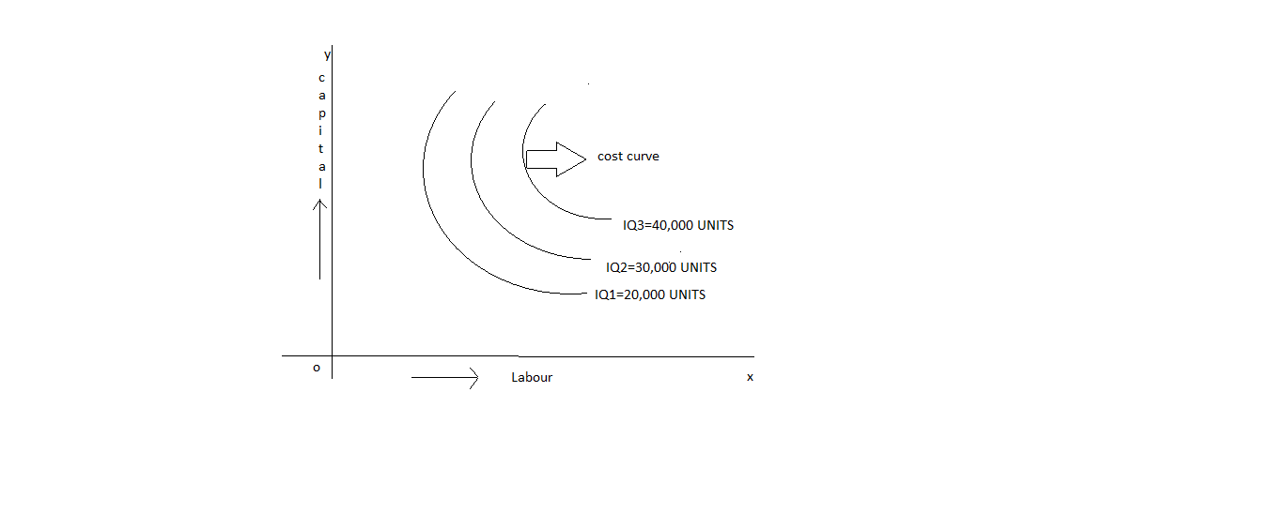Least cost combination of inputs:
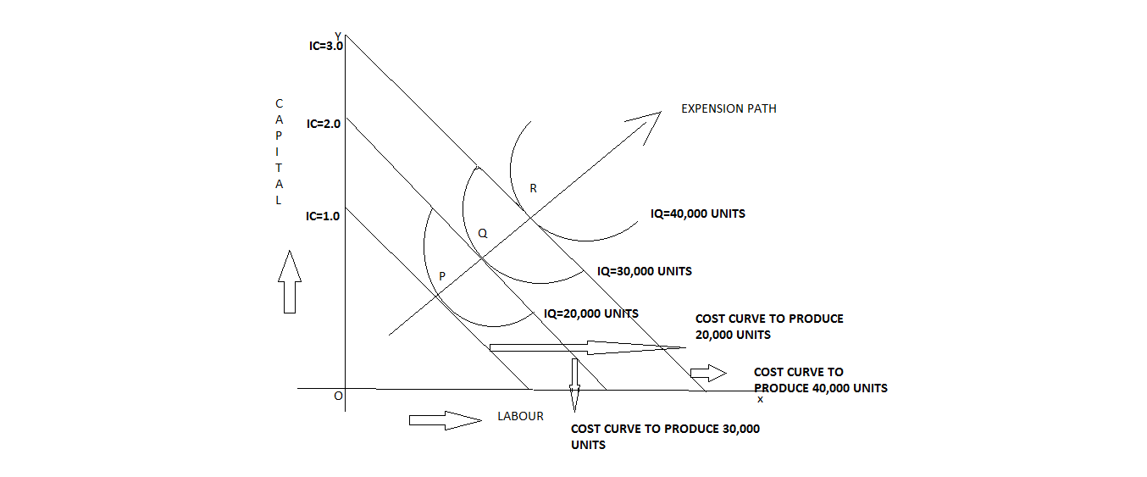

COBB- DOUGLAS PRODUCTION FUNCTION
P=L^ a c^1-a
P=total output
L= labour
C=capital
- We can change labour and capital
- If capital increases then automatically decreases the labour.

LAWS OF RETURNS TO SCALE
- Laws of increasing return to scale.
- Laws of decreasing return to scale.
- Laws of constant return to scale.

Ex: laws of return to scale
CAPITAL | LABOUR | % OF INCREASE IN INPUTS | OUTPUT | %OF INCREASE OUTPUTS | LAWS APPLICABLE
1 | 3 |  | 50
2 | 6 | 100 | 120 | 140 | LAW OF INCREASE
4 | 12 | 100 | 240 | 100 | LAW OF CONSTANT
8 | 24 | 100 | 360 | 50 | LAW OF DECREASE

ECONOMIES OF SCALE
- Economies means “advantages”.
- Scale means “return”.
- It may says that “return related advantages”.
- Again economies advantages are categorized into two types
- Internal advantages
- External advantages
The economies of scale is the result because in scale in production. Alfred marshall divided the economies of scale into two groups:
- Internal economies of scale
- external economies of scale

INTERNAL ECONOMIES OF SCALE: It means that total economies are to be hold. Again internal economies of scale is of seven categories:
- Managerial economies
- Commercial economies
- Financial economies
- Technical economies
- Marketing economies
- risk bearing economies
- research &development economies
- managerial economies:- “managerial economies is the integration of economic theory with business practice for the purpose of facilitating decision making &forward planning by management”.
- Commercial economies:- in this category size of function is large then production department may produce or purchase products.
- Financial economies:- this may able to recutes the large business
- Technical economies:-it may not able buy the advance technology
- Marketing economies:- in this economies market is a place at which buyers and seller at a particular place for price (we may say that buying& selling is possible)
- risk bearing economies:-sharing the risk with so many people along with insurance
- research &development economies:- this type of economies is not easy task in the case of small company .In India there are 5 big companies are started in medicine

EXTERNAL ECONOMIES OF SCALE:- in this economies equal economies are to be hold everyone. These external economies of scale are categorized into 4 types:
- Infrastructural
- Specialization
- Information and market
- Research &development.
Information and market: if the size of business is large that may provides the real information
Research &development:
It was of two types:
- Internal Research &development
- External Research &development
Internal Research & development :- in this type existing product should be improved.
External Research &development :- In this type finding out a new product.
COST ANALYSIS
Types of costs:
- Long run cost
- Short run cost
- Fixed cost
- Variable cost
- Marginal cost
- Controllable cost
- Non-controllable cost
- Explicit cost
- Implicit cost
- Out of pocket cost
- Book cost
Types of costs in- detail explanation:-
Long- run cost:-the cost to bare for fixed assets, to be worked out that in life time.
Short-run cost:-the cost to bare for current assets
Fixed cost:-the cost is said to be fixed it cannot be change even for life time
Ex: rent, salaries .
Variable cost:- the cost is said to be varied in our day-to-day life .
Ex: where as in markets the price value of goods &services are not constant it may varied in our day-to-day life (based on price value demand may depends we may say that if price value increase then demand may get decrease, if price value decrease then demand may get increase)
Marginal cost:- If the producer wants to produce additional product then additional cost is required that additional cost may considered as marginal cost.
Controllable cost:- In this type cost may controlled over a particular period of time.
Ex: reducing the wastage, power bill, telephone bill, etc….
Non-controllable cost:- In this type cost may not be controlled is considered as Non-controllable cost(fixed representation they may not changed)
Ex:
- payment of taxes from government may not be controlled.
- Share valve in market may not be controlled
- Avoiding to see movies, listening songs may not be controlled

Explicit cost :- The cost required for cash payments.
Implicit cost:- The cost required for non- cash payments ,depreciation.
Out -of pocket cost:- The cost required for payment in the case of day-to-day life for business operation.
Book cost:-this cost may to able consider any type of (land value,
Price value ) may written in particular book.
Ex:-
- Land is a asset
- Land is bought by 5crore it may able to written in a book.
- Land may get reselled with in 5 years the demand of land either increase or decrease it may be constant
Breakeven point:-(BEP)
This Breakeven point requires for to find out no profit ,no loss is called as Breakeven point .
Break even analysis:-
It is used to analyze Breakeven point is called as Break even analysis.

SIGNIFICANCE OF BREAKEVEN ANALYSIS:
- To ascertain the profit on a particular level of sales volume or a given capacity of production.
- To calculate sales required to earn a particular level of profits.
- To compare the product lines, sales area methods of sale for individual company.
- To compare the efficiency of the different firms.
- To decide whether to add a particular products to the existing product line or drop one from it.
- To decide to make or buy a given component or spare part.
- To decide what promotion mix will yield optimum sales.
- To assess the input of changes in fixed cost, variable cost or selling price on BEP and points during a given period.
LMITATIONS OF BREAK EVEN ANALYSIS:
- Breakeven point is based on fixed cost, variable cost and revenue. A change in one variable is going to affect the BEP.
- All costs cannot be classified into fixed and variable costs. We have semi variable cost also.
- In case of multi-product firms a single chart cannot be of any use series of charts have to be made use of.
- It is based on fixed cost concept and hence holds good only in the short run.
- Total cost and total revenue lines are not always straight as shown in the figure. The quantity and price discounts are the usual phenomenon affecting the total revenue line.
- Where the business conditions are volatile BEP cannot give stable results.

