UNIT-I

CONTENTS

Operating System Introduction

- Operating systems objectives & functions

- Computer System Architecture

- OS operations

- Evolution of Operating systems

  - Simple Batch

  - Multi programmed

  - Time shared

  - Distributed Systems

  - Real time systems

  - Special Purpose Systems

- Operating system services

- Systems calls

- Types of systems calls

- System programs

- Protection and security

- Operating system design & implementation

- OS structure

- Virtual Machines.

1.1 Definition of Operating System:

An Operating system acts as an intermediatory between the users of computer hardware. The purpose of an Operating System is to provide an environment in which a user can execute programs in a convenient and efficient manner.

OS objectives:

- Convenience: make the computer more convenient to use

- Efficiency: allows computer system resources to be used in an efficient manner

- Ability to evolve: permits the effective development, testing, and introduction of new system functions without interfering with service

OS Functions:

  - Process management

  - Memory management

  - File management

  - Disk management

  - Protection & Security

- Computer System Architecture:

A computer system may be organized in a number of different ways, which we can categorize roughly

according to the number of general-purpose processors used.

- Single-Processor Systems

On a single-processor system, there is one main CPU capable of executing a general-purpose instruction set, including instructions from user processes.

All the special-purpose processors run a limited instruction set and do not run user processes. Sometimes they are managed by the operating system, in that the operating system sends them information about their next task and monitors their status.

4
- Multiprocessor Systems

Multiprocessor systems have two or more processors in close communication, sharing the computer bus and sometimes the clock, memory, and peripheral devices.

Advantages:

  - Increased throughput. By increasing the number of processors, we expect to get more work done in less time. When multiple processors cooperate on a task, a certain amount of overhead is incurred in keeping all the parts working correctly. This overhead, plus contention for shared resources, lowers the expected gain from additional processors.

  - Economy of scale. Multiprocessor systems can cost less than equivalent multiple single-processor systems, because they can share peripherals, mass storage, and power supplies. If several programs operate on the same set of data, it is cheaper to store those data on one disk and to have all the processors share them than to have many computers with local disks and many copies of the data.

  - Increased reliability. If functions can be distributed properly among several processors, then the failure of one processor will not halt the system, only slow it down. Thus, the entire system runs only 10 percent slower, rather than failing altogether.

The multiple-processor systems in use today are of two types.

- Some systems use asymmetric multiprocessing, in which each processor is assigned a specific task. A master processor controls the system; the other processors either look to the master for instruction or have predefined tasks. This scheme defines a master-slave relationship. The master processor schedules and allocates work to the slave processors.

- The most common systems use symmetric multiprocessing (SMP), in which each processor performs all tasks within the operating system. SMP means that all processors are peers; no master-slave relationship exists between processors.

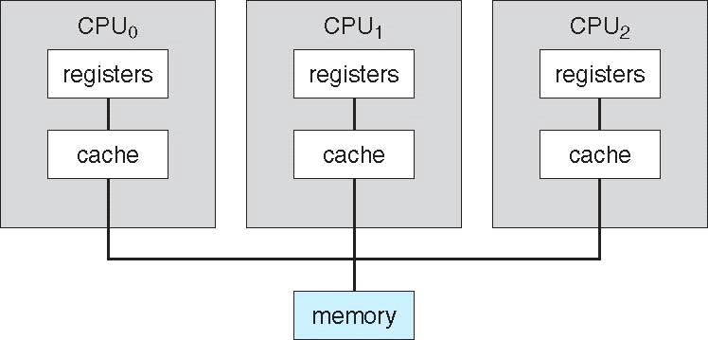

- Clustered Systems

Like multiprocessor systems, clustered systems gather together multiple CPUs to accomplish computational work. Clustered systems differ from multiprocessor systems, however, in that they are composed of two or more individual systems coupled together.

Clustering is usually used to provide high-availability service; that is, service will continue even if one or more systems in the cluster fail. High availability is generally obtained by adding a level of redundancy in the system.

Clustering can be structured asymmetrically or symmetrically.

  - In asymmetric clustering, one machine is in hot-standby mode while the other is running the applications. The hot-standby host machine does nothing but monitor the active server. If that server fails, the hot-standby host becomes the active server.

  - In symmetric mode, two or more hosts are running applications, and are monitoring each other. This mode is obviously more efficient, as it uses all of the available hardware. It does require that more than one application be available to run.

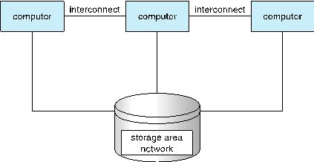
1.3 OS Operations:

Modern operating systems are Interrupt driven. If there are no processes to execute, no I/O devices to service, and no users to whom to respond, an operating system will sit quietly, waiting for something to happen. Events are almost always signaled by the occurrence of an interrupt or a trap.

A trap (or an exception) is a software-generated interrupt caused either by an error (for example, division by zero or invalid memory access) or by a specific request from a user program that an operating-system service be performed.
Dual-mode operation allows OS to protect itself and other system components

- User mode and kernel mode

- Mode bit provided by hardware

  - Provides ability to distinguish when system is running user code or kernel code

  - Some instructions designated as privileged, only executable in kernel mode

  - System call changes mode to kernel, return from call resets it to use

  - At system boot time, the hardware starts in kernel mode. The operating system is then loaded and starts user applications in user mode. Whenever a trap or interrupt occurs, the hardware switches from user mode to kernel mode.

Transition from user mode to kernel mode:
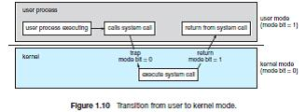

1.4 Evolution of Operating System:

Serial Processing (from the late 1940s to the mid-1950s):

The programmer interacted directly with the computer hardware; there was no OS; the computers were run from a console with display lights, toggle switches, input device – e.g. a card reader - and printer; the users had access to the computer in series.

1.4.1 Simple Batch Systems (from the mid-1950s):

A software, known as the monitor, controls the sequence of events; the user does not have direct access to processor, but submits the job on cards or tape to a computer operator who batches the jobs together and places the entire batch on an input device, for use by the monitor; each job branches back to the monitor when it completes. With each job, instructions are included in a primitive form of job control language, used to provide instructions to the monitor (what compiler to use, what data to use, etc.).

New hardware features:

- Timer: a single job must not monopolize the system;

- Interrupts: OS can relinquish control to and regain control from user programs;

- Privileged instructions: certain machine level instructions can be executed only by the monitor;

- Memory protection: a user program must not alter memory area containing the monitor.

8
New concept of modes of operations:

    - User program executes in user mode: certain areas of memory are protected, certain instructions may not be executed;

  - Monitor executes in system mode: privileged instructions may be executed, protected areas of memory may be accessed.

- Multi programmed Batch Systems:

The central theme of modern OS is multitasking: if there is enough memory to hold the OS and two, three or more user programs, when one job needs to wait for I/O, the processor can switch to the other job.

New hardware features:

- I/O interrupts

- DMA (direct memory access)

New concepts:

  - Memory management

  - Algorithm for scheduling

- Time-Sharing Systems:

Multiprogramming is used to handle multiple batch jobs and multiple interactive jobs. The processor time is shared among multiple users, which simultaneously access the system through terminals.

1.4.4 Distributed Operating Systems:

Distributed systems use multiple central processors to serve multiple real time application and multiple users. Data processing jobs are distributed among the processors accordingly to which one can perform each job most efficiently.

The processors communicate with one another through various communication lines (such as high-speed buses or telephone lines). These are referred as loosely coupled systems or distributed systems. Processors in a distributed system may vary in size and function. These processors are referred as sites, nodes, and computers and so on.
1.4.5 Real time systems:

Real-time systems are used when there are rigid time requirements on the operation of a processor or the flow of data and real-time systems can be used as a control device in a dedicated application.
There are two types of real-time operating systems.

  - Hard real-time systems: Hard real-time systems guarantee that critical tasks complete on time. In hard real-time systems secondary storage is limited or missing with data stored in ROM. In these systems virtual memory is almost never found.

  - Soft real-time systems: Soft real time systems are less restrictive. Critical real-time task gets priority over other tasks and retains the priority until it completes. Soft real-time systems have limited utility than hard real time systems. Example: Multimedia, virtual reality, Advanced Scientific Projects like undersea exploration and planetary rovers etc.

- Special-Purpose Systems:

There are, however, different classes of computer systems whose functions are more limited and whose

objective is to deal with limited computation domains.

- Real-Time Embedded Systems:

  - Embedded computers are the most prevalent form of computers in existence. They tend to have very specific tasks. The systems they run on are usually primitive, and so the operating systems provide limited features. Usually, they have little or no user interface, preferring to spend their time monitoring and managing hardware devices, such as automobile engines and robotic arms.

  - Embedded systems almost always run real-time operating systems. A real-time system is used when rigid time requirements have been placed on the operation of a processor or the flow of data; thus, it is often used as a control device in a dedicated application.

  - A real-time system has well-defined, fixed time constraints. Processing mustbe done within the defined constraints, or the system will fail. For instance, it would not do for a robot arm to be instructed to halt after it had smashed into the car it was building.

- Multimedia Systems:
Multimedia data consist of audio and video files as well as conventional files. These data differ from conventional data in that multimedia data—such as frames of video—must be delivered (streamed) according to certain time restrictions

- Handheld Systems:

Handheld systems include personal digital assistants (PDAs), such as Palm and Pocket-PCs, and cellular telephones, many of which use special-purpose embedded operating systems. The amount of physical memory in a handheld depends upon the device, but typically is somewhere between 512 KB and 128 MB. As a result, the operating system and applications must manage memory efficiently. This includes returning all allocated memory back to the memory manager when the memory is not being used.
1.5 OS Services:
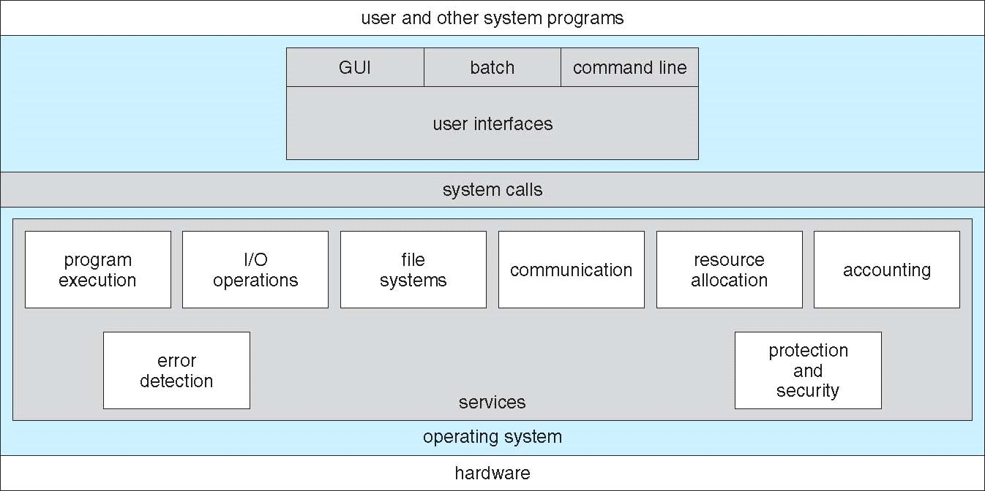

- User interface - Almost all operating systems have a user interface (UI).

• Varies between Command-Line (CLI), Graphics User Interface (GUI), Batch

- Program execution: The system must be able to load a program into memory and to run that program, end execution, either normally or abnormally (indicating error).

- I/O operations: A running program may require I/O, which may involve a file or an I/O device

- File System manipulation: The file system is of particular interest. Programs need to read and write files and directories, create and delete them, search them, list file Information, permission management.

- Communication: Processes may exchange information, on the same computer or between computers over a network

11

    - Communications may be via shared memory or through message passing (packets moved by the OS)

  - Error Detection: OS needs to be constantly aware of possible errors

    - May occur in the CPU and memory hardware, in I/O devices, in user program

    - For each type of error, OS should take the appropriate action to ensure correct and consistent computing

    - Debugging facilities can greatly enhance the user’s and programmer’s abilities to efficiently use the system

  - Resource Allocation: When multiple users or multiple jobs running concurrently, resources must be allocated to each of them

    - Many types of resources - CPU cycles, main memory, file storage, I/O devices.

  - Accounting: To keep track of which users use how much and what kinds of computer resources

  - Protection & Security: The owners of information stored in a multiuser or networked computer system may want to control use of that information, concurrent processes should not interfere with each other

    - Protection involves ensuring that all access to system resources is controlled

    - Security of the system from outsiders requires user authentication, extends to defending external I/O devices from invalid access attempts

- System Calls:

The mechanism used by an application program to request service from the operating system. System calls often use a special machine code instruction which causes the processor to change mode (e.g. to "supervisor mode" or "protected mode").

Let's first use an example to illustrate how system calls are used: Writing a simple program to read data from one file and copy them to another file.
- The first input that the program will need is the names of the two files: the input file and the output file. These names can be specified in many ways, depending on the operating-system

12

design. One approach is for the program to ask the user for the names of the two files. In an interactive system, this approach will require a sequence of system calls, first to write a prompting message on the screen and then to read from the keyboard the characters that define the two files. On mouse-based and icon-based systems, a menu of file names is usually displayed in a window. The user can then use the mouse to select the source name, and a window can be opened for the destination name to be specified.

- This sequence requires many I/O system calls. Once the two file names are obtained, the program must open the input file and create the output file. Each of these operations requires another system call.

- There are also possible error conditions for each operation. When the program tries to open the input file, it may find that there is no file of that name or that the file is protected against access. In these cases, the program should8 print a message on the and then terminate abnormally (another system call). If the input file exists, then we must create a new output file. We may find that there is already an output file with the same name. This situation may cause the program to abort (a system call), or we may delete the existing file (another system call) and create a new one (another system call). Another option, in an interactive system, is to ask the user whether to replace the existing file or to abort the program.

- Now that both files are set up, we enter a loop that reads from the input file (a system call) and writes to the output file (another system call). Each read and write must return status information regarding various possible error conditions. On input, the program may find that the end of the file has been reached or that there was a hardware failure in the read (such as a parity error).

- The write operation may encounter various errors, depending on the output device (no more disk space, printer out of paper, and so on). Finally, after the entire file is copied, the program may close both files (another system call), write a message to the console or window (more system calls), and finally terminate normally (the final system call). As we can see, even simple programs may make heavy use of the operating system. Frequently, systems execute thousands of system calls per second.

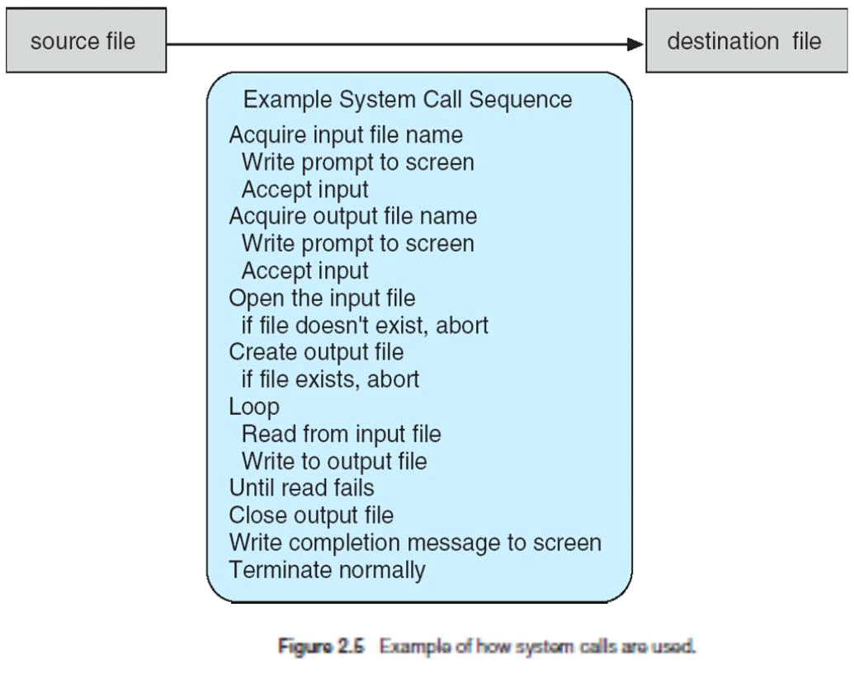

The run-time support system (a set of functions built into libraries included with a compiler) for most programming languages provides a system-call interface that serves as the link to system calls made available by the operating system. The system-call interface intercepts function calls in the API and invokes the necessary system call within the operating system. Typically, a number is associated with each system call, and the system-call interface maintains a table indexed according to these numbers. The system call interface then invokes the intended system call in the operating system kernel and returns the status of the system call and any return values.

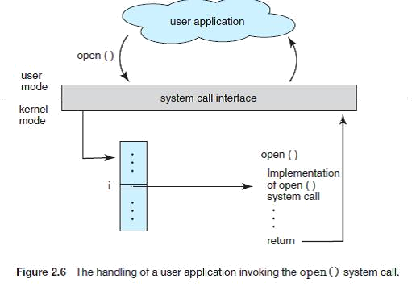

1.7 Types of System calls:

- Process control

  - end, abort

  - load, execute

  - create process, terminate process

  - get process attributes, set process attributes

  - wait for time

  - wait event, signal event

  - allocate and free memory

- File management

  - create file, delete file

  - open, close

  - read, write, reposition

  - get file attributes, set file attributes

- Device management

  - request device, release device

  - read, write, reposition

  - get device attributes, set device attributes

  - logically attach or detach devices

- Information maintenance

  - get time or date, set time or date

  - get system data, set system data

  - get process, file, or device attributes

  - set process, file, or device attributes

- Communications

  - 0 create, delete communication connection

  - ° send, receive messages

  - transfer status information

  - attach or detach remote devices

1.8 System Programs:

System programs provide a convenient environment for program development and execution.

They can be divided into these categories:

- File management. These programs create, delete, copy, rename, print, dump, list, and generally manipulate files and directories.

- Status information. Some programs simply ask the system for the date, time, amount of available memory or disk space, number of users, or similar status information. Others are more complex, providing detailed performance, logging, and debugging information. Typically, these programs format and print the output to the terminal or other output devices or files or display it in a window of the GUI. Some systems also support a registry, which is used to store and retrieve configuration information.

- File modification. Several text editors may be available to create and modify the content of files stored on disk or other storage devices. There may also be special commands to search contents of files or perform transformations of the text.
- Programming-language support. Compilers, assemblers, debuggers and interpreters for common programming languages (such as C, C++, Java, Visual Basic, and PERL) are often provided to the user with the operating system.

- Program loading and execution. Once a program is assembled or compiled, it must be loaded into memory to be executed. The system may provide absolute loaders, relocatable loaders, linkage editors,

16

and overlay loaders. Debugging systems for either higher-level languages or machine language are needed as well.

• Communications. These programs provide the mechanism for creating virtual connections among processes, users, and computer systems. They allow users to send messages to one another's screens, to browse web pages, to send electronic-mail messages, to log in remotely, or to transfer files from one machine to another.
Operating system services

1.9 Protection & Security:

Protection – Mechanism for controlling the access of processes or users to the resources defined by a computer system. This mechanism must provide means for specification of the controls to be imposed and means for enforcement.

Security – defense of the system against internal and external attacks huge range, including denial-of-service, worms, viruses, identity theft, theft of service

Systems generally first distinguish among users, to determine who can do what

  - User identities (user IDs, security IDs) include name and associated number, one per user

  - User ID then associated with all files, processes of that user to determine access control

  - Group identifier (group ID) allows set of users to be defined and controls managed, then also associated with each process, file

  - Privilege escalation allows user to change to effective ID with more rights

- Operating-System Design and Implementation:

Design Goals:

- User goals – operating system should be convenient to use, easy to learn, reliable, safe, and fast
- System goals – operating system should be easy to design, implement, and maintain, as well as flexible, reliable, error-free, and efficient

17
Mechanisms and Policies:

  - Mechanisms determine how to do something, policies decide what will be done

  - The separation of policy from mechanism is a very important principle, it allows maximum flexibility if policy decisions are to be changed later (example – timer)

- OS Structure:

Simple Structure:

MS-DOS – written to provide the most functionality in the least space

- Not divided into modules

- Although MS-DOS has some structure, its interfaces and levels of functionality are not well separated
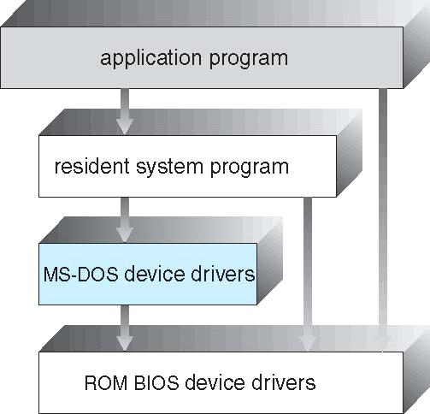

Layered Approach:

\ UNIX – limited by hardware functionality, the original UNIX operating system had limited structuring. The UNIX OS consists of two separable parts

- Systems programs

- The kernel

  - Consists of everything below the system-call interface and above the physical hardware

  - Provides the file system, CPU scheduling, memory management, and other operating-system functions; a large number of functions for one level

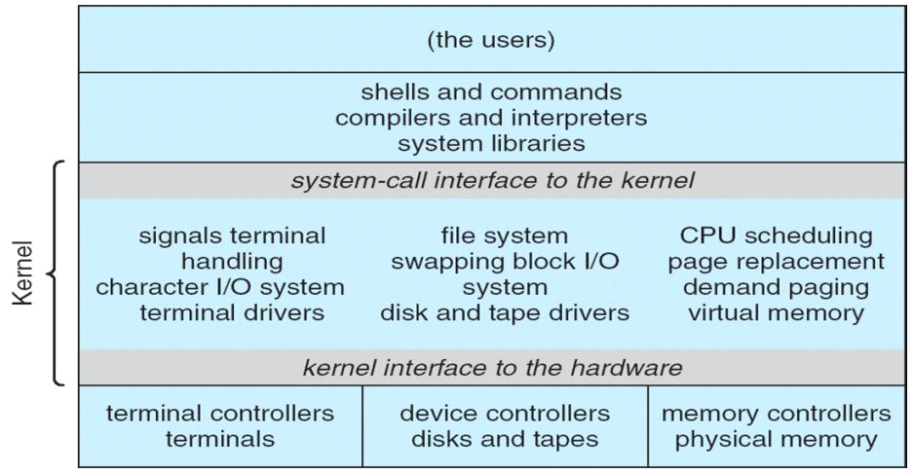

- The operating system is divided into a number of layers (levels), each built on top of lower layers. The bottom layer (layer 0), is the hardware; the highest (layer N) is the user interface.

- With modularity, layers are selected such that each uses functions (operations) and services of only lower-level layers
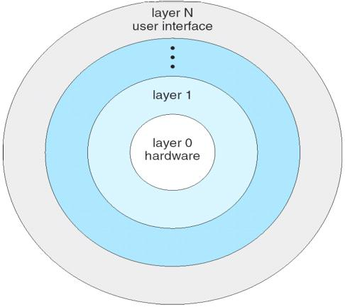

Micro Kernels:

The main function of the microkernel is to provide a communication facility between the client program and the various services that are also running in user space.

For example, if the client program wishes to access a file, it must interact with the file server. The client program and service never interact directly. Rather, they communicate indirectly by exchanging messages with the microkernel.

One benefit of the microkernel approach is ease of extending the operating system. All new services are added to user space and consequently do not require modification of the kernel. When the kernel does have to be modified, the changes tend to be fewer, because the microkernel is a smaller kernel.
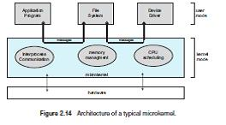

Modules:

The kernel has a set of core components and dynamically links in additional services either during boot time or during run time. Such a strategy uses dynamically loadable modules and is common in modern implementations of UNIX, such as Solaris, Linux, and Mac OS X.
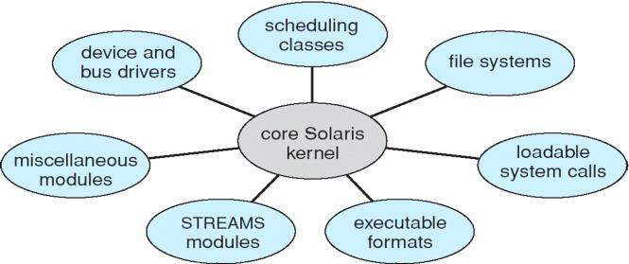

1.12 Virtual Machines:

A virtual machine takes the layered approach to its logical conclusion. It treats hardware and the operating system kernel as though they were all hardware. A virtual machine provides an interface identical to the underlying bare hardware.

- The operating system host creates the illusion that a process has its own processor and (virtual memory).

- Each guest provided with a (virtual) copy of underlying computer.


