UNIT-III

CONTENTS:

Memory Management:

- Logical & Physical address space

- Swapping

- Contiguous memory allocation

- Paging

- Segmentation

Virtual memory:

- Demand paging

- Performance of demand paging

- Page replacement

- Page replacement algorithms

- Allocation of frames

- Thrashing

53
Memory Management

Basic Hardware:

Main memory and the registers built into the processor itself are the only storage that the CPU can access directly. There are machine instructions that take memory addresses as arguments, but none that take disk addresses. Therefore, any instructions in execution, and any data being used by the instructions, must be in one of these direct-access storage devices. If the data are not in memory, they must be moved there before the CPL can operate on them.

Registers that are built into the CPU are generally accessible within one cycle of the CPU clock. Most CPUs can decode instructions and perform simple operations on register contents at the rate of one or more operations per clock tick. The same cannot be said of main memory, which is accessed via a transaction on the memory bus. Memory access may take many cycles of the CPU clock to complete, in which case the processor normally needs to stall, since it does not have the data required to complete the instruction that it is executing. This situation is intolerable because of the frequency of memory accesses. The remedy is to add fast memory between the CPU and main memory. A memory buffer used to accommodate a speed differential, called a cache.
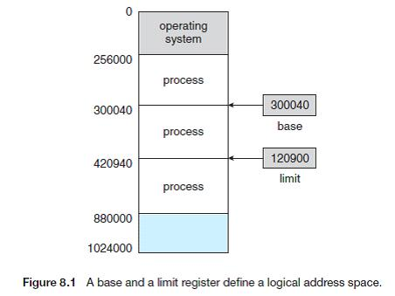

We first need to make sure that each process has a separate memory space. To do this, we need the ability to determine the range of legal addresses that the process may access and to ensure that the process can access only these legal addresses. We can provide this protection by using two registers, usually a base

54

and a limit. The base register holds the smallest legal physical memory address; the limit register specifies the size of the range. For example, if the base register holds 300040 and limit register is 120900, then the program can legally access all addresses from 300040 through 420940 (inclusive).

Protection of memory space is accomplished by having the CPU hardware compare even/ address generated in user mode with the registers. Any attempt by a program executing in user mode to access operating-system memory or other users' memory results in a trap to the operating system, which treats the attempt as a fatal error (Figure 8.2). This scheme prevents a user program from (accidentally or deliberately) modifying the code or data structures of either the operating system or other users.

The base and limit registers can be loaded only by the operating system, which uses a special privileged instruction. Since privileged instructions can be executed only in kernel mode, and since only the operating system executes in kernel mode, only the operating system can load the base and limit registers.

This scheme allows the operating system to change the value of the registers but prevents user programs from changing the registers' contents. The operating system, executing in kernel mode, is given unrestricted access to both operating system and users' memory. This provision allows the operating system to load users' programs into users' memory, to durrtp out those programs in case of errors, to access and modify parameters of system calls, and so on.
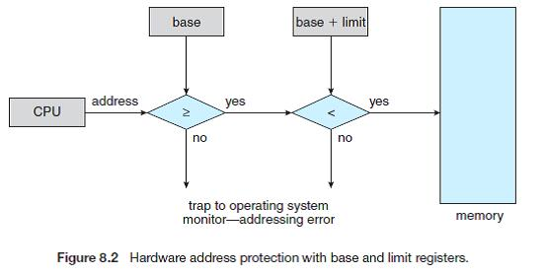

Address Binding

Usually, a program resides on a disk as a binary executable file. To be executed, the program must be brought into memory and placed within a process. Depending on the memory management in use, the

55

process may be moved between disk and memory during its execution. The processes on the disk that are waiting to be brought into memory for execution form the input queue. The normal procedure is to select one of the processes in the input queue and to load that process into memory. As the process is executed, it accesses instructions and data from memory. Eventually, the process terminates, and its memory space is declared available.

Most systems allow a user process to reside in any part of the physical memory. Thus, although the address space of the computer starts at 00000, the first address of the user process need not be 00000. This approach affects the addresses that the user program can use. In most cases, a user program will go through several steps—some of which maybe optional-—before being executed. Addresses may be represented in different ways during these steps. Addresses in the source program are generally symbolic (such as count). A compiler will typically bind these symbolic addresses to relocatable addresses (such as "14 bytes from the beginning of this module''). The linkage editor or loader will in turn bind the relocatable addresses to absolute addresses (such as 74014). Each binding is a mapping from one address space to another.

Classically, the binding of instructions and data to memory addresses can be done at any step along the way:

• Compile time. If you know at compile time where the process will reside in memory, then absolute code can be generated. For example, if you know that a user process will reside starting at location R, then the generated compiler code will start at that location and extend up from there. If at some later time, the starting location changes, then it will be necessary to recompile this code.

- Load time. If it is not known at compile time where the process will reside in memory, then the compiler must generate relocatable code. In this case, final binding is delayed until load time. If the starting addresses change, we need only reload the user code to incorporate this changed value.

- Execution time. If the process can be moved during its execution from one memory segment to another, then binding must be delayed until run time. Special hardware must be available for this scheme to work. Most general-purpose operating systems use this method. A major portion of this chapter is devoted to showing how these various bindings can be implemented effectively in a computer system and to discussing appropriate hardware support.

56
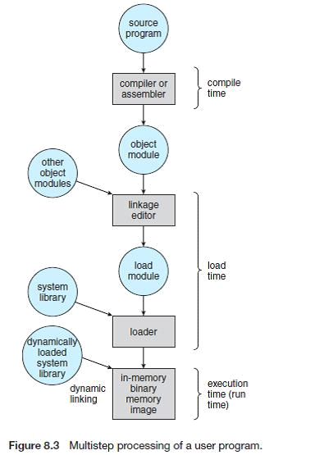

- Logical versus Physical Address Space:

  - An address generated by the CPU is a logical address whereas address actually available on memory unit is a physical address. Logical address is also known a Virtual address.

  - Virtual and physical addresses are the same in compile-time and load-time address-binding schemes. Virtual and physical addresses differ in execution-time address-binding scheme.

  - The set of all logical addresses generated by a program is referred to as a logical address space. The set of all physical addresses corresponding to these logical addresses is referred to as a physical address space.

57
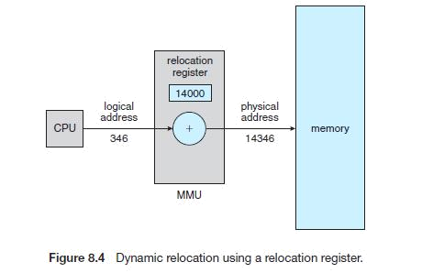

Dynamic Loading

The entire program and all data of a process must be in physical memory for the process to execute. The size of a process is thus limited to the size of physical memory. To obtain better memory-space utilization, we can use dynamic loading. With dynamic loading, a routine is not loaded until it is called. All routines are kept on disk in a relocatable load format. The main program is loaded into memory and is executed.

In Dynamic Loading when a routine needs to call another routine, the calling routine first checks to see whether the other routine has been loaded or not. If not, the relocatable linking loader is called to load the desired routine into memory and to update the program's address tables to reflect this change. Then control is passed to the newly loaded routine.

The advantage of dynamic loading is that an unused routine is never loaded. This method is particularly useful when large amounts of code are needed to handle infrequently occurring cases, such as error routines. In this case, although the total program size may be large, the portion that is used (and hence loaded) may be much smaller. Dynamic loading does not require special support from the operating system. It is the responsibility of the users to design their programs to take advantage of such a method. Operating systems may help the programmer, however, by providing library routines to implement dynamic loading.

Dynamic Linking and Shared Libraries
Some operating systems support only static linking, in which system language libraries are treated like any other object module and are combined by the loader into the binary program image. The concept of

58

dynamic linking is similar to that of dynamic loading. Here, though, linking, rather than loading, is postponed until execution time. This feature is usually used with system libraries, such as language subroutine libraries. Without this facility, each program on a system must include a copy of its language library (or at least the routines referenced by the program) in the executable image. This requirement wastes both disk space and main memory.

With dynamic linking, a stub is included in the image for each library routine reference. The stub is a small piece of code that indicates how to locate the appropriate memory-resident library routine or how to load the library if the routine is not already present. When the stub is executed, it checks to see whether the needed routine is already in memory. If not, the program loads the routine into memory. Either way, the stub replaces itself with the address of the routine and executes the routine. Thus, the next time that particular code segment is reached, the library routine is executed directly, incurring no cost for dynamic linking. Under this scheme, all processes that use a language library execute only one copy of the library code.

This feature can be extended to library updates (such as bug fixes). A library may be replaced by a new version, and all programs that reference the library will automatically use the new version. Without dynamic linking, all such programs would need to be re linked to gain access to the new library.
So that programs will not accidentally execute new, incompatible versions of libraries, version information is included in both the program and the library.

More than one version of a library may be loaded into memory, and each program uses its version information to decide which copy of the library to use. Minor changes retain the same version number, whereas major changes increment the version number. Thus, only programs that are compiled with the new library version are affected by the incompatible changes incorporated in it. Other programs linked before the new library was installed will continue using the older library. This system is also known as
shared libraries.

MMU:
The run-time mapping from virtual to physical address is done by the memory management unit (MMU) which is a hardware device.

MMU uses following mechanism to convert virtual address to physical address:

59

  - The value in the base register is added to every address generated by a user process which is treated as offset at the time it is sent to memory. For example, if the base register value is 10000, then an attempt by the user to use address location 100 will be dynamically reallocated to location 10100.

  - The user program deals with virtual addresses; it never sees the real physical addresses.

- Swapping:

A process must be in memory to be executed. A process, however, can be swapped temporarily out of memory to a backing store and then brought back into memory for continued execution. For example, assume a multiprogramming environment with a round-robin CPU-scheduling algorithm. When

a quantum expires, the memory manager will start to swap out the process that just finished and to swap another process into the memory space that has been freed (Figure 8.5). In the meantime, the CPU scheduler will allocate a time slice to some other process in memory. When each process finishes its quantum, it will be swapped with another process. Ideally, the memory manager can swap processes fast enough that some processes will be in memory, ready to execute, when the CPU scheduler wants to reschedule the CPU. In addition, the quantum must be large enough to allow reasonable amounts of computing to be done between swaps.

A variant of this swapping policy is used for priority-based scheduling algorithms. If a higher-priority process arrives and wants service, the memory manager can swap out the lower-priority process and then load and execute the higher-priority process. When the higher-priority process finishes, the

Lower priority process can be swapped back in and continued. This variant of swapping is sometimes called roll out, roll in.
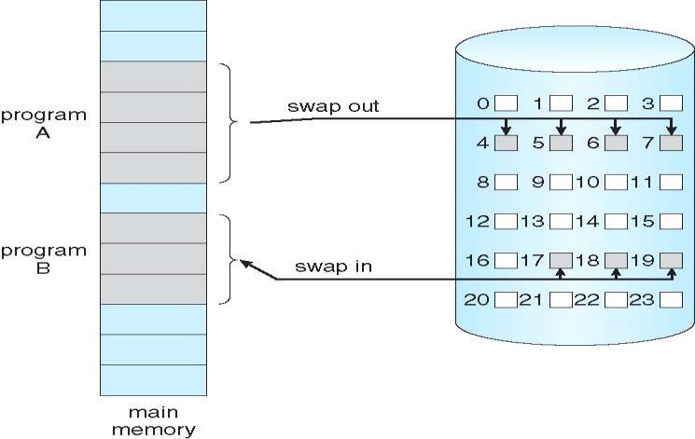

60

Normally, a process that is swapped out will be swapped back into the same memory space it occupied previously. This restriction is dictated by the method of address binding. If binding is done at assembly or load time, then the process cannot be easily moved to a different location. If execution-time binding is being used, however, then a process can be swapped into a different memory space, because the physical addresses are computed during execution time.

Swapping requires a backing store. The backing store is commonly a fast disk. It must be large enough to accommodate copies of all memory images for all users, and it must provide direct access to these memory images. The system maintains a ready queue consisting of all processes whose memory images are on the backing store or in memory and are ready to run. Whenever the CPU scheduler decides to execute a process, it calls the dispatcher. The dispatcher checks to see whether the next process in the queue is in memory. If it is not, and if there is no free memory region, the dispatcher swaps out a process currently in memory and swaps in the desired process. It then reloads registers and transfers control to the selected process.

The context-switch time in such a swapping system is fairly high. To get an idea of the context-switch time, let us assume that the user process is 10 MB in size and the backing store is a standard hard disk with a transfer rate of 40 MB per second. The actual transfer of the 10-MB process to or from main memory takes

10000 KB/40000 KB per second = 1/4 second = 250 milliseconds.

Assuming that no head seeks is necessary, and assuming an average latency of 8 milliseconds, the swap time is 258 milliseconds. Since we must both swap out and swap in, the total swap time is about 516 milliseconds.

For efficient CPU utilization, we want the execution time for each process to be long relative to the swap time. Thus, in a round-robin CPU-scheduling algorithm, for example, the tune quantum should be substantially larger than 0.516 seconds.

Notice that the major part of the swap time is transfer time. The total transfer time is directly proportional to the amount of memory swapped. If we have a computer system with 512 MB of main memory and a resident operating system taking 25 MB, the maximum size of the user process is 487

MB. However, many user processes may be much smaller than this—say, 10 MB. A 10-MB process could be swapped out in 258 milliseconds, compared with the 6.4 seconds required for swapping 256 MB. Clearly, it would be useful to know exactly how much memory a user process is using, not simply how much it might be using. Then we would need to swap only what is actually used, reducing swap time. For

61

this method to be effective, the user must keep the system informed of any changes in memory requirements. Thus, a process with dynamic memory requirements will need to issue system calls (request memory and release memory) to inform the operating system of its changing memory needs.

Swapping is constrained by other factors as well. If we want to swap a process, we must be sure that it is completely idle. Of particular concern is any pending I/O. A process may be waiting for an I/O operation when we want to swap that process to free up memory. However, if the I/O is asynchronously accessing the user memory for I/O buffers, then the process cannot be swapped. Assume that the I/O operation is queued because the device is busy. If we were to swap out process Pi and swap in process Po, the I/O operation might then attempt to use memory that now belongs to process Pi. There are two main solutions to this problem: Never swap a process with pending I/O, or execute I/O operations only into operating-system buffers. Transfers between operating-system buffers and process memory then occur only when the process is swapped in.

3.3 Contiguous Memory Allocation

The memory is usually divided into two partitions: one for the resident operating system and one for the user processes. We can place the operating system in either low memory or high memory. The major factor affecting this decision is the location of the interrupt vector. Since the interrupt vector is often in low memory, programmers usually place the operating system in low memory as well. Thus, in this text, we discuss only the situation where the operating system resides in low memory. The development of the other situation is similar.

We usually want several user processes to reside in memory at the same time. We therefore need to consider how to allocate available memory to the processes that are in the input queue waiting to be brought into memory. In this contiguous memory allocation, each process is contained in a single contiguous section of memory.

Memory Mapping and Protection

The relocation register contains the value of the smallest physical address; the limit register contains the range of logical addresses (for example, relocation = 100040 and limit = 74600). With relocation and limit registers, each logical address must be less than the limit register; the VIMU maps the logical address
dynamically by adding the value in the relocation register. This mapped address is sent to memory.

62

When the CPU scheduler selects a process for execution, the dispatcher loads the relocation and limit registers with the correct values as part of the context switch. Because every address generated by the CPU is checked against these registers, we can protect both the operating system and the other users' programs and data from being modified by this running process.

The relocation-register scheme provides an effective way to allow the operating-system size to change dynamically. This flexibility is desirable in many situations. For example, the operating system contains code and buffer space for device drivers. If a device driver (or other operating-system service) is not commonly used, we do not want to keep the code and data in memory, as we might be able to use that space for other purposes. Such code is sometimes called transient operating-system code; it comes and goes as needed. Thus, using this code changes the size of the operating system during program execution.
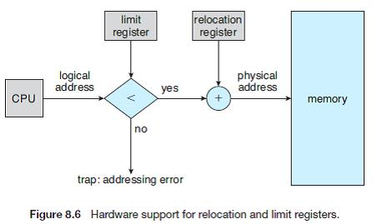

Memory Allocation

In the fixed-partition scheme, the operating system keeps a table indicating which parts of memory are available and which are occupied. Initially, all memory is available for user processes and is considered one large block of available memory, a hole. When a process arrives and needs memory, we search for a hole large enough for this process. If we find one, we allocate only as much memory as is needed, keeping the rest available to satisfy future requests. As processes enter the system, they are put into an input queue. The operating system takes into account the memory requirements of each process and the amount of available memory space in determining which processes are allocated memory. When a process is allocated space, it is loaded into memory, and it can then compete for the CPU. When a process

63

terminates, it releases its memory, which the operating system may then fill with another process from the input queue.

At any given time, we have a list of available block sizes and the input queue. The operating system can order the input queue according to a scheduling algorithm. Memory is allocated to processes until, finally, the memory requirements of the next process cannot be satisfied—that is, no available block of memory (or hole) is large enough to hold that process. The operating system can then wait until a large enough blocks is available, or it can skip down the input queue to see whether the smaller memory requirements of some other process can be met.

In general, at any given time we have a set of holes of various sizes scattered throughout memory. When a process arrives and needs memory, the system searches the set for a hole that is large enough for this process. If the hole is too large, it is split into two parts. One part is allocated to the arriving process; the other is returned to the set of holes. When a process terminates, it releases its block of memory, which is then placed back in the set of holes. If the new hole is adjacent to other holes, these adjacent holes are merged to form one larger hole. At this point, the system may need to check whether there are processes waiting for memory and whether this newly freed and recombined memory could satisfy the demands of any of these waiting processes.

This procedure is a particular instance of the general dynamic storage allocation problem, which concerns how to satisfy a request of size n from a list of free holes. There are many solutions to this problem. The first-fit, best-fit, and worst-fit strategies are the ones most commonly used to select a free hole from the set of available holes.

Fragmentation:

In the contiguous memory allocation we can get the problem of fragmentation. And it is of two types:

- External Fragmentation – total memory space exists to satisfy a request, but it is not contiguous. External fragmentation exists when there is enough total memory space to satisfy a request, but the available spaces are not contiguous; storage is fragmented into a large number of small holes. This fragmentation problem can be severe. In the worst case, we could have a block of free (or wasted) memory between every two processes. If all these small pieces of memory were in one big free block instead, we might be able to run several more processes.

64

- Internal Fragmentation – allocated memory may be slightly larger than requested memory; this size difference is memory internal to a partition, but not being used.

One solution to the problem of external fragmentation is compaction. The goal is to shuffle the memory contents so as to place all free memory together in one large block. Compaction is not always possible, however. If relocation is static and is done at assembly or load time, compaction cannot be done; compaction is possible only if relocation is dynamic and is done at execution time. If addresses are relocated dynamically, relocation requires only moving the program and data and then changing the base register to reflect the new base address. When compaction is possible, we must determine its cost. The simplest compaction algorithm is to move all processes toward one end of memory; all holes move in the other direction, producing one large hole of available memory. This scheme can be expensive.

Another possible solution to the external-fragmentation problem is to permit the logical address space of the processes to be noncontiguous, thus allowing a process to be allocated physical memory wherever the latter is available. Two complementary techniques achieve this solution: paging and segmentation.

3.4 Paging:

Paging is a memory-management scheme that permits the physical address space of a process to be noncontiguous. Paging avoids the considerable problem of fitting memory chunks of varying sizes onto the backing store; most memory-management schemes used before the introduction of paging suffered from this problem. The problem arises because, when some code fragments or data residing in main memory need to be swapped out, space must be found n the backing store.

65
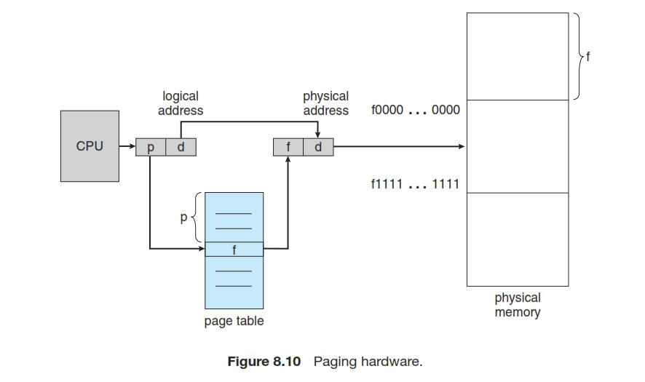

The backing store also has the fragmentation problems discussed in connection with main memory; except that access is much slower, so compaction is impossible. Because of its advantages over earlier methods, paging in its various forms is commonly used in most operating systems.

The basic method for implementing paging involves breaking physical memory into fixed-sized blocks called frames and breaking logical memory into blocks of the same size called pages. When a process is to be executed, its pages are loaded into any available memory frames from the backing store. The backing store is divided into fixed-size blocks that are of the same size as the memory frames.

Every address generated by the CPU is divided into two parts: a page number (p) and a page offset (d).

The page number is used as an index into a page table. The page table contains the base address of each page in physical memory. This base address is combined with the page offset to define the physical memory address that is sent to the memory unit.

The page size (like the frame size) is defined by the hardware. The size of a page is typically a power of 2, varying between 512 bytes and 16 MB per page, depending on the computer architecture. The selection of a power of 2 as a page size makes the translation of a logical address into a page number and page offset particularly easy. If the size of logical address space is 2'"* and a page size is 2" addressing units (bytes or words), then the high-order
m - n bits of a logical address designate the page number, and the n low-order bits designate the page offset. Thus, the logical address is as follows:

66
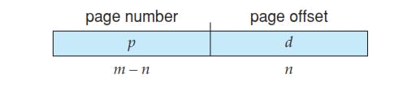

Hardware Support:

The hardware implementation of the page table can be done in several ways. In the simplest case, the page table is implemented as a set of dedicated registers. These registers should be built with very high-speed logic to make the paging-address translation efficient. Every access to memory must go through the paging map, so efficiency is a major consideration. The CPU dispatcher reloads these registers, just as it reloads the other registers.

The standard solution to this problem is to use a special, small, fast lookup hardware cache, called a translation look-aside buffer (TLB). The TLB is associative, high-speed memory. Each entry in the TLB consists of two parts: a key (or tag) and a value. When the associative memory is presented with an item, the item is compared with all keys simultaneously. If the item is found, the corresponding value field is returned. The search is fast; the hardware, however, is expensive. Typically, the number of entries in a TLB is small, often numbering between 64 and 1,024.

The TLB is used with page tables in the following way. The TLB contains only a few of the page-table entries. When a logical address is generated by the CPU, its page number is presented to the TLB. If the page number is found, its frame number is immediately available and is used to access memory. The whole task may take less than 10 percent longer than it would if an unmapped memory reference were used.

If the page number is not in the TLB (known as a TLB miss), a memory reference to the page table must be made. When the frame number is obtained, we can use it to access memory (Figure 8.11). In addition, we add the page number and frame number to the TLB, so that they will be found quickly on the next reference. If the TLB is already full of entries, the operating system must select one for replacement. Replacement policies range from least recently used (LRU) to random. Furthermore, some TLBs allow entries to be wired down, meaning that they cannot be removed from the TLB. Typically, TLB entries for kernel code are wired down.

67

Some TLBs store address-space identifiers (ASIDs) in each TLB entry. An ASID uniquely identifies each process and is used to provide address-space protection for that process. When the TLB attempts to resolve virtual page numbers, it ensures that the ASID for the currently running process matches the ASID associated with the virtual page. If the ASIDs do not match, the attempt is treated as a TLB miss.
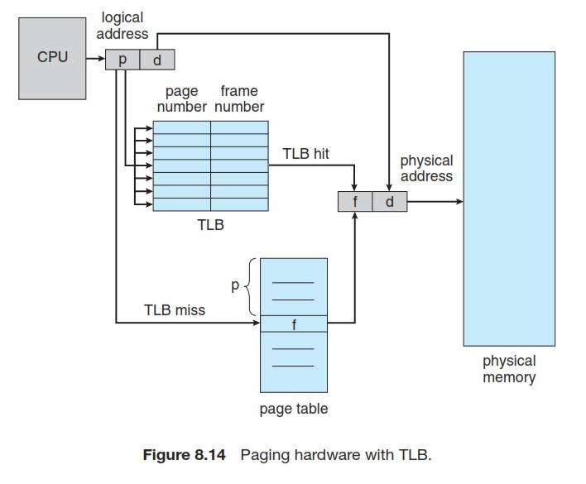

The percentage of times that a particular page number is found in the TLB is called the hit ratio. An 80-percent hit ratio means that we find the desired page number in the TLB 80 percent of the time. If it takes 20 nanoseconds to search the TLB and 100 nanoseconds to access memory, then a mapped-memory access takes 120 nanoseconds when the page number is in the TLB. If we fail to find the page number in the TLB (20 nanoseconds), then we must first access memory for the page table and frame number (100 nanoseconds) and then access the desired byte in memory (100 nanoseconds), for a total of 220 nanoseconds.

68
To find the effective memory-access time, we weight each case by its probability:

Effective access time = 0.80 x 120 + 0.20 x 220 = 140 nanoseconds.

In this example, we suffer a 40-percent slowdown in memory-access time (from 100 to 140 nanoseconds).

For a 98-percent hit ratio, we have

Effective access time = 0.98 x 120 + 0.02 x 220 = 122 nanoseconds.

This increased hit rate produces only a 22 percent slowdown in access time.

Protection

Memory protection in a paged environment is accomplished by protection bits associated with each frame. Normally, these bits are kept in the page table.

One bit can define a page to be read-write or read-only. Every reference to memory goes through the page table to find the correct frame number. At the same time that the whysical address is being computed, the protection bits can be checked to verify that no writes are being made to a read-only page. An attempt to write to a read-only page causes a hardware trap to the operating system (or memory-protection violation).

We can easily expand this approach to provide a finer level of protection. We can create hardware to provide read-only, read-write, or execute-only protection; or, by providing separate protection bits for each kind of access, we can allow any combination of these accesses. Illegal attempts will be trapped to the operating system.

One additional bit is generally attached to each entry in the page table: a valid-invalid bit. When this bit is set to "valid," the associated page is in the process's logical address space and is thus a legal (or valid) page. When the bit is set to "invalid,'" the page is not in the process's logical address space. Illegal addresses are trapped by use of the valid-invalid bit. The operating system sets this bit for each page to allow or disallow access to the page.

69
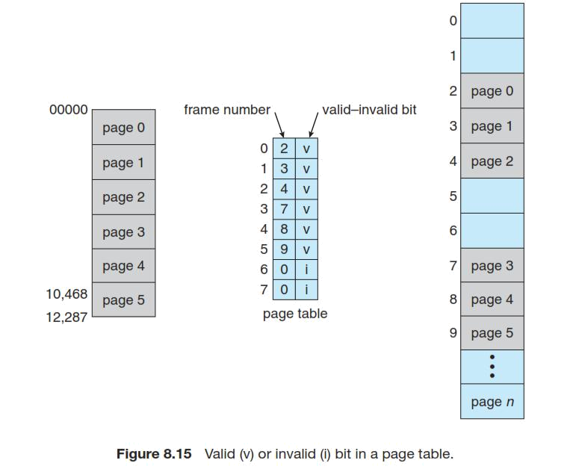

3.5 Segmentation:

Memory management scheme supports user view of memory. A program is a collection of segments. A segment is a logical unit such as: main program, procedure, function, method, object, local variables, global variables, common block, stack, symbol table, arrays.

A logical address space is a collection of segments. Each segment has a name and a length. The addresses specify both the segment name and the offset within the segment. The user therefore specifies each address by two quantities: a segment name and an offset.

For simplicity of implementation, segments are numbered and are referred to by a segment number, rather than by a segment name. Thus, a logical address consists of a two tuple:

< segment-number, offset >.

70

Normally, the user program is compiled, and the compiler automatically constructs segments reflecting the input program.

Hardware Support:

This mapping is affected by a segment table. Each entry in the segment table has a segment base and a segment limit. The segment base contains the starting physical address where the segment resides in memory, whereas the segment limit specifies the length of the segment.

A logical address consists of two parts: a segment number, s, and an offset into that segment, d. The segment number is used as an index to the segment table. The offset d of the logical address must be between 0 and the segment limit. If it is not, we trap to the operating system (logical addressing attempt beyond, end of segment).

When an offset is legal, it is added to the segment base to produce the address in physical memory of the desired byte. The segment table is thus essentially an array of base-limit register pairs.

Virtual Memory:

Separation of user logical memory from physical memory is the work of Virtual memory.

  - Only part of the program needs to be in memory for execution.

  - Logical address space can therefore be much larger than physical address space.

  - Allows address spaces to be shared by several processes.

  - Allows for more efficient process creation.

- Demand Paging:

In demand paging it checks when a process is to be swapped in, the pager guesses which pages will be used before the process is swapped out again. Instead of swapping in a whole process, the pager brings only those necessary pages into memory. Thus, it avoids reading into memory pages that will not be used in anyway, decreasing the swap time and the amount of physical memory needed. If there is a reference to a page, first reference to that page will trap to operating system:
page fault

71
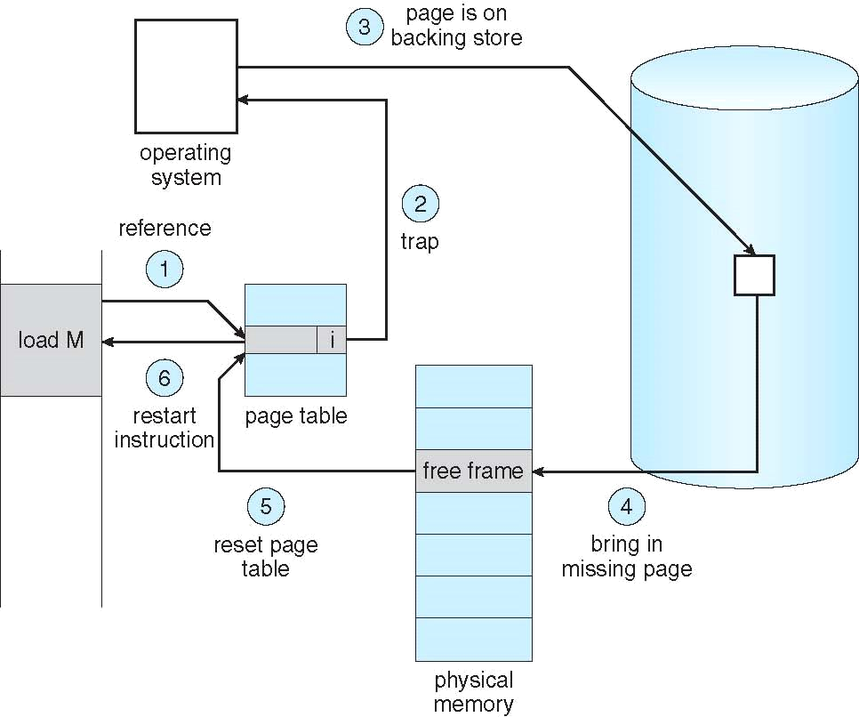

The procedure for handling this page fault is straightforward:

- We check an internal table (usually kept with the process control block) for this process to determine whether the reference was a valid or an invalid memory access.

- If the reference was invalid, we terminate the process. If it was valid, but we have not yet brought in that page, we now page it in.

- We find a free frame (by taking one from the free-frame list, for example).

- We schedule a disk operation to read the desired page into the newly allocated frame.

- When the disk read is complete, we modify the internal table kept with the process and the page table to indicate that the page is now in memory.

- We restart the instruction that was interrupted by the trap. The process can now access the page as though it had always been in memory.

The hardware to support demand paging is the same as the hardware for paging and swapping:

- Page table. This table has the ability to mark an entry invalid through a valid-invalid bit or special value of protection bits.

- Secondary memory. This memory holds those pages that are not present in main memory. The secondary memory is usually a high-speed disk. It is known as the swap device, and the section of disk used for this purpose is known as swap space.

72

3.7 Performance of Demand Paging

Demand paging can significantly affect the performance of a computer system. To see why, let's compute the effective access time for a demand-paged memory. For most computer systems, the memory-access time, denoted ma ranges from 10 to 200 nanoseconds. As long as we have no page faults, the effective access time is equal to the memory access time. If, however, a page fault occurs, we must first read the relevant page from disk and then access the desired word.

Let p be the probability of a page fault (0 s p 5 1). We would expect p to be close to zero—that is, we would expect to have only a few page faults. The effective access time is then

Effective access time = (1 - p) x ma + p x page fault time.

To compute the effective access time, we must know how much time is needed to service a page fault. A page fault causes the following sequence to occur:

- Trap to the operating system.

- Save the user registers and process state.

- Determine that the interrupt was a page fault. '

- Check that the page reference was legal and determine the location of the page on the disk.

- Issue a read from the disk to a free frame:

  - Wait in a queue for this device until the read request is serviced.

  - Wait for the device seek and /or latency time.

  - Begin the transfer of the page to a free frame.

- While waiting, allocate the CPU to some other user (CPU scheduling, optional).

- Receive an interrupt from the disk I/O subsystem (I/O completed).

- Save the registers and process state for the other user (if step 6 is executed).

- Determine that the interrupt was from the disk.

- Correct the page table and other tables to show that the desired page is now in memory.

- Wait for the CPU to be allocated to this process again.

- Restore the user registers, process state, and new page table, and then resume the interrupted instruction.

73
- Page Replacement:

  - Page replacement completes separation between logical memory and physical memory – large virtual memory can be provided on a smaller physical memory

  - The string of memory references is called a reference string.

  - Steps in Page replacement

    - Find the location of the desired page on disk

    - Find a free frame:

      - If there is a free frame, use it

      - If there is no free frame, use a page replacement algorithm to select a victim frame

      - Write victim frame to disk if dirty

    - Bring the desired page into the (newly) free frame; update the page and frame tables

    - Continue the process by restarting the instruction that caused the trap
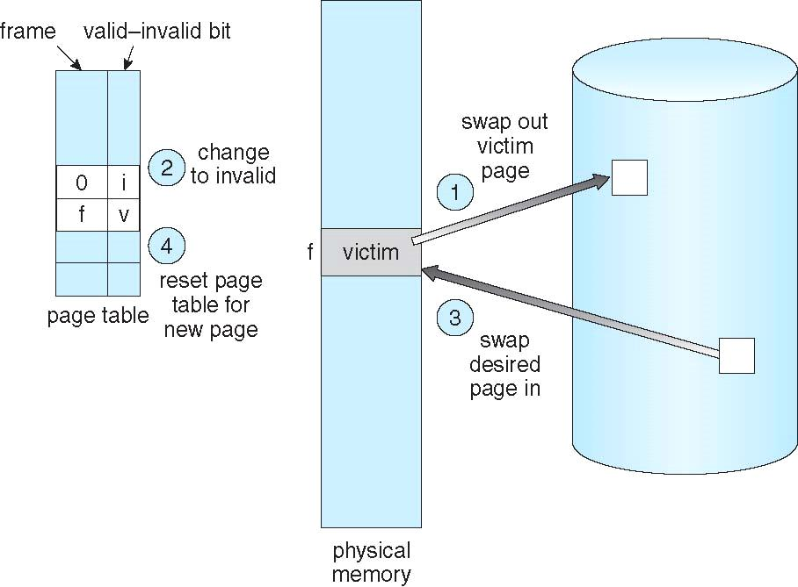

3.9 Page Replacement Algorithms:

The following are the various page replacement algorithms:

- FIFO Page Replacement

- Optimal Page Replacement

- Least Recently Used (LRU) Algorithm

74
- FIFO (First In First Out) Page Replacement Algorithm:

  - Oldest page in main memory is the one which will be selected for replacement.

  - Easy to implement, keep a list, replace pages from the tail and add new pages at the head.
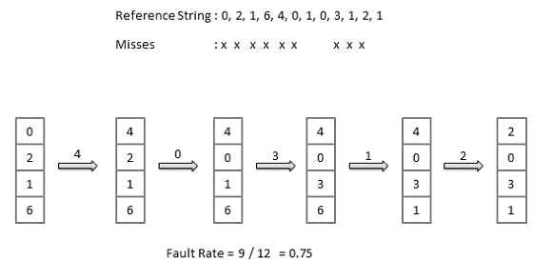

- Optimal Page Replacement Algorithm:

  - An optimal page-replacement algorithm has the lowest page-fault rate of all algorithms. An optimal page-replacement algorithm exists, and has been called OPT or MIN.

  - Replace the page that will not be used for the longest period of time. Use the time when a page is to be used.
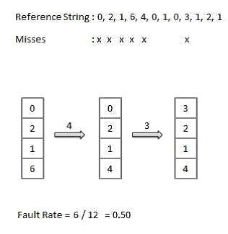

75
- Least Recently Used (LRU) Algorithm

  - Page which has not been used for the longest time in main memory is the one which will be selected for replacement.

  - Easy to implement, keep a list, replace pages by looking back into time.
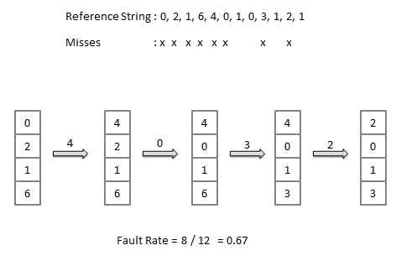

One reason for allocating at least a minimum number of frames involves performance. Obviously, as the number of frames allocated to each process decreases, the page-fault rate increases, slowing process execution. In addition, remember that, when a page fault occurs before an executing instruction is complete, the instruction must be restarted. Consequently, we must have enough frames to hold all the different pages that any single instruction can reference.

3.10 Global versus Local Allocation

Another important factor in the way frames are allocated to the various processes is page replacement. With multiple processes competing for frames, we can classify page-replacement algorithms into two broad categories: global replacement and local replacement. Global replacement allows a process to select a replacement frame from the set of all frames, even if that frame is currently allocated to some other process; that is, one process can take a frame from another. Local replacement requires that each process select from only its own set of allocated frames.

3.11 Thrashing
If the number of frames allocated to a low-priority process falls below the minimum number required by the computer architecture, we must suspend, that process's execution. We should then page out its

76

remaining pages, freeing all its allocated frames. This provision introduces a swap-in, swap-out level of intermediate CPU scheduling.

In fact, look at any process that does not have ''enough" frames. If the process does not have the number of frames it needs to support pages in active use, it will quickly page-fault. At this point, it must replace some page. However, since all its pages are in active use, it must replace a page that will be needed again right away. Consequently, it quickly faults again, and again, and again, replacing pages that it must bring back in immediately.

This high paging activity is called thrashing. A process is thrashing if it is spending more time paging than executing.

Cause of Thrashing

Thrashing results in severe performance problems. Consider the following scenario, which is based on the actual behavior of early paging systems.

The operating system monitors CPU utilization. If CPU utilization is too low, we increase the degree of multiprogramming by introducing a new process to the system. A global page-replacement algorithm is used; it replaces pages without regard to the process to which they belong. Now suppose that a process enters a new phase in its execution and needs more frames. It starts faulting and taking frames away from other processes. These processes need those pages, however, and so they also fault, taking frames from other processes. These faulting processes must use the paging device to swap pages in and out. As they queue up for the paging device, the ready queue empties. As processes wait for the paging device, CPU utilization decreases.

The CPU scheduler sees the decreasing CPU utilization and increases the degree of multiprogramming as a result. The new process tries to get started by taking frames from running processes, causing more page faults and a longer queue for the paging device. As a result, CPU utilization drops even further, and the CPU scheduler tries to increase the degree of multiprogramming even more. Thrashing has occurred, and system throughput plunges. The page fault rate increases tremendously. As a result, the effective memory-access time increases.

77
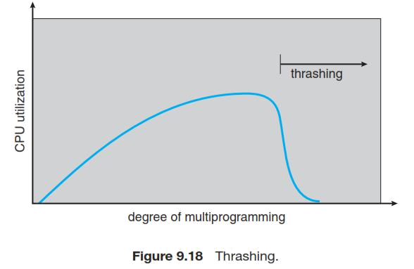

78

