G PULLAIAH COLLEGE OF ENGINEERING & TECHNOLOGY
DEPARTMENT OF ELECTRICAL & ELECTRONICS ENGINEERING
BASIC ELECTRICAL AND ELECTRONICS ENGINEERING (15A99301)
PART – A
BASIC ELECTRICAL ENGINEERING
UNIT-1
BASIC TERMS & DEFINITIONS
Term | Description
Voltage | Voltage is defined as the work done per unit charge.  V= (volts)
Current | Current is defined as the rate of change of charge with respect to the time. Mathematically the current is given by I = (Amps)
Energy | Capacity for doing work. Its S.I units are Joules.
Power | Power is defined as rate of change of energy with respect to the time.  Mathematically the power is given by P = (Watts)
Resistors | The resistor is an electrical device whose primary function is to introduce resistance to flow of electric current. The magnitude of opposition to flow of current is the resistance of resistor.
Capacitor | Capacitance of a capacitor is the ability of a dielectric to store electric charge. Its unit is Farad.
Inductors | Inductance is used for the storage of magnetic energy. Magnetic energy is stored as long as current keeps flowing through the inductor.
Ohm’s Law | Ohm’s law states that at constant temperature the current flowing through a conductor is directly proportional to the voltage applied across the terminals of the conductor.
Kirchoff’s Voltage Law | Kirchoff’s Voltage law states that the algebraic sum of voltages in a closed loop is equal to zero.
Kirchoff’s Current Law | Kirchoff’s Current law states that the algebraic sum of currents at node or junction is equal to zero. It can also be stated as the sum of currents entering a node is equal to sum of currents coming out of that node.
Series Circuit | In a Series Circuit the current is same and voltage is different.
Parallel Circuit | In a Parallel circuit the voltage is same and current is different.
Average Value | The average value is defined as “the average of all instantaneous values during one alternation”.
RMS Value | The RMS value is the effective value of a varying voltage or current. It is the equivalent steady DC (constant) value which gives the same effect.
Form Factor | The form factor of an alternating current waveform (signal) is the ratio of the RMS (root mean square) value to the average value (mathematical mean of absolute values of all points on the waveform).
Peak Factor | Peak Factor is defined as the ratio of maximum value to the R.M.S value of an alternating quantity.
Z- Parameters | Impedance parameters or Z-parameters (the elements of an impedance matrix or Z-matrix) are properties used in electrical engineering, electronic engineering, and communication systems engineering to describe the electrical behavior of linear electrical networks.
Y- Parameters | Admittance parameters or Y-parameters (the elements of an admittance matrix or Y-matrix) are properties used in many areas of electrical engineering, such as power, electronics, and telecommunications. These parameters are used to describe the electrical behavior of linear electrical networks.
ABCD- Parameters | A, B, C and D are the constants also known as the transmission parameters or chain parameters. These parameters are used for the analysis of an electrical network. It is also used for determining the performance of input, output voltage and current of the transmission network.
Hybrid- Parameters | Hybrid parameters are also referred as h parameters. These are referred as hybrid because, here Z parameters, Y parameters, voltage ratio, current ratio, all are used to represent the relation between voltage and current in a two port network.
Thevenin’s Theorem | It’s states that “Any linear circuit containing several voltages and resistances can be replaced by just one single voltage in series with a single resistance connected across the load“.
Norton’s Theorem | Norton’s Theorem states that “Any linear circuit containing several energy sources and resistances can be replaced by a single Constant Current generator in parallel with a Single Resistor“.
Superposition Theorem | The total current in any part of a linear circuit equals the algebraic sum of the currents produced by each source separately.
Maximum Power Transfer Theorem | It’s states that “the maximum amount of power will be dissipated in the load resistance if it is equal in value to the Thevenin’s or Norton’s source resistance of the network supplying the power“.

CONCEPTS
DC CIRCUITS
OHM’S LAW
The most basic quantities of electricity are voltage, current and resistance or impedance. Ohm's law shows a simple relationship between these three quantities. This law is one of the most basic laws of electricity. This law helps to calculate the power, efficiency, current, voltage and resistance or impedance of any element of electrical circuit.
Whenever, we apply a potential difference i.e. voltage across a resistor of a closed electric circuit, current starts flowing through it. The statement of Ohm's law says that The current (I) is directly proportional to the applied voltage (V), provided temperature and all other factors remain constant. Mathematically, 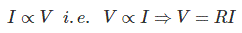Where, R is constant of proportionality. This equation presents the statement of Ohm's law. Here, we measure current in Ampere (or amps), voltage in unit of volt. The constant of proportionality R is the property of the conductor, we know it as resistance and measure it in ohm (Ω). Theoretically, the resistance has no dependence on the applied voltage, or on the flow of current. The value of R changes only if the conditions (like temperature, diameter and length etc.) of the resistor are changed by any means.
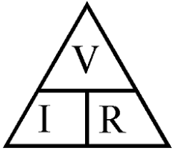
The limitations of Ohm's law are explained as follows:
- This law cannot be applied to unilateral networks. A unilateral network has unilateral elements like diode, transistors, etc., which do not have same voltage current relation for both directions of current.
- Ohm's law is also not applicable for non – linear elements.
Non-linear elements are those which do not have current exactly proportional to the applied voltage, that means the resistance value of those elements changes for different values of voltage and current. Examples of non – linear elements are thyristor, electric arc, etc.
KIRCHOFF’S LAWS
Kirchoff’s current law or point law (KCL)
Statement:- In any electrical network, the algebraic sum of the currents meeting at a point is zero.
Σ I = 0 ……………………at a junction or node
Assumption:- Incoming current = positive
Outgoing current = negative
Kirchoff’s voltage law or mesh law (KVL)
Statement:- The algebraic sum of the products of currents and resistances in each of the conductors in any closed path (or mesh) in a network plus the algebraic sum of the emfs in that path is zero.
Σ IR +Σemf = 0 …………………………..round the mesh
Assumption:- i) Rise in voltage (If we go from negative terminal of the battery to positive terminal) = positive ii) Fall in voltage (If we go from positive terminal of the battery to negative terminal) = negative iii) If we go through the resistor in the same direction as current then there is a fall in potential. Hence this voltage is taken as negative. iv)If we go through the resistor against the direction of current then there is a rise in potential. Hence this voltage drop is taken as positive.
NETWORK ELEMENTS

Active and Passive Elements
Those elements which have the capability of delivering power to some external device are known as active elements, e.g., energy sources such as voltage sources and current sources. On the other hand, elements that are only capable of receiving power are known as passive elements. Some passive elements such as inductors and capacitors are capable of storing energy and delivering it to an external element later.

Bilateral and Unilateral Elements
The elements in which the voltage–current relation is the same for current flowing in either direction are called as bilateral elements. On the other hand, those elements which have different relations between voltage and current for two possible directions of current are called unilateral elements. High-conductivity materials form bilateral elements, while elements such as vacuum diodes, silicon diodes, etc., form unilateral elements.

Linear and Non-linear Elements
An element in which the voltage–current characteristics form a straight line passing through the origin is called a linear element. For example, the current passing through a resistor is proportional to the voltage applied through it. An element in which the voltage–current characteristics are not in the form of a straight line passing through the origin is called non-linear element. Inductors and capacitors can be seen as non-linear elements.

Lumped or Distributed Elements
The elements which are small in size and in which simultaneous actions take place for any cause at the same instant of time are called lumped elements. Capacitors, resistors, etc., are some examples of lumped elements. On the other hand, distributed elements are those which are not electrically separable for analytical purposes. For example, a transmission line which has distributed resistance, inductance, and capacitance along its length may extend for hundreds of miles.

STAR DELTA AND DELTA STAR TRANSFORMATION

Need:- Complicated networks can be simplified by successively replacing delta mesh to star equivalent system and vice-versa.
In delta network, three resistors are connected in delta fashion (Δ) and in star network three resistors are connected in wye (Y) fashion.
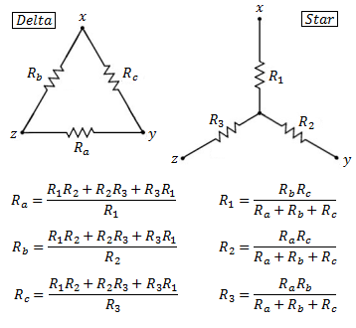

AC CIRCUITS
AVERAGE VALUE

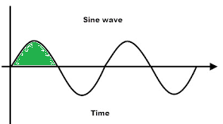

The average value is defined as “the average of all instantaneous values during one alternation”.
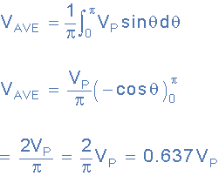

RMS VALUE
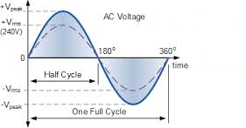
The RMS value is the effective value of a varying voltage or current. It is the equivalent steady DC (constant) value which gives the same effect.
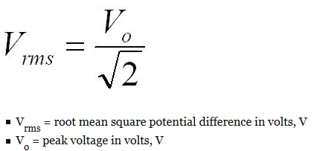
V_{rms} = 0.707 V_{m}
PEAK FACTOR
Definition: Peak Factor is defined as the ratio of maximum value to the R.M.S value of an alternating quantity.
Mathematically it is expressed as
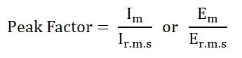
Where,
I_{m} and E_{m} are the maximum value of the current and the voltage respectively, and I_{r.m.s} and E_{r.m.s} are the roots mean square value of the alternating current and the voltage respectively.
For the current varying sinusoidally, the peak factor is given as
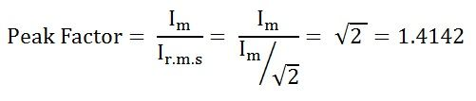
The value of Peak Factor is 1.4142
FORM FACTOR
The form factor of an alternating current waveform (signal) is the ratio of the RMS (root mean square) value to the average value (mathematical mean of absolute values of all points on the waveform).
Mathematically, it is expressed as
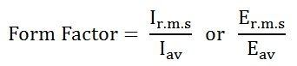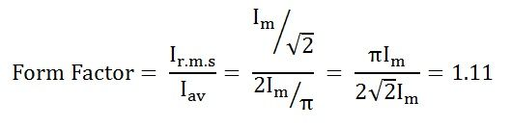

TWO PORT NETWORKS

Z PARAMETERS

Z parameters are also known as impedance parameters. When we use Z parameter for analyzing two part network, the voltages are represented as the function of currents.
So,
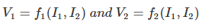
The Z parameters are,
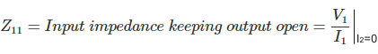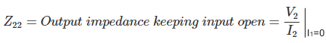
The voltages are represented as
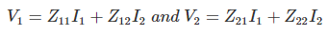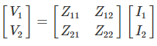

Y PARAMETERS

Y parameter is dual of Z parameter.
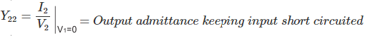In the two part network represented by admittance, the current and voltage related by the following equations,
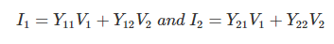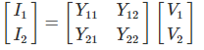

H – PARAMETERS

h parameters also known as hybrid parameters.
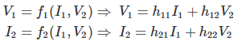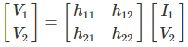
In hybrid parameter circuit, voltage gain, current gain, impedance and admittance are used to determines relation between current and voltage of two port network.
Hence, 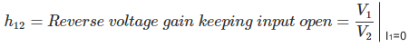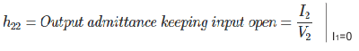

ABCD PARAMETERS

These are also called transmission parameters. Here, voltage and current and of input part are expressed in term of output part.
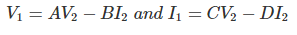
In matrix form it can be written as
, 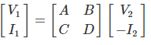

NETWORK THEOREMS
THEVENIN’S THEOREM
Thevenin’s Theorem is especially useful in the circuit analysis of power or battery systems and other interconnected resistive circuits where it will have an effect on the adjoining part of the circuit.

Thevenin’s Equivalent Circuit

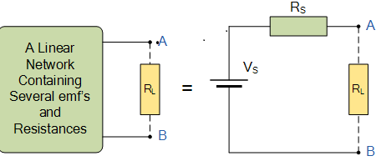

As far as the load resistor R_{L} is concerned, any complex “one-port” network consisting of multiple resistive circuit elements and energy sources can be replaced by one single equivalent resistance Rs and one single equivalent voltage Vs. Rs is the source resistance value looking back into the circuit and Vs is the open circuit voltage at the terminals.
The basic procedure for solving a circuit using Thevenin’s Theorem is as follows:
1. Remove the load resistor R_{L} or component concerned.
2. Find R_{S} by shorting all voltage sources or by open circuiting all the current sources.
3. Find V_{S} by the usual circuit analysis methods.
4. Find the current flowing through the load resistor R_{L}.

NORTON’S THEOREM
Nortons theorem is an analytical method used to change a complex circuit into a simple equivalent circuit consisting of a single resistance in parallel with a current source
As far as the load resistance, R_{L} is concerned this single resistance, R_{S} is the value of the resistance looking back into the network with all the current sources open circuited and I_{S} is the short circuit current at the output terminals as shown below.

Norton’s Equivalent Circuit
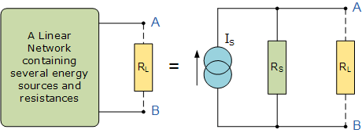
The basic procedure for solving a circuit using Nortons Theorem is as follows:
1. Remove the load resistor R_{L} or component concerned.
2. Find R_{S} by shorting all voltage sources or by open circuiting all the current sources.
3. Find I_{S} by placing a shorting link on the output terminals A and B.
4. Find the current flowing through the load resistor R_{L}.

MAXIMUM POWER TRANSFER THEOREM:
Suppose we have a voltage source or battery that's internal resistance is R_{i} and a load resistance R_{L} is connected across this battery. Maximum power transfer theorem determines the value of resistance R_{L} for which, the maximum power will be transferred from source to it. Actually the maximum power, drawn from the source, depends upon the value of the load resistance.

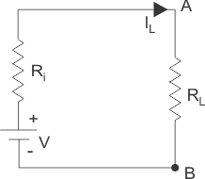

Power delivered to the load resistance,
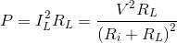
To find the maximum power, differentiate the above expression with respect to resistance R_{L} and equate it to zero. Thus,
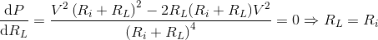

Thus in this case, the maximum power will be transferred to the load when load resistance is just equal to internal resistance of the battery.

SUPERPOSITION THEOREM:
The superposition theorem states that in any linear network containing two or more sources, the response (current) in any element is equal to the algebraic sum of the response (current) caused by individual sources acting alone, while the other sources are inoperative.

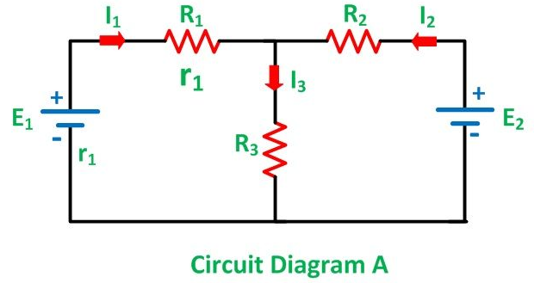

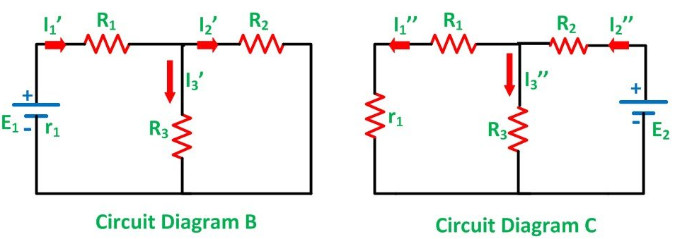
Steps to be followed to apply the superposition theorem :
Step 1:Select any one energy source.
Step 2:Replace all the other energy sources by : their internal series resistances for voltage sources. their internal shunt resistances for current sources.
Step 3:With only one energy source calculate the voltage drops or branch currents paying attention to the voltage polarities and current directions.
Step 4:Repeat steps 1, 2 and 3 for each source individually.
Step 5:Add algebraically the voltage drops or branch currents obtained due to the individual source to obtain the combined effect of all the sources.
Limitations of superposition Theorem
Superposition theorem doesn’t work for power calculation. Because power calculations involve either the product of voltage and current, the square of current or the square of the voltage, they are not linear operations. Superposition theorem cannot be applied for non linear circuit ( Diodes or Transistors ).

IMPORTANT QUESTIONS
1.State and explain ohms law.
2.State & explain super position theorem.
3. State and explain Kirchhoff’s law.
4. State & explain Thevenin’s & Norton’s Theorems.
5.Derive the equation for delta to star transformation.
6.Show that peak factor & form factor of a sinusoidal wave is 1.414 & 1.11
7.State & explain Z & Y-Parameters.
8. State & explain ABCD & H-Parameters.

