**UNIT-II**

**OPERATIONS MANAGEMENT**

**OPERATIONS MANAGEMENT:**

Operations management refers to the application of management principles to the production function in a factory. It involves application of planning, organizing, directing and controlling to the production process.

**PLANT LOCATION**:

**Plant location:** Plant location is a strategic decision, several factors influence this decision. The main objective of any business is to optimize its cost and revenue that is, minimize its costs and maximize its returns.

The degree of significance for the selection of location for any enterprise mainly depends on its size and nature large scale industries requiring huge amount of investment there are many considerations other than the local demand in the selection proper plant location these plants cannot be easily shifted to other place and an error of judgment in the selection of site can be very expensive to the organization. However, small-scale industry mainly selects the site where in accordance with its capacity; the local market is available for its products. It can easily shift to other place when there is any change in the market.

**Factors influencing plant location:**

**Nearness to Market:** If the plant is located close to the market, the cost of transportation can be minimized. This also helps the producers to have direct knowledge of the requirements of the customers.

**Nearness to supply of raw materials:** As far as possible the site selected should be near the source of raw materials, so that the cost of transportation can be minimized and storing cost can be reduced due to shorter lead time.

**Availability of labour:** Availability of right kind of labour force in required number at reasonable rates is also a deciding factor in selection of site

**Transport and communication facilities:** Generally, industries have a tendency to locate the industrial units near the railway station, highway or port areas.

**Availability of power and fuel:** Coal, electricity, oil and natural gas are the important sources of power in the industries. Ex: Tata iron and steel industry is established near the coalmines of Bihar.

**Climatic conditions:** Climatic conditions largely affect certain production processes and also the efficiency of the employees. Ex: Textile mills require moist climate that why these plant located at Mumbai and Ahmadabad.

**Availability of water:** Water is used in industries for processing as in paper in chemical industries, for generation of power in hydroelectric power, plants and also required for drinking sanitary purpose also.

**Ancillary industries:** Many industries such as processing and assembly industries are not producing al the parts of their product but purchase some of the parts from ancillary industries producing it.

**Financial and other aids**: For the development of backward regions central as well as state government provide certain incentives and facilities such as cash-subsides, concession financial assistance, land, power and other facilities at cheaper rates, tax concession etc.

**PLANT LAYOUT:**

A technique of locating machines, processes and plant serviceswithin the factory in order to secure the greatest possible output of high quality at the lowest possible total cost of production.

**Types of plant layout**:

* **Product or line layout**: This type of layout is developed for product-focusedsystems. In this type of layout only one product, or one type of product, is produced in a given area. The logical sequence in the production process forms the basis for the arrangement of machinery under this layout. In case of product being assembled, this type of layout is popularly known as an assembly line layout.

|  |  |  |
| --- | --- | --- |
| Raw Material  Stores | 5  4  3  2  1  Cutting  Turning  Milling  Packing  Inspect | Finished Goods Stores |

|  |  |
| --- | --- |
| **Merits** | **Demerits** |
| * Faster and Cheaper production * Lower cost of material handling * Effective utilisation of floor space * Easy monitoring * Team work benefits | * Threat of duplication * Huge capital outlay * Little flexibility * Discontinuity in production likely |

* **Process or Functional layout**: This type of layout is developed for processfocused systems. The processing units are organized by functions into departments on the assumption that certain skills and facilities are available in each department similar equipments and operations are grouped together, e.g., milling, foundry, drilling, plating, heat treatment etc.

|  |  |  |  |  |  |
| --- | --- | --- | --- | --- | --- |
| Raw Material Stores | **Forging section**  1 | **Milling Section**  4 | **Welding Section**  3 | **Heat Treatment**  1 | Finished Goods Stores |
| **Turning Section**  2 | **Grinding section**  5 | **Drilling Section**  2  6 | **Inspection Department**  3  7 |

Product P, Product Q

|  |  |
| --- | --- |
| **Merits** | **Demerits** |
| * Optimum utilisation of resources. * Flexibility * Continuity * Interesting to workers | * Higher material handling cost * Larger production cycle * Monitoring may be complex * Higher inspection cost   Higher wage bill |

* **Project or Fixed position Layout**: This is the layout for project type systems inwhich the major component is kept at a fixed position and all other materials, components, tools machines, work etc. are brought and assembly or fabrication is carried out. This type of layout is now not used very commonly as the machines required for manufacturing work are big and complicated. The fixed position layout is used only when it is difficult to move the major component and fabrication is to be carried out. Ex: production of ships.

|  |  |
| --- | --- |
| **Merits** | **Demerits** |
| * It does not involve large investment * High degree of flexibility * Interesting to workers | * Higher material handling cost * Sometimes, the resources are underutilised. |

**METHODS OF PRODUCTION**:

**Productivity:**

Definition: Productivity is defined as the rate at which the goods and services are produced.

It refers to the relationship between the inputs and the output. It is calculated as a ratio between the amount produced and the amount of resources (land, labour, capital, technology etc.) used in the course of production in other words,

Productivity =Output/ Input

Based on the nature of product, demand for the product, cost, competition etc, the firm has to adopt the appropriate method of production:

|  |  |  |  |
| --- | --- | --- | --- |
|  | **Job Production** | **Batch Production** | **Mass Production** |
| **No. of units manufactured** | Every time, only one product or service can be provided. | Every time, a few, say 100 or 1000 are produced. | It is a continuous production process. |
| **Design** | From product to product design differs. | From batch to batch, the design differs: every batch has identical products. | There is no change in design. |
| **Cost per unit** | Cost per unit changes from job to job. | Cost per unit is relatively lower when compared to job production, but keep on changing from batch to batch. | Cost per unit is likely to be lowest of all methods of production. |
| **Plant layout** | Process type | Process type | Product type |
| **Degree of planning** | Moderate degree of planning is required. | Large degree of planning is required. | Meticulous planning is required at every stage of production. |
| **Degree of Control** | Greater degree of control is exercised. | Moderate control is exercised. | Less control is required. |
| **Accuracy of product quality** | Tends to be satisfactory. | Likely to be good | Likely to be very high. |
| **Example** | Special purpose  Machines, large turbo generators etc. | Pharmaceuticals, readymade garments, paints etc | All FMCG goods |

**WORK STUDY:**

Work study is one of the most important management techniques which is employed to improve the activities in the production. The main objective of work study is to assist the management in the optimum use of the human and material resources.

**Definition:** Work study refers to the method study and work measurement, which are used to examine human work in all its contexts by systematically investigating into all factors affecting its efficiency and economy to bring forth the desired improvement.

Work study has two parts, Method Study and Work Measurement. Method study deals with the techniques of analyzing the way to do a given job better, Work Measurement seeks to measure the time required to perform the job.

**METHOD STUDY:**

**Definition:** The systematic recording and critical examination of existing and proposed ways of doing work, as a means of developing and applying easier and more effective methods and reducing cost it is also called motion study.

The **main aim** of method study is to develop better working methods.

**Basic procedure for Method Study:**

**Select:** The work to be studied.

**Record:** All the relevant facts of the present or proposed method study by observation.

**Examine:** The recorded facts critically everything that is done, considering in turn, the purpose of the activity, the place where it is performed, the sequence in which it is done, the person who is doing it and the means by which it is done.

**Develop:** The most practical, economical and effective method considering all the circumstances.

**Define:** The new method so that it can always be identified.

**Install:** The method as standard practice

**Maintain:** That standard practice by regular routine checks.

**Recording in Method Study:** The current process of doing the job has to be recorded, while doing so every detail however small it may be, has to be identified using the process chart symbols as follows:

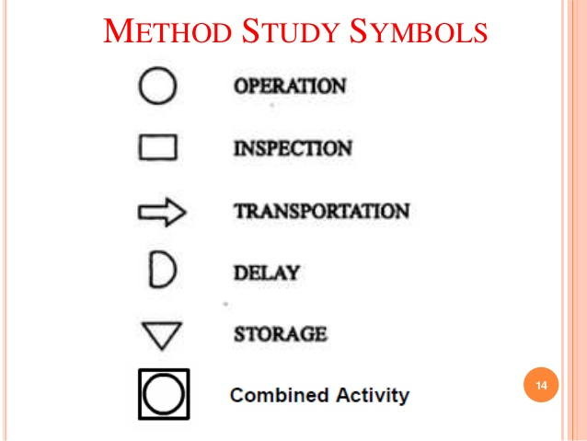

**WORK MEASUREMENT/ TIME STUDY:**

**Definition:** Work measurement is the application of techniques designed to establish time for a qualified worker to carry out a specified job at a defined level of performance.

The **main aim** of work measurement is to develop standard time.

**Procedure for Work Measurement:**

1) **Select:** The work to be studied and determine the objectives of the study

2) **Record:** All the relevant data relating to circumstances in which the work is being done, the methods to be used breakdown the job into its elements

3) **Examine:** The recorded data and the detailed breakdown critically to ensure the most effective method and motions are being used and that unproductive elements are separated from productive elements.

4) **Measure:** The time required to complete each element using the appropriate work measurement techniques and calculate the time required to compete the work cycle which is known as basic time.

5) **Compile:** The standard time for the operation or work place, in case of stop watch time study the various allowances to cover relation, personal needs etc. are added to the basic time to estimate the standard time.

**STATISTICAL QUALITY CONTROL**

**Introduction:** Quality is the determining factor. The success of any product or service large resources is committed in every organization to ensure quality

**Definition:** It is defined as customer satisfaction in general and fitness for use in particular. Both the external consumer who buy the product and services and the internal consumers that is, all divisions or departments of the business organization are equally interested in the quality.

**STATISTICAL QUALITY CONTROL:** The process of applying statistical principles to solve the problem of controlling the quality of a product or service is called statistical quality control.

Quality elements: a) Quality design b) Quality conformance

a) **Quality design**: Quality of design refers to product feature such as performance, reliability durability, ease of use, serviceability

b) **Quality conformance:** Quality conformance means whether the product meets the given quality specification or not

**INSPECTION:** The process of measuring the output and comparing it to check whether it meets the given specified requirements or not, is called inspection.

**Inspection Methods**: The following are the methods of inspection based on merits

**1) Incoming inspection:** In this method, the quality of the goods and services arriving into the organization is inspected. This ensures that the material suppliers adhere to the given specifications with this defective material cannot enter into the production process. This focuses on the vendor’s quality and ability to supply acceptable raw materials.

**2) Critical point inspection:** Inspecting at the critical points of a product manufacture gives valuable insight into the completely functional process. At the points of manufacture that involve high costs or which offer no possibility for repair or rework, inspection is crucial further operation depend on these results critical point inspection helps to drop the defective production, and thereby, facilitate avoiding unnecessary further expenditure on them.

**3) Process inspection:** This is also called patrolling inspection or floor inspection or roving inspection. Here the inspector goes around the manufacturing points in the shop floor to inspect the goods produced on random sample basis from time to time.

**4) Fixed inspection**: It provides for a centralized and independent where work is brought for inspection from time to time. This method is followed where the inspection equipment cannot be moved to the points of productions.

**5) Final inspection:** This is centralized inspection making use of special equipment. This certifies the quality of the goods before they are shipped.

**Elements of statistical Quality Control:** The technique under SQC can be divided into two parts a) Process control b) Acceptance sampling

**PROCESS CONTROL:** Process control is a technique of ensuring the quality of the products during the manufacturing process itself. If a process consistently produces items with acceptable or tolerable range of specification, it is said to be statically under control. Process control is achieved through **control charts**. Process control aims to control and maintain the quality of the products in the manufacturing process.

**Control limit:** Control limits are found in the control charts.

There are two control limits: 1) Upper control limit (UCL)

2) Lower control limit (LCL)

**Control charts for variables:** A variable is one whose quality measurement changes from unit to unit. The quality of these variables is measured in terms of hardness, thickness, length, and so on. The control charts for variables are drawn using the principles of normal distribution. There are two types of control charts for variables x and R chart.

**X –bar and R Chart:**

The **X-bar chart** is used to show the process variations based on the average measurement of samples collected. It shows more light on diagnosing quality problem when read along with R chart. It shows the erratic or cyclic shifts in the manufacturing process. It can also focus on when to take a remedial measure to set right the quality problems. However, collecting data about all the variables involves a large amount of time and resources.

The **R chart** is based on the range of the items in the given ample. It highlights the changes in the process variability. It is a good measure of spread or range. It shows better results when read along with the X chart.

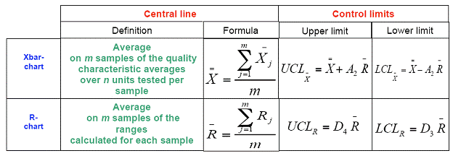

When x = Mean of Means, R = Mean of sample range, A2= Constant

Where, D4, D3 are constants, R is the average of sample ranges (Ranges is the difference between the maximum variable and minimum variable)

**Control charts for attributes:** The quality of attributes can be determined on the basis of ‘Yes’ or ‘No’, ‘Go’ or ‘No go’. In other words, in case of a mirror glass, even if there is one scratch it is not considered to be a quality mirror, in such a case quality is decided base on whether the mirror has any scratch or not. The control charts for attributes are ‘C’ chart and ‘P’ charts

‘C’ Chart: ‘C’ chart is use where there a number defects per unit. This control charts controls the number of defects per unit. Here the sample size should be constant. This calculates as below.

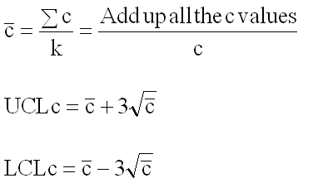

Where the c= number of defects,

k= Number of samples inspected

**‘P’ Chart:** ‘P’ Chart is used where there is date about the number of defectives per sample. It is also called fraction defective chart or percentage defectives chart. Here each item is classified on ‘go or no go’ basis that is good or bad. Hence if the sample size is larger, the results could be better.

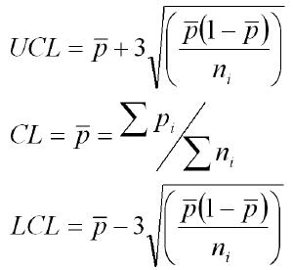

**Where,**

P = Number of defectives found

‘n’ = Number of pieces inspected per day

**Acceptance Sampling:** Acceptance sampling is a technique of deciding whether to accept the whole lot or not based on the number of defectives from a random drawn sample.

It is widely use in buying food products, such as rice, wheat etc. Before buying the random samples drawn from the bags of say rice are tested. If the quality of sample drawn looks good or free from defects then according to the requirement the entire bag or part of it can be brought

**Sampling plans**: Based on the number of samples drawn for taking accept/ reject decisions, the sampling methods are used.

1) **Single sampling plan:** A lot is accepted or rejected on the basis of a single sample drawn from that cost

2) **Double sampling plan:** If it is not possible to decide the fate of the lot on the basis of first sample, a second sample is drawn and the decision is taken on the basis of the combined results of first and second sample.

**MATERIALS**: Materials refer to inputs into the production process,most of which are embodied in the finished goods being manufactured. It may be raw materials, work-in-progress, finished goods, spare parts and components, operating supplies such as lubricating oil, cleaning materials, and others, required for maintenance and repairs.

**MATERIAL MANAGEMENT**: Material management deals withcontrolling and regulating the flow of materials in relation to changes in variables like demand, prices, availability, quality, delivery schedules etc.

**INVENTORY**:Inventory is the stock of materials of any kind stored for future use which is mainly for the production process. Inventories consists of raw materials, semi finished goods and finished products.

**INVENTORY MANAGEMENT:** Inventory management is the management of inventory and stock.

**OJECTIVES OF INVENTORY MANAGEMENT:**

(a) To ensure a continuous supply of materials to facilitate uninterrupted pro­duction.

(b) To maintain sufficient stocks of raw materials during short-supply;

(c) To maintain sufficient finished goods for efficient customer service;

(d) To minimise the carrying cost; and

(e) To maintain the optimum level of investment in inventories.

**INVENTORY CONTROL:** Inventory control is defined as the scientific method of providing the right type of material at the right time in the right quantities and at the right price to sustain given production schedule.

**NEED FOR INVENTORY CONTROL:**

1. Efficient use of financial resources: Effective inventory control system brings efficient use of investment on inventories; it also keeps procurement & carrying cost & maintenance cost at the least.

2. Economy in purchasing:Purchase of inventory is an art as well as science & requires negotiation skills to buy at least effective cost by using the technique of inventory control.

3. Keep the wheels ofproduction moving:Inventory control acts as an agent to supply sufficient quantity of materials by reducing stock outs & shortage.

4. Solid protection against material losses: A good inventory system develops a policy where the materials in various firms are subjected to least loss within limit.

5. Proper calculation of cost of production: Production is continuous process & scientific inventory management concerned with materials from the stage of purchase to shipment. It makes possible the calculation of the both direct & indirect cost individually & also a part of total cost.

6. Keeping prompt delivery to the customers:These days the customers are not prepare to wait for you. It is not possible for the organization to supply the products in time. The customer shifts to another brand. Only a firm with good scheduling system can built the image in the market.

7. Reduces excess or dead inventory:The scientific inventory control reduces dead inventories surplus stock. Dead inventories are the materials which are no longer needed by the organization because of the fall in demand.

**ABC ANALYSIS**:

ABC analysis is a technique of controlling inventories basedon their value and quantities. It is more remembered as an analysis for ‘Always Better Control’ of inventory. Here all items of the inventory are listed in the order of descending values, showing quantity held and their corresponding value. Then, the inventory is divided into three categories A, B and C based on their respective values.

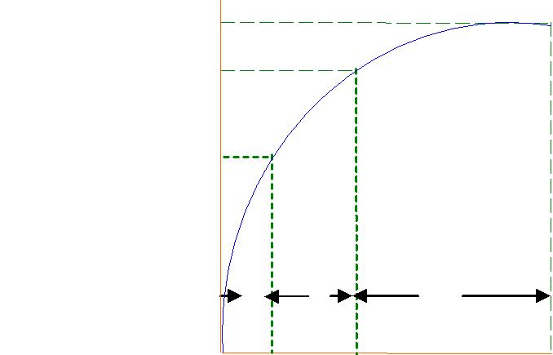

100

90

Volume of 70 inventory (Rs.)

|  |  |  |  |
| --- | --- | --- | --- |
|  | A | B | C |
| 0 | 10 | 30 | 100 |

Volume of inventory (Units)

A – Refers to high value item

B – Refers to medium value item

C – Refers to low value item

**A** category comprises of inventory, which is very costly and valuable.Normally 70% of the funds are tied up in such costly stocks, which would be around 10% of the total volume of stocks. Because the stocks in this category are very costly, these require strict monitoring on a day-to-day basis.

**B** category comprises of inventory, which is less costly. Twentypercent of the funds are tied up in such stocks and these accounts for over 20% of the volume of stocks. These items require monitoring on a weekly or fortnightly basis.

**C** category consists of such stocks, which are of least cost. Volume-wise, they form 70% of the total stocks but value-wise, they do not cost more than 10% of the investment in the stocks. This category of stocks can be monitored on a monthly or bi-monthly basis.

The following table summarizes the concept of ABC analysis;

|  |  |  |  |  |
| --- | --- | --- | --- | --- |
| Category | Value (%) | Volume (%) | Desired Degree |  |
| of Control |  |
|  |  |  |  |
|  |  |  |  |  |
| A | 70 | 10 | STRICT |  |
|  |  |  |  |  |
| B | 20 | 20 | MODERATE |  |
|  |  |  |  |  |
| C | 10 | 70 | LOW |  |
|  |  |  |  |  |

**ECONOMIC ORDER QUANTITY (EOQ)**

Economic order quantity is defined thatquantity of materials, which can be ordered at one time to minimize the cost of ordering and carrying the stocks. In other words, it refers to size of each order that keeps the total cost low.

**Inventory costs**:The inventory costs can be classified into two categories,1) Inventory ordering cost 2) Inventory carrying cost

1) Inventory ordering cost:

The cost refer to the cost incurred to procure the materials particularly in large organizations, these cost are significant. This is also called as procurement cost.

Definition: It is the cost of placing an order from a vendor. This includes all costs incurred from calling for quotation to the point at which the item is taken into stock.

**Ex:** Receiving quotations, processing purchase requisition, Receivingmaterials and then inspecting it, Follow up and expediting purchase order, processing sellers invoice.

2)Inventory Carrying cost: Carrying cost which are also known as holding costs are the costs incurred in maintaining the stores in the firm. They are based on average inventory and consist of Storage cost includes: Rent for storage facilities, Salary of person andrelated storage expenses, Cost of insurance, Cost of capital.

**Determine EOQ**:

|  |  |  |  |  |  |  |  |  |  |  |  |
| --- | --- | --- | --- | --- | --- | --- | --- | --- | --- | --- | --- |
|  |  |  |  | | | | | | |  |  |
|  | S  | | 2AO | | | | | | |  |  |
|  |  | C | | | | | |  |  |
|  |  |  |  |  |  |
|  |  |  |  |  |  |  |  |  |  |  |  |
|  |  |  |  |  |  |  |  | |  |  |  |
|  |  |  |  |  |  |  | Total Cost | | |  |  |
|  |  |  |  |  |  |  |  | |  |  |  |
|  |  |  |  |  |  |  |  | | |  |  |
|  |  |  |  |  |  |  | Carrying Cost | | |  |  |
| Annual Cost |  |  |  |  |  |  |  |  |  |  |  |
|  |  |  |  |  |  |  |  |  |  |  |
|  |  |  |  |  |  | |  | | |  |  |
| EOQ |  |  |  |  | Ordering Cost | | | |  |  |  |
|  |  |  |  |  |  |  |  |  |  |  |
|  |  |  |  |  |  |  |  |  |  |  |  |

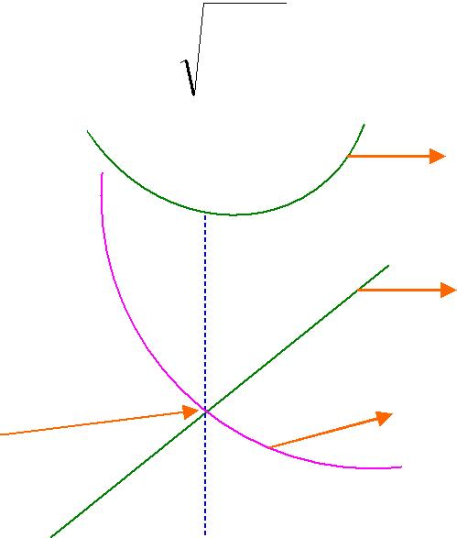

Ordering Quantity

Step1:

Total Ordering cost per year = No. of orders placed per year x ordering cost per Order

= (A/S) x O

A = Annual demand

S = Size of each order (units per order)

O = Ordering cost per order

Step2:

Total Carrying cost per year = Average inventory level x Carrying cost per year = (S/2) x C

A = Annual demand

S = Size of each order (units per order)

C = Carrying cost per unit

Step3:

EOQ is one where the total ordering is equal to total carrying cost

(A/S) x O = (S/2) x C

2AO/C= S2

EOQ= S= √2AO/C

Where S is the Economic order quantity, A is the annual demand in units, O is the ordering cost per order and C is the carrying cost per unit

**Ex**: A biscuit manufacturing company buys a lot of 10,000 bags wheatper annum. The cost per bag is Rs.500 and ordering cost is Rs.400. The inventory carrying cost is estimated at 10% of the price of the wheat. Determine EOQ and number of orders required per year.

**Solution:**

Annual demand (A) = 10,000 bags

Ordering cost per order (O) = Rs.400

Carrying cost per unit (C) = 10% of Cost price

= 0.10 x 500 = Rs.50/-

EOQ = 2AO

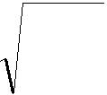C

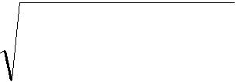

2 * 10,000 * 400

=

50

= 1, 60,000



EOQ = 400 bags

The number of orders to be placed during the year = ANNUAL DEMAND

EOQ

10000/400 =25 ORDERS

In the above case, the company has to place 25 orders to optimize its ordering and carrying .

**MARKETING MANAGEMENT**

**Marketing**:Marketing as a social process by which individuals and groupsobtain what they need and want through creating, offering exchanging products and services of value with others.

“Creating, communicating, delivering a value for a target market of a profit is called marketing.” – Philip Kotler

**Selling versus Marketing**:

Selling refers to the act of transferring the ownership of the goods and services from the seller to the buyer.

Marketing refers to the whole process encompassing the entire range of activities starting from identifying the customers’ requirements to satisfying these in a mutually beneficial manner.

|  |  |
| --- | --- |
| **Selling** | **Marketing** |
| Product Oriented | Customer needs oriented |
| Promoting Sales | Integrated Marketing |
| Profits through enhanced sales | Profits through customer satisfaction |

**NATURE OF MARKETING:**

Marketing is a never ending task. Marketing concerns itself with a arranging all the resources in a way that meets the needs of the customers. The following points will bring forth the nature of marketing.

**1.** **Marketing is customer oriented:** Marketing begins and ends with the customer. Marketing concerns itself not only with the satisfaction of the customer but also objects to delight him/her. All the organizational activities must be targeted and focused towards the customer. Customers must be allowed to decree product specifications and standards regarding quality. And for this, customer’s needs must be examined continuously.

**2. Marketing is the delivery of value:** When a customer is satisfied from a particular product based on its overall performance, then the satisfaction that he has received is known as customer value. Customers consider the product’s value and price before making a decision and make a trade-off between cost and benefit of the product. They will choose a product that gives them more value per rupee. According to De Rose, “Value is the satisfaction of customer requirements at the lowest possible cost of acquisition, ownership and use”. Thus, the organization must aim to deliver greater customer value than that of their competitors. **3.** **Marketing is network of relationships:** The focal point of all marketing activities is the customer. The term relationships marketing came into light in1990’s. According to Philip Kotler, “Relationship Marketing is the practice of building long-term satisfying relations with key parties like customers, suppliers and distributors in order to retain their long term preference and business.” So the marketers should aim at maintaining long term relationships by delivering high quality products, better services and fair prices than their competitors.

**4. Marketing is business:** All activities start from marketing i.e. through knowing customer’s needs and wants and ends on the customer i.e. providing after sales service and knowing customer dissonance. The entire business revolves around marketing.

**5. Marketing is dynamic:** The word dynamic means ever changing. The needs and wants of the customer are changing constantly. Since the goal of marketing is to meet customer’s needs and wants by furnishing them with the products they want to buy, therefore, marketing must also change constantly to meet those needs and wants.

**FUNCTIONS OF MARKETING:**

* **Functions of exchange:** Exchange means giving and taking of goods and services. In olden days the barter system was prevalent. Now a day’s paper currencies, coins, are used as medium of exchange.

1. **Buying:** Buying means the purchase of goods and services. The customers according to their taste and preferences, lifestyle, ability to purchase, buy the product in the market. The producer, manufacturers’ definite products by using raw materials. These finished products are purchased by distributers and they are brought by whole sellers’ later retailers and finally customers.
2. **Selling:** It is the most important activity in marketing .Any business can’t stand in the market without the concept of selling. The marketing manager finds out many ways for selling his product in the competitive environment.
3. **Assembling:** In normal sense assembling means gathering. As per marketing it is pooling up of all finished products of different varieties at one place for a sale.

* **Functions of physical supply:**

Physical supply in the context of marketing involves the main activities of transportation and warehousing.

1. **Transportation:** It takes place from domestic markets to international markets through different means of transport. In case of marketing, transportation is needed because the manufacturing units are located at the place where the raw material sources are available whereas customers are scattered with the products.
2. **Warehousing:** It plays a key role in the areas of marketing by keeping the goods or reserving them for future purpose.

* **Functions of facilitating:** Facilitating functions are also known as supporting functions. They involve in different activities like financing, risk taking, grading, market research or market information etc.,

1. **Financing:** Financing is a compulsory aspect for any firm of business, for getting the assets the company takes credits from banks or social institutions etc.,
2. **Risk taking:** Risk arises due to natural calamities or change in taste and preferences of customers, fire accidents, perishability of goods etc., these risks are to be handled carefully by the marketing manager.
3. **Grading:** Products are produced for the fulfillment of the consumers desire in order to have identification for the product from other similar products. A grade is given for each and every product by the marketing manager.
4. **Market information:** This is the major function of marketing where the company needs to do the market research, to find out the taste and preferences of customers so as to produce related ones.

**PRODUCT MIX**

Product mix (also called assortment) is a set of all product lines and items that a particular seller offers for sale to buyers. An organization with several product lines has a product mix.

Product mix need that consists of related products in other words it is the composite of products offered for sale by a firm, it is a collection of products manufactured as distributed by a firm. It is the full list of all products offered by a firm.

**Ex:** A firm manufactured luxury products, machinery items, electrical equipments, cosmetics, etc.

Product mix has four main characteristics.

**1.** Product width

**2.** Product length

**3.** Product depth

**4.** Product consistency

**1.** **Product mix width:** It refers to number of different product lines the company carries. Ex: P&G Company offers fabric, home care, baby care, beauty care, health care, beverages etc.

**2. Product mix Length:**It refers to the total number of items the company carries within its product line. Ex: 7 Laundary detergents, 6 soaps, 5 shampoos etc.

**3. Product mix depth:** It refers to number of versions offered of each product in the line. Ex: P&G crest Tooth paste comes in 13 varieties- Multicare, cavity protection, sensitivity protection etc.

**4. Product mix consistency:** It refers to how closely related the various product line in end use, production requirements, distribution channels or some other ways.

**Examples:**

**MARKETING MIX:**

Marketing mix refers to the combination of four basic elements, viz., product, price, promotion and the place, known as the four P’s of marketing.

1. Product Mix: It is used to describe the assortment of different product types (product lines) and their varieties (product depth). In addition, different tangible and intangible features of the product also form the product mix.
2. Price Mix: Price mix refers to the decisions relating to the price charged for the product, service or idea.
3. Promotion Mix: Refers to the activities relating to promotion of the product, service or idea.
4. Place Mix: Place or physical distribution mix refers to the activities that are involved in transferring ownership to consumers at the right time and price.

**PRODUCT LIFE CYCLE**:

Product Life Cycle is the course of a product's sales and profits over time. product life cycle(PLC) deals with the life of a product in the market with respect to business or commercial costs and sales measures. The product life cycle contains four distinct stages: **introduction, growth, maturity and decline**. Each stage is associated with changes in the product's marketing position. You can use various marketing strategies in each stage to try to prolong the life cycle of your products.

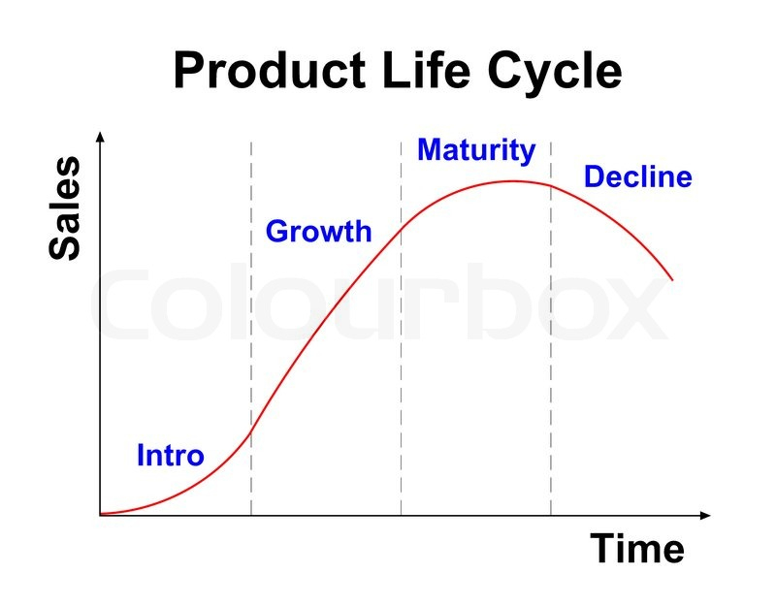

1. **Introduction:**

The introduction stage is about developing a market for the product and building product awareness. Marketing costs are high at this stage, as it is necessary to reach out to potential customers. This is also the stage where intellectual property rights protection is

**Marketing strategies** used in introduction stages include:

* rapid skimming - launching the product at high price and high promotional level
* slow skimming - launching the product at high price and low promotional level
* rapid penetration - launching the product at low price with significant promotion
* slow penetration - launching the product at a low price and minimal promotion

### ****Growth:****

In the growth stage, the product has been accepted by customers, and companies are striving to increase market share. For innovative products there is limited competition at this stage, so pricing can remain at a higher level. Both product demand and profits are increasing, and marketing is aimed at a broad audience.

**Marketing strategies** used in the growth stage mainly aim to increase profits. Some of the common strategies to try are:

* improving product quality
* adding new product features or support services to grow your market share
* enter new markets segments
* keep pricing as high as is reasonable to keep demand and profits high
* increase distribution channels to cope with growing demand
* shifting marketing messages from product awareness to product preference
* Skimming product prices if your profits are too low.

### ****Maturity:****

At the mature stage, sales will level off.  Competition increases, so product features may need to be enhanced to maintain market share. While unit sales are at their highest at this stage, prices tend to decline to stay competitive.  When your sales are at peak, your product will enter the maturity stage. This often means that your market will be saturated and you may find that you need to change your marketing tactics to prolong the life cycle of your product.   
**Marketing strategies** that can help during this stage fall under one of two categories:

* market modification - this includes entering new market segments, redefining target markets, winning over competitor’s customers, converting non-users
* product modification - for example, adjusting or improving your product’s features, quality, pricing and differentiating it from other products in the marking

### ****Decline:****

The decline stage of the product life cycle is associated with decreasing revenue due to market saturation, high competition, and changing customer needs. During the end stages of your product, you will see declining sales and profits. This can be fuelled by changes in consumer preferences, technological advances and alternatives on the market. At this stage, you will have to decide what **Marketing strategies** to take. If you want to save money, you can:

* reduce your promotional expenditure on the products
* reduce the number of distribution outlets that sell them
* implement price cuts to get the customers to buy the product
* fin another use for the product
* maintain the product and wait for competitors to withdraw from the market first
* harvest the product or service before discontinuing it

Another option is for your business to discontinue the product from your offering. You may choose to:

* sell the brand to another business
* significantly reduce the price to get rid of all the inventory

**CHANNELS OF DISTRIBUTION**:Channels of distribution refer to the waysand means of reaching the customer through the intermediaries such as wholesalers, retailers, and other agencies, if any.

1. Manufacturer – consumer: This is a direct marketing channel where the manufacturer contacts the customer directly without involving middlemen or intermediaries. The manufacturers of industrial goods such as aeroplanes, turbo-engines, ships, and other high-value capital goods mostly follow this route.

However, consumer product manufacturers also through Internet, mail order operations, and door-to-door selling are following this method. It is common sight to find the representatives of the manufacturers going from house to house to sell their products, which are normally used in the households.

1. Manufacturer – wholesaler – consumer: This channel is primarily used in the case of industrial goods and high-value consumer durable products. The wholesaler, who may also be called as distributor in this channel, carries out the functions of retailing to large customers who may in themselves be the manufacturers also. The wholesalers in this channel buy goods from many manufacturers, stock, and subsequently, sell them through internet or directly to the customers in a wider geographical area. An example of the use of this method can be observed in the computer hardware industry.
2. Manufacturer – retailer – consumer: Here, the large retailing chains, including supermarkets, use this channel to buy products in large quantities from manufacturers at a very competitive price and sell the same to the ultimate consumers. As the retailers enjoy large discounts in this process, they share this benefit with their customers by keeping their products competitively priced. The consumers patronage this channel because they can buy in small quantities from a wide variety at lower prices.
3. Manufacturer – wholesaler – retailer – consumer**:** This is a chain widely followed for fast moving consumer goods, which are likely to have mass markets. When the consumers are large in number, widely dispersed geographically, and products are of low value, this channel is favoured. Manufacturers would find it prohibitively expensive to set up their own outlets in such circumstances. For manufacturers of consumer goods such as hosiery, food items, confectionery, clothes, and readymade garments, cosmetics, and so on, intermediaries are indispensable in the distribution chain.

**ADVERTISING**

Advertising may be defined as the process of buying sponsor-identified media space or time in order to promote a product or an idea. The American Marketing Association, Chicago, has defined advertising as “any form of non-personal presentation or promotion of ideas, goods or services, by an identified sponsor.”

**Advertising Objectives:**

* **Informative advertising:** Aims to create Brand Awareness and knowledge of new products. - Havells
* **Persuasive advertising:** Aims to create liking, preference, conviction, and purchase of a product / service - Ujala fabric whitner, comparative ad
* **Reminder advertising**: Aims to stimulate repeat purchase of product/Service - Coco Cola, Pepsico, Bike ads
* **Reinforcement Advertising:** Aims to convince current purchasers that they made the right choice - Automobile Ads

**Functions of Advertising:**

* Introduces the new product
* Developing Brand preference
* Increases sales volume
* Market expansion
* Create image and reputation in the market

**5M’s of Advertising:**

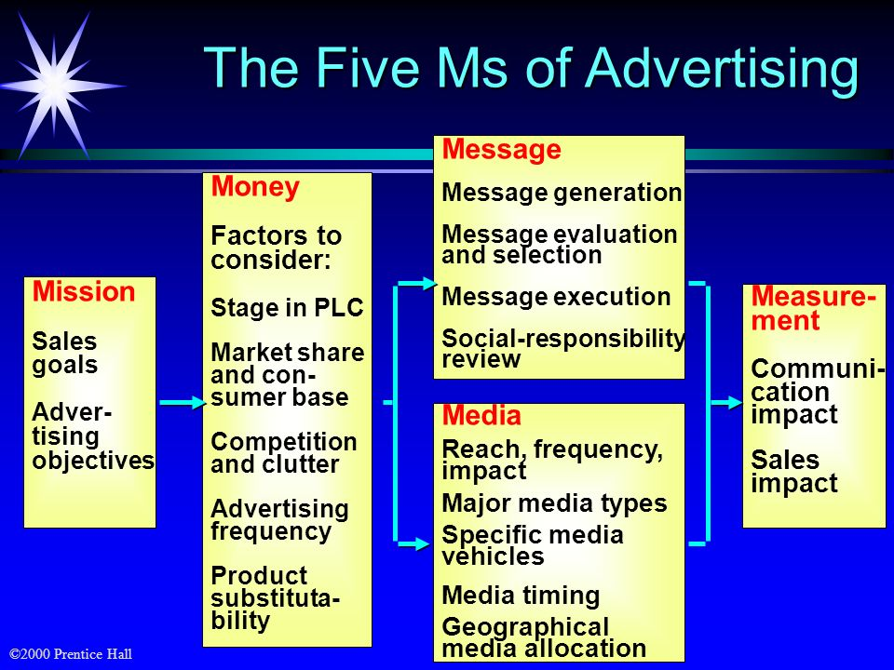

**1. Mission:**

Advertising Objectives can be classified as to whether their aim is:

**• To inform:** This aim of Advertising is generally true during the pioneering stage of a product category, where the objective is building a primary demand.

**• To persuade:** Most advertisements are made with the aim of persuasion. Such advertisements aim at building selective brand.

**• To remind:**Such advertisements are highly effective in the maturity stage of the product. The aim is to keep the consumer thinking about the product.

**2. Money:**

This M deals with deciding on the Advertising Budget

There are five specific factors to be considered when setting the Advertising budget.

**i. Stage in PLC:**New products typically receive large advertising budgets to build awareness and to gain consumer trial.  Established brands are usually supported with lower advertising budgets as a ratio to sales.

**ii. Market Share and Consumer base:** high-market-share brands usually require less advertising expenditure as a percentage of sales to maintain their share. To build share by increasing market size requires larger advertising expenditures. Additionally, on a cost-per-impressions basis, it is less expensive to reach consumers of a widely used brand them to reach consumers of low-share brands.

**iii. Competition and clutter:**In a market with a large number of competitors and high advertising spending, a brand must advertise more heavily to be heard above the noise in the market. Even simple clutter from advertisements not directly competitive to the brand creates the need for heavier advertising.

**iv. Advertising frequency:** the number of repetitions needed to put across the brands message to consumers has an important impact on the advertising budget.

Product substitutability: brands in the commodity class (example cigarettes, beer, soft drinks) require heavy advertising to establish a different image. Advertising is also important when a brand can offer unique physical benefits or features.

**3. Message:**

Choosing the right advertising message requires four major steps- Message generation, message evaluation and selection, message execution, and review of social responsibility.

**4. Media:**

The next M to be considered while making an Advertisement Program is the Media through which to communicate the Message generated during the previous stage. The media can be print media like the newspapers and magazines, audio-visual media like TV or radio, display media like hoardings, wall paintings and posters, and online media using the internet. Exhibitions, launching and inaugural shows, press meets etc.

**5. Measurement:**

Evaluating the effectiveness of the Advertisement Program is very important as it helps prevent further wastage of money and helps make corrections that are important for further advertisement campaigns. Researching the effectiveness of the advertisement is the most used method of evaluating the effectiveness of the Advertisement Program. Research can be in the form of:

* 1. Communication-Effect Research
  2. Sales-Effect Research

**SALES PROMOTION**

According to Philip Kotler, “Sales promotion consists of short term incentives to encourage purchase or sales of a product.”

**The objectives of a sales promotion are:**

* To increase consumer demand, stimulate market demand
* To get potential buyers to heed a call to action
* Increase the size of purchases
* Improve product availability using media and non-media marketing communications.

**CONSUMER-ORIENTED SALES PROMOTIONS**

It aims to encourage repurchases by rewarding current users, boost sales of complementary products, and increase impulse purchases.

• **Coupons:** most widely used form of sales promotion.

• **Refunds or Rebates**: help packaged-goods companies increase purchase rates, promote multiple purchases, and reward product users.

• **Samples, Bonus Packs, And Premiums:** a “try it, you’ll like it” approach.

• **Contests:** require entrants to complete a task such as solving a puzzle or answering questions in a trivia quiz.

• **Sweepstakes:** choose winners by chance; no product purchase is necessary.

• **Specialty Advertising:** sales promotion technique that places the advertiser’s name, address, and advertising message on useful articles that are then distributed to target consumers.

**TRADE-ORIENTED PROMOTIONS**

Trade-oriented sales promotion appeals to marketing intermediaries rather than to final consumers. It accounts for half of typical firm’s promotion budget.

**Trade allowances**—special financial incentives offered to wholesalers and retailers that purchase or promote specific products.

**Point-of-purchase advertising**—display or other promotion located near the site of the actual buying decision.

**Trade shows**—vendors who serve the industries display and demonstrate their products for members.

**Dealer loaders** – Incentives used to persuade retailers to purchase and display a product.

**Trade contests** – Contests used to reward retailers that sell the largest quantity or highest units of a brand’s product.

**Training programs –** Training instructing dealer employees in selling the brand’s product.

**Push money (also known as “spiffs”) –** Extra commission paid to retail employees to push products.

**Trade discounts (also called functional discounts)** – Payments to distribution channel members for performing certain functions.