**G PULLAIAH COLLEGE OF ENGINEERING & TECHNOLOGY**

**DEPARTMENT OF ELECTRICAL & ELECTRONICS ENGINEERING**

**BASIC ELECTRICAL AND ELECTRONICS ENGINEERING (15A99301)**

**PART – A**

**BASIC ELECTRICAL ENGINEERING**

**UNIT-3**

**AC MACHINES**

**BASIC TERMS & DEFINITIONS**

|  |  |
| --- | --- |
| **(I)-Transformer** | An electrical device, without continuously moving parts, which, by electro-magnetic induction, transforms energy from one or more circuits to other circuits at the same frequency, usually with changed values of voltage and current. |
| **Electromagnetic induction** | A voltage is induced in a circuit whenever relative motion exists between a conductor and a magnetic field and that the magnitude of this voltage is proportional to the rate of change of the flux”. |
| **Mutual Inductance** | The interaction of one coils magnetic field on another coil as it induces a voltage in the adjacent coil |
| **Core-Form Construction** | A type of core construction where the winding materials completely enclose the core. |
| **Shell-type Construction** | A type of transformer construction where the core completely surrounds the coil. |
| **Primary Winding** | The transformer winding located on the energy input (supply) side. |
| **Secondary Winding** | The transformer  winding located on the energy output (load) side. |
| **Bushing** | An [electrical](https://testguy.net/) insulator (porcelain, epoxy, etc.) that is used to control the high voltage stresses that occur when an energized cable must pass through a grounded barrier. |
| **Insulation** | Material with a high [electrical](https://testguy.net/) resistance. |
| **Transformer windings** | These are made of solid or stranded copper or aluminium strip conductors. |
| **Insulation materials** | Those materials used to insulate the [transformer](https://testguy.net/)'s [electrical](https://testguy.net/) windings from each other and ground.example: cloth, paper,etc. |
| **Natural Cooling** | Smaller size transformers are immersed in a tank containing transformer oil. Natural circulation is quite effective as the transformer oil has large coefficient of expansion. |
| **Forced Cooling** | For transformer sizes beyond 5 MVA additional cooling would be needed, For better cooling oil-to air heat exchanger unit is provided |
| **Buchholz relay** | It is used in transformers for protection against all kinds of faults. |
| **Core losses** | Losses (expressed in watts) caused by magnetization of the core and its resistance to magnetic flux. Also called no-load losses or excitation losses. Core losses are always present when the [transformer](https://testguy.net/) is energized. |
| **Copper Losses** | In a [transformer](https://testguy.net/) that are incidental to carrying a load: coil resistance, stray loss due to stray fluxes in the windings, core clamps, and the like, as well as circulating currents (if any) in parallel windings. Also called load losses. |
| **Eddy currents** | The currents that are induced in the body of a conducting mass by the time variation of magnetic flux or varying magnetic field. |
| **Hysteresis** | The tendency of a magnetic substance to persist in any state of magnetization. |
| **Active /Working/Iron loss component** | It mainly supplies the iron loss plus small quantity of primary copper loss. (Iw ). It is in phase with primary voltage. |
| **Magnetising component** | This is in quadrature with V1 . Its function is to sustain the alternating flux in the core. It is wattles. (Iµ) |
| **Efficiency** | The ratio of the power output from a [transformer](https://testguy.net/) to the total power input. Typically expressed as a %. |
| **Regulation** | Usually expressed as the percent change in output voltage when the load goes from full load to no load. |
| **(II)-Induction Motor** | An [AC electric motor](https://en.wikipedia.org/wiki/AC_motor) in which the [electric current](https://en.wikipedia.org/wiki/Electric_current) in the [rotor](https://en.wikipedia.org/wiki/Rotor_(electric)) needed to produce torque is obtained by [electromagnetic induction](https://en.wikipedia.org/wiki/Electromagnetic_induction) from the [magnetic field](https://en.wikipedia.org/wiki/Magnetic_field) of the [stator](https://en.wikipedia.org/wiki/Stator) winding. |
| **Stator** | The stator is the stationary part of a rotary system, found in [electric generators](https://en.wikipedia.org/wiki/Electric_generator), [electric motors](https://en.wikipedia.org/wiki/Electric_motor) .In an electric motor, the stator provides a rotating magnetic field that drives the rotating armature. |
| **Rotor** | The rotor is a moving component of an electromagnetic system in the [electric motor](https://en.wikipedia.org/wiki/Electric_motor), [electric generator](https://en.wikipedia.org/wiki/Electric_generator), or [alternator](https://en.wikipedia.org/wiki/Alternator). Its rotation is due to the interaction between the windings and magnetic fields which produces a [torque](https://en.wikipedia.org/wiki/Torque) around the rotor's axis. |
| **Squirrel-cage rotor** | The [squirrel-cage rotor](https://en.wikipedia.org/wiki/Squirrel-cage_rotor) consists of laminated steel in the core with evenly spaced bars of copper or aluminum placed axially around the periphery, permanently shorted at the ends by the end rings. |
| **Wound rotor** | The rotor is a cylindrical core made of steel lamination with slots to hold the wires for its 3-phase windings which are evenly spaced at 120 electrical degrees apart and connected in a 'Y' configuration. |
| **Slip** | Can be defined as the difference between the flux speed (Ns) and the rotor speed (N). Speed of the rotor of an induction motor is always less than its synchronous speed. It is usually expressed as a percentage of synchronous speed (Ns) and represented by the symbol 'S' |
| **Synchronous Speed** | The speed at which the magnetic field rotates. Depending on motor design, the actual mechanical speed may be equivalent (synchronous motor) or slightly smaller (asynchronous motor). The synchronous speed is a function of: The electrical frequency used, typically 60 Hz or 50 Hz |
| **Plugging** | It is also known as reverse current braking. The armature terminals or supply polarity of a separately excited DC motor or shunt DC motor when running are reversed. |
| **(III)-Damper Winding** | is used to 1. reduce the oscillations developed in the rotor  of alternator when it is suddenly loaded.  2. The damper winding is used to start the synchronous motor as an  induction motor. |
| **Pole Pitch** | It is centre to centre distance between two adjacent poles. Two poles are responsible for 360 degree electrical of induced emf so one pole is responsible for 180 degree electrical of induced emf. Hence 180 degree electrical is called 1 pole pitch. |
| **Short Pitch Winding** | If coil pitch is equal to less than pole pitch it is called short pitch winding. |
| **Full Pitch Winding** | If coil pitch is equal to pole pitch it is called full pitch winding. |
| **Pitch Factor Or Coil Span Factor** | The pitch factor is defined as the ratio of vector sum of emf induced in a coil to arithmetic sum of emf induced in the coil.  OR  It is the ratio of resultant emf induced when coil is short pitch to the resultant emf induced when the coil is full pitched. |
| **Distributed Winding** | When coil-sides belonging to each phase are housed or distributed in more than one slot under each pole region then the winding is called distributed winding. |
| **Concentrated Winding** | If all the conductors or coils belonging to a phase are placed in one slot under every pole then winding is called concentrated winding. |
| **Distribution Factor Or Winding Factor Or Breadth Factor Or Spread Factor** | The distribution factor is defined as the ratio of vector sum to arithmetic sum of emf induced in the conductor of one phase spread.  OR  It is ratio of resultant emf induced when coils are distributed to the resultant emf induced when coils are concentrated |
| **Slot Angle β** | The phase difference contributed by 1 slot in electrical degree is called slot angle.  Slot angle β - angle between adjacent slots in electrical degree  =180/n  =180/(slots/pole) |
| **Distribution Factor** | Kd = sin (mβ/2) / msin(β/2)  where  m - number of slots/pole/phase  Slot angle β - angle between adjacent slots in electrical degree =180/(slots/pole) |
| **Synchronous Reactance** | It is the combination of leakage reactance and armature reactance |
| **Synchronous Impedance** | It is the combination of synchronous reactance and armature resistance. |
| **Voltage Regulation Of Alternator** | The voltage regulation of an Alternator is defined as the change in terminal voltage from no-load to load condition expressed as a fraction or percentage of terminal voltage at load condition ; the speed and excitation conditions remaining same. |
| **Synchronizing** | The operation of connecting an alternator in parallel with another alternator or with common bus bars is known as synchronizing. |

**CONCEPTS**

**Principle of operation of Transformer:**

It is a static device which transfers electrical energy from one circuit to another circuit with constant frequency.

As it is static device it does not contain any rotating part. Its working is based on the principle of mutual induction, converts from one level voltage to another level voltage.

A transformer is an electrical device that transfers electrical energy between two or more circuits through electromagnetic induction. A varying current in one coil of the transformer produces a varying magnetic field, which in turn induces a voltage in a second coil. Power can be transferred between the two coils through the magnetic field, without a metallic connection between the two circuits. Faraday's law of induction discovered in 1831 described this effect. Transformers are used to increase or decrease the alternating voltages in electric power applications

Transformers are capable of either increasing or decreasing the voltage and current levels of their supply, without modifying its frequency, or the amount of electrical power being transferred from one winding to another via the magnetic circuit.

A single phase voltage transformer basically consists of two electrical coils of wire, one called the “Primary Winding” and can other called the “Secondary Winding”. For this tutorial we will define the “primary” side of the transformer as the side that usually takes power, and the “secondary” as the side that usually delivers power. In a single-phase voltage transformer the primary is usually the side with the higher voltage.

These two coils are not in electrical contact with each other but are instead wrapped together around a common closed magnetic iron circuit called the “core”. This soft iron core is not solid but made up of individual laminations connected together to help reduce the core’s losses.

The two coil windings are electrically isolated from each other but are magnetically linked through the common core allowing electrical power to be transferred from one coil to the other. When an electric current passed through the primary winding, a magnetic field is developed which induces a voltage into the secondary winding as shown below.

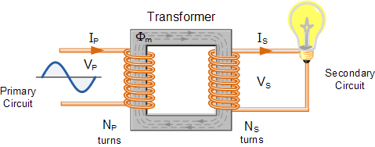

In other words, for a transformer there is no direct electrical connection between the two coil windings, thereby giving it the name also of an Isolation Transformer. Generally, the primary winding of a transformer is connected to the input voltage supply and converts or transforms the electrical power into a magnetic field. While the job of the secondary winding is to convert this alternating magnetic field into electrical power producing the required output voltage as shown.

Transformation ratio K = $\frac{V2}{V1}=\frac{N2}{N1}=\frac{I1}{I2}$

**Core Type Transformer:**

The windings are wound around the two legs of a rectangular magnetic core  

Leakage is reduced by bringing the two coils closer. this is achieved by winding half low-voltage (LV) and half high-voltage (HV) winding on each limb of the core as shown in Fig. (a). The LV winding is wound on the inside and HV on outside to reduce the amount of insulation needed. Insulation between the core and the inner winding is then stressed to low voltage. The two windings are arranged as *concentric* coils. The core-type construction has a longer mean length of core and a shorter mean length of coil turn. This type is better suited for EHV (extra high voltage) requirement since there is better scope for insulation

**Shell Type Transformer:**

The windings are wound on the central leg of a three-legged core. Leakage is reduced by subdividing each winding into subsections (wound as *pancake* coils) and interleaving LV and HV windings as shown in Fig.

 

The shell-type construction has better mechanical support and good provision for bracing the windings. The shell-type transformer requires more specialized fabrication facilities than core-type, while the latter offers the additional advantage of permitting visual inspection of coils in the case of a fault and ease of repair at substation site. For these reasons, the present practice is to use the core-type transformers in large high-voltage installation.

**EMF Equation of a Transformer:**

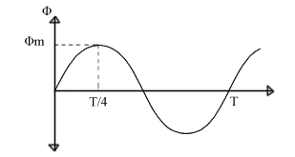Let,   
N1 = Number of turns in primary winding  
N2 = Number of turns in secondary winding  
Φm = Maximum flux in the core (in Wb) = (Bm x A)   
f = frequency of the AC supply (in Hz)

As, shown in the fig., the flux rises sinusoidally to its maximum value Φm from 0. It reaches to the maximum value in one quarter of the cycle i.e in T/4 sec (where, T is time period of the sin wave of the supply = 1/f).  
 Therefore,  
average rate of change of flux = Φm /(T/4)    = Φm/(1/4f)  
Therefore,  
average rate of change of flux = 4f Φm       ....... (Wb/s).  
Now,  
Induced emf per turn = rate of change of flux per turn  
Therefore, average emf per turn = 4f Φm   ..........(Volts).  
Now, we know,  Form factor = RMS value / average value  
Therefore, RMS value of emf per turn = Form factor X average emf per turn.  
As, the flux Φ varies sinusoidally, form factor of a sine wave is 1.11  
Therefore, RMS value of emf per turn =  1.11 x 4f Φm = 4.44f Φm.  
RMS value of induced emf in whole primary winding (E1) = RMS value of emf per turn X Number of turns in primary winding  
          E1 = 4.44f N1 Φm          ............................. eq 1  
Similarly, RMS induced emf in secondary winding (E2) can be given as  
          E2 = 4.44f N2 Φm.          ............................ eq 2  
from the above equations 1 and 2,

[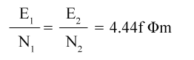](https://2.bp.blogspot.com/-lPhzxkyPGAw/UzbPKKV6NwI/AAAAAAAAAqg/BI4nFivMOu8/s1600/Untitled-1.png)

This is called the **emf equation of transformer**, which shows, emf / number of turns is same for both primary and secondary winding.

**Voltage Transformation Ratio (K)**

As derived above,

[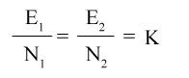](https://2.bp.blogspot.com/-MFCEwDtX8_4/UzbWcaAjQII/AAAAAAAAAq8/SSdUwNiLCas/s1600/voltage+transformation+ratio.png)

Where, K = constant  
This constant K is known as **voltage transformation ratio**.

* If N2 > N1, i.e. K > 1, then the transformer is called step-up transformer.
* If N2 < N1, i.e. K < 1, then the transformer is called step-down transformer.

**Open circuit test**

The purpose of this test is to determine the shunt branch parameters of the equivalent circuit of the transformer. One of the windings is connected to supply at rated voltage, while the other winding is kept open-circuited. The test is usually performed from the LV side, while the HV side is kept open circuited as shown in Fig.



Indeed the no-load current *I*0 is so small (it is usually 2-6% of the rated current) and *R*1 and *X*1 are also small, that *V*1 can be regarded as = *E*1 by neglecting the series impedance. This means that for all practical purposes the power input on no-load equals the core (iron) loss i.e. *P*0 = *Pi* (iron-loss),

The shunt branch parameters can easily be determined by the following circuit computations

*Y*0 = *Gi* – *jBm*

*Y*0 =*I0/V1*

*V12* *G1* = *P0*

It then follows that



**Short circuit test**

This test serves the purpose of determining the series parameters of a transformer. the test is usually conducted from the HV side of the transformer, while the LV is short-circuited as shown in Fig. The equivalent circuit as seen from the HV under short-circuit conditions is drawn in Fig. Since the transformer resistances and leakage reactances are very small, the voltage *V*SC needed to circulate the full-load current under short-circuit is as low as 5-8% of the rated voltage. As a result the exciting current *I*0 (SC) under these conditions is only about 0.1 to 0.5% of the full-load current (*I*0 at the rated voltage is 2-6% of the full-load current).



While conducting the SC test, the supply voltage is gradually raised from zero till the transformer draws full-load current. The meter readings under these conditions are:

voltage = *VSC*; current = *ISC*; power input = *PSC*

Since the transformer is excited at very low voltage, the iron-loss is negligible (that is why shunt branch is left out), the power input corresponds only to the copper-loss, i.e.

*PSC* = *Pc* (copper-loss)

the circuit parameters are computed as below:



Equivalent resistance,



Equivalent reactance,



**INDUCTION MOTORS**

An induction motor can be treated as Rotating Transformer i.e; one in which primary winding is stationary but the secondary is free to rotate.

**Advantages:**

1. It has very simple and extremely rugged, almost unbreakable construction.

2. Its cost is low and it is very reliable.

3. It has high efficiency. As no brushes are needed so losses are reduced.

4. Require s minimum maintenance.

5. It starts up from rest and has not to be synchronised.

**Disadvantages**:

1. Speed cannot be varied without sacrificing some of its efficiency.
2. Just like a DC shunt motor, its speed decreases with increase in load.
3. Its starting torque is somewhat inferior to that of a DC shunt motor.

**Principle of Operation**

The stator of the motor consists of overlapping winding offset by an electrical angle of 120o. When we connect the primary winding, or the stator to a 3 phase AC source, it establishes [rotating magnetic field](https://www.electrical4u.com/rotating-magnetic-field/) which rotates at the synchronous speed. The stator of the motor consists of overlapping winding offset by an electrical angle of 120o. When we connect the primary winding, or the stator to a 3 phase AC source, it establishes [rotating magnetic field](https://www.electrical4u.com/rotating-magnetic-field/) which rotates at the synchronous speed.

As the rotor winding in an [induction motor](https://www.electrical4u.com/induction-motor-types-of-induction-motor/) are either closed through an external [resistance](https://www.electrical4u.com/electrical-resistance-and-laws-of-resistance/) or directly shorted by end ring, and cut the stator rotating magnetic field, an emf is induced in the rotor copper bar and due to this emf a [current](https://www.electrical4u.com/electric-current-and-theory-of-electricity/) flows through the rotor conductor.

Here the relative speed between the rotating flux and static rotor conductor is the cause of current generation; hence as per [Lenz's law](https://www.electrical4u.com/lenz-law-of-electromagnetic-induction/), the rotor will rotate in the same direction to reduce the cause, i.e. the relative velocity.

Thus from the working principle of three phase induction motor, it may be observed that the rotor speed should not reach the synchronous speed produced by the stator. If the speeds become equal, there would be no such relative speed, so no emf induced in the rotor, and no current would be flowing, and therefore no torque would be generated.

### Slip

A stator magnetic field rotates at synchronous speed, {\displaystyle n_{s}}ns = (120*f)/P

{\displaystyle n_{s}={\frac {120f}{p}}} where {\displaystyle f}f= frequency

{\displaystyle p}P= number of poles

The speed of induction motor is given by, speed-control-of-three-phase-induction-motor-2

Where, N is the speed of the rotor of an induction motor,

Ns is the synchronous speed,

S is the slip.

**Rotor Frequency**

The frequency of the voltage induced in the rotor is given by



Where *fr* = the rotor frequency (Hz)

*p* = number of stator poles

*nslip =* slip speed (rpm)



* When the rotor is blocked (*s=*1) , the frequency of the induced voltage is equal to the supply frequency.
* On the other hand, if the rotor runs at synchronous speed (*s* = 0), the frequency will be zero.

**Torque equation of a**[**three phase induction motor**](http://www.electricaleasy.com/2014/02/three-phase-induction-motor.html)

Torque  is proportional to flux per stator pole, rotor current and the power factor of the rotor.  
T ∝  ɸ I2 cosɸ2      OR      T = k ɸ I2 cosɸ2 .  
where, ɸ = flux per stator pole,  
            I2 = rotor current at standstill,   
            ɸ2 = angle between rotor emf and rotor current,  
             k = a constant.  
Now, let E2 = rotor emf at standstill  
we know, rotor emf is directly proportional to flux per stator pole, i.e. E2 ∝ ɸ.  
therefore,  T ∝ E2 I2 cosɸ2       OR      T =k1 E2 I2 cosɸ2.  
Starting Torque

The torque developed at the instant of starting of a motor is called as starting torque. Starting torque may be greater than running torque in some cases, or it may be lesser.

We know, T =k1 E2 I2 cosɸ2.

let, R2 = rotor resistance per phase

      X2 = stand still rotor reactance

[rotor-impedance](https://2.bp.blogspot.com/-MoPP4grodog/UvRrwboQRRI/AAAAAAAAAUk/xzayK8B10Pw/s1600/rotor-impedance.png)

 then,

[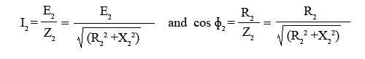](https://3.bp.blogspot.com/-kAGRlz6CP_E/UvRtvbU5rJI/AAAAAAAAAUw/xU_838FdPZ0/s1600/standstill-cuurrent-pf.png)

Therefore, starting torque can be given as,

[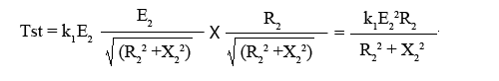](https://2.bp.blogspot.com/-7dlWq07k1w8/UvRwdohuI0I/AAAAAAAAAU8/Two22aWUkfg/s1600/starting-torque.png)

The constant k1 = 3 / 2πNs

[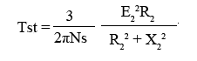](https://2.bp.blogspot.com/-PwPxVfTOYrA/UvRyK94VPDI/AAAAAAAAAVI/4R4kT2uq5L4/s1600/starting-torque-3phase-motor.png)

### Torque Slip Characteristics

The torque slip curve for an [induction motor](https://www.electrical4u.com/induction-motor-types-of-induction-motor/) gives us the information about the variation of torque with the slip. The slip is defined as the ratio of difference of synchronous speed and actual rotor speed to the synchronous speed of the machine. The variation of slip can be obtained with the variation of speed that is when speed varies the slip will also vary and the torque corresponding to that speed will also vary.

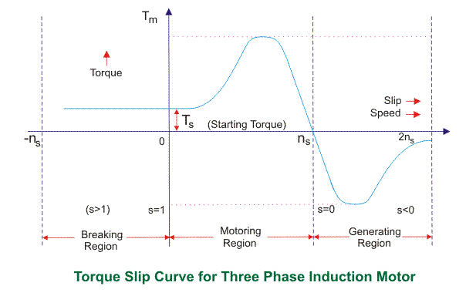

**3-Ø ALTERNATOR (OR) SYNCHRONOUS GENERATOR**

An alternator is such a machine which converts mechanical energy from a prime mover to AC electric power at specific voltage and frequency. It is also known as synchronous generator.

**Types of alternator** classified according to their design.

1.Salient pole type

We use it as low and medium speed alternator. It has a large number of projecting poles having their cores bolted or dovetailed onto a heavy magnetic wheel of cast iron or steel of good magnetic quality. Such generators get characterised by their large diameters and short axial lengths. These generators look like a big wheel. These are mainly used for low-speed turbine such as in hydel power plant.

2.Smooth cylindrical type

We use it for a steam turbine driven alternator. The rotor of this generator rotates at very high speed. The rotor consists of a smooth solid forged steel cylinder having certain numbers of slots milled out at intervals along the outer periphery for accommodating field coils. These rotors are designed mostly for 2 poles or 4 poles turbo generator running at 3600 rpm or 1800 rpm respectively.

**Construction of Alternator**

An alternator is basically a type of AC generator which also known as synchronous generator. The field poles are made to rotate at synchronous speed Ns = 120 f/P for effective power generation. Where, f signifies the alternating current frequency and the P represents the number of poles.

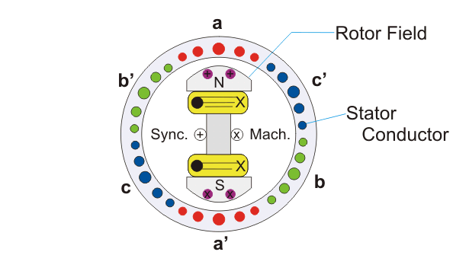

There are mainly two types of rotor used in construction of alternator,

1.Salient pole type.

2.Cylindrical rotor type.

**Salient Pole Type**

The term salient means protruding or projecting. The salient pole type of rotor is generally used for slow speed machines having large diameters and relatively small axial lengths. The poles, in this case, are made of thick laminated steel sections riveted together and attached to a rotor with the help of joint.

An alternator as mentioned earlier is mostly responsible for generation of very high electrical power. To enable that, the mechanical input given to the machine in terms of rotating torque must also be very high. This high torque value results in oscillation or hunting effect of the alternator or synchronous generator. To prevent these oscillations from going beyond bounds the damper winding is provided in the pole faces as shown in the figure. The damper windings are basically copper bars short-circuited at both ends are placed in the holes made in the pole axis. When the alternator is driven at a steady speed, the relative velocity of the damping winding with respect to the main field will be zero. But as soon as it departs from the synchronous speed there will be relative motion between the damper winding and the main field which is always rotating at synchronous speed. This relative difference will induce the current in them which will exert a torque on the field poles in such a way as to bring the alternator back to synchronous speed operation.

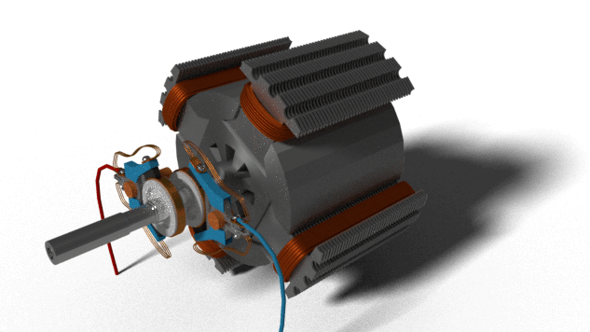

The salient feature of pole field structure has the following special feature-

They have a large horizontal diameter compared to a shorter axial length.

The pole shoes covers only about 2/3rd of pole pitch.

Poles are laminated to reduce eddy current loss.

The salient pole type motor is generally used for low-speed operations of around 100 to 400 rpm, and they are used in power stations with hydraulic turbines or diesel engines.

Salient pole alternators driven by water turbines are called hydro-alternators or hydro generators.

**Cylindrical Rotor Type**

The cylindrical rotor is generally used for very high speed operation and employed in steam turbine driven alternators like turbogenerators. The machines are built in a number of ratings from 10 MVA to over 1500 MVA. The cylindrical rotor type machine has a uniform length in all directions, giving a cylindrical shape to the rotor thus providing uniform flux cutting in all directions. The rotor, in this case, consists of a smooth solid steel cylinder, having a number of slots along its outer periphery for hosting the field coils.

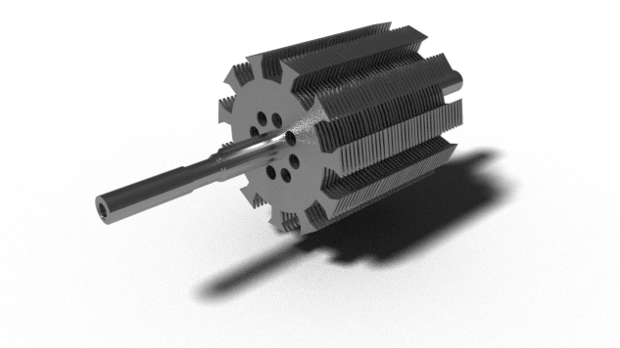

The cylindrical rotor alternators are generally designed for 2-pole type giving very high

speed of

https://www.electrical4u.com/images/2017/may/1494485850.PNG

Or 4-pole type running at a speed of

https://www.electrical4u.com/images/2017/may/1494485924.PNG

Where, f is the frequency of 50 Hz.

The cylindrical rotor synchronous generator does not have any projections coming out from the surface of the rotor, rather central polar area is provided with slots for housing the field windings as we can see from the diagram above. The field coils are so arranged around these poles that flux density is maximum on the polar central line and gradually falls away as we move out towards the periphery. The cylindrical rotor type machine gives better balance and quieter-operation along with lesser windage losses.

**Working Principle of Alternator**

The **working principle of alternator** is very simple. It is just like [basic principle of DC generator](https://www.electrical4u.com/principle-of-dc-generator/). It also depends upon [Faraday's law of electromagnetic induction](https://www.electrical4u.com/faraday-law-of-electromagnetic-induction/) which says the [current](https://www.electrical4u.com/electric-current-and-theory-of-electricity/) is induced in the conductor inside a [magnetic field](https://www.electrical4u.com/what-is-magnetic-field/) when there is a relative motion between that [conductor](https://www.electrical4u.com/electrical-conductor/) and the [magnetic field](https://www.electrical4u.com/what-is-magnetic-field/).

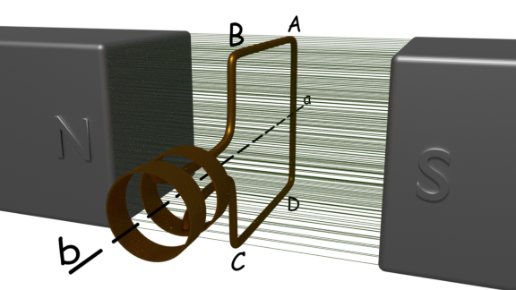

For understanding **working of alternator** let us think about a single rectangular turn placed in between two opposite magnetic poles as shown above.

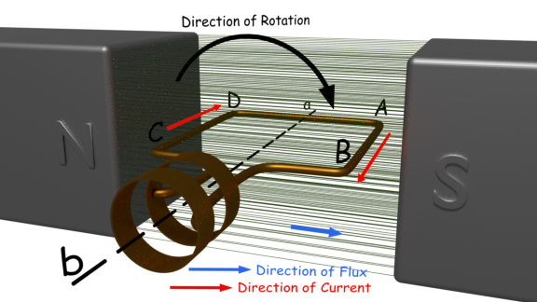

Say this single turn loop ABCD can rotate against axis a-b. Suppose this loop starts rotating clockwise. After 90o rotation the side AB or [conductor](https://www.electrical4u.com/electrical-conductor/) AB of the loop comes in front of S-pole and conductor CD comes in front of N-pole. At this position the tangential motion of the conductor AB is just perpendicular to the [magnetic flux lines](https://www.electrical4u.com/what-is-magnetic-field/) from N to S pole. Hence, the rate of flux cutting by the conductor AB is maximum here and for that flux cutting there will be an induced current in the conductor AB and the direction of the induced current can be determined by [Flemming's right-hand rule](https://www.electrical4u.com/fleming-left-hand-rule-and-fleming-right-hand-rule/). As per this rule the direction of this [current](https://www.electrical4u.com/electric-current-and-theory-of-electricity/) will be from A to B. At the same time conductor CD comes under N pole and here also if we apply [Fleming right-hand rule](https://www.electrical4u.com/fleming-left-hand-rule-and-fleming-right-hand-rule/) we will get the direction of induced current and it will be from C to D.

Now after clockwise rotation of another 90o the turn ABCD comes at vertical position as shown below. At this position tangential motion of [conductor](https://www.electrical4u.com/electrical-conductor/) AB and CD is just parallel to the [magnetic flux](https://www.electrical4u.com/what-is-magnetic-field/#Magnetic-Flux-or-Magnetic-Lines-of-Force) lines, hence there will be no flux cutting that is no current in the conductor.

While the turn ABCD comes from horizontal position to vertical position, angle between flux lines and direction of motion of conductor, reduces from 90o to 0o and consequently the induced current in the turn is reduced to zero from its maximum value.

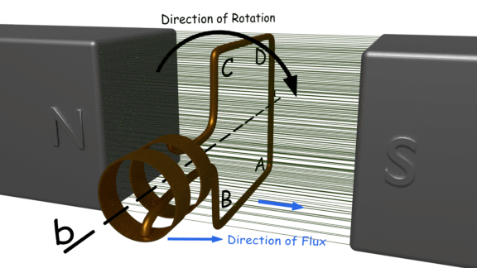

After another clockwise rotation of 90o the turn again comes to horizontal position, and here conductor AB comes under N-pole and CD comes under S-pole, and here if we again apply [Fleming right-hand rule](https://www.electrical4u.com/fleming-left-hand-rule-and-fleming-right-hand-rule/), we will see that induced current in conductor AB, is from point B to A and induced current in the conductor CD is from D to C.

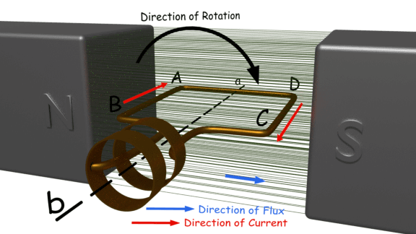

As at this position the turn comes at horizontal position from its vertical position, the [current](https://www.electrical4u.com/electric-current-and-theory-of-electricity/) in the conductors comes to its maximum value from zero. That means current is circulating in the close turn from point B to A, from A to D, from D to C and from C to B, provided the loop is closed although it is not shown here. That means the current is in reverse of that of the previous horizontal position when the current was circulating as A → B → C → D → A.

While the turn further proceeds to its vertical position the current is again reduced to zero. So if the turn continues to rotate the current in turn continually alternate its direction. During every full revolution of the turn, the current in turn gradually reaches to its maximum value then reduces to zero and then again it comes to its maximum value but in opposite direction and again it comes to zero. In this way, the current completes one full sine wave cycle during each 360o revolution of the turn. So, we have seen how an alternating current is produced in a turn is rotated inside a magnetic field. From this, we will now come to the actual **working principle of alternator**.

Now we place one stationary brush on each slip ring. If we connect two terminals of an external load with these two brushes, we will get an alternating current in the load. This is our elementary model of [alternator](https://www.electrical4u.com/alternator-or-synchronous-generator/).

Having understood the very basic principle of an alternator, let us now have an insight into its basic operational principle of a practical alternator. During discussion of basic **working of alternator**, we have considered that the magnetic field is stationary and [conductors](https://www.electrical4u.com/electrical-conductor/) (armature) is rotating. But generally in practical [construction of alternator](https://www.electrical4u.com/construction-of-alternator/), armature conductors are stationary and field magnets rotate between them. The rotor of an [alternator](https://www.electrical4u.com/alternator-or-synchronous-generator/) or a [synchronous generator](https://www.electrical4u.com/alternator-or-synchronous-generator/) is mechanically coupled to the shaft or the [turbine](https://www.electrical4u.com/steam-turbine/) blades, which being made to rotate at synchronous speed Ns under some mechanical force results in magnetic flux cutting of the stationary armature conductors housed on the stator. As a direct consequence of this flux cutting an induced emf and [current](https://www.electrical4u.com/electric-current-and-theory-of-electricity/) starts to flow through the armature conductors which first flow in one direction for the first half cycle and then in the other direction for the second half cycle for each winding with a definite time lag of 120o due to the space displaced arrangement of 120o between them as shown in the figure below. This particular phenomenon results in three phase power flow out of the alternator which is then transmitted to the distribution stations for domestic and industrial uses.

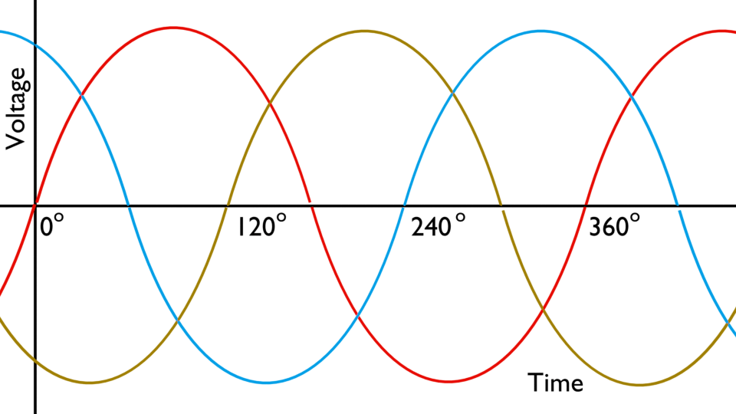

**EMF Equation of a Synchronous Generator**

The generator which runs at a synchronous speed is known as the synchronous generator. The synchronous generator converts the mechanical power into electrical energy for the grid. The Derivation of EMF Equation of a synchronous generator is given below.

Let,

P be the number of poles

ϕ is Flux per pole in Webers

N is the speed in revolution per minute (r.p.m)

f be the frequency in Hertz

Zph is the number of conductors connected in series per phase

Tph is the number of turns connected in series per phase

Kc is the coil span factor

Kd is the distribution factor

Flux cut by each conductor during one revolution is given as Pϕ Weber. Time taken to complete one revolution is given by 60/N sec

Average EMF induced per conductor will be given by the equation shown below

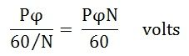

Average EMF induced per phase will be given by the equation shown below

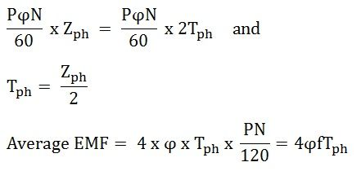

The average EMF equation is derived with the following assumptions given below.

1. Coils have got the full pitch.

2. All the conductors are concentrated in one stator slot.

**Root mean square (R.M.S)** value of the EMF induced per phase is given by the equation shown below.

Eph = Average value x form factor

Therefore,

https://circuitglobe.com/wp-content/uploads/2015/12/EMF-EQUATION-OF-SYNCHRONOUS-GENERATOR-EQ3-compressor.jpg

If the coil span factor Kc and the distribution factor Kd , are taken into consideration than the Actual EMF induced per phase is given as

https://circuitglobe.com/wp-content/uploads/2015/12/EMF-EQUATION-OF-SYNCHRONOUS-GENERATOR-EQ4-compressor.jpg

Equation (1) shown above is the EMF equation of the Synchronous Generator.

**Coil Span Factor**

The Coil Span Factor is defined as the ratio of the induced emf in a coil when the winding is short pitched to the induced emf in the same coil when the winding is full pitched.

**Distribution Factor**

Distribution factor is defined as the ratio of induced EMF in the coil group when the winding is distributed in a number of slots to the induced EMF in the coil group when the winding is concentrated in one slot.

**IMPORTANT QUESTIONS**

1.Derive the e.m.f equation of a transformer

2. Write short notes on O.C & S.C test on a single phase transformer

3. Explain the principle of operation of single phase transformer

4. Explain the constructional details of single phase transformer

5. Explain the principle of operation of three phase induction motor

6. Derive torque equation of a three phase induction motor.

7. Explain torque slip characteristics of a three phase induction motor.

8. Derive e.m.f equation of an alternator.