**G. PULLAIAH COLLEGE OF ENGINEERING & TECHNOLOGY, Kurnool**

**Department of MBA**

**A REPORT ON “YOGA ACTIVITY”**

***“Yoga is the art work of awareness on the canvas of body, mind and soul”***

With respect to the above quote, a refreshing Yoga Session was organised for I MBA students as Part of MBA I Year Induction Programme at **8:50 Am** on **24th August, 2018**. Dr. K. E. Sreenivasa Murthy, HOD- ECE, GPCET acted as Yoga Trainer.

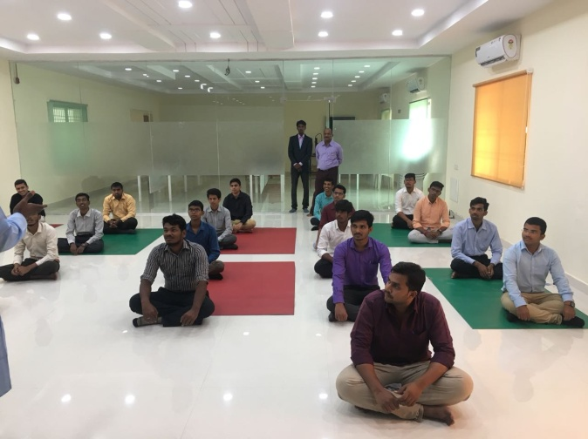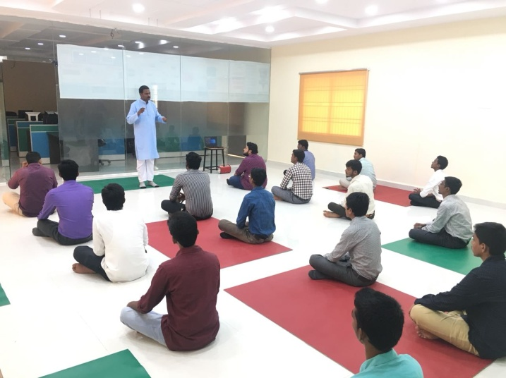

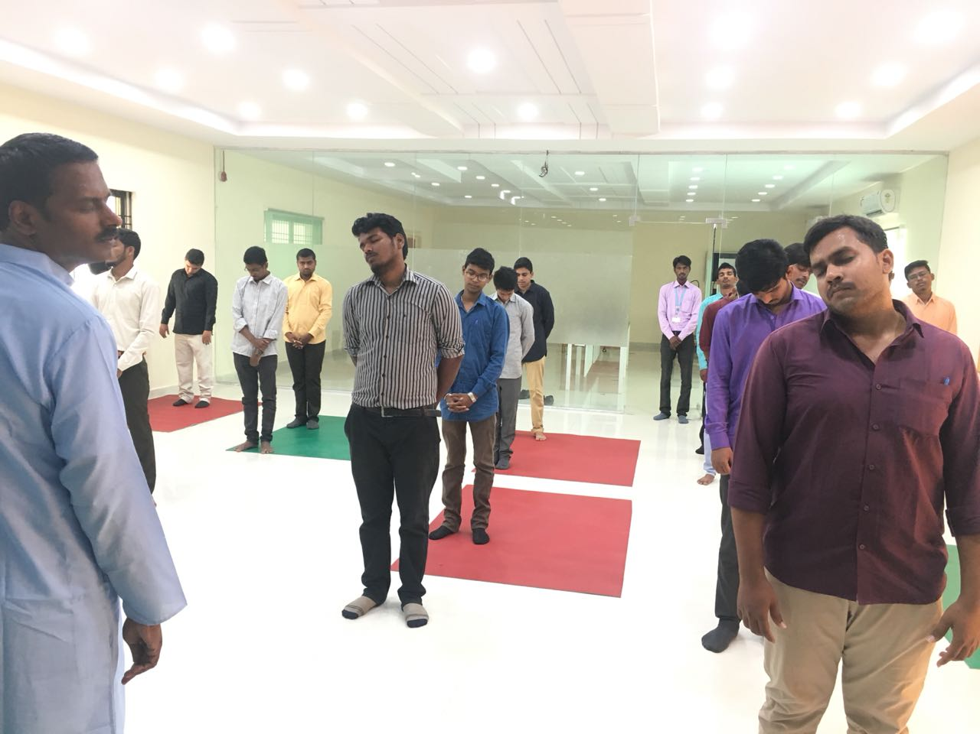

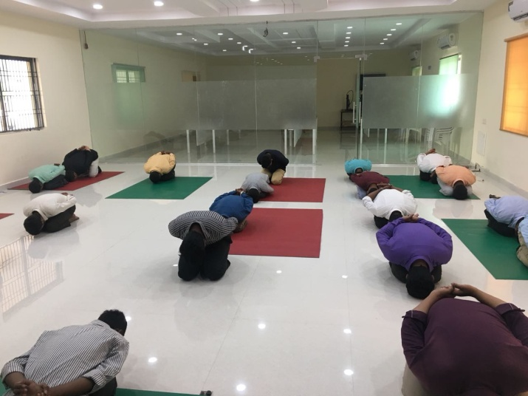

**SNAPSHOTS OF THE EVENT**