G. PULLAIAH COLLEGE OF ENGINEERING & TECHNOLOGY,Kurnool
(AUTONOMOUS)
Department of MBA
A Report on Industrial Visit
“The only source of knowledge is Experience.”
With the above motive, two batches of I MBA students and two staff coordinators visited JKC Cement, Nandyal, Andhra Pradesh on 3rd and 5th November, 2018.
Mr. Kalyan, HR Executive, addressed the students and introduced about the JKC. He explained about the functioning of this Unit. Later Mr. Pavan, Technical Engineer, explained the different steps employed in production of Cement.
During this session, students interacted with the officials very effectively, particularly about the Cement manufacturing, Recruitment Policy and various management practices adopted by the firm. The students gained practical knowledge about Cement manufacturing, HR Management Practises, Logistics etc.
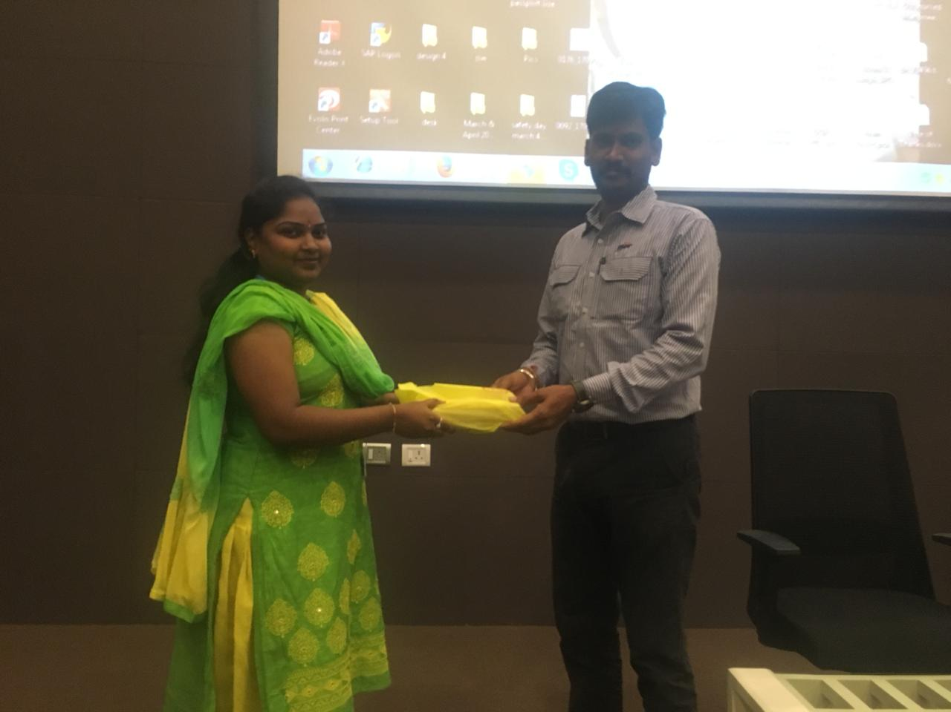
After this session all the students were offered a nice lunch. On behalf of the Department of MBA, GPCET; Mr.Kalyan, HR Excutive was honored with a small token of Gratitude. All the students expressed their thanks to the officials for the opportunity given.This trip was highly useful for the students in terms of practical knowledge about the Cement manufacturing and management practises. This trip will also be helpful for them to find placement opportunities in such industries.

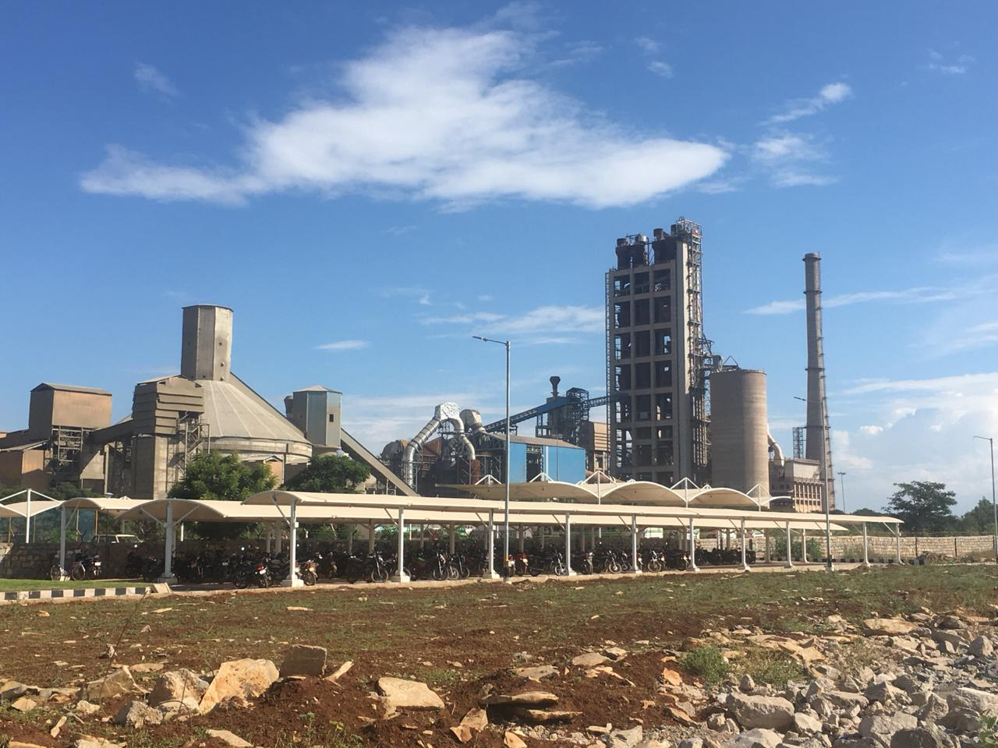

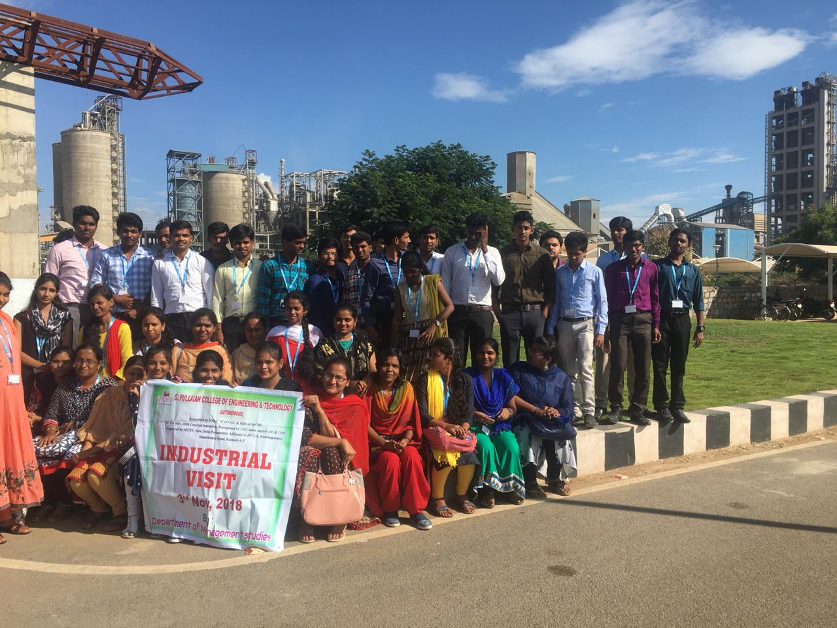
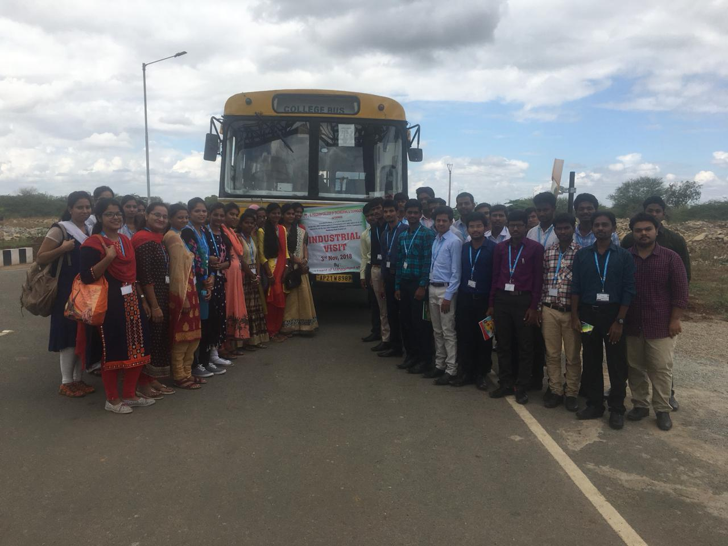
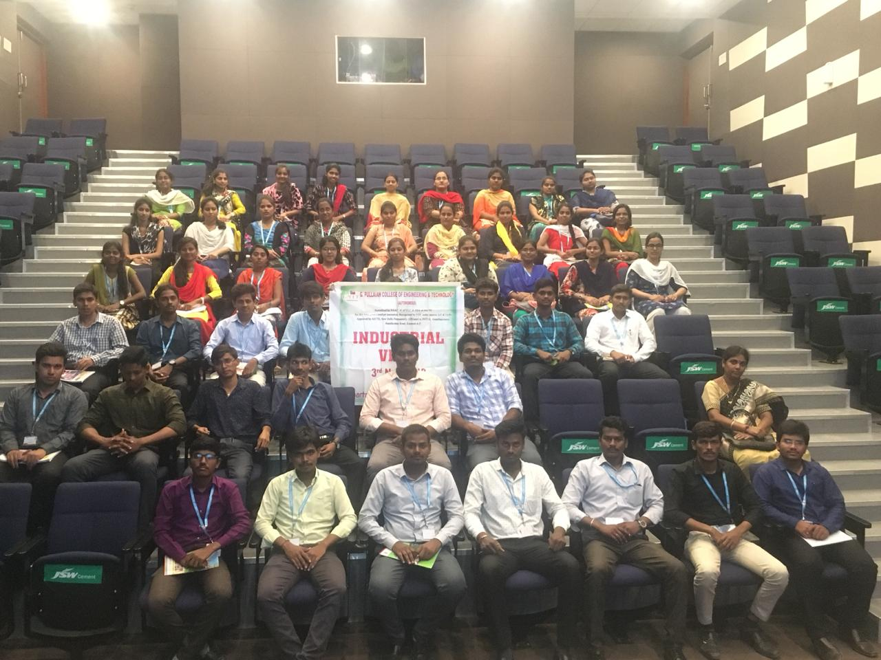

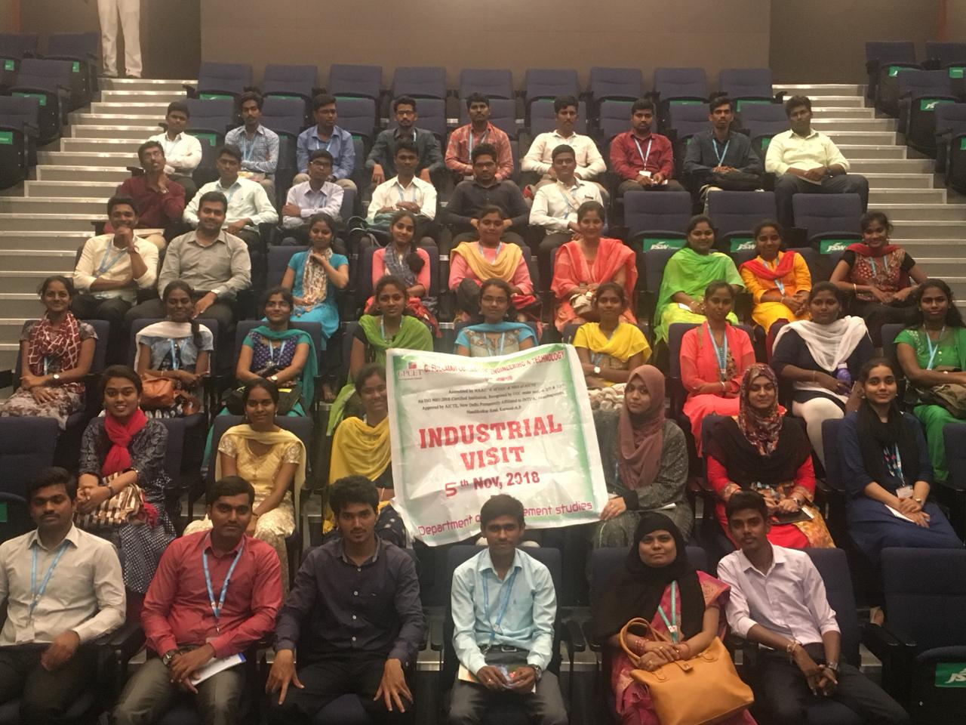
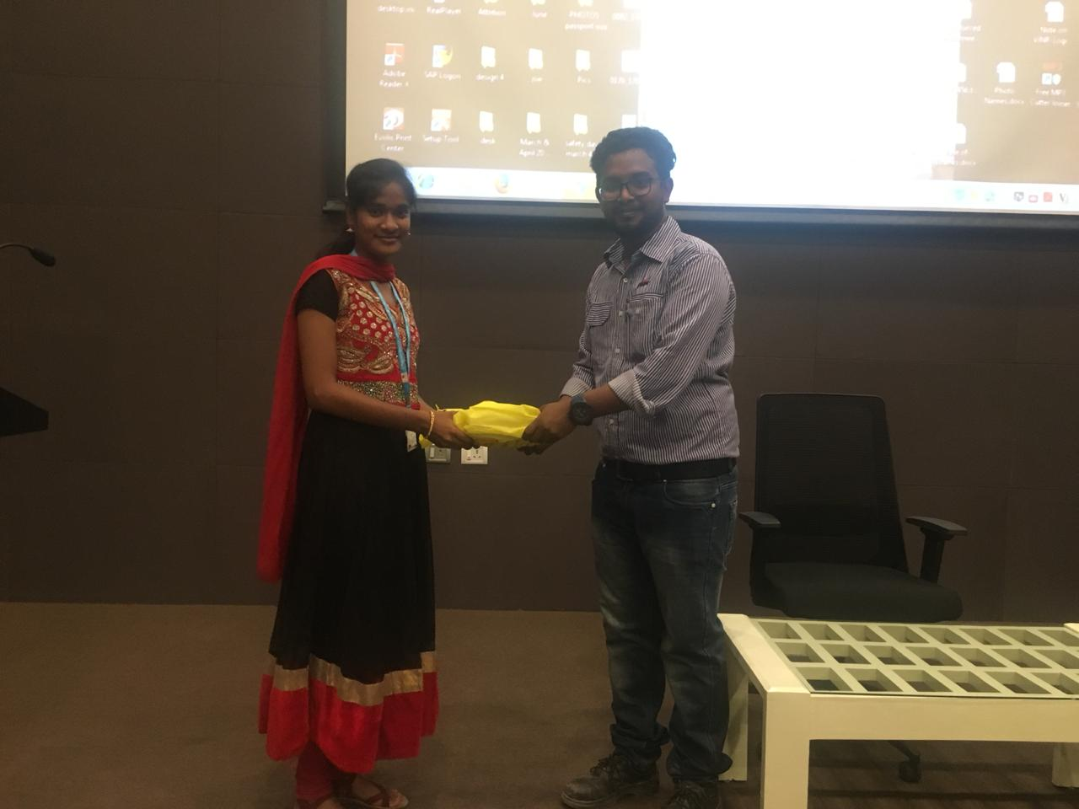

SNAPSHOTS OF THE INDUSTRIAL VISIT

