G.Pullaiah College of Engineering & Technology, Kurnool
Department of ECE

Report on A Five-Day Workshop (Module-2) on “LabVIEW”
(Under the activities of IEI & ISTE Students Chapter)
From 11th to 15th Dec 2017

Department of ECE, GPCET organized a five-day workshop on “LabVIEW Module-2” under the activities of IEI & ISTE Students chapter from 11-15 Dec 2017. Resource person was Mr.G.Nagarajan, Applications Engineer, VI Solutions, Bangalore.

The inaugural function was started at 9:30am at Block-3 in VI Laboratory. Dignitaries for the inaugural function were Dr.S.Prem Kumar, Dean, Dr.K.E.Sreenivasa Murthy, HOD-ECE, Mr. G.Nagarajan, Applications Engineer, VI Solutions, Bangalore, Dr.P.RamPrasad Reddy, HOD-EEE, Mr.P.Vishnu Kumar, Asst. Professor, Coordinator. A total of 21 participants were attended the workshop.
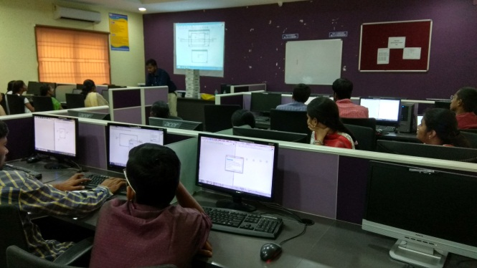
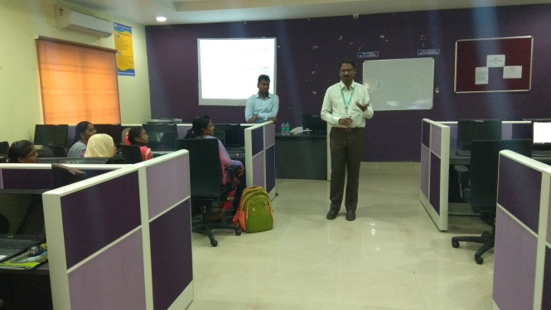
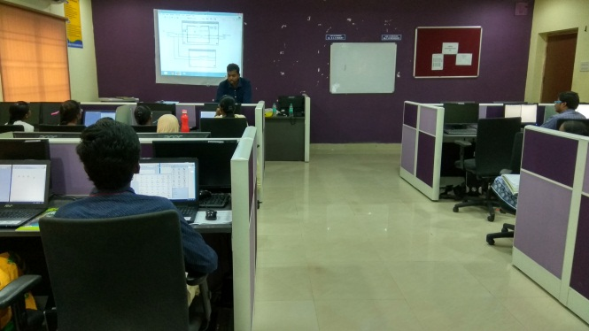
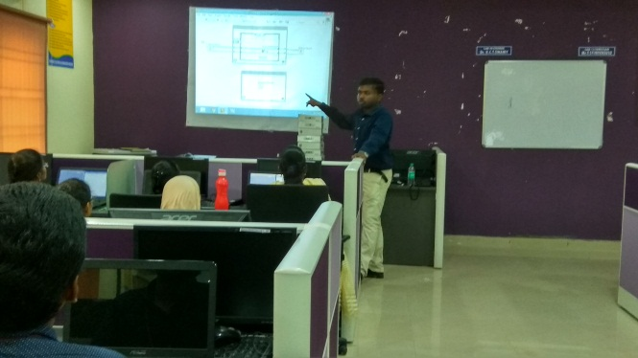
The following concepts were taught in the five-day Workshop on “LabVIEW Module-2”.

Day1:
- LabVIEW Basics Concepts: Data types
- Arrays
- Cluster
- String
- File I/O
- State Machine, Task based on State machine
- Event structures, Task based on Event structure.
Day2:
- Introduction to myDAQ
- DAQ Concepts [Sensors, Signal Conditioning, Types of signal, filters, Resolution, Range, Code width]
- Connecting and configuring myDAQ [Test panel]
- Accessing myDAQ using DAQ Assistant Acquisition [using LM35]
- Accessing myDAQ using DAQ Assistant [LM 35] Acquisition and calibration.

Day3:
- Accessing myDAQ using DAQ Assistant [IR sensor] Acquisition and calibration and logging.
- Accessing myDAQ using DAQ Assistant [IR sensor] Acquisition and calibration.
- Accessing myDAQ using DAQ Assistant [IR sensor] Acquisition and control. Analog input and Digital output.
- Accessing myDAQ using DAQ Assistant Acquisition & Linearization [IR Sensor]
Day4:
- Synchronization technique producer consumer [Queue] and master slave [Notifiers] technique
- Accessing myDAQ using DAQ Assistant Acquisition [IR Sensor], counter with Digital output.
- Hands-on NI myDAQ sampling rate and its strategies
- Hands-on NI myDAQ – Audio Signal Acquisition & Processing (Continuous Samples)
- Hands-on NI myDAQ – Application Development (Audio Equalizer)
- Hands-on NI myDAQ – using Low level VI’s.
Day5:
- Customization techniques – Custom Control, Type definition, strictly type definition.
- Hands-on NI myDAQ – PWM & DAQ Counters using Low level VI’s.
- Hands-on NI myDAQ – PWM using [LED, DC motor]
- Hands-on NI myDAQ – Audio Signal Acquisition & Processing (Continuous Samples) using low level VI’s.
- Accessing myDAQ using DAQ Assistant Acquisition & Linearization [using IR Sensor] using Low Level VI’s.
Participants List

S.NO. | ROLL NO. | NAME OF THE STUDENT | BRANCH
1 | 15AT1A0465 | V NIHARIKA | ECE
2 | 15AT1A0478 | BUSETTY PUSHPAK KUMAR | ECE
3 | 15AT1A0484 | GUNDA RAJESWARI | ECE
4 | 15AT1A0486 | SAREDDY RAJYALAKSHMI | ECE
5 | 15AT1A0493 | DUDDELA ROOPA | ECE
6 | 15AT1A0495 | SHAIK RUHEENA BEGUM | ECE
7 | 15AT1A04A2 | HARDAGERI SAI MOUNIKA | ECE
8 | 15AT1A04B2 | TAKKASILA SANDHYA | ECE
9 | 15AT1A04D7 | A SUNDAR CHAITANYA | ECE
10 | 15AT1A04E0 | ALURU MEGHAVALLI SUSEELA | ECE
11 | 15AT1A04E8 | Y TINA JAIN | ECE
12 | 15AT1A04G2 | PETNIKOTA VENKATESH | ECE
13 | 15AT1A0266 | B.K.SAI SWETHA | EEE
14 | 15AT1A0265 | S.SAI NITHIN KRISHNA | EEE
15 | 15AT1A0269 | SHAIK SHAHEN SHAVALI | EEE
16 | 15AT1A0273 | P SIVA GANGADHAR REDDY | EEE
17 | 15AT1A0288 | T VISHNU PRIYANKA REDDY | EEE
18 | 16AT5A0213 | JEREDDY LAKSHMIKANTH REDDY | EEE
19 | 16AT5A0227 | B SARATH CHANDRA | EEE
20 | 16AT5A0228 | BENDAKAYALA SHAHANAZ | EEE
21 | 16AT5A0231 | KURVA SIVA KUMAR | EEE

