G.Pullaiah College of Engineering & Technology, Kurnool
Department of ECE

Report on A Five-Day Workshop (Module-1) on “LabVIEW”
(Under the activities of IEI & ISTE Students Chapter)
From 12th to 16th Sep 2017

Department of ECE, GPCET organized a five-day workshop on “LabVIEW Module-1” under the activities of IEI & ISTE Students chapter from 12-16 Sep 2017. Resource person was Mr. R.Rajkumar, Applications Engineer, VI Solutions, Bangalore.

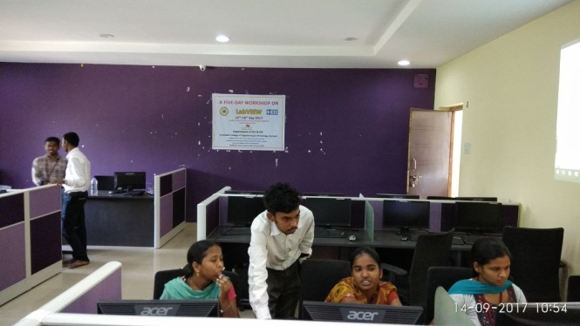
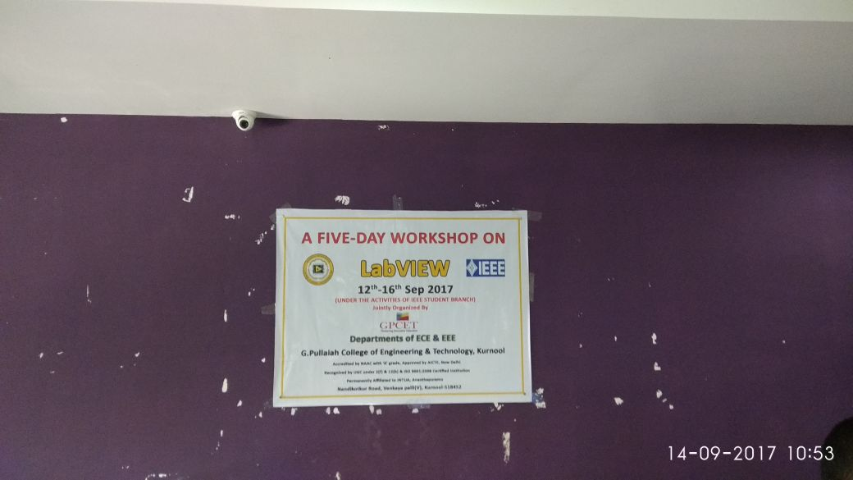
The inaugural function was started at 9:30am at Block-3 in VI Laboratory. Dignitaries for the inaugural function were Dr.S.Prem Kumar, Dean, Dr.K.E.Sreenivasa Murthy, HOD-ECE, Mr. R.Rajkumar, Applications Engineer, VI Solutions, Bangalore, Dr.P.RamPrasad Reddy, HOD-EEE. A total of 26 participants were attended the workshop.
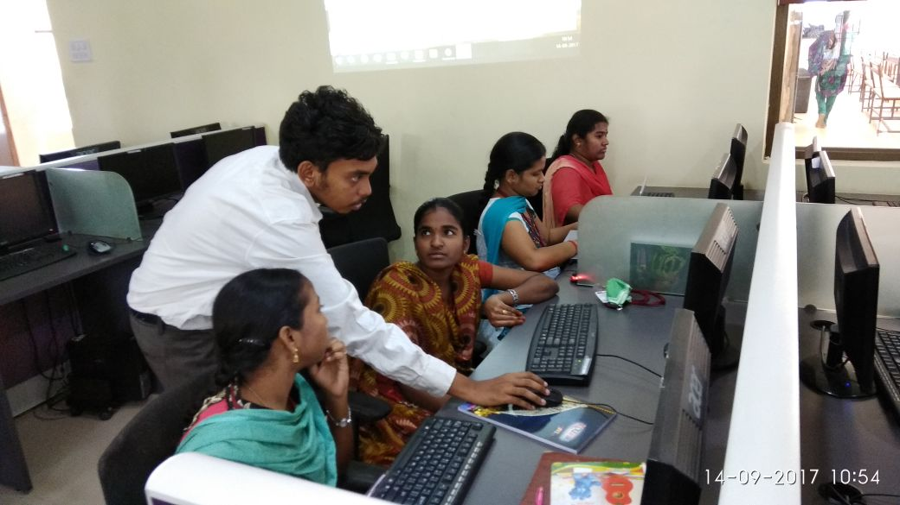

The following concepts were taught in the five-day Workshop on “LabVIEW Module-1”.

Day1:
- Introduction to LabVIEW Environment.
- Virtual Instrumentation Explanation.
- Getting started to LabVIEW Programming.
- Data Types, Data Flow Programming.
- Case structures.
Day2:
- Sequence structures.
- Formula & Expression nodes.
- Tasks using above concepts.

Day3:
- Loops.
- Shift registers.
- Arrays.
- Clusters
Day4:
- Strings
- Charts & Graphs
- File I/O
- Event Structures
- Sub VI
- State Machine
- Property nodes
Day5:
- Producer Consumer Architecture
- Master Slave Architecture
- Custom Controls
- Invoke nodes
Participants List

S.NO. | ROLL NO. | NAME OF THE STUDENT | BRANCH
1 | 15AT1A0486 | S.RAJYA LAKSHMI | ECE
2 | 15AT1A04B2 | T.SANDYA | ECE
3 | 15AT1A0478 | B.PUSHPAK KUMAR | ECE
4 | 15AT1A04E8 | Y.TINA JAIN | ECE
5 | 15AT1A04E0 | A.MEGHAVALLI SUSEELA | ECE
6 | 15AT1A04G2 | P.VENKATESH | ECE
7 | 15AT1A04D7 | A.SUNDER CHAITANYA | ECE
8 | 15AT1A0465 | V.NIHARIKA | ECE
9 | 15AT1A0493 | D.ROOPA | ECE
10 | 15AT1A0495 | S.RUSHEENA BEGUM | ECE
11 | 15AT1A0484 | G.RAJESHWARI | ECE
12 | 15AT1A04A2 | H.SAI MOUNIKA | ECE
13 | 16AT5A0213 | J.LAKSHMI KANTHA REDDY | EEE
14 | 16AT5A0227 | B.SARATH CHANDRA | EEE
15 | 16AT5A0228 | B.SHAHANAZ | EEE
16 | 16AT5A0231 | K.SHIVA KUMAR | EEE
17 | 16AT5A0202 | K.AZITH | EEE
18 | 15AT1A0273 | P.SIVA GANGADHAR REDDY | EEE
19 | 15AT1A0269 | S.SHAHEN SHAVALI | EEE
20 | 15AT1A0243 | M.MOUNIKA | EEE
21 | 15AT1A0266 | B.K.SWETHA | EEE
22 | 15AT1A0288 | T.VISHNU PRIYANKA REDDY | EEE
23 | 15AT1A0286 | M.V.TEJASWINI | EEE
24 | 15AT1A0265 | S.SAI NITHIN KRISHNA | EEE
25 | 15AT1A0285 | M.V.SHANMUKHA REDDY | EEE
26 | 15AT1A0212 | M.BHUVANESHWARI | EEE

