G.Pullaiah College of Engineering & Technology, Kurnool
Department of ECE

Report on A Five-Day FDP on “LabVIEW”
(Under the activities of ISTE Faculty Chapter)
From 15th to 19th Nov 2017

Department of ECE, GPCET organized a five-day faculty development program on “LabVIEW” under the activities of ISTE faculty chapter from 15-19 Nov 2017. Resource person was Mr.V.Jeejesh Kumar, Applications Engineer, VI Solutions, Bangalore.

The inaugural function was started at 9:30am at Block-3 in lecture hall B3-201. Dignitaries for the inaugural function were Dr.S.Prem Kumar, Dean, Dr.K.E.Sreenivasa Murthy, HOD-ECE, Mr.V.Jeejesh Kumar, Applications Engineer, VI Solutions, Bangalore, Dr.V.Vijay Kishore, Professor, Dr.P.RamPrasad Reddy, HOD-EEE, Mr.P.Vishnu Kumar, Asst. Professor, Coordinator. A total of 21 participants were attended the FDP.
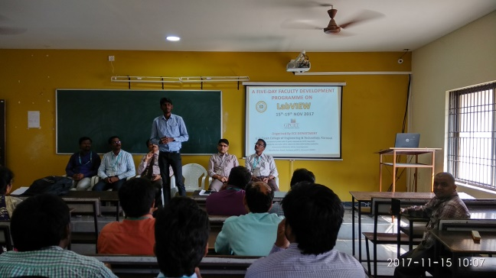
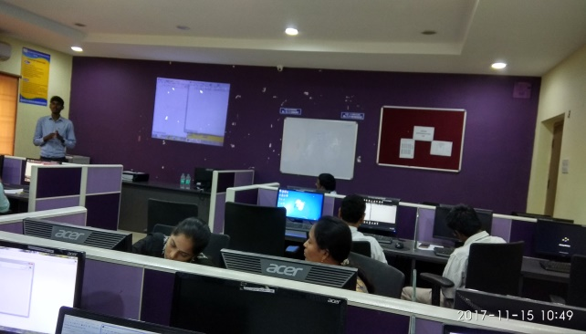
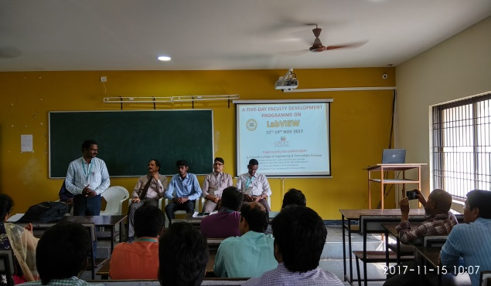
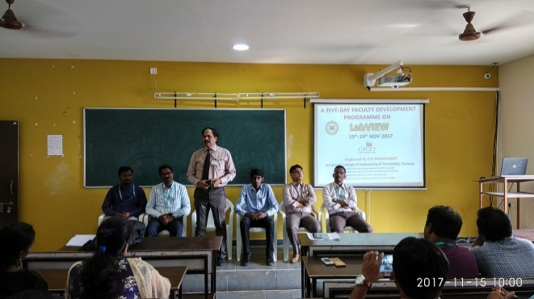
The following concepts were taught in the five-day FDP on “LabVIEW”.

Day1:
- Introduction to LabVIEW Environment.
- Virtual Instrumentation Explanation.
- Getting started to LabVIEW Programming.
- Data Types, Data Flow Programming.
- Case structures.
Day2:
- Sequence structures.
- Formula & Expression nodes.
- Tasks using above concepts.

Day3:
- Loops.
- Shift registers.
- Arrays.
- Clusters
Day4:
- Strings
- Charts & Graphs
- File I/O
- Event Structures
- Sub VI
- State Machine
- Property nodes
Day5:
- Producer Consumer Architecture
- Master Slave Architecture
- Custom Controls
- Invoke nodes
- Introduction to Data Acquisition
- Sensor Interfacing with DAQ.
Participants List

S.No. | Participant Name | Dept./College
1 | P.Vishnu Kumar | ECE, GPCET
2 | Dr.KCT Swamy | ECE, GPCET
3 | G.Rama Rao | ECE, GPCET
4 | D.Rajasekhar | ECE, GPCET
5 | G.Sreedhar Kumar | ECE, GPCET
6 | E.Upendranath Goud | ECE, GPCET
7 | V.Krishna Kanth Yadav | ECE, GPCET
8 | B.Geetha Rani | ECE, GPCET
9 | V.Shanthi | ECE, GPCET
10 | K.Narasimhaiah Achari | EEE, GPCET
11 | R.Sheba Rani | EEE, GPCET
12 | K.Jagadeesh | EEE, GPCET
13 | S.Sankara Prasad | EEE, GPCET
14 | P.Vinod Kumar | EEE, GPCET
15 | B.Urmila | EEE, GPCET
16 | K.Jayasree | EEE, GPCET
17 | E.Jyothirmai | EEE, GPCET
18 | P.Kishor Kumar | ECE, RCEW
19 | K.V Siva Reddy | ECE, RCEW
20 | M.Jyothirmai | ECE, RCEW
21 | R.Himabindu | ECE, RCEW

