G.Pullaiah College of Engineering & Technology, Kurnool
Department of ECE

Report of Training/Examination on “NI LabVIEW-CLAD Examination”
(Under the activities of IEI & ISTE Students Chapter)
Date: 26th March 2018

Department of ECE, GPCET conducted a “NI LabVIEW-CLAD Examination” under the activities of IEI & ISTE Students chapter on 26th March 2018. Resource person and was Mr. R.Rajkumar, Applications Engineer, VI Solutions, Bangalore.
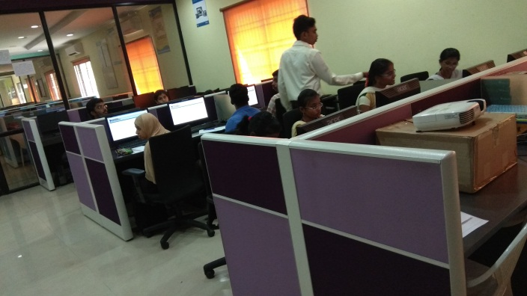
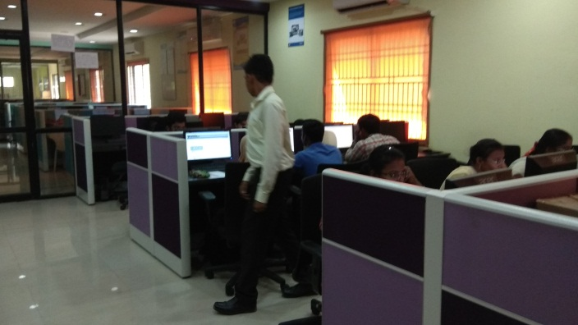
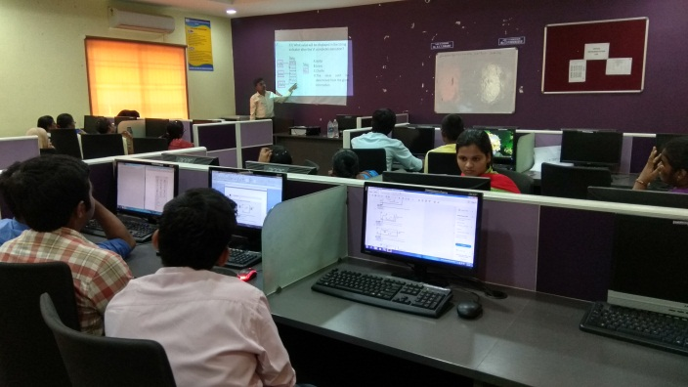
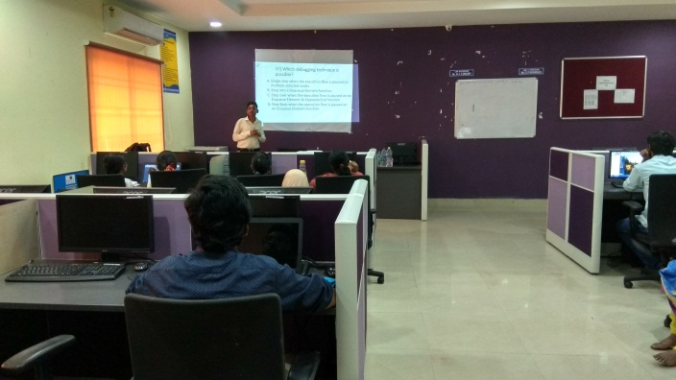

The following is the Report for the Training/Examination on “NI LabVIEW-CLAD Examination” for students conducted on 26th March 2018.

DAY OF CLAD EXAMINATION:
- 9:30AM - 12:30PM: Refreshed some concepts and cleared the doubts of participants.
- 1:30PM - 2:30PM: Refreshed Sample papers and cleared the doubts faced by students.
- 2:30PM - 3:00PM: Made sure CLAD Exam Portal are made available in Test Computers. General instructions were given during this period. Students were allotted their seats in exam hall.
- 3:00PM - 4:00PM: CLAD Exam Starts at 3:00PM. No Technical issues were faced during the examination.
- Result: Out of 17 Candidates, 16 Candidates met the requirements to pass CLAD examination and 1 Candidate did not meet the requirements to pass the CLAD Exam.

- The following is the List who cleared the CLAD Examination

CLAD Certified Student List

S.NO. | ROLL NO. | NAME OF THE STUDENT | BRANCH
1 | 15AT1A0465 | V NIHARIKA | ECE
2 | 15AT1A0478 | BUSETTY PUSHPAK KUMAR | ECE
3 | 15AT1A0484 | GUNDA RAJESWARI | ECE
4 | 15AT1A0486 | SAREDDY RAJYALAKSHMI | ECE
5 | 15AT1A0493 | DUDDELA ROOPA | ECE
6 | 15AT1A0495 | SHAIK RUHEENA BEGUM | ECE
7 | 15AT1A04A2 | HARDAGERI SAI MOUNIKA | ECE
8 | 15AT1A04B2 | TAKKASILA SANDHYA | ECE
9 | 15AT1A04D7 | A SUNDAR CHAITANYA | ECE
10 | 15AT1A04E0 | ALURU MEGHAVALLI SUSEELA | ECE
11 | 15AT1A04E8 | Y TINA JAIN | ECE
12 | 15AT1A04G2 | PETNIKOTA VENKATESH | ECE
13 | 15AT1A0266 | B.K.SAI SWETHA | EEE
14 | 15AT1A0265 | S.SAI NITHIN KRISHNA | EEE
15 | 15AT1A0269 | SHAIK SHAHEN SHAVALI | EEE
16 | 15AT1A0288 | T VISHNU PRIYANKA REDDY | EEE

