G.PULLAIAH COLLEGE OF ENGINEERING AND TECHNOLOGY, Kurnool
Department of Computer science and Engineering

Report on EPAM Java Training
Date: 06-01-2019

The department of CSE conducted EPAM Academy Java Training for III CSE students of G.Pullaiah College of Engineering and Technology. A total of 50 students attended the training programme. They were trained in the basics of Java by Mr.K.Anil Kumar, free Lancer, Corporate Trainer, Hyd. The students expressed satisfaction about the training and opinioned that this training would help them in improving their technical skills.

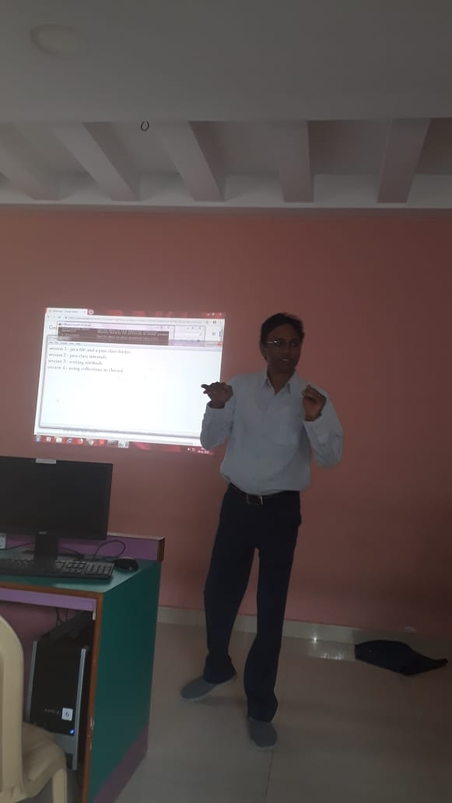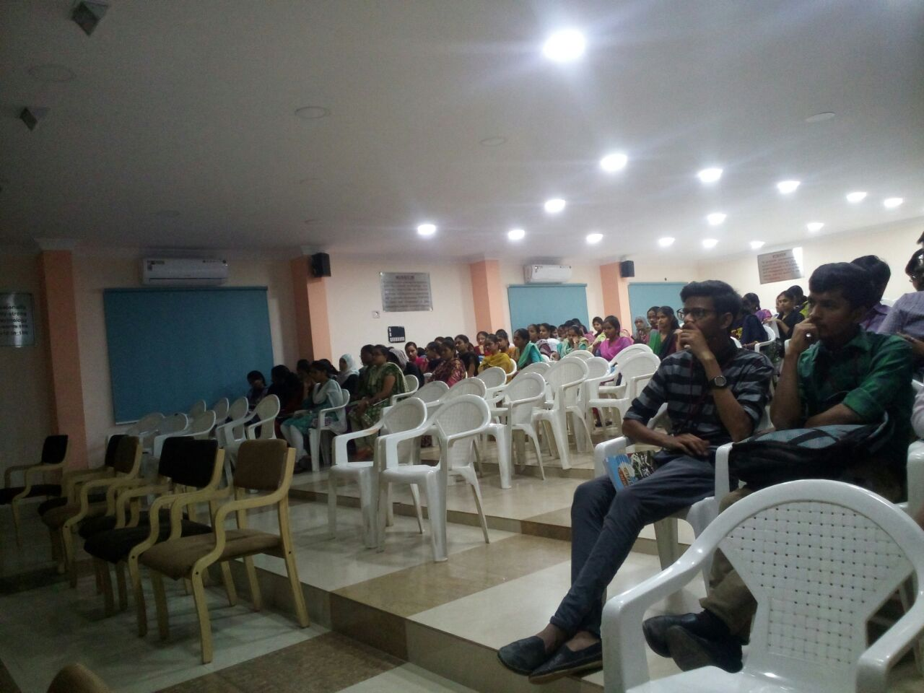

HOD-CSE

