G.PULLAIAH COLLEGE OF ENGINEERING AND TECHNOLOGY, Kurnool
Department of Computer science and Engineering

Report of 3 day Workshop on INTERNET OF THINGS(IOT)
Date: 05-01-2019

G.Pullaiah college of Engineering and Technology in association with Andhra Pradesh State Skill Development Corporation conducted a 3 day workshop on “Internet of Things” from 29/10/2018 to 31/10/2018. Mr. Uppala Sumanth and Mr.Macharla Umamaheswar Rao from APSSDC trained I B.Tech students of all departments. Certificates were also awarded to the students who had performed well in the subsequent assessment tests.

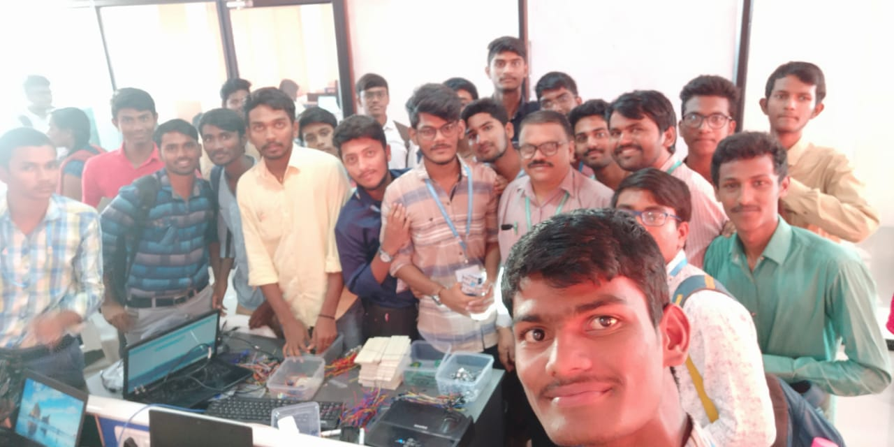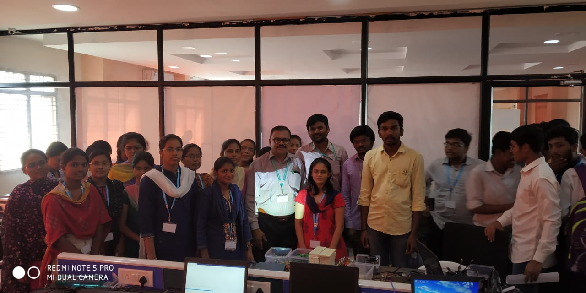
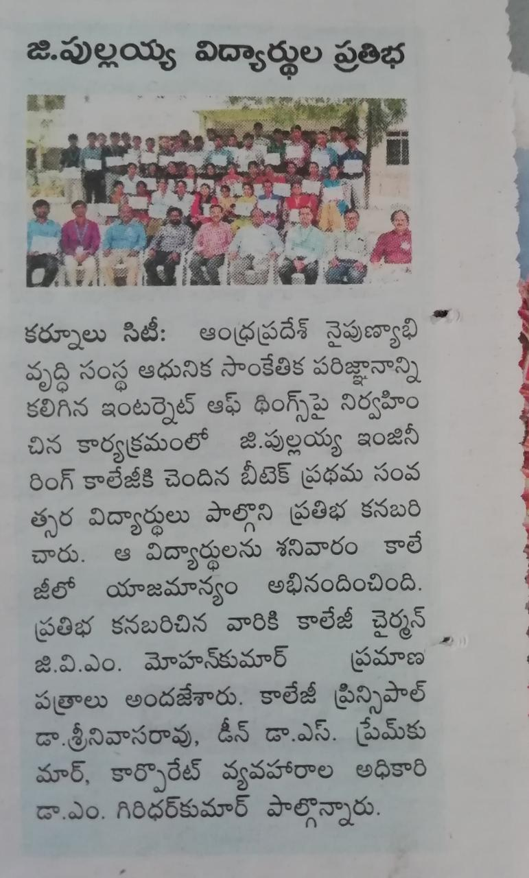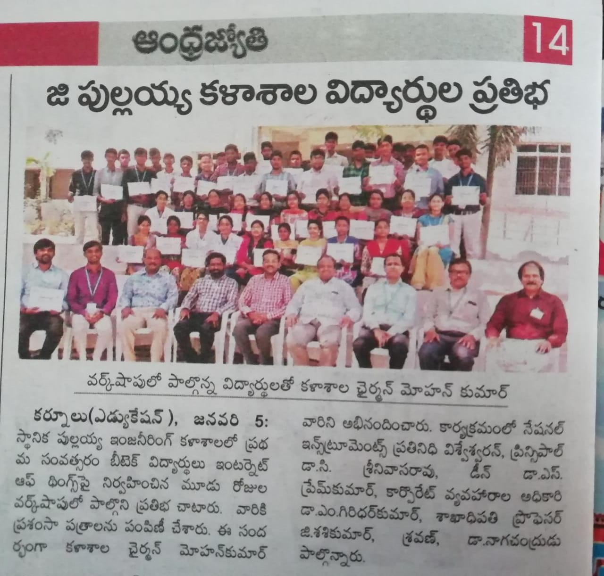

HOD-CSE

