G.PULLAIAH COLLEGE OF ENGINEERING & TECHNOLOGY: KURNOOL
(Autonomous)
Accredited by NAAC A of UGC and NBA of AICTE
Nandikotkur Road, Venkayapalli, Kurnool- 518 452

Women’s Grievance Cell

Date : 08-03-2019
Name of the Activity : International Women’s day
Target Group : All Girl Students & Lady Faculty
Resource Person : Dr.P.Yamini Purna Thilaka, Obstetrician & Gynaecologist
Summary:
8th of March, is considered International Women’s Day. This day brings many things for women – a cause for celebration, a reason to pause and re-evaluate a remembrance, an inspiration and a time to honor, loved and admired ones. To commemorate this womanhood, Women’s Grievance Cell of G.Pullaiah College of Engineering & Technology celebrates the International Women’s Day every year .
The chief guest, Dr.P.Yamini Purna Thilaka,Obstetrician & Gynaecologist, addressed the gathering that they should learn to balance between work style and domestic life and also shared her experiences of both struggle and success. Further, she said that gender equality is very important for a healthy society. She also emphasized importance of health for girls and women and also suggested some measures to maintain it. Our Principal, Dr.C.Srinivasa Rao said that it was the time to uphold women's achievements, recognize challenges and focus greater attention on women's rights and gender equality to mobilize all people to do their best. Even with the feminism movement gaining momentum and receiving widespread support, women face certain setbacks in various aspects of life- be it social, educational or technical. Our Dean , Dr.S.Prem Kumar proceeded to highlight the role of education in moulding the future of Indian women by recognising the wide pool of talent available in the country. The convenor, Dr.T.Sujatha concluded the occasion with the address by paying a tribute to all the hardworking and sincere women in India and the role they play as the guardians of our culture. The students enacted a skit on Women Empowerment and the seminar hall became a rhythmic platform with the songs and dances. Physically engaging competitions like Speed Walk and Badminton were organized to enhance the spirit of sportsmanship that women displays, to the forefront. The event saw many female players volunteering to participate in the sport. The winners were facilitated with mementos. The Program ended with Vote of Thanks.

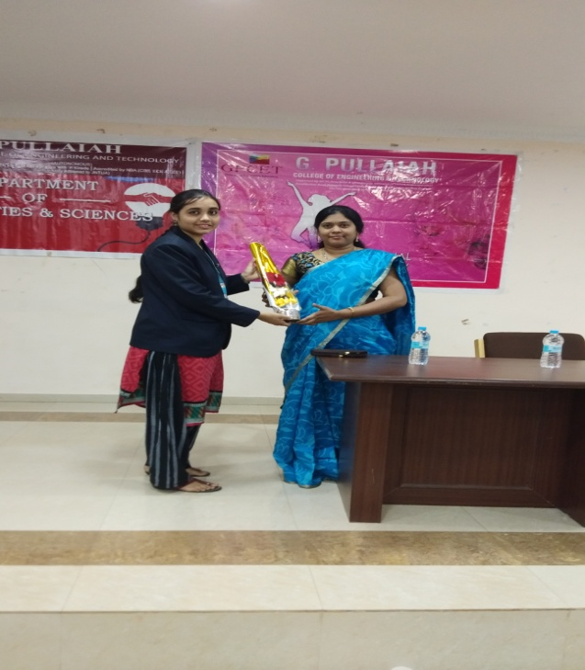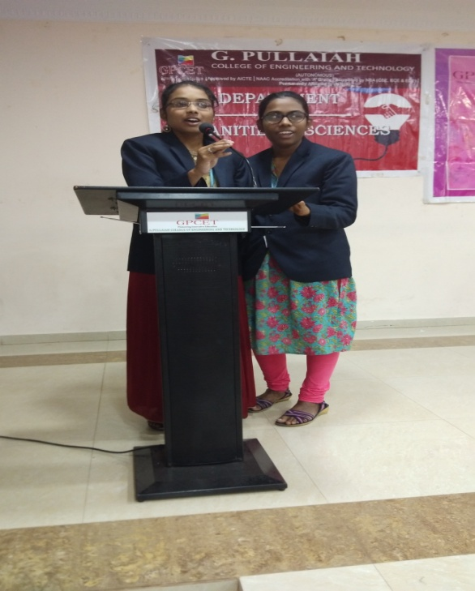
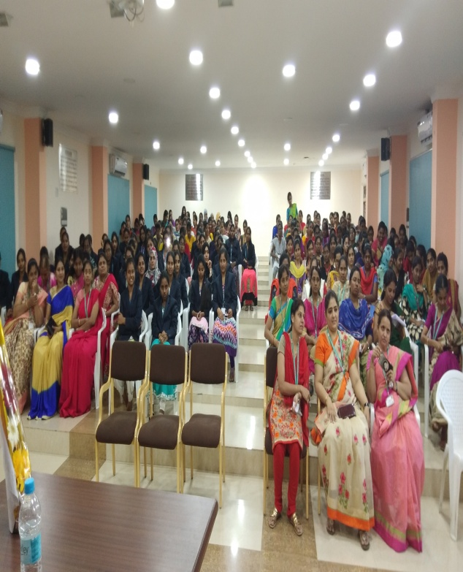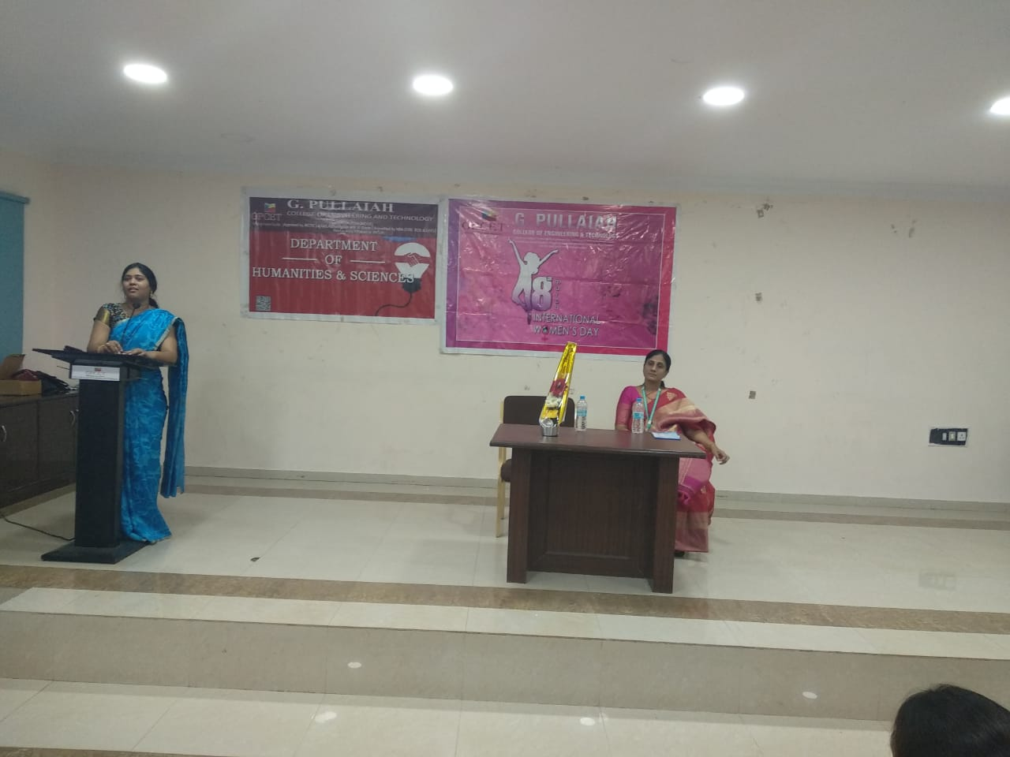

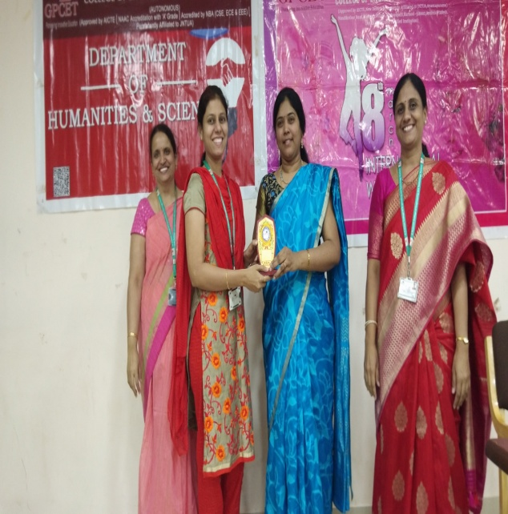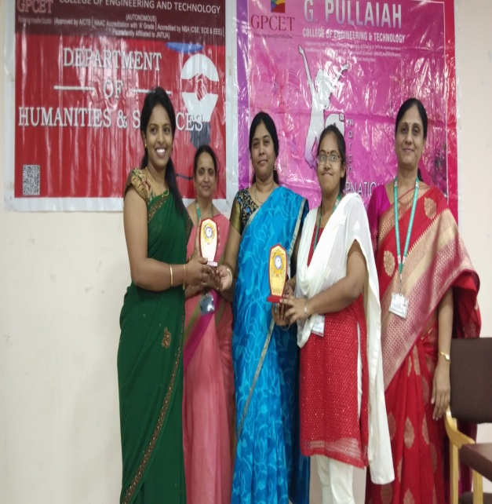

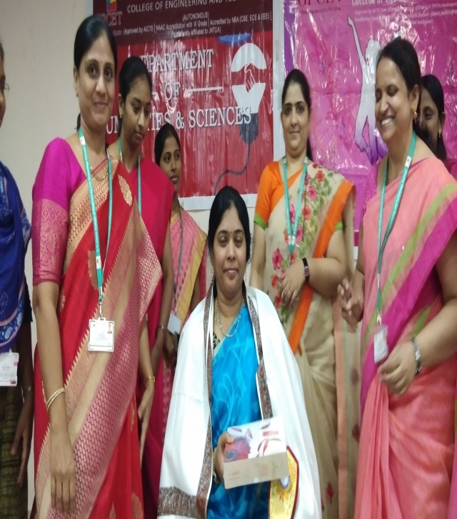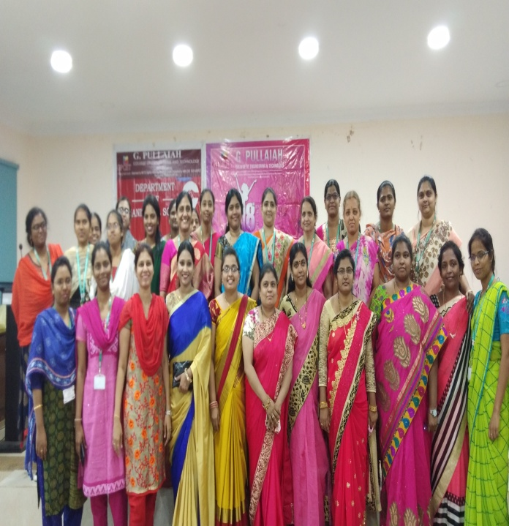

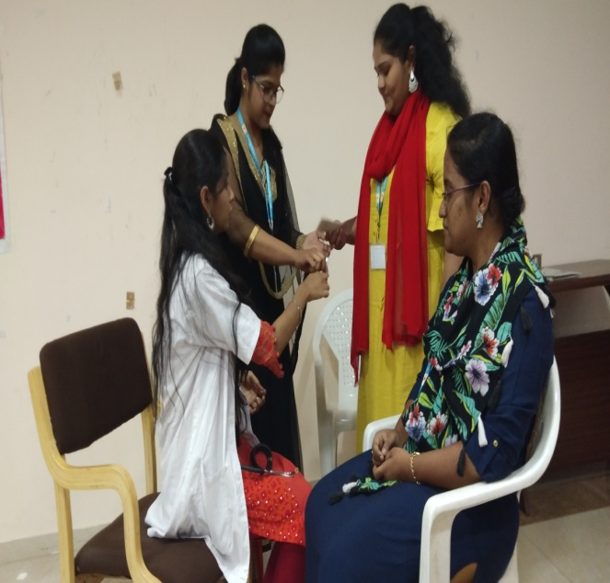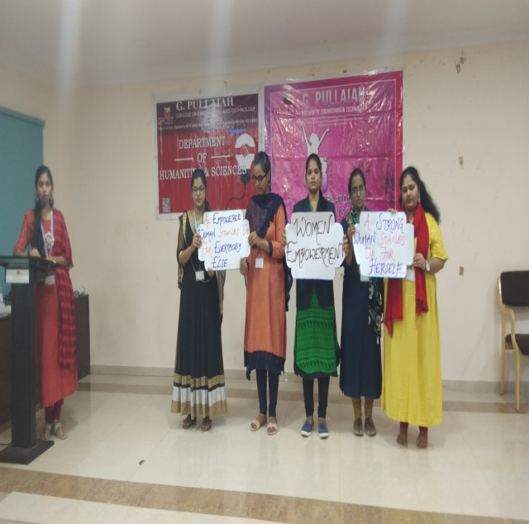
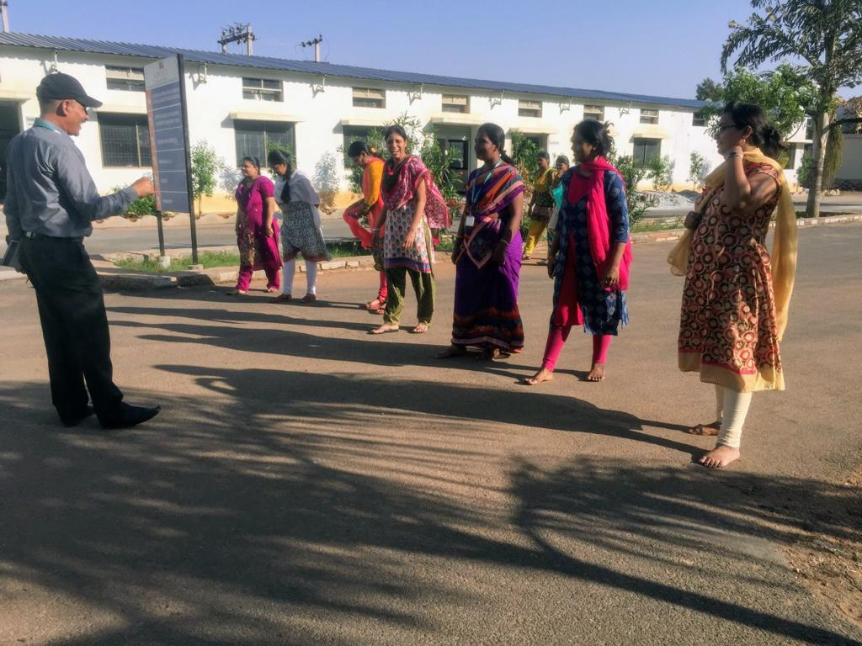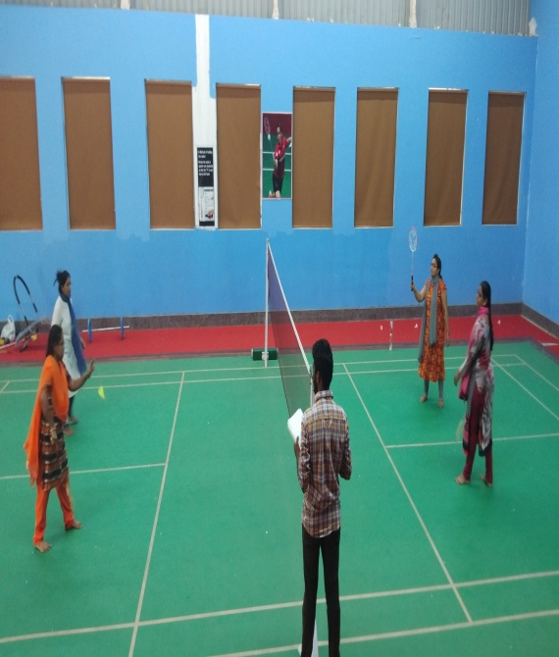

Convenor

