G.Pullaiah College of Engineering&Technology:Kurnool
Department of Electrical and Electronics Engineering
Report on IGNITE 2K19
10thNational Level Technical Symposium
22-03-2019&23-03-2019
G.Pullaiah College of Engineering &Technology,Kurnool, Department of Electrical and Electronics Engineering under ISTE student chapter organized a 10th National level technical symposium on 23rd March 2019 in the seminar Hall of GPCET, Kurnool.
Dr. S.Prem Kumar, HOD CSEDept. and Convener of IGNITE 2K18 welcomed the chief guest faculty, student delegates to the inaugural function and in his address stressed the need of technical symposiums for improving the technical and communication skills and to serve the nation in future with their innovations.
Dr.C.SrinivasaRao,Principal, GPCET, Kurnool addressed the need and the advantages of technical symposiums which in turn will help the student community to improve their knowledge and to update their skills for better employment opportunities. He also stressed the importance of research oriented education. He insisted the importance of inter disciplinary research for societal benefits.
Mr.Balaji Mausam,HRDirector,EagerTech,Hyderabadis the chief guest and speaker explained the importance of identifying the pain points of society and converting every problem into opportunity. He cautioned that the technology should not overtake the human limits. Its usage should be optimized and need to apply for real cause. His concluding message focused on incubation centers, startups and entrepreneurs development programs acquiring strong knowledge in fundamentals.
The inaugural program concluded with announcing the event platforms and proposing vote of thanks.
Photo Gallery:
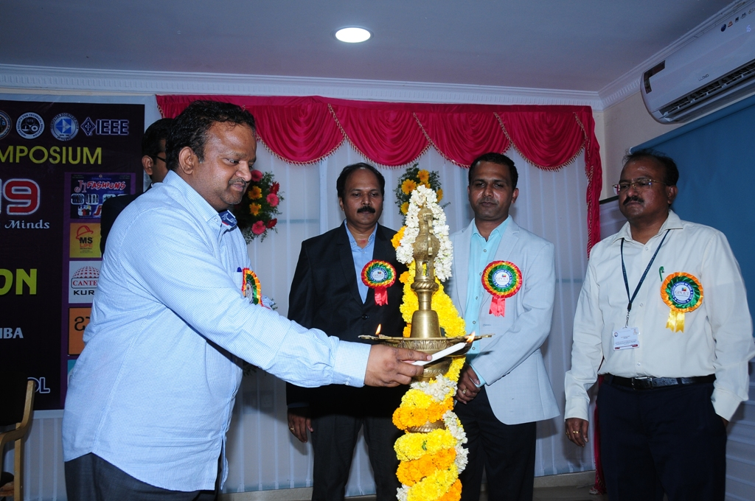
Lighting the lamp by chairman sir

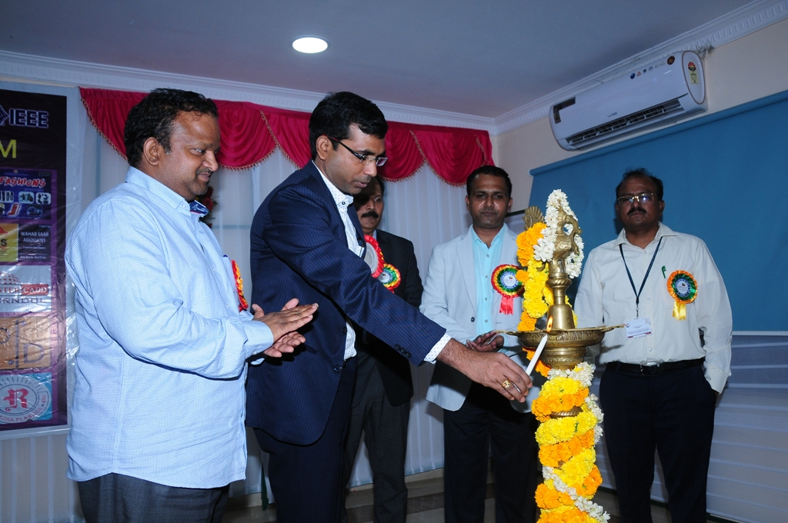
Lighting the lamp by chief guest
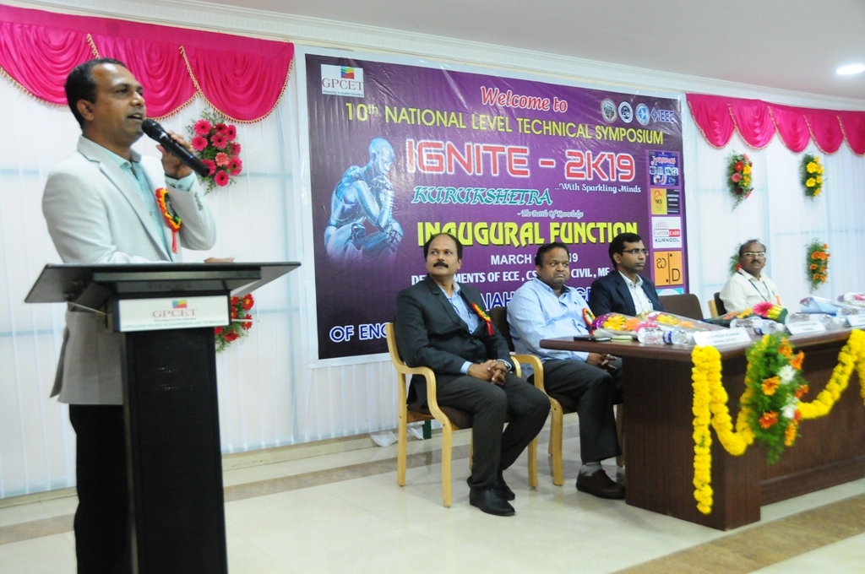
Speech by Principal

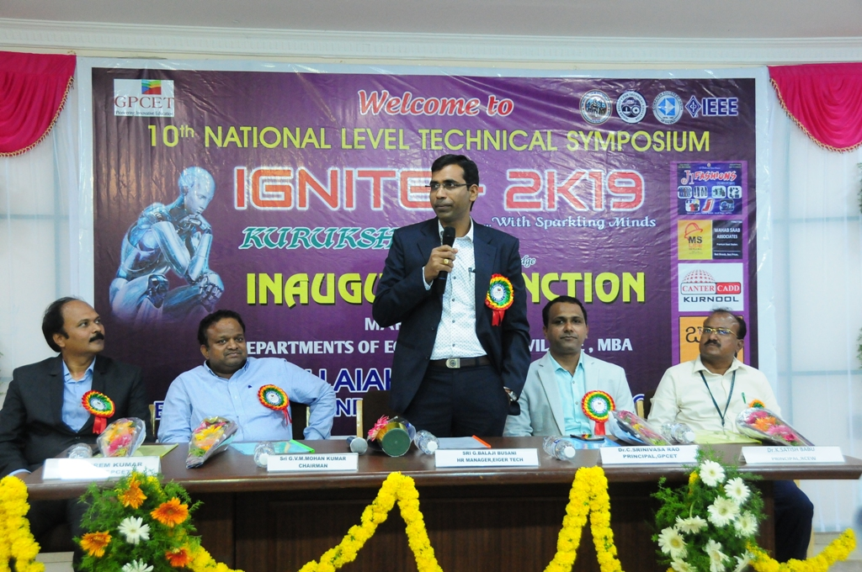
Speech by Chief guest
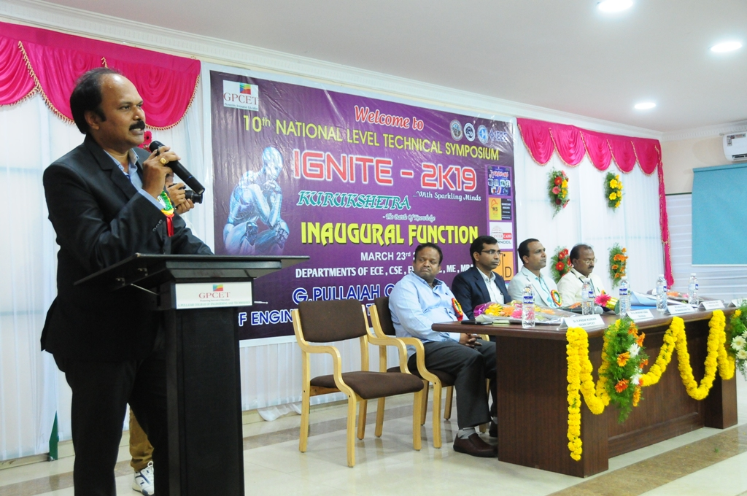
Speech by Convener
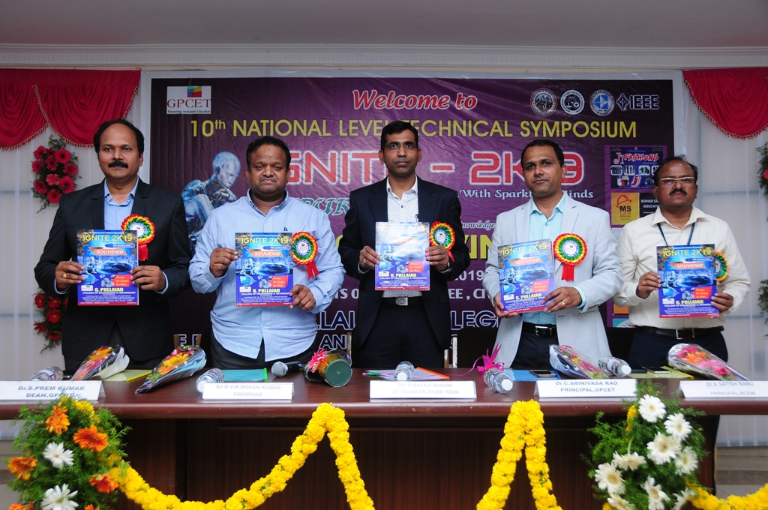
Souvenir Release by Dignitaries
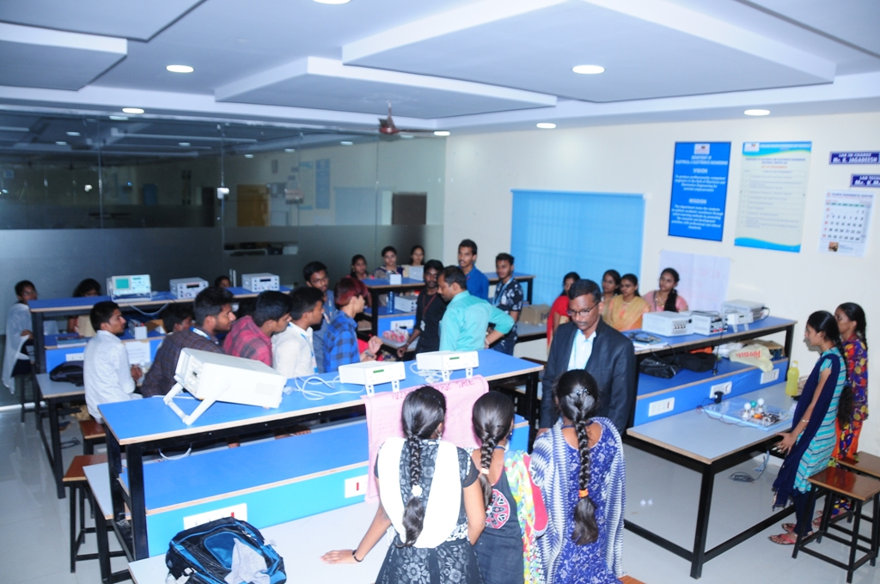
Project Expo of EEE Dept

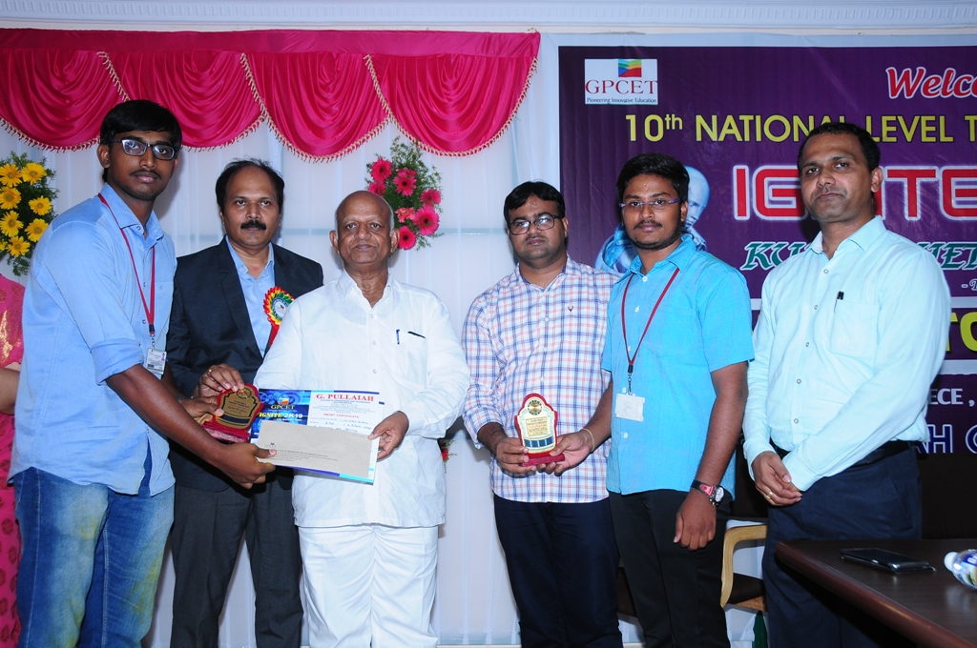
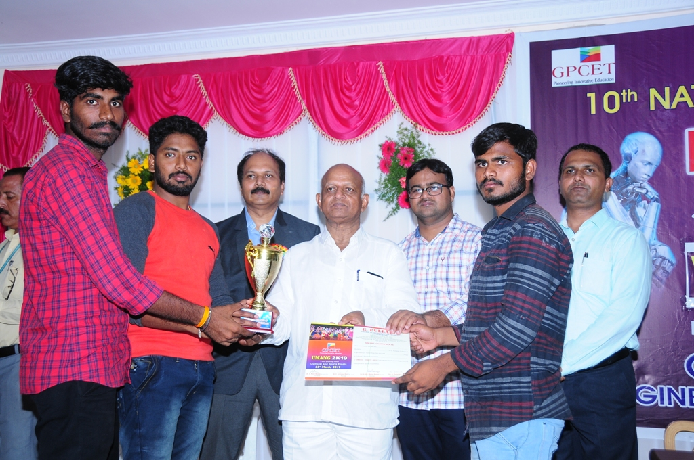
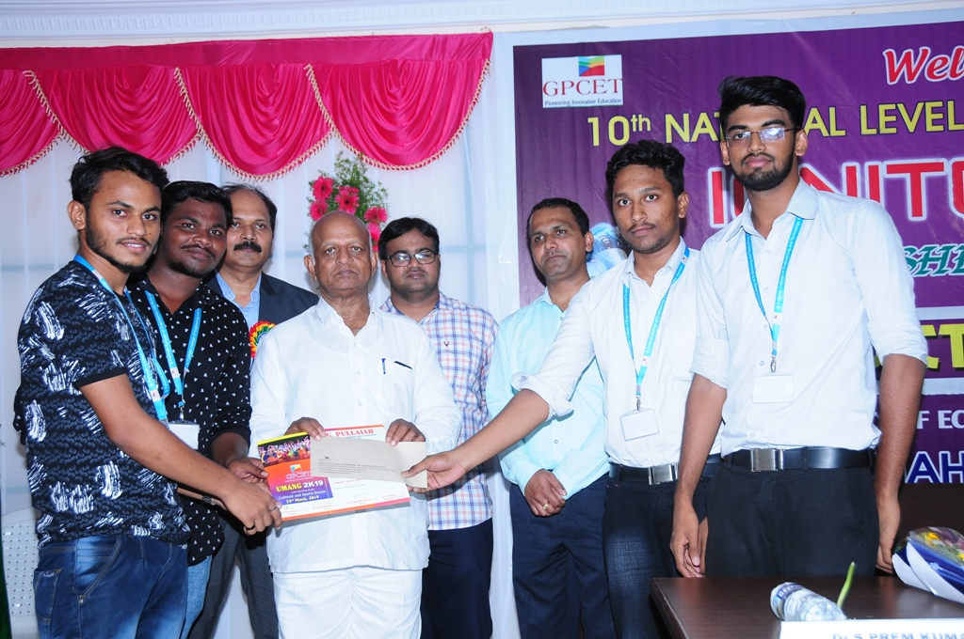
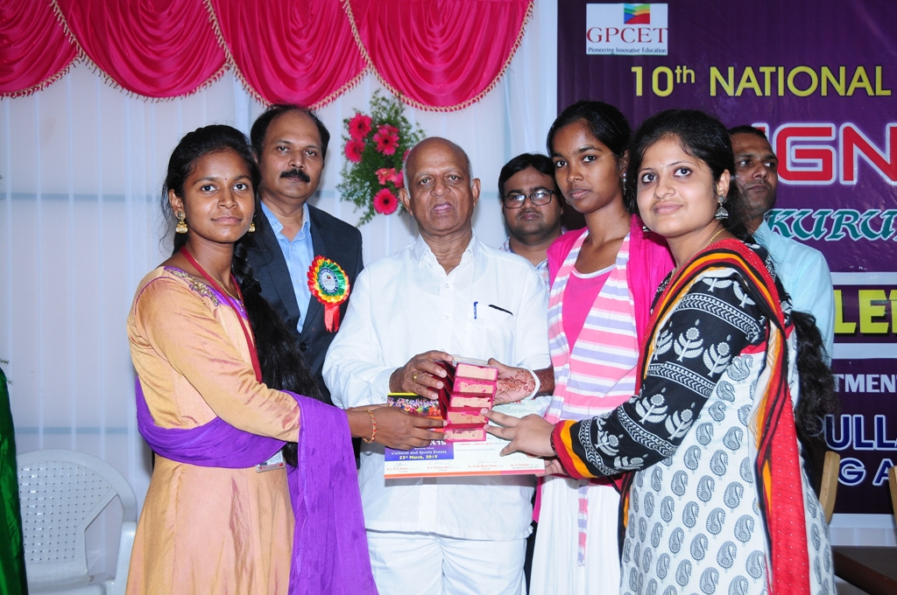

Prize distribution in valedictory function by G.Pullaiah sir
In the valedictory function, prizes were distributed to the winners and participation certificates were given to the participants. The program was ended by the vote of thanks by Ms.TahseenKhanam, Assistant professor, H&S department.

The details of technical participation are as follows .
Department | Paper presentation | Poster | Working models | Session Judges
EEE | 22 | 03 | 13 | Dr. V. Naga Bhaskar Reddy,  Professor & HOD,  RGMCET, Nandyal
Dr.B.V.Rami Reddy,
Associate Professor,
GPCET,Kurnool.

IGNITE-2K19
WINNERS LIST
Paper Presentation:
 | Title | Name of the student | College
I-Prize | Bubble Power Technology | M.Haritha  K.Meghana | GPCET,  Kurnool
II-Prize | Car Control by Using LABVIEW and IOT | P.SivaGangadhar Reddy  S.SaiNithin Krishna | GPCET,  Kurnool
Poster Presentation:
 | Title | Name of the student | College
I-Prize | Micro Grid | Y.Obula Reddy  M.Shiva | GATES,GOOTY
Working Model Exhibition:
 | Title | Name of the student | College
I-Prize | Home Automation by Using Aurdino and LABVIEW | M.V.Tejaswini  V.Sahanaz  D.Vara Lakshmi  B.Teja  M.Vasanthi | GPCET,  Kurnool
II-Prize | Waste Heat Recovery and Generating Electricity | E.Vignatha  B.Sai Naga Teja | GPCET,  Kurnool

HOD-EEE

