G.PULLAIAH COLLEGE OF ENGINEERING AND TECHNOLOGY, Kurnool
Department of Computer Science and Engineering

Report of One day Workshop on “Introduction to Virtualization”
Date: 20-02-2019
G.Pullaiah college of Engineering and Technology in association with Andhra Pradesh Information Technology Academy (APITA) conducted a one day workshop on “Introduction to Virtualization” on 20/02/2019. Mr.Dan Albergue Eddy from APITA trained III B.Tech students of CSE department through online videos. He trained the students on how to create virtual machines. Lab assignments were given at the end of training program and the students who submitted the assignments were awarded with Digital Badges.

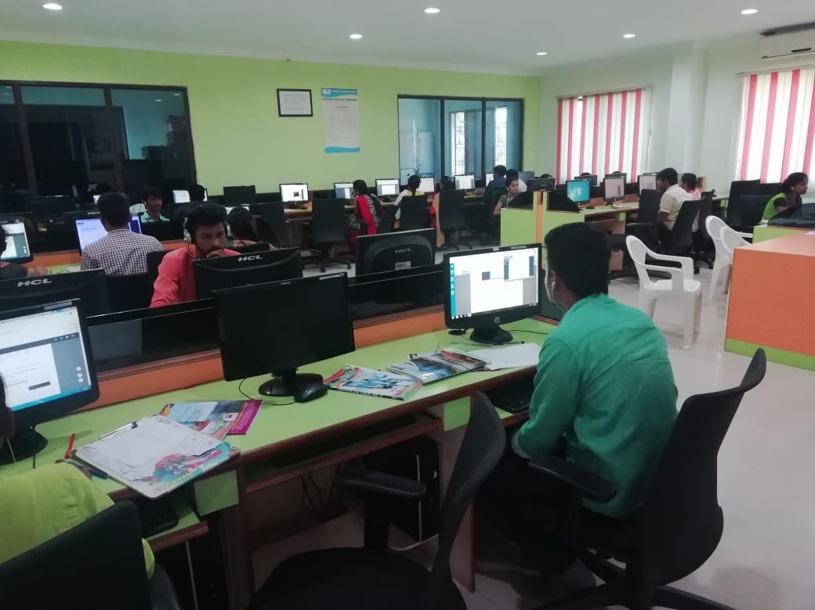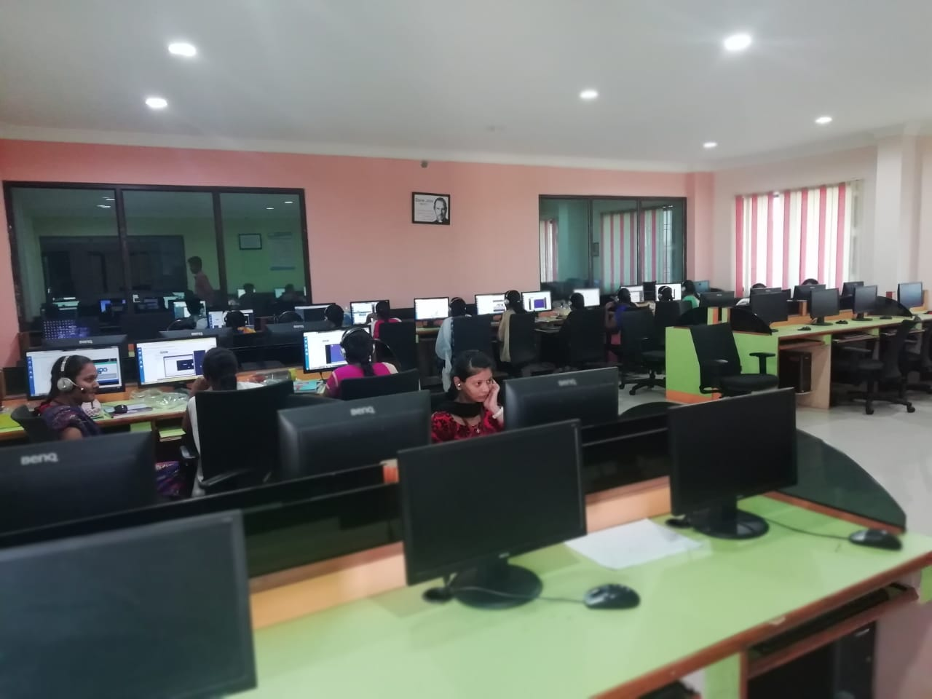
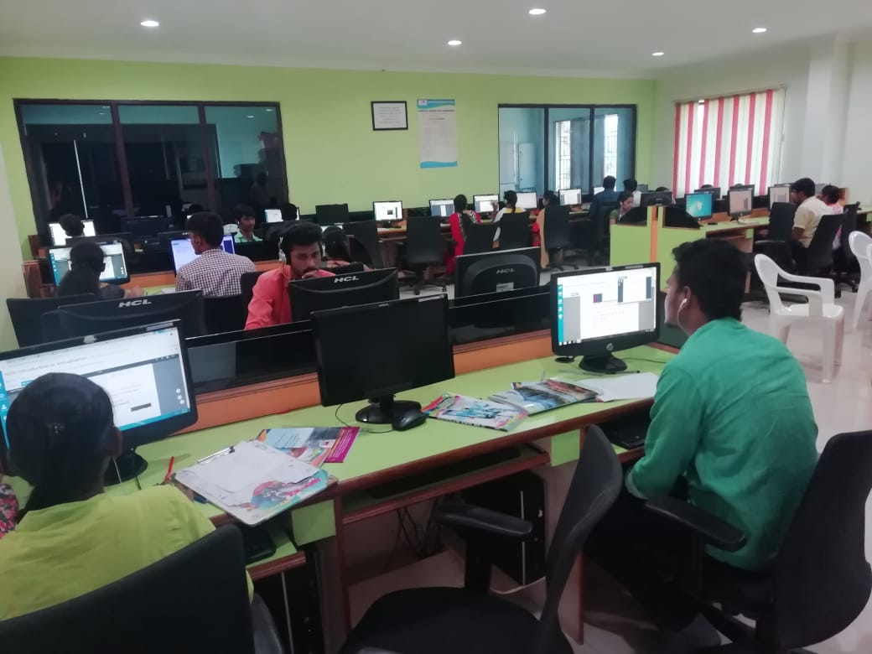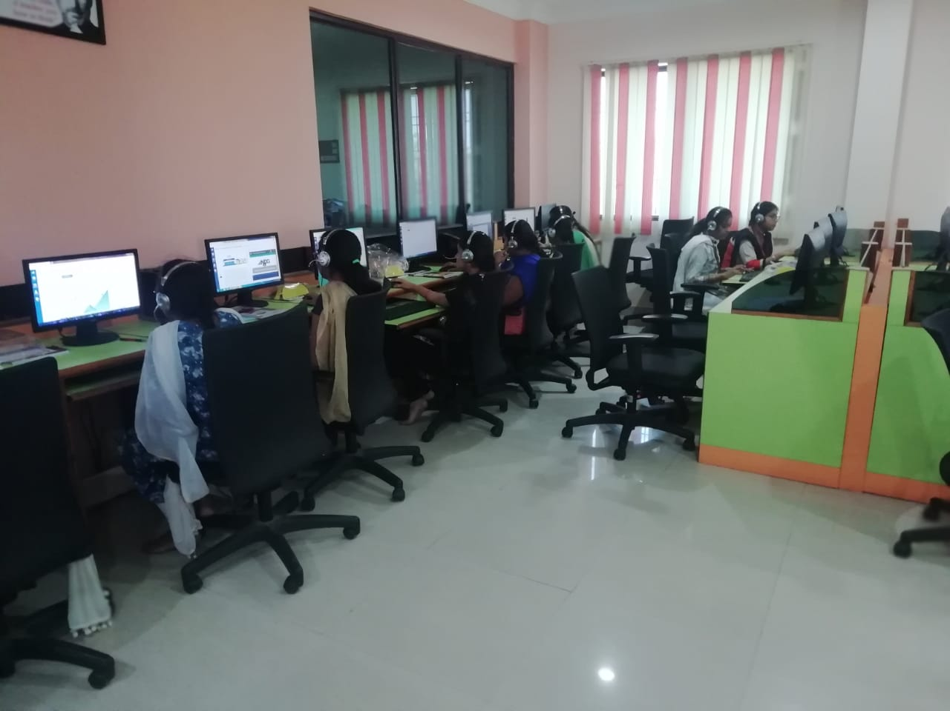

HOD-CSE

