**G. PULLAIAH COLLEGE OF ENGINEERING & TECHNOLOGY, Kurnool**

**(Autonomous)**

**Department of MBA**

**Report on “Kurukshetra-The Battle for Knowledge”**

**Date:** 23-03-2019

Competitions provide a myriad of opportunity and also a platform for students to demonstrate their talent. So the Department of Management Studies, G. Pullaiah College of Engineering and Technology organized the 7th National level Management meet, **“Kurukshetra 2k19- The battle for knowledge”** on **23rd March, 2019** for MBA students all over the nation.

Kurukshetra aims to provide a platform for sharing experiences and information to the budding managers from across the country. The overall objective of the event is to elucidate the major business activities through different events and to elicit diverse responses from the students of management.

**Chief Guest for the Event:** Dr. Aliya Sultana, Professor & HOD, Department of Management Studies, Rajeev Gandhi Memorial College of Engineering & Technology, Nandyal

**EVENTS HOSTED:**

* Biz Mavins– Business Quiz
* Patraparichay – Paper presentation
* Young Manager
* **B-MAVINS:**

1. Round 1 – Written test

The written test consists of 25 fill in the blanks related to current affairs, Business, Sports and etc., the duration of the written test is 30 minutes.

1. Round 2 – Final round

The final round consists of 5 rounds again.

1. Take a punch – Logos and punch lines
2. Buzzer round
3. Picture assembling
4. Face the rival
5. I’M nutty

**Winners of B-Quiz**: M. V Laxman & S.M. Shoaib from RGM College, Nandyal

**Runners of B-Quiz:** K. Madhusudhan Reddy & A. Diana Shiri Mounisha from RGM College, Nandyal

* **YOUNG MANAGER:**

1. Round 1- Written Test

The written test consists of 20 fill in the blanks related to current affairs, Business, Sports and etc., the duration of the written test is 30 minutes.

1. Round 2- Business Plan

The participants were asked to give poster presentation on their Dream Venture

1. Round 3- Stress Interview

**Stress interviews**" are an offbeat way to see how candidates react to unusual circumstances under pressure. Dr. Aliya Sultana, Professor & HOD, Department of Management Studies, Rajeev Gandhi Memorial College Engineering & Technology, Nandyal and faculty of GPCET acted as interviewers. The best performer won the title of “YOUNG MANAGER”.

**Winner of the Title “YOUNG MANAGER”:** C. Farhath Jabeen from Bheemi Reddy Institute of Management Science, Adoni.

* **PATRAPARICHAY – PAPER PRESENTATION**

A Good number of papers were presented in the Paper Presentation contest held during the event. Dr. Aliya Sultana, Professor & HOD, Department of Management Studies, Rajeev Gandhi Memorial College Engineering & Technology, Nandyal had acted as an adjudicator for Paper Presentation and gave her valuable inputs to students.

**Winners of PPT**: M. Mounica, G. Krishnaveni from G. Pullaiah College of Engineering and Technology.

**Runners of PPT**: J. Prashanth, K. Siva Krishna from Bheemi Reddy Institute of Management Science, Adoni.

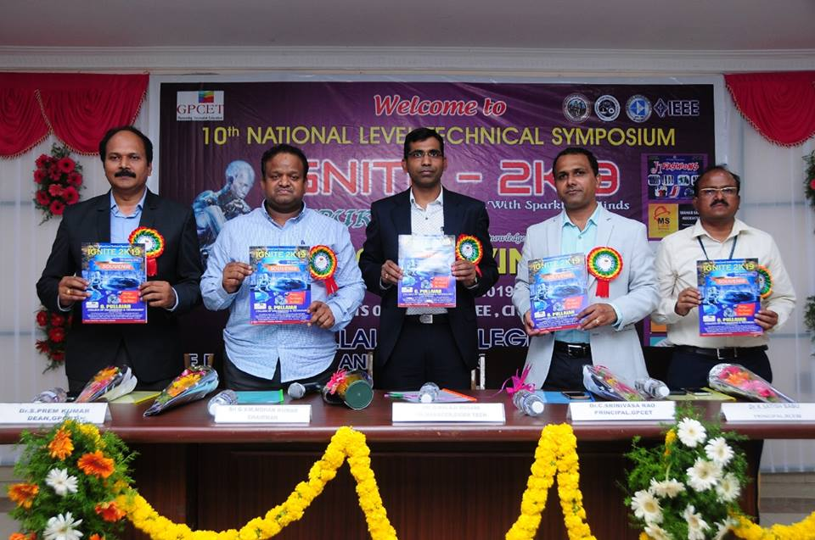

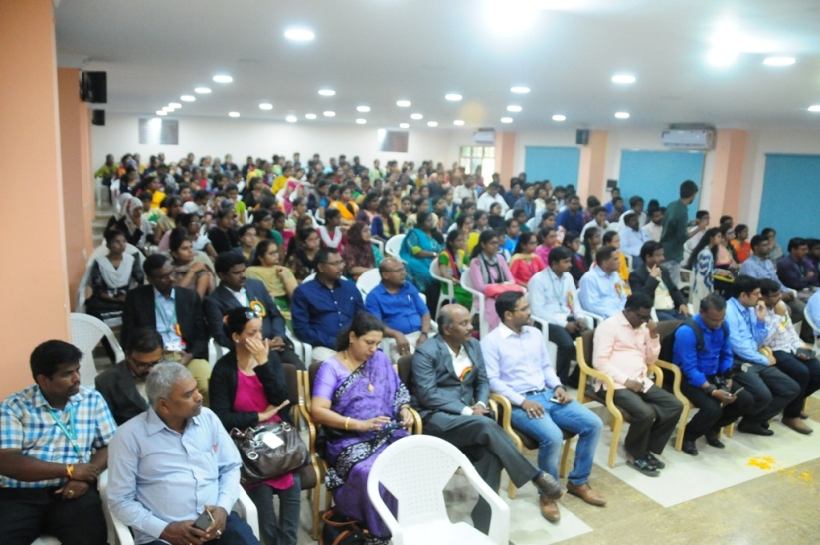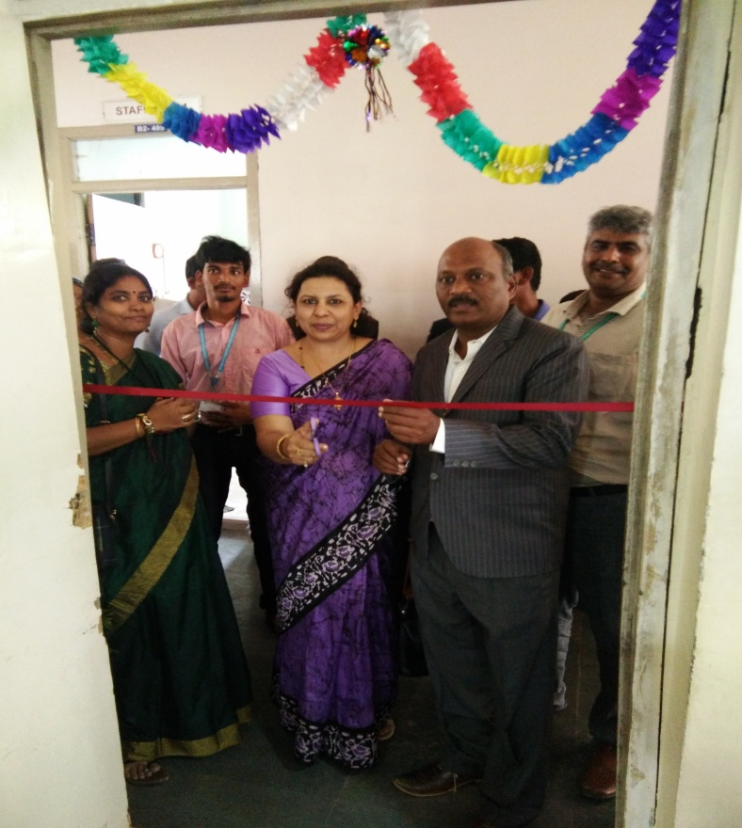

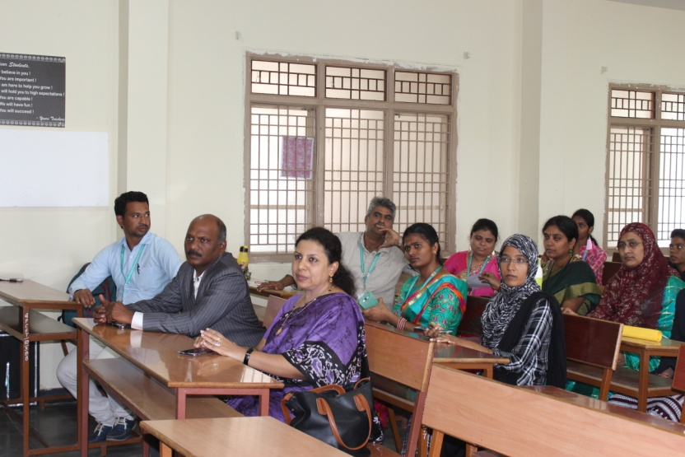

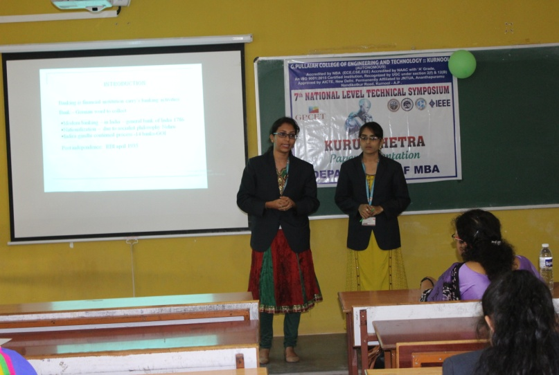

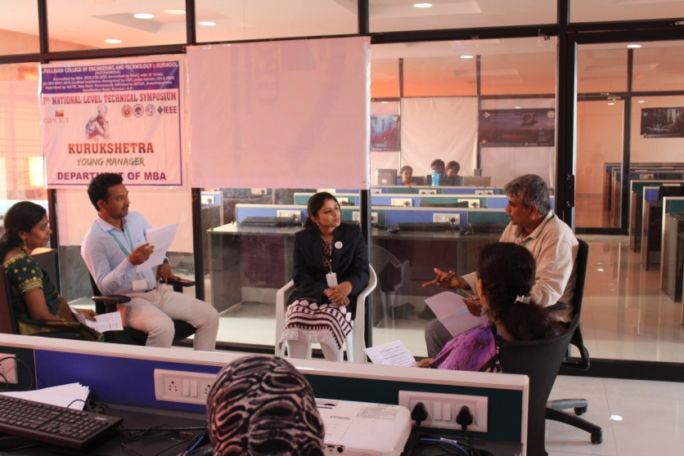

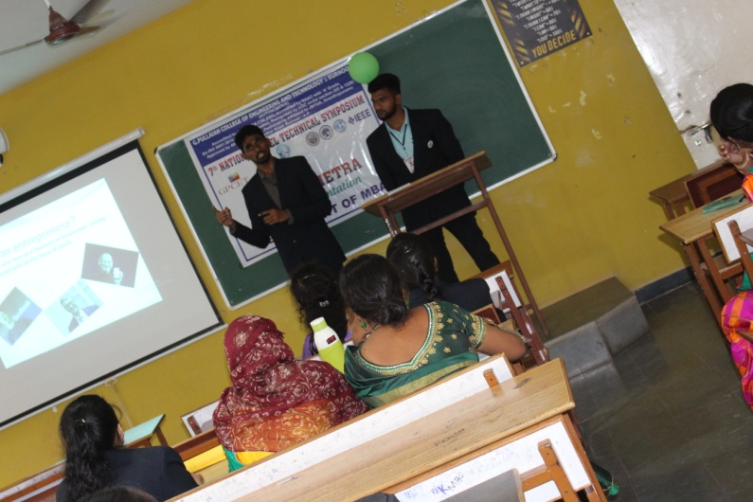

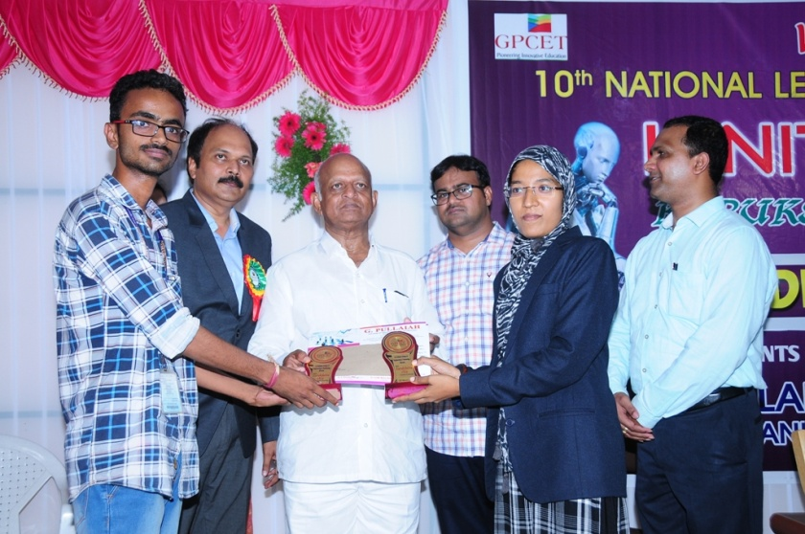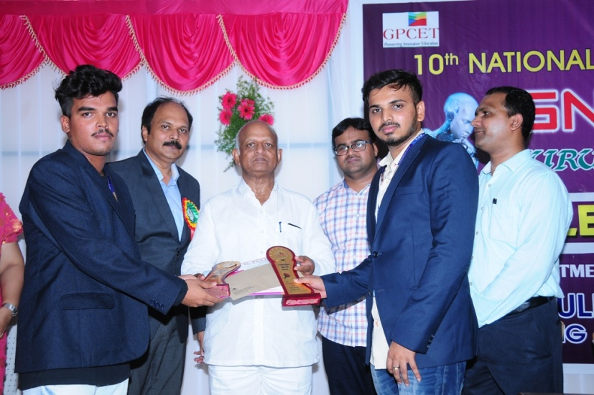**BIZ-MAVINS WINNERS**

**YOUNG MANAGER**

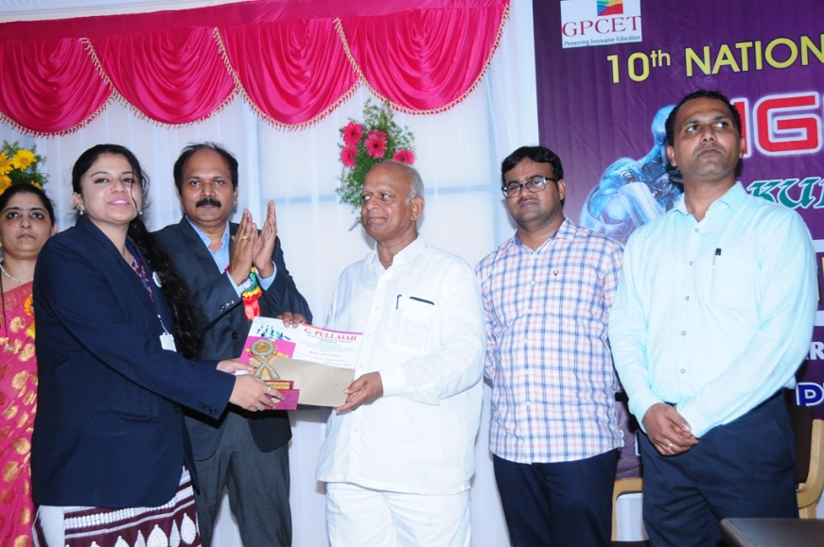

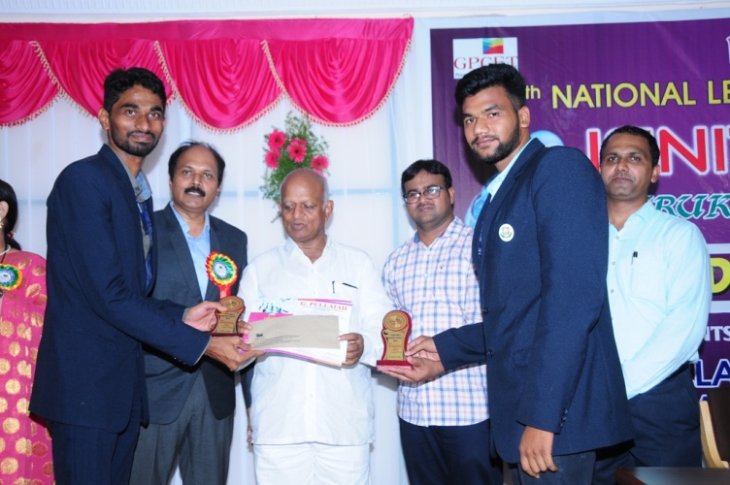**PATRAPARICHAY WINNERS**

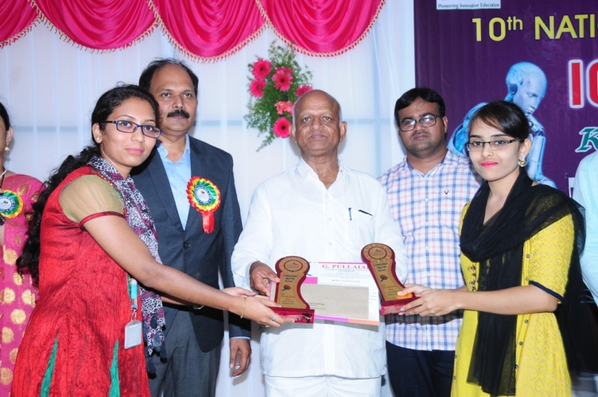

**SNAPSHOTS OF THE EVENT AND PRIZE DISTRIBUTION**