G. PULLAIAH COLLEGE OF ENGINEERING & TECHNOLOGY
(Autonomous)
Department of MBA
A Report on One Week Training on Employability Skills
A one week training program on Employability Skills was organized as part of the Skilling Initiative; it was conducted by Mahindra Pride Classroom in association with APSSDC for IV semester MBA students from 17th to 22nd December, 2018 at GPCET. Ms. Kalpana acted as Trainer for the Training Program.
Students were given inputs on employability skills. The Training focused on various employability skills such as Resume Preparation, Interview Techniques, Goal Setting, Team Building and Money Management. Life Skills were also taught which highly motivated the students. The session ended by conducting Mock Interviews and Certificate distribution.
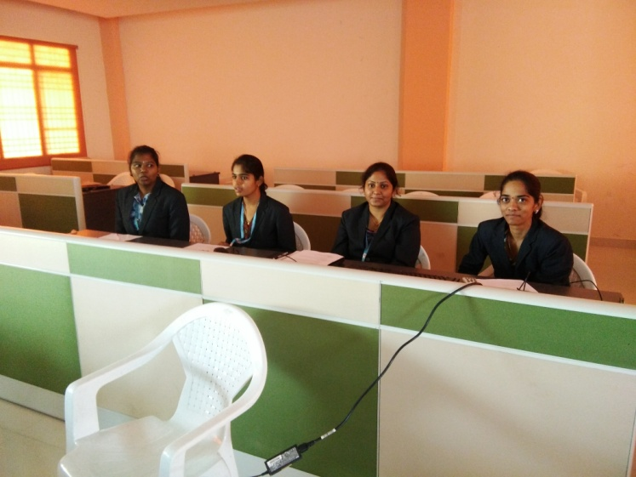
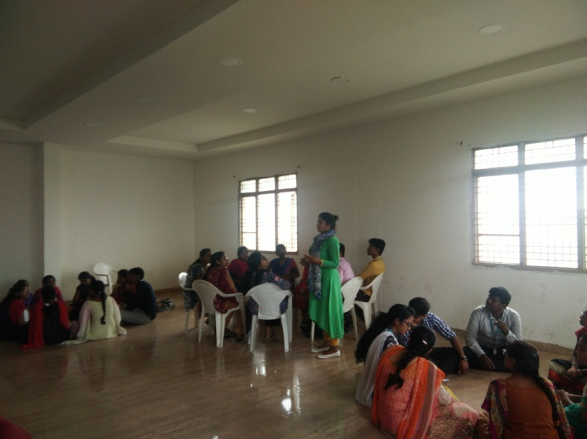

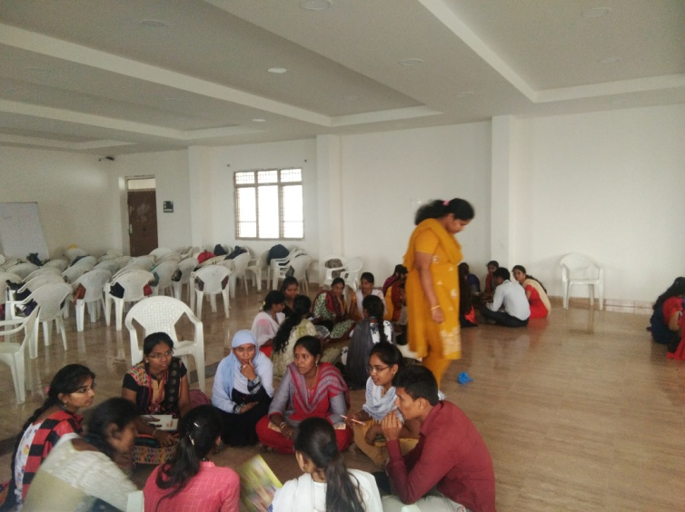
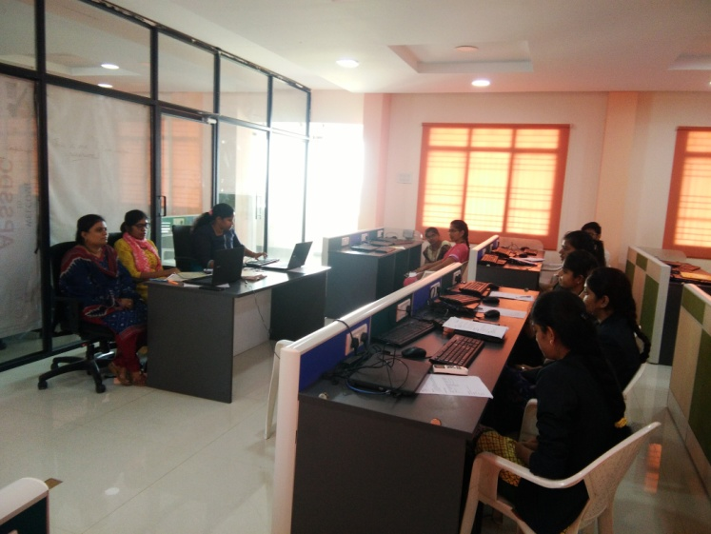

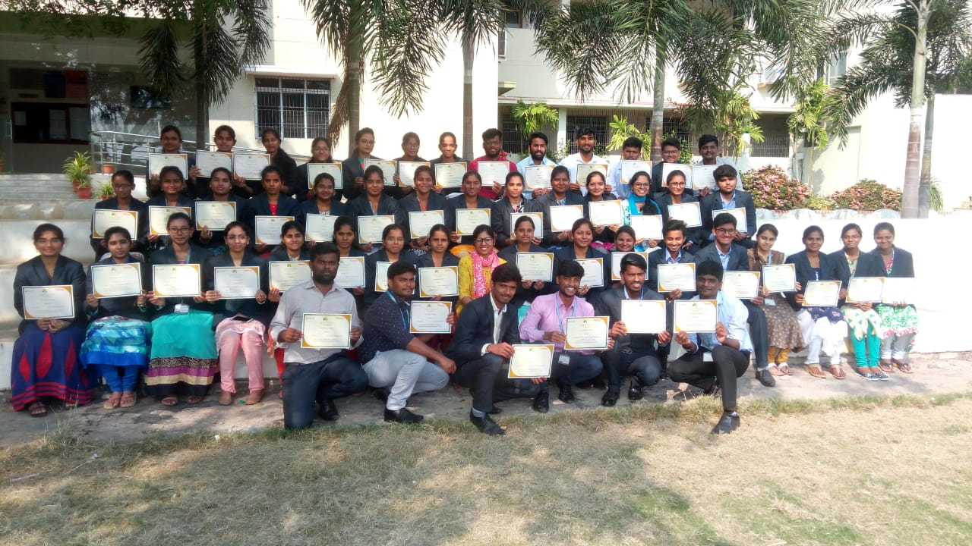

SNAPSHOTS OF THE WORKSHOP

