G. PULLAIAH COLLEGE OF ENGINEERING & TECHNOLOGY, Kurnool
Department of MBA
A Report on Orientation Day
“Orientation Day is the best way to find out what college life has to offer.”
With the above motive, Orientation Day was organized for I MBA students on 20th August, 2018 at Seminar hall, GPCET. Orientation Day gave the new students a chance to get familiar with the campus, ask questions, meet people and get sorted for day one at college. It also gave an opportunity to the parents to find out more about the college. The various Dignitaries on the dais were:
- Sri. G.Pullaiah- Secretary, Ravindra Group of Institutions
- Dr. S.Prem Kumar- Dean, GPCET
- Dr. M. Giridhar Kumar- Head Corporate Affairs, HOD-MBA
Everyone motivated the budding managers to concentrate on their studies and hence develop their career as Successful Managers and Entrepreneurs. Cash prizes were also awarded to the College Toppers.

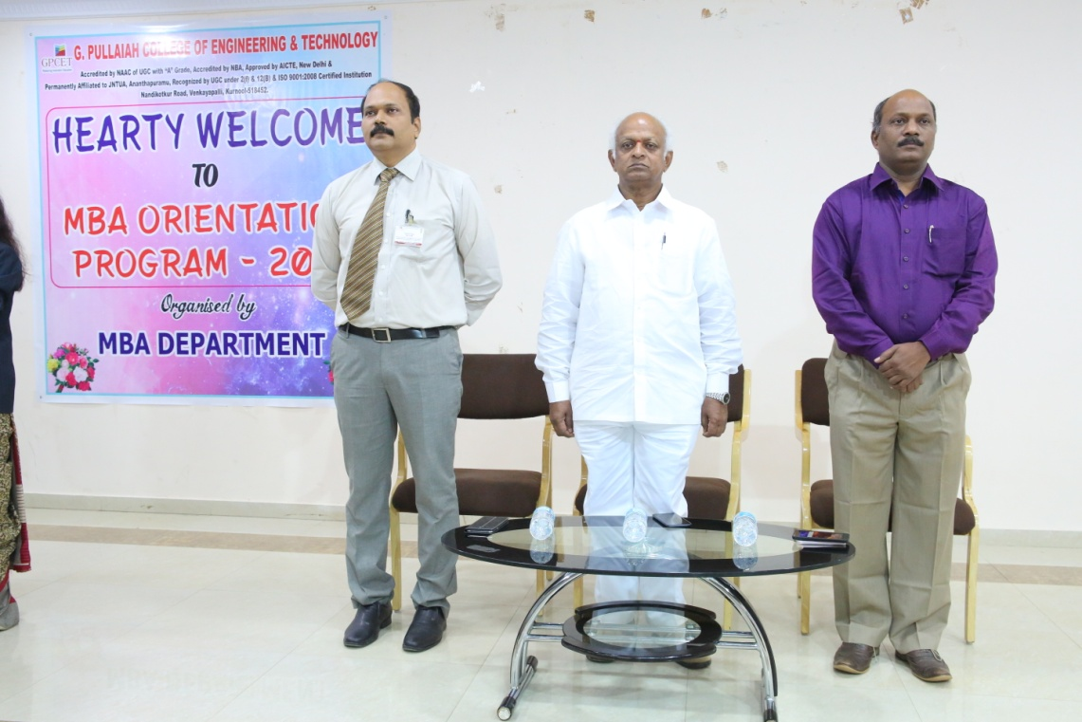

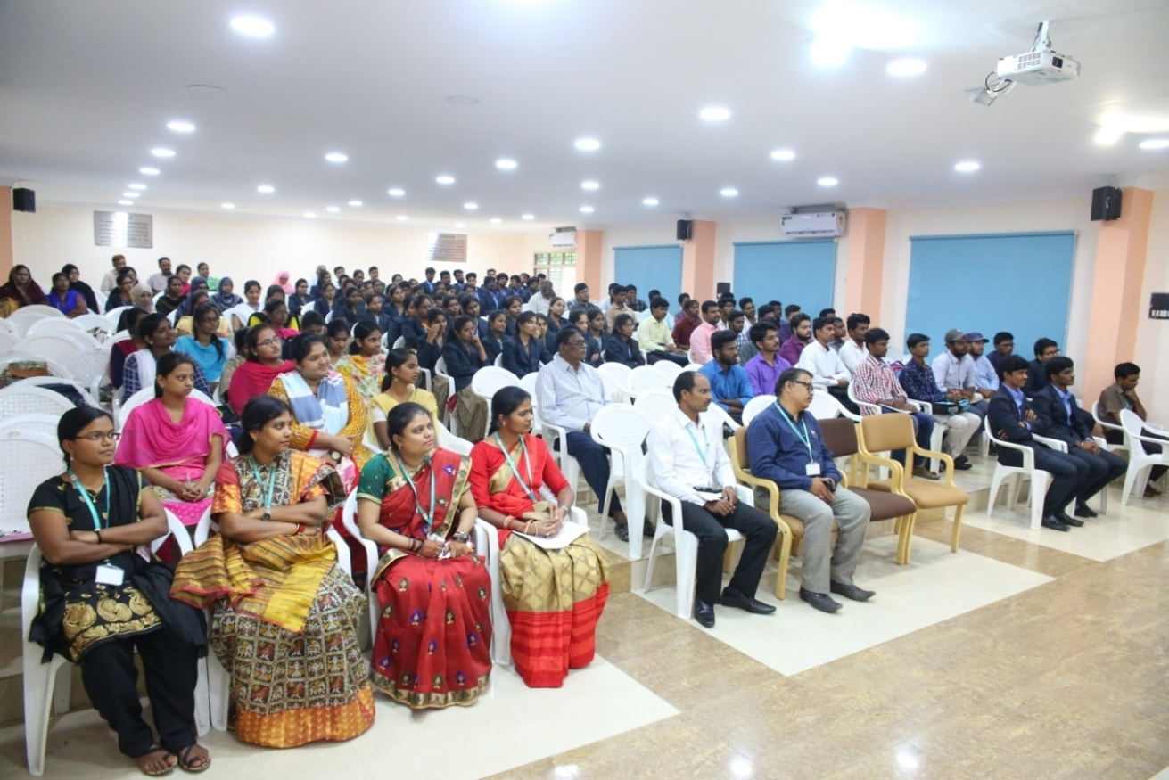

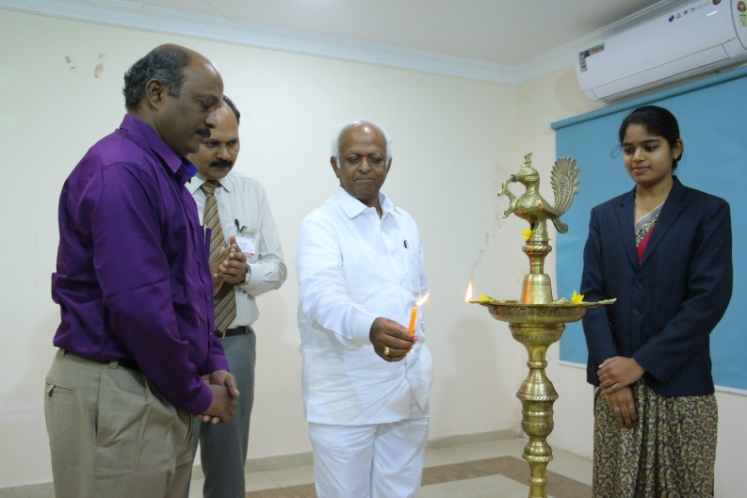
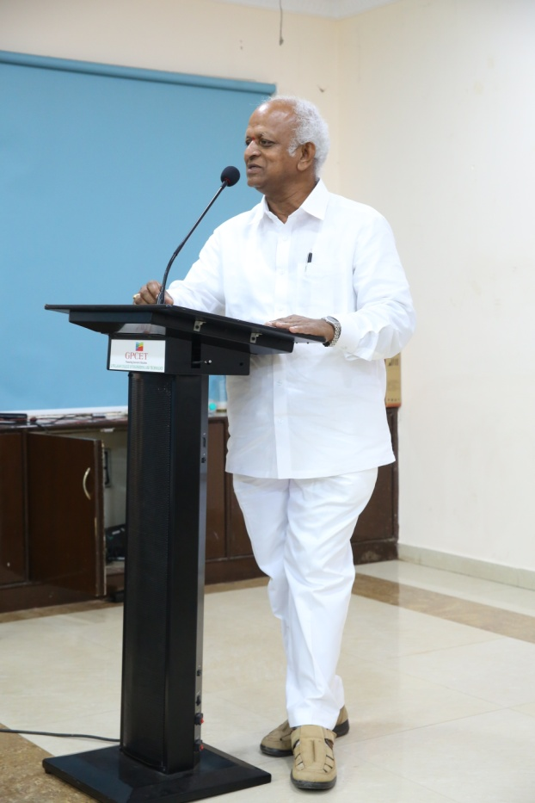

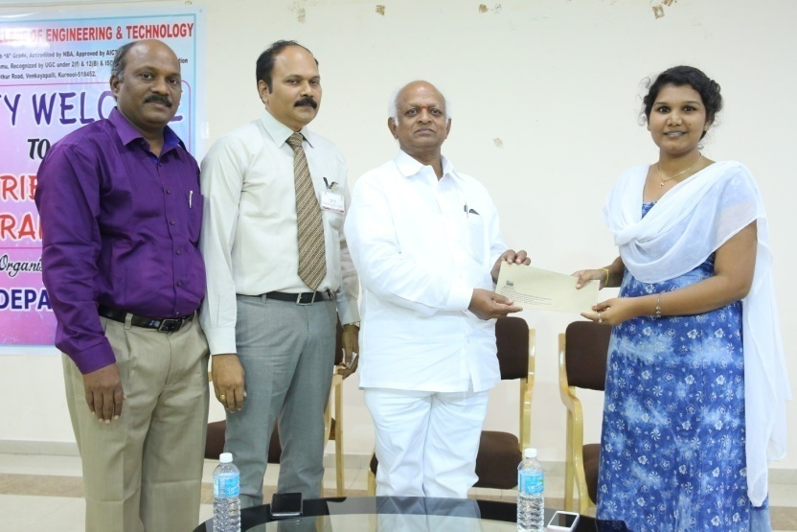

SNAPSHOTS OF THE EVENT

