G. PULLAIAH COLLEGE OF ENGINEERING & TECHNOLOGY: KURNOOL
(AUTONOMOUS)
DEPARTMENT OF MBA

Date: 21st December, 2018

Mahindra Finance, as a part of Corporate Social Responsibility has initiated a Merit Scholarship worth Rs. 25,000 to assist the meritorious students to take up their higher studies. In this regard, they have selected the students with outstanding academic performance and awarded the Merit Scholarship.
The following II Year- MBA students backed Merit Scholarship:

S. No | Roll No | Name of the Student
1 | 17AT1E0076 | LAGISETTY SANGHAVI
2 | 17AT1E0097 | KARALA VEERA GAYATHRI
3 | 17AT1E00A6 | B VYSHNAVI
4 | 17AT1E00B1 | MANASA VEENA
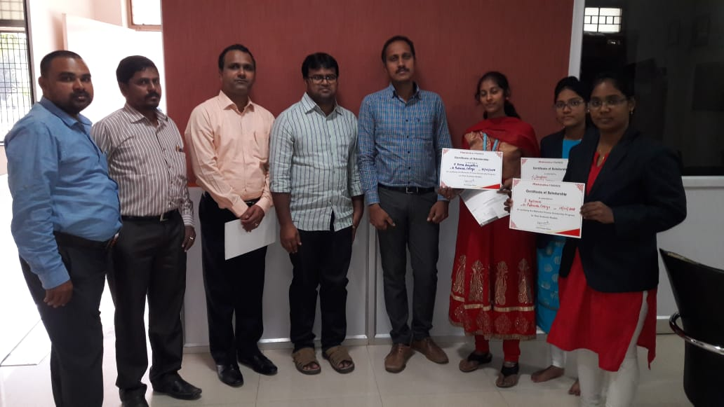

SNAPSHOTS OF THE EVENT

