G. PULLAIAH COLLEGE OF ENGINEERING & TECHNOLOGY, Kurnool
Department of MBA
A Report on Seminar on Entrepreneurship Development
A seminar on Entrepreneurship Development was organized on 7th August, 2018 for II Year I semester MBA students. The resource person for the seminar was Sri Thirumalesh Kurva, Sr. Lead Development Manager, Sijang Group, Hyderabad. The session continued for two hours, where the students were given inputs on Entrepreneurship Development. The main focus was on business opportunities, how to raise the funds and how to allocate the funds. The session also gave awareness about impact of taxes on business decisions.
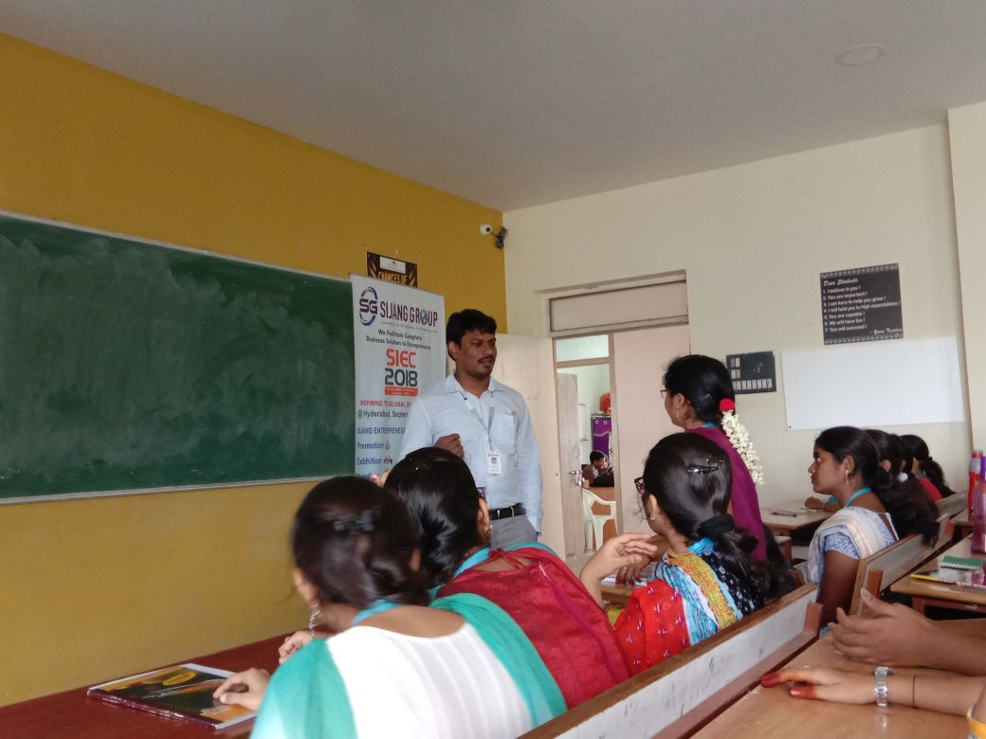
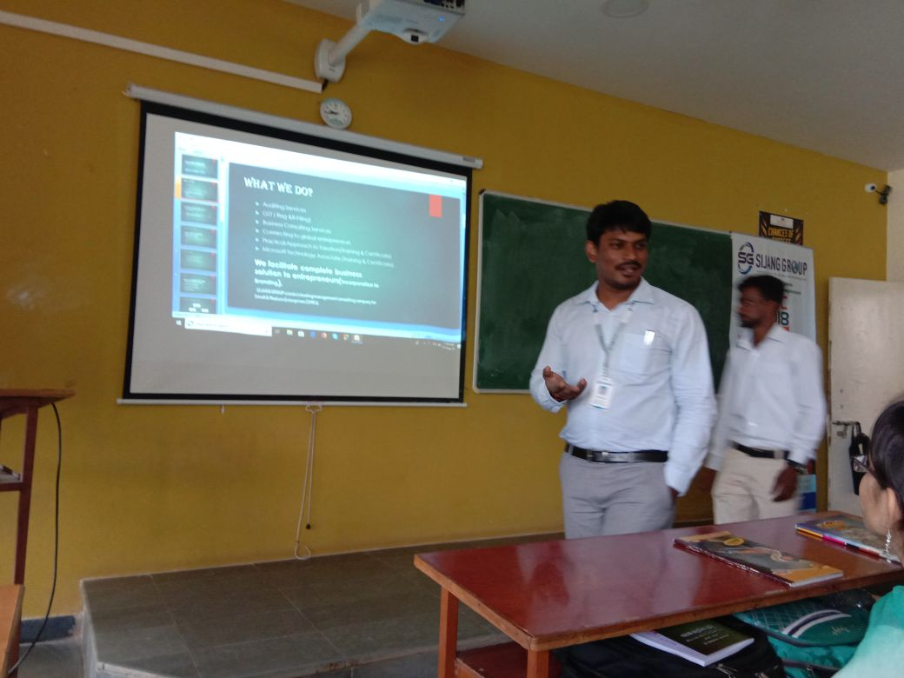

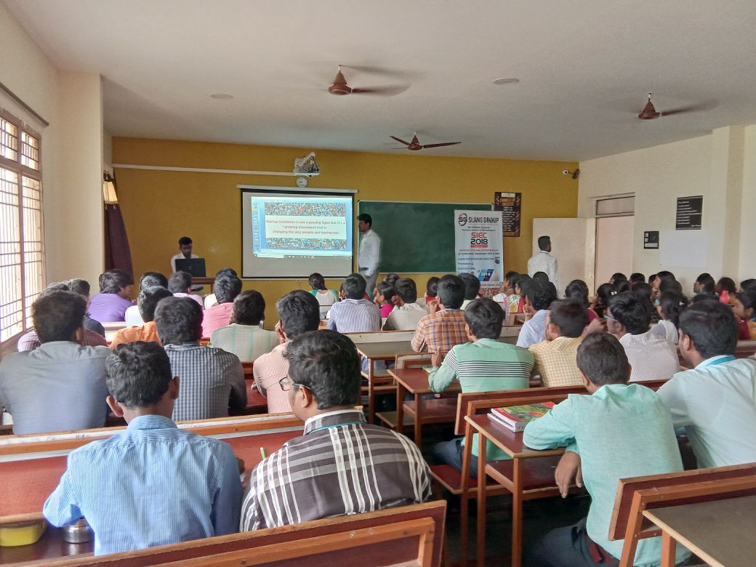
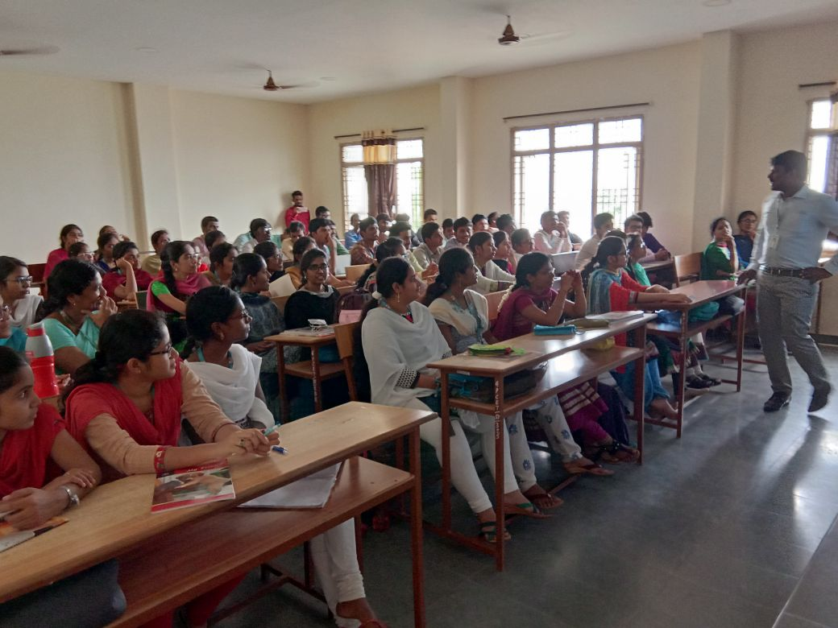

SNAPSHOTS OF THE SEMINAR

