G. PULLAIAH COLLEGE OF ENGINEERING & TECHNOLOGY, KURNOOL
(AUTONOMOUS)
Department of MBA
HR CLUB
Date: 06-03-2019
Day: Wednesday
Name of the Activity : Vyakthithva
Targeted Group : I MBA II semester students
A Report on Activity:
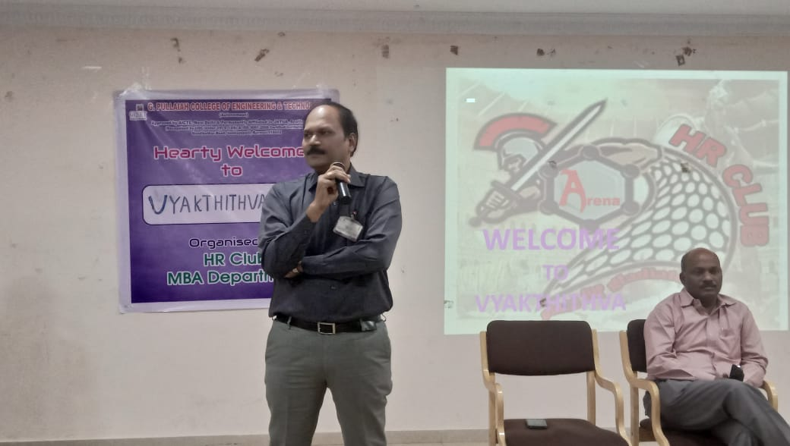
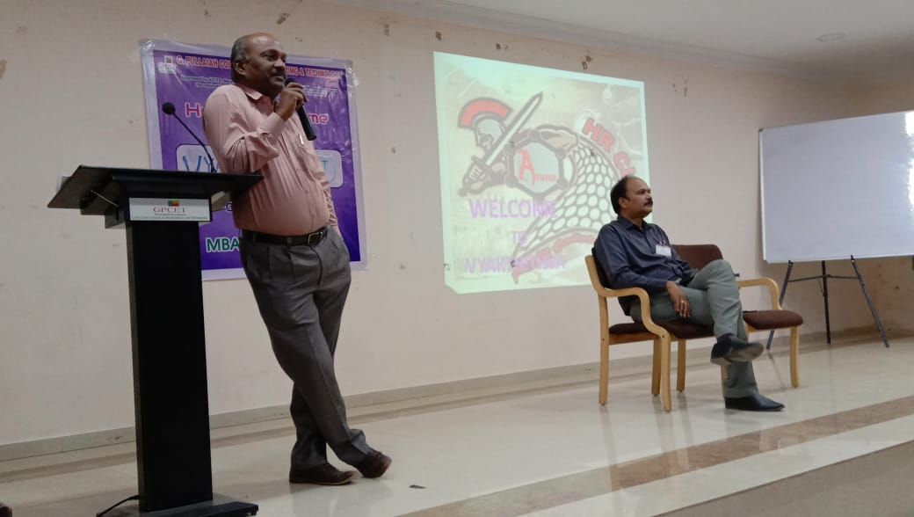
An activity named “Vyakthithva” was organized by HR Club for I Year II Semester MBA students on 06th March, 2019 from 10:00am to 4:00 pm., in Seminar Hall. In this activity, the students were divided into teams and each team had played a skit on various functions of Human Resource Management and different personalities (employees) in the organizations. The activity was combination of fun and learn as students enjoyed the skits and also learned various HRM concepts like Grievance Handling, Workforce Diversity, Performance Appraisal, Motivation, Work life Balance, Transfers etc. The best skits were awarded prizes.

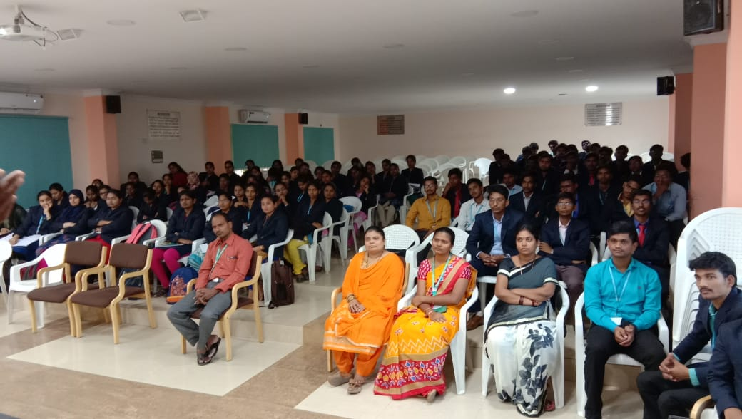
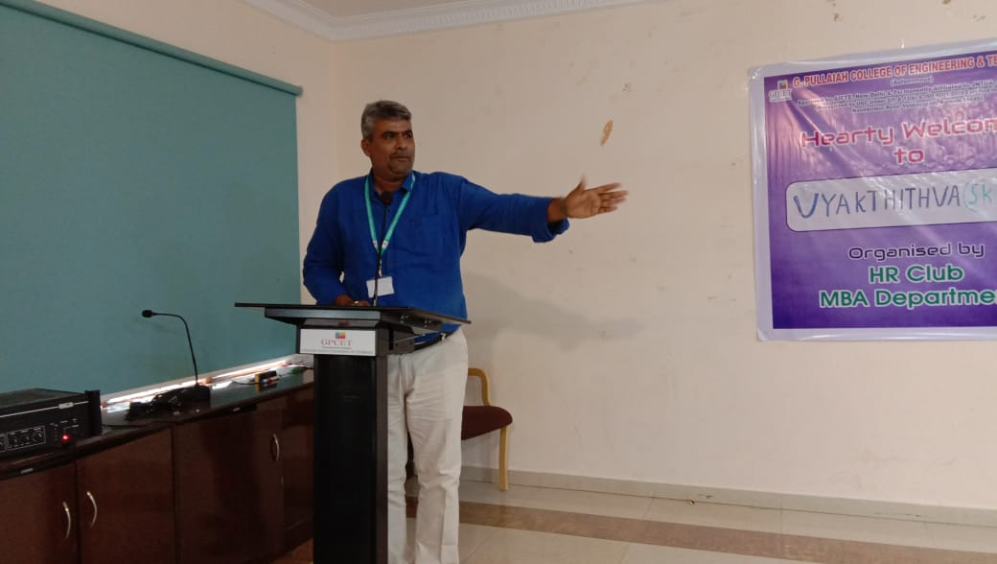

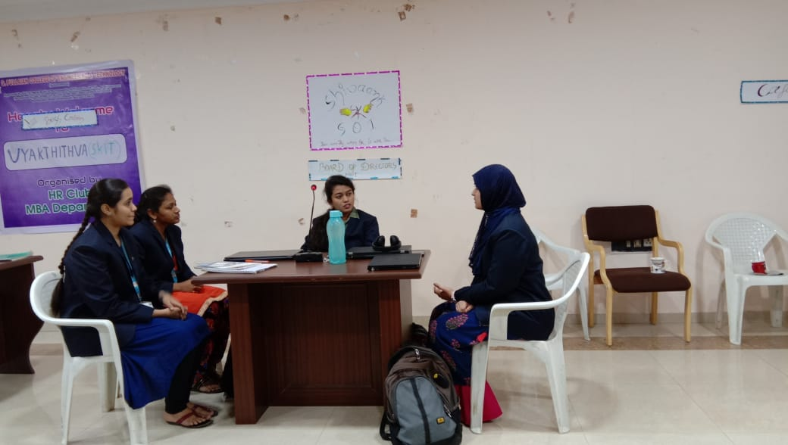
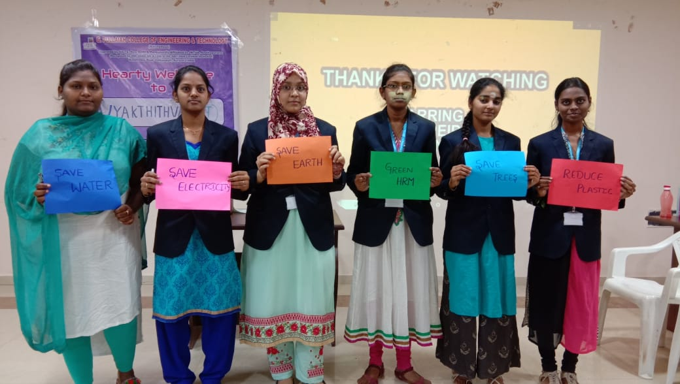
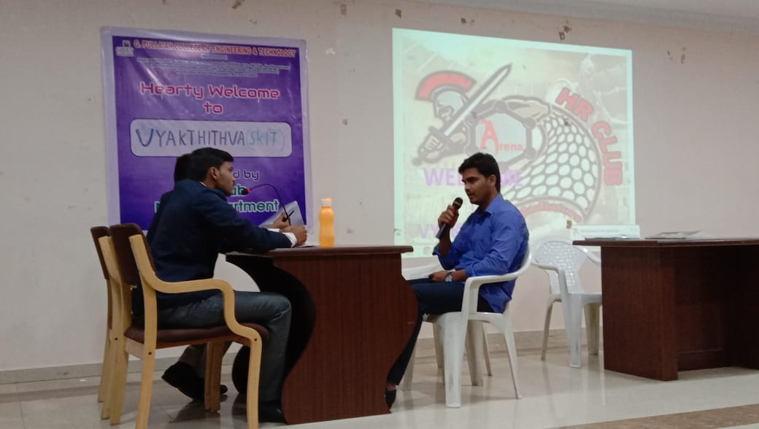
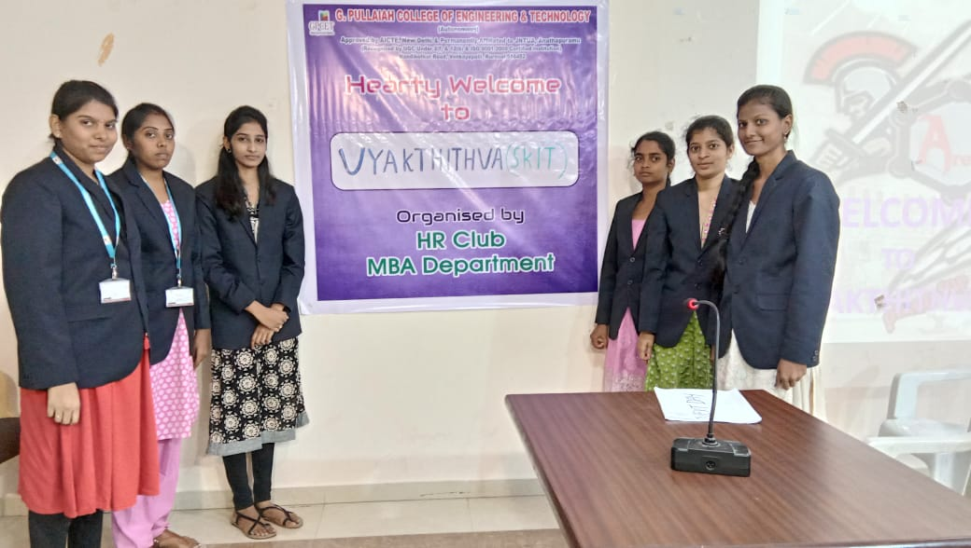
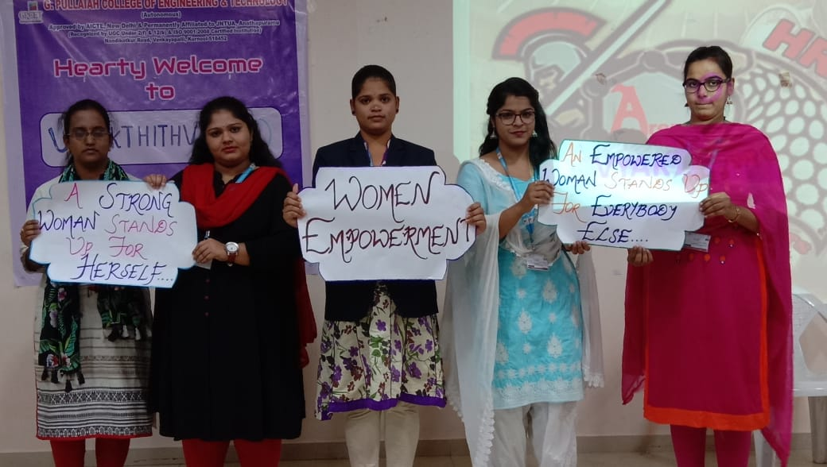
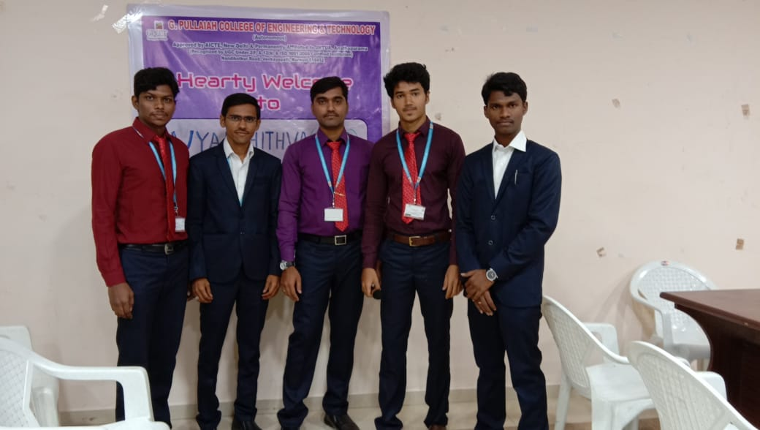

WINNERS
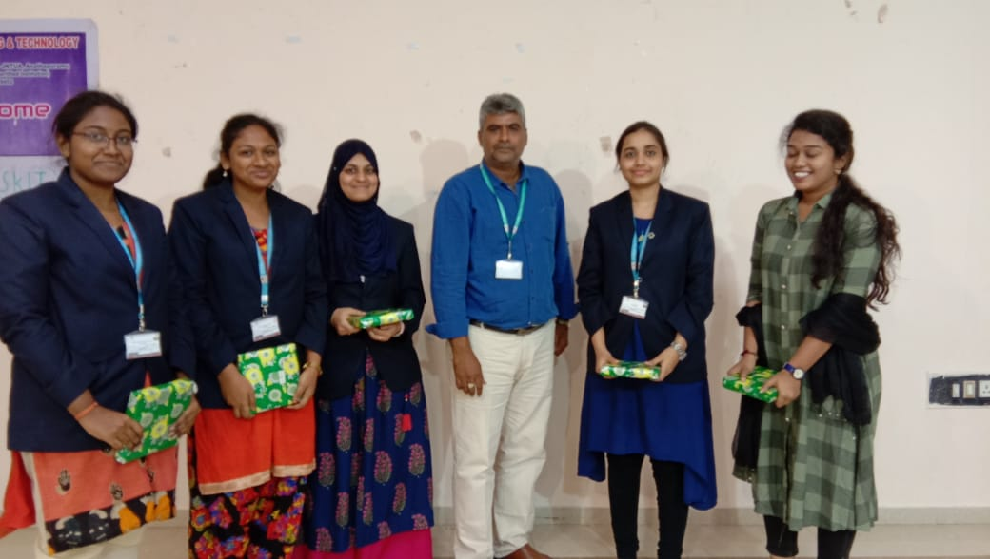
FIRST PRIZE

SECOND PRIZE THIRD PRIZE
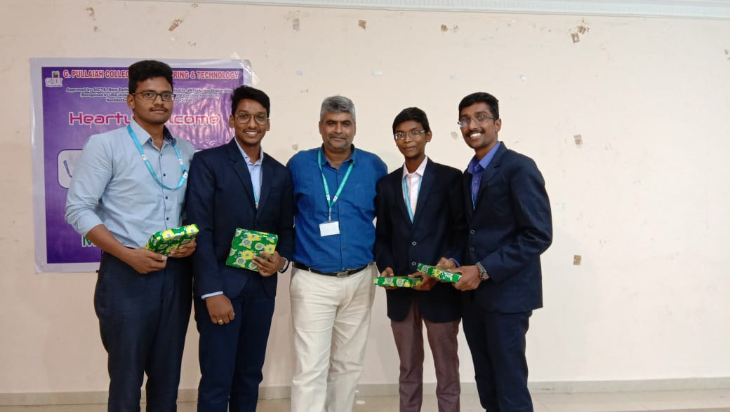
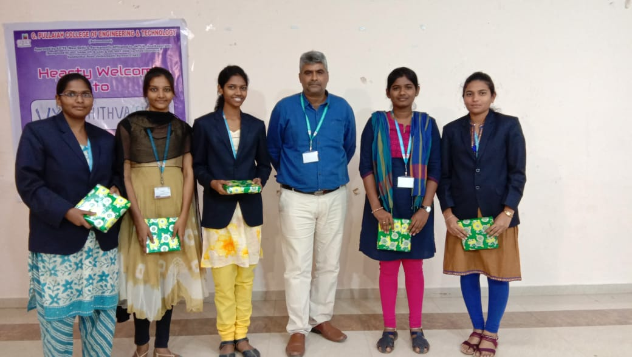

SNAPSHOTS OF THE EVENT AND PRIZE DISTRIBUTION

