G.PULLAIAH COLLEGE OF ENGINEERING & TECHNOLOGY, KURNOOL
(AUTONOMOUS)
DEPARTMENT OF MANAGEMENT STUDIES
MARKETING CLUB
Date: 06-02-2019
Day: Wednesday
NAME OF THE ACTIVITY: YOU CAN WIN
TARGETED GROUP: MBA II & IV semester students
A REPORT ON ACTIVITY:
An activity named “YOU CAN WIN”; a Book Review was organized by Marketing Club for II & IV Semester- MBA students on 06th February, 2019 from 10:30 am to 03:50 pm. “YOU CAN WIN” is a motivational book authored by Shiv Khera. Dr. S. Prem Kumar, Dean, G. Pullaiah College of Engineering and Technology, Kurnool acted as Chief Guest for the program.
The main aim of the activity was to help the students to understand and develop new goals, new sense of purpose and new ideas to achieve life time success. The students had been divided into 16 teams and each team had presented a different chapter like Attitude, Success, Self Esteem, Goal Setting, Interpersonal Communication skills, Motivation etc., . The activity ended with feedback on presentations and prize distribution.
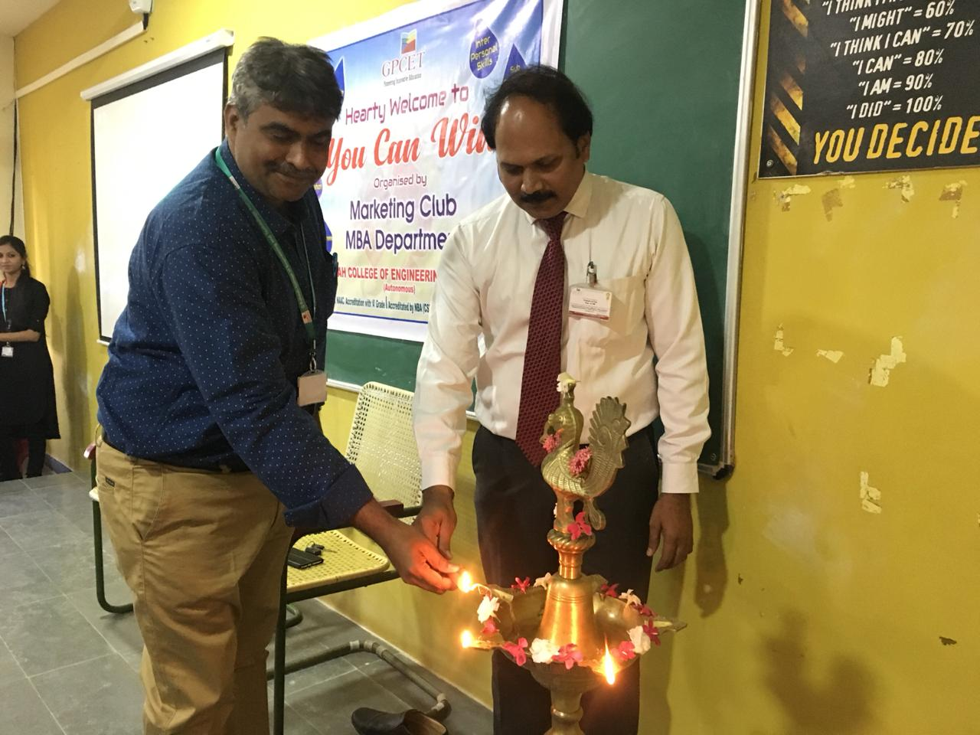

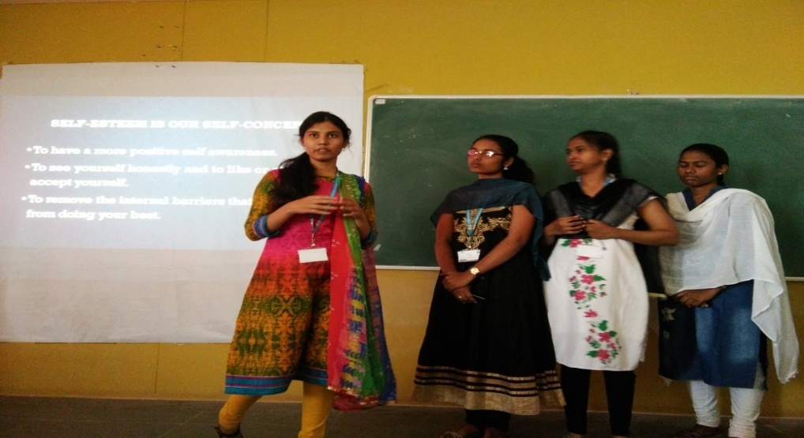

WINNERS
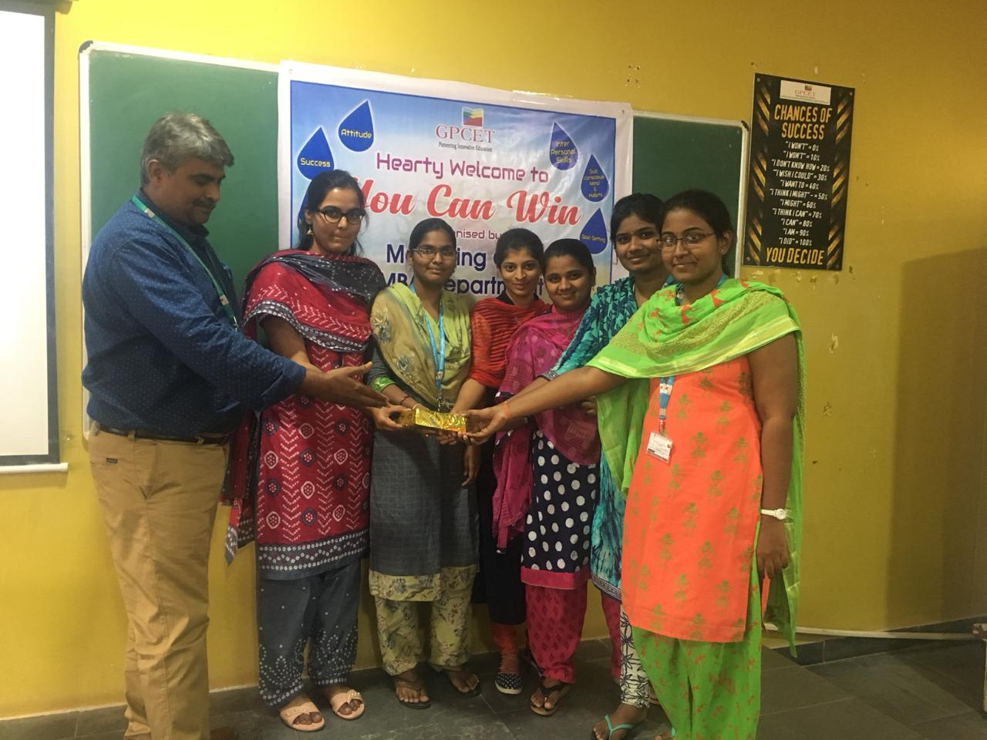
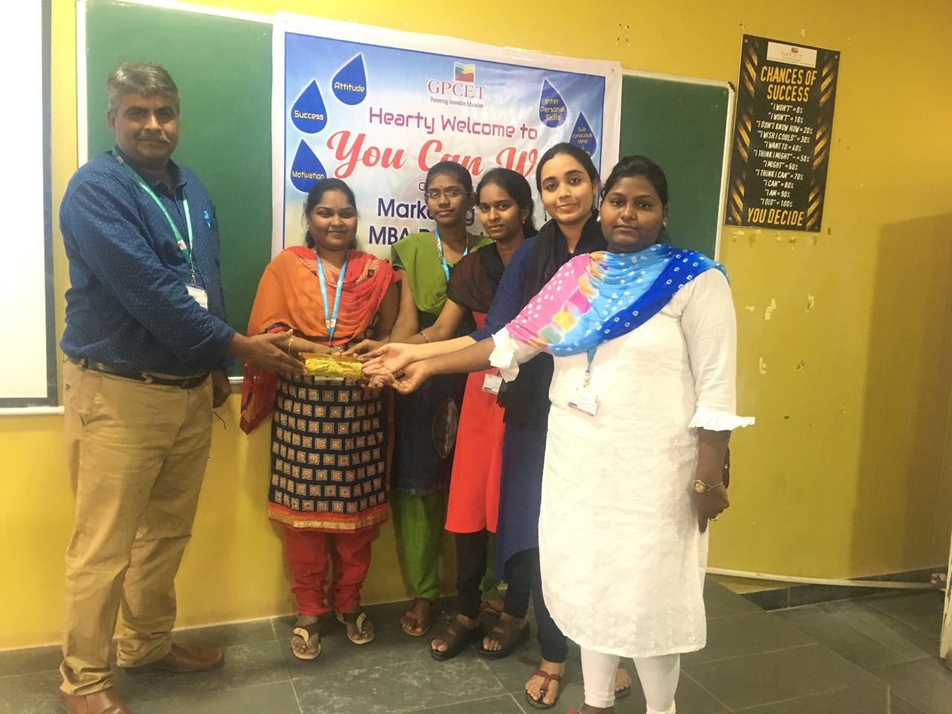

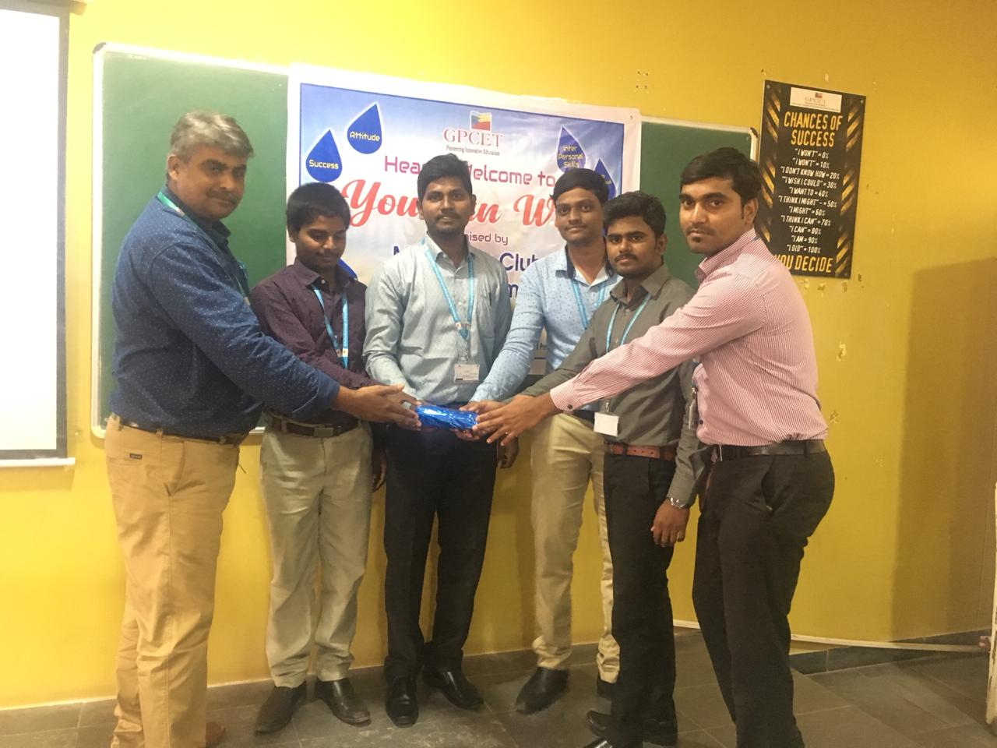
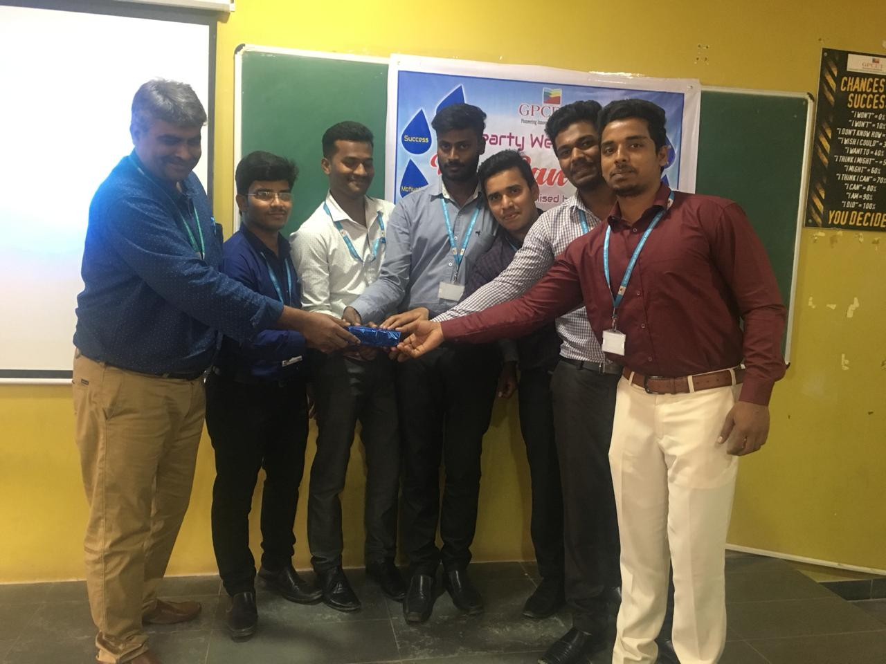
RUNNERS

SNAPSHOTS OF THE ACTIVITY

