**LECTURE NOTES**

**ON**

**15A05802 MOBILE COMPUTING**

**IV YEAR B.TECH II SEMESTER CSE**

**UNIT-II AD HOC Wireless Networks**

1. APPLICATIONS OF AD HOC WIRELESS NETWORKS:

Ad hoc wireless networks, due to their quick and economically less demanding deployment, find applications in several areas. Some of these include: military applications, collaborative and distributed computing, emergency operations, wireless mesh networks, wireless sensor networks, and hybrid wireless network architectures.

* 1. **Military Application**

Ad hoc wireless networks can be very useful in establishing communication among a group of soldiers for tactical operations. Setting up of a fixed infrastructure for communication among group of soldiers in enemy territories or in inhospitable terrains may not be possible. In such a case, ad hoc wireless networks provide required communication mechanism quickly. Coordination of military objects moving at high speeds such as fleets of airplanes, warships .Ad hoc used in secure communication, compromise of other security threats and safety of personnel in the tactical operation. In military application multiple high- power transceivers, each with the ability to hop between different frequencies, with long life batteries. The primary nature of the communication required in a military environment enforces certain important requirements on ad hoc wireless networks namely, Reliability, Efficiency, Secure communication & Support for multicast routing.

## Collaborative & Distributed computing

Ad hoc wireless network helps in collaborative computing, by establishing temporary communication infrastructure for quick communication with minimal configuration among a group of people in a conference. In distributed file sharing application reliability is of high importance which would be provided by ad hoc network, Other applications such as streaming of multimedia objects among participating nodes in ad hoc Wireless networks require support for soft real-time communication. Devices used for such applications could typically be laptops with add -on wireless interface cards, enhanced personal digital assistants (PDAs) or mobile devices with high processing power

## Emergency Operations

Ad hoc wireless networks are very useful in emergency operations such as search and rescue, crowd control and commando operations. The major factors that favor ad hoc wireless networks for such tasks are self-configuration of the system with minimal overhead, independent of fixed or centralized infrastructure, the freedom and flexibility of mobility, and unavailability of conventional communication infrastructure. In environments, where the conventional infrastructure based communication facilities are destroyed due to a war or due to natural calamities, immediate deployment of ad hoc wireless networks would be a good solution for coordinating rescue activities. They require minimum initial network configuration with very little or no delay

## Wireless Mesh Network

Wireless mesh networks are ad hoc wireless network that are formed to provide an alternate communication infrastructure for mobile or fixed nodes/users, without the spectrum reuse constraint & requirement of network planning of cellular network. It provides many alternate paths for a data transfer session between a source & destination, resulting in quick reconfiguration of the path when the existing path fails due to node failure. Since the infrastructure built is in the form of small radio relaying devices, the investment required in wireless mesh networks is much less than what is required for the cellular network counterpart.

The possible deployment scenarios of wireless mesh networks include: residential zones, highways, business zones, important civilian regions and university campuses. Wireless mesh networks should be capable of self-organization and maintenance. It operates at license-free ISM band around 2.4 GHz & 5 GHz. It is scaled well to provide support to large number of points.

Major advantage is the support for a high data rate, quick & low cost of deployment, enhanced services, high scalability, easy extendibility, high availability & low cost per bit.

## Wireless Sensor Networks:

Sensor networks are special category of Ad hoc wireless network that are used to provide a wireless communication infrastructure among the sensors deployed in a specific application domain. Sensor nodes are tiny devices that have capability of sensing physical parameters processing the data gathered, & communication to the monitoring system. The issues that make sensor network a distinct category of ad hoc wireless network are the following:

1. ***Mobility of nodes***:

Mobility of nodes is not a mandatory requirement in sensor networks. For example, the nodes used for periodic monitoring of soil properties are not required to be mobile & the nodes that are fitted on the bodies of patients in a post -surgery ward of a hospital are designed to support limited or partial mobility. In general, sensor networks need not in all cases be designed to support mobility of sensor nodes.

2. ***Size of the network*** :

The number of nodes in sensor network can be much larger than that in a typical ad hoc wireless network.

3. ***Density of deployment*** :

The density of nodes in a sensor network varies with the domain of application. For example, Military applications require high availability of the network, making redundancy a high priority.

4. ***Power constraints*** :

The power constraints in sensor networks are much more stringent than those in ad hoc wireless networks. This is mainly because the sensor nodes are expected to operate in harsh environmental or geographical conditions, with minimum or no human supervision and maintenance. In certain case, the recharging of the energy source is impossible. Running such a network, with nodes powered by a battery source with limited energy, demands very efficient protocol at network, data link, and physical layer.

The power sources used in sensor networks can be classified into the following 3 categories:

1. Replenishable Power source: The power source can be replaced when the existing source is fully drained.

2. Non-replenishable Power source: The power source cannot be replenished once the network has been deployed. The replacement of sensor node is the only solution.

3. Regenerative Power source: Here, Power source employed in sensor network have the capability of regenerating power from the physical parameter under measurement.

***5. Data / Information fusion :***

Data fusion refers to the aggregation of multiple packets into one before relaying it. Data fusion mainly aims at reducing the bandwidth consumed by redundant headers of the packets and reducing the media access delay involved in transmitting multiple packets. Information fusion aims at processing the sensed data at the intermediate nodes and relaying the outcome to the monitor node.

***6. Traffic Distribution :***

The communication traffic pattern varies with the domain of application in sensor networks. For example, the environmental sensing application generates short periodic packets indicating the status of the environmental parameter under observation to a central monitoring station. This kind of traffic requires low bandwidth.

Ad hoc wireless networks generally carry user traffic such as digitized & packetized voice stream or data traffic, which demands higher bandwidth.

**ISSUES IN AD HOC WIRELESS NETWORKS:**

The major issues that affect the design, deployment, & performance of an ad hoc wireless network system are:

1. Medium Access Scheme.

2. Transport Layer Protocol.

3. Routing.

4. Multicasting.

5. Energy Management.

6. Self-Organization.

7. Security.

8. Addressing & Service discovery.

9. Deployment considerations.

10. Scalability.

11. Pricing Scheme.

12. Quality of Service Provisioning

**1. Medium Access Scheme**

The primary responsibility of a Medium Access Control (MAC) protocol in ad hoc wireless networks is the distributed arbitration for the shared channel for transmission of packets. The major issues to be considered in designing a MAC protocol for ad hoc wireless networks are as follows:

***Distributed Operation:***

The ad hoc wireless networks need to operate in environments where no centralized coordination is possible.

The MAC protocol design should be fully distributed involving minimum control overhead.

***Synchronization:***

The MAC protocol design should take into account the requirement of time synchronization. Synchronization is mandatory for TDMA-based systems for management of transmission and reception slots.

***Hidden Terminals:***

Hidden terminals are nodes that are hidden (or not reachable) from the sender of a data transmission session, but are reachable to the receiver of the session.

***Exposed terminals:***

Exposed terminals, the nodes that are in the transmission range of the sender of an on going session, are prevented from making a transmission.

***Throughput:***

The MAC protocol employed in ad hoc wireless networks should attempt to maximize the throughput of the system.

The important considerations for throughput enhancement are - Minimizing the occurrence of collisions.

- Maximizing channel utilization and - Minimizing control overhead.

***Access delay:***

The average delay that any packet experiences to get transmitted. The MAC protocol should attempt to minimize the delay.

***Fairness****:*

Fairness refers to the ability of the MAC protocol to provide an equal share or weighted share of the bandwidth to all competing nodes. Fairness can be either *node-based* or *flow based.*

***Real-time Traffic support*:**

In a contention-based channel access environment, without any central coordination, with limited bandwidth, and with location-dependent contention, supporting time- sensitive traffic such as voice, video, and real-time data requires explicit support from the MAC protocol.

***Resource reservation*:**

The provisioning of QoS defined by parameters such as bandwidth, delay, and jitter requires reservation of resources such as *bandwidth, buffer space*, and *processing power*.

***Ability to measure resource availability:***

In order to handle the resources such as bandwidth efficiently and perform call admission control based on their availability, the MAC protocol should be able to provide an estimation of resource availability at every node. This can also be used for making *congestion control decisions*.

***Capability for power control:***

The transmission power control reduces the energy consumption at the nodes, causes a decrease in interference at neighboring nodes, and increases frequency reuse.

***Adaptive rate control:***

This refers to the variation in the data bit rate achieved over a channel. A MAC protocol that has adaptive rate control can make use of a high data rate when the sender and receiver are nearby & adaptively reduce the data rate as they move away from each other.

***Use of directional antennas:***

This has many advantages that include increased spectrum reuse, Reduction in interference and Reduced power consumption.

**2. Routing**

The responsibilities of a routing protocol include exchanging the route information; finding a feasible path to a destination. The major challenges that a routing protocol faces are as follows:

***Mobility :***

The Mobility of nodes results in frequent path breaks, packet collisions, transient loops, stale routing information, and difficulty in resource reservation.

***Bandwidth constraint:***

Since the channel is shared by all nodes in the broadcast region, the bandwidth available per wireless link depends on the number of nodes & traffic they handle.

***Error-prone and shared channel:***

The Bit Error Rate (BER) in a wireless channel is very high [10-5 to 10 -3 ] compared to that in its wired counterparts [ 10-12 to 10-9 ].

Consideration of the state of the wireless link, signal-to-noise ratio, and path loss for routing in ad hoc wireless networks can improve the efficiency of the routing protocol.

***Location-dependent contention:***

The load on the wireless channel varies with the number of nodes present in a given geographical region.

This makes the contention for the channel high when the number of nodes increases. The high contention for the channel results in a high number of collisions & a subsequent wastage of bandwidth.

***Other resource constraints:***

The constraints on resources such as computing power, battery power, and buffer storage also limit the capability of a routing protocol. The major requirements of a routing protocol in adhoc wireless networks are the following.

1. Minimum route acquisition delay 2. Quick route reconfiguration

3. Loop-free routing

4. Distributed routing approach

5. Minimum control overhead 6. Scalability

7. Provisioning of QoS

8. Support for time-sensitive traffic:

9. Security and privacy

**3. Multicasting:**

It plays important role in emergency search, rescue operations & in military communication. Use of single link connectivity among the nodes in a multicast group results in a tree-shaped multicast routing topology. Such a tree-shaped topology provides high multicast efficiency, with low packet delivery ratio due to the frequency tree breaks. The major issues in designing multicast routing protocols are as follows:

***Robustness :***

The multicast routing protocol must be able to recover & reconfigure quickly from potential mobility- induced link breaks thus making it suitable for use in high dynamic environments.

***Efficiency :***

A multicast protocol should make a minimum number of transmissions to deliver a data packet to all the group members.

***Control overhead :***

The scarce bandwidth availability in ad hoc wireless networks demands minimal control overhead for the multicast session.

***Quality of Service :***

QoS support is essential in multicast routing because, in most cases, the data transferred in a multicast session is time-sensitive.

***Efficient group management :***

Group management refers to the process of accepting multicast session members and maintaining the connectivity among them until the session expires.

***Scalability :***

The multicast routing protocol should be able to scale for a network with a large number of node

***Security :***

Authentication of session members and prevention of non-members from gaining unauthorized information play a major role in military communications.

**4. Transport Layer Protocol**

The main objectives of the transport layer protocols include: Setting up & maintaining end-to-end connections, Reliable end-to-end delivery of packets, Flow control & Congestion control. Examples of some transport layers protocols are,

***a. UDP (User Datagram Protocol) :***

It is an unreliable connectionless transport layer protocol. It neither performs flow control & congestion control. It do not take into account the current network status such as congestion at the intermediate links, the rate of collision, or other similar factors affecting the network throughput.

***b. TCP (Transmission Control Protocol):***

It is a reliable connection-oriented transport layer protocol. It performs flow control & congestion control. Here performance degradation arises due to frequent path breaks, presence of stale routing information, high channel error rate, and frequent network partitions.

**5. Pricing Scheme**

Assume that an optimal route from node A to node B passes through node C, & node C is not powered on. Then node A will have to set up a costlier & non-optimal route to B. The non-optimal path consumes more resources & affects the throughput of the system. As the intermediate nodes in a path that relay the data packets expend their resources such as battery charge & computing power, they should be properly compensated. Hence, pricing schemes that incorporate service compensation or service reimbursement are required.

**6. Quality of Service Provisioning (QoS)**

QoS is the performance level of services offered by a service provider or a network to the user. QoS provisioning often requires ,Negotiation between host & the network, Resource reservation schemes, Priority scheduling & Call admission control.

***QoS parameters :***

Applications Corresponding QoS parameter

1. Multimedia application - 1. Bandwidth & Delay

2. Military application - 2.Security & Reliability

3. Defense application - 3.Finding trustworthy intermediate hosts & routing

4. Emergency search and - 4 .Availability rescue operations

5. Hybrid wireless network - 5.Maximum available link life, delay, bandwidth & channel utilization.

***QoS-aware routing :***

Finding the path is the first step toward a QoS-aware routing protocol. The parameters that can be considered for routing decisions are, Network throughput, Packet delivery ratio, Reliability, Delay, Delay jitter, Packet loss rate Bit error rate, Path loss.

***QoS framework :***

I. A framework for QoS is a complete system that attempts to provide the promised services to each user or application.

II. The key component of QoS framework is a QoS service model which defines the way user requirements are served.

**7. Self-Organization**

One very important property that an ad hoc wireless network should exhibit is organizing & maintaining the network by itself.

The major activities that an ad hoc wireless network is required to perform for self organization are, Neighbour discovery, Topology organization & Topology reorganization(updating topology information)

**8. Security**

Security is an important issue in ad hoc wireless network as the information can be hacked. Attacks against network are of 2 types :

I. *Passive attack* without disrupting the operations.

II. *Active attack*

Further active attacks are of 2 types :

1. *External attack*: The active attacks that are executed by nodes outside the network.

2. *Internal attack:* The active attacks that are performed by nodes belonging to the same network.

The major security threats that exist in ad hoc wireless networks are as follows :

***Denial of service***

The attack affected by making the network resource unavailable for service to other nodes, either by consuming the bandwidth or by overloading the system.

***Resource consumption***

The scarce availability of resources in ad hoc wireless network makes it an easy target for internal attacks, particularly aiming at consuming resources available in the network. The major types of resource consumption attacks are, *Energy depletion*:

1. Highly constrained by the energy source

2. Aimed at depleting the battery power of critical nodes.

*Buffer overflow* :

1. Carried out either by filling the routing table with unwanted routing entries or by consuming the data packet buffer space with unwanted data.

2. Lead to a large number of data packets being dropped, leading to the loss of critical information.

***Host impersonation***

A compromised internal node can act as another node and respond with appropriate control packets to create wrong route entries, and can terminate the traffic meant for the intended destination node.

***Information disclosure***

compromised node can act as an informer by deliberate disclosure of confidential information to unauthorized nodes.

***Interference***

A common attack in defense applications to jam the wireless communication by creating a wide spectrum noise.

**9. Addressing and service discovery**

Addressing & service discovery assume significance in ad hoc wireless network due to the absence of any centralized coordinator.

An address that is globally unique in the connected part of the ad hoc wireless network is required for a node in order to participate in communication. Auto-configuration of addresses is required to allocate non-duplicate addresses to the nodes.

**10. Energy Management**

Energy management is defined as the process of managing the sources & consumers of energy in a node or in the network for enhancing the lifetime of a network. Features of energy management are :

finding routes that consumes minimum energy. Energy management can be classified into the following categories:

***Transmission power management* :**

The power consumed by the Radio Frequency (RF) module of a mobile node is determined

by several factors such as

* The state of operation.

* The transmission power and

* The technology used for the RF circuitry.

The state of operation refers to transmit, receive, and sleep modes of the operation. The transmission power is determined by Reach ability requirement of the network, Routing protocol and MAC protocol employed.

***Battery energy management :***

The battery management is aimed at extending the battery life of a node by taking advantage of its chemical properties, discharge patterns, and by the selection of a battery from a set of batteries that is available for redundancy.

***Processor power management :***

The clock speed and the number of instructions executed per unit time are some of the processor parameters that affect power consumption.

The CPU can be put into different power saving modes during low processing load conditions. The CPU power can be completely turned off if the machines are idle for a long time. In such a cases, interrupts can be used to turn on the CPU upon detection of user interaction or other events.

***Devices power management :***

Intelligent device management can reduce power consumption of a mobile node significantly. This can be done by the operating system( OS) by selectively powering down interface devices that are not used or by putting devices into different power saving modes, depending on their usage.

**11. Scalability**

Scalability is the ability of the routing protocol to scale well in a network with a large number of nodes. It requires minimization of control overhead & adaptation of the routing protocol to the network size.

**12. Deployment Considerations**

The deployment of a commercial ad hoc wireless network has the following benefits when compared to wired networks.

***Low cost of deployment :***

The use of multi-hop wireless relaying eliminates the requirement of cables & maintenance in deployment of communication infrastructure. The cost involved is much lower than that of wired networks.

***Incremental deployment :***

Deployment can be performed incrementally over geographical regions of the city. The deployed part of the network starts functioning immediately after the minimum configuration is done.

***Short deployment time :***

Compared to wired networks, the deployment time is considerably less due to the absence of any wired links.

***Reconfigurability :***

The cost involved in reconfiguring a wired network covering a Metropolitan Area Network(MAN) is very high compared to that of an ad hoc wireless network covering the same service area. The following are the major issues to be considered in deploying an ad hoc wireless network :

**a) *Scenario of deployment* :**

The scenario of deployment has significance because the capability required for a mobile node varies with the environment in which it is used.

The following are some of the different scenarios in which the deployment issues vary widely:

1. *Military deployment :*

It can be either, Data-centric network: Handle a different pattern of data traffic & can be partially comprised of static nodes. Eg : a wireless sensor network. User-centric network: Consists of highly mobile nodes with or without any support from any infrastructure. Eg :soldiers or armored vehicles carrying soldiers equipped with wireless communication devices.

2. *Emergency operations deployment*:

Demands a quick deployment of rescue personnel equipped with hand-held communication equipment. The network should provide support for time-sensitive traffic such as voice & video. Short data messaging can be used in case the resource constraints do not permit voice communication.

3. *Commercial wide-area deployment:*

Eg : wireless mesh networks.

The aim of the deployment is to provide an alternate communication infrastructure for wireless communication in urban areas & areas where a traditional cellular base station cannot handle the traffic volume.

*3. Home network deployment :*

Deployment needs to consider the limited range of the devices that are to be connected by the network.

Eg : short transmission range avoid network partitions.

b) ***Required longevity of network :***

If the network is required for a short while, battery-powered mobile nodes can be used. If the connectivity is required for a longer duration of time, fixed radio relaying equipment with regenerative power sources can be deployed.

c) ***Area of coverage :***

Determined by the nature of application for which the network is set up.

Eg : the home area network is limited to the surroundings of a home. hardware, software, & power source should match the area of coverage required.

d) ***Service availability*** *:*

Defined as the ability of an ad hoc wireless network to provide service even with the failure of certain nodes. Has significance in a Fully mobile ad hoc wireless network used for tactical communication & in partially fixed ad hoc wireless network used in commercial communication infrastructure such as wireless mesh networks.

e) ***Operational integration with other infrastructure :***

Considered for improving the performance or gathering additional information, or for providing better QoS. In military environment, integration of ad hoc wireless networks with satellite networks or unmanned aerial vehicles (UAVs) improves the capability of the ad hoc wireless networks.

f) ***Choice of protocol :***

The choice of protocols at different layers of the protocol stack is to be done taking into consideration the deployment scenario. A TDMA-based & insecure MAC protocol may not be the best suited compared to a CDMA based MAC protocol for a military application.

**AD HOC WIRELESS INTERNET**

The ad hoc wireless Internet extends the services of the Internet to the end users over an ad hoc wireless network. Some of the applications of the ad hoc wireless Internet are wireless mesh networks, provisioning of

temporary Internet services to major conference venues, sports venues, temporary military settlements, battlefields, and broadband Internet services in rural regions. A schematic diagram of the ad hoc wireless Internet is shown in below Figure.



The major issues to be considered for a successful ad hoc wireless Internet are the following are

1. Gate ways
2. Address Mobility
3. Routing
4. Transport layer Protocol
5. Load Balancing
6. Pricing/Billing
7. Provisioning of Security
8. QoS Support
9. Service, address and Location Discovery

Below fig shows an illustration of AD HOC Networks Internet implemented by wireless mesh network.



**MAC PROTOCOLS FOR AD HOC WIRELESS NETWORKS**

**INTRODUCTION**

Nodes in an ad hoc wireless network share a common broadcast radio channel. Since the radio spectrum is limited, the bandwidth available for communication in such networks is also limited. Access to this shared medium should be controlled in such a manner that all nodes receive a fair

share of the available bandwidth, and that the bandwidth is utilized efficiently. Since the characteristics of the wireless medium are completely different from those of the wired medium, and since ad hoc wireless networks need to address unique issues (such as node mobility, limited

band width availability, error-prone broadcast channel, hidden and exposed terminal problems, and power constraints) that are not applicable to wired networks, a different set of protocols is required for controlling access to the shared medium in such networks. This chapter focuses on media access protocols for ad hoc wireless networks. First, the issues involved in designing a medium access control (MAC) protocol for ad hoc wireless networks are presented, followed by several classifications of the currently existing MAC protocols. This chapter then provides detailed descriptions of several existing MAC protocols.

**ISSUES IN DESIGNING MAC PROTOCOL FOR AD HOC WIRELESS NETWORK**

The main issues in designing MAC protocol for ad hoc wireless network are:

**Bandwidth efficiency:**

Bandwidth must be utilized in efficient manner Minimal Control overhead . BW = ratio of BW used for actual data transmission to the total available BW .

**Quality of service support**

Essential for supporting time-critical traffic sessions. They have resource reservation mechanism that takes into considerations the nature of wireless channel and the mobility of nodes

**Synchronization**

MAC protocol must consider synchronization between nodes in the network Synchronization is very important for BW (time slot) reservation by nodes Exchange of control packets may be required for achieving time synchronization among nodes

**Hidden and exposed terminal problems**

The hidden terminal problem refers to the collision of packets at a receiving node due to the simultaneous transmission of those nodes that are not within the direct transmission range of the sender but are within the transmission range of the receiver.

Collision occurs when both nodes transmit packets at the same time without knowing about the transmission of each other. S1 and S2 are hidden from each other & they transmit simultaneously to R1 which leads to collision. The exposed terminal problem refers to the inability of a node, which is blocked due to transmission by a nearby transmitting node, to transmit to another node. If S1 is already transmitting to R1, then S3 cannot interfere with on-going transmission & it cannot transmit to R2.

The hidden & exposed terminal problems reduce the throughput of a network when traffic load is high

**Error-prone shared broadcast channel**

When a node is receiving data, no other node in its neighborhood should transmit a node should get access to the shared medium only when its transmission do not affect any ongoing session. MAC protocol should grant channel access to nodes in such a manner that collisions are minimized. Protocol should ensure fair BW allocation.

**Distributed nature/lack of central coordination**

Do not have centralized coordinators, Nodes must be scheduled in a distributed fashion for gaining access to the channel MAC protocol must make sure that additional overhead, in terms of BW consumption, incurred due to this control information is not very high Mobility of nodes.

Nodes are mobile most of the time

The protocol design must take this mobility factor into consideration so that the performance of the system is not affected due to node mobility.

**DESIGN GOALS OF A MAC PROTOCOL FOR AD HOC WIRELESS NETWORKS**

The operation of a protocol should be distributed

The protocol should provide QoS support for real-time traffic

The access delay, which refers to the average delay experienced by any packet to get transmitted, must be kept low

The available bandwidth must be utilized efficiently

The protocol should ensure fair allocation of bandwidth to nodes Control overhead must be kept as low as possible

The protocol should minimize the effects of hidden and exposed terminal problems The protocol must be scalable to large networks

It should have power control mechanisms in order to efficiently manage energy consumption of the nodes

The protocol should have mechanisms for adaptive data rate control

It should try to use directional antennas which can provide advantages such as reduced interference, increased spectrum reuse, and reduced power consumption

The protocol should provide time synchronization among nodes

**CLASSIFICATION OF MAC PROTOCOLS**

Ad hoc network MAC protocols can be classified into three basic Types:

i. Contention-based protocols

ii. Contention-based protocols with reservation mechanisms

iii. Contention-based protocols with scheduling mechanisms

iv. Other MAC protocols which do not fall under above 3 categories

**1. Contention-based protocols**

***Sender-initiated protocols***: Packet transmissions are initiated by the sender node.

*Single-channel sender-initiated protocols*: A node that wins the contention to the channel can make use ofthe entire bandwidth. *Multichannel sender-initiated protocols:* The available bandwidth is divided into multiple channels.

***Receiver-initiated protocols*:**The receiver node initiates the contention resolution protocol.

**2. Contention-based protocols with reservation mechanisms**

***Synchronous protocols***: All nodes need to be synchronized. Global time synchronization is difficult toachieve.

***Asynchronous protocols:*** These protocols use relative time information for effecting reservations.

3. **Contention-based protocols with scheduling mechanisms**

Node scheduling is done in a manner so that all nodes are treated fairly and no node is starved of bandwidth.

Scheduling-based schemes are also used for enforcing priorities among flows whose packets are queued at nodes.

Some scheduling schemes also consider battery characteristics.

**CONTENTION-BASED PROTOCOLS**

**1. MACAW (MACA for Wireless) is a revision of MACA.**

The sender senses the carrier to see and transmits a **RTS** (**Request To Send)** frame if no nearby station transmits a RTS.

The receiver replies with a **CTS** (**Clear To Send**) frame.

The MACAW protocol uses one more control packet called the **request-for-request-to-send (RRTS)**

Neighbors

See CTS, and then keep quiet.

See RTS but not CTS, and then keep quiet until the CTS is back to the sender.

The receiver sends an ACK when receiving a frame.

Neighbors keep silent until see ACK.

Collisions

There is no collision detection.

They each wait for the exponential back-off time.

The senders kn

They each wait for the exponential back-off time.

**Floor acquisition Multiple Access Protocols (FAMA)**

Based on a channel access discipline which consists of a carrier-sensing operation and a collision avoidance dialog between the sender and the intended receiver of a packet. Floor acquisition refers to the process of gaining control of the channel. At any time only one node is assigned to use the channel.arrier-sensing by the sender, followed by the RTS-CTS control packet exchange, enables the protocol to perform as efficiently as MACA. Two variations of FAMA RTS-CTS exchange with no carrier-sensing uses the ALOHA protocol for transmitting RTS packets. RTS-CTS exchange with non-persistent carrier-sensing uses non-persistent CSMA for the same purpose.

1. **MACA-By Invitation Protocol**

It is a receiver-initiated protocol, It reduces the number of control packets used in the MACA protocol, It eliminated the need for the RTS packet In MACA-BI, the receiver node initiates data transmission by transmitting a ready-to-receive (RTR) control packet to the sender as shown in the figure

If it is ready to transmit, the sender node respond by sending a DATA packet Thus data transmission in MACA-BI occurs through a two-way handshake mechanism .The efficiency of the MACA-BI scheme is mainly dependent on the ability of the receiver node to predict accurately the arrival rates of traffic at the sender nodes

**3. Media Access with Reduced Handshake Protocol**

It is a receiver-initiated protocol. Exploits the broadcast nature of traffic from Omni-directional antennas to reduce the number of handshakes involved in the data transmission .A node obtains information about the data packet arrivals at its neighboring nodes by over heading the CTS packets transmitted by them. It then sends a CTS packet to the concerned neighbor node for relaying data from that node This mechanism is as shown below. The throughput of MARCH is significantly high compared to MACA Control overhead is much less Less BW is consumed for control traffic

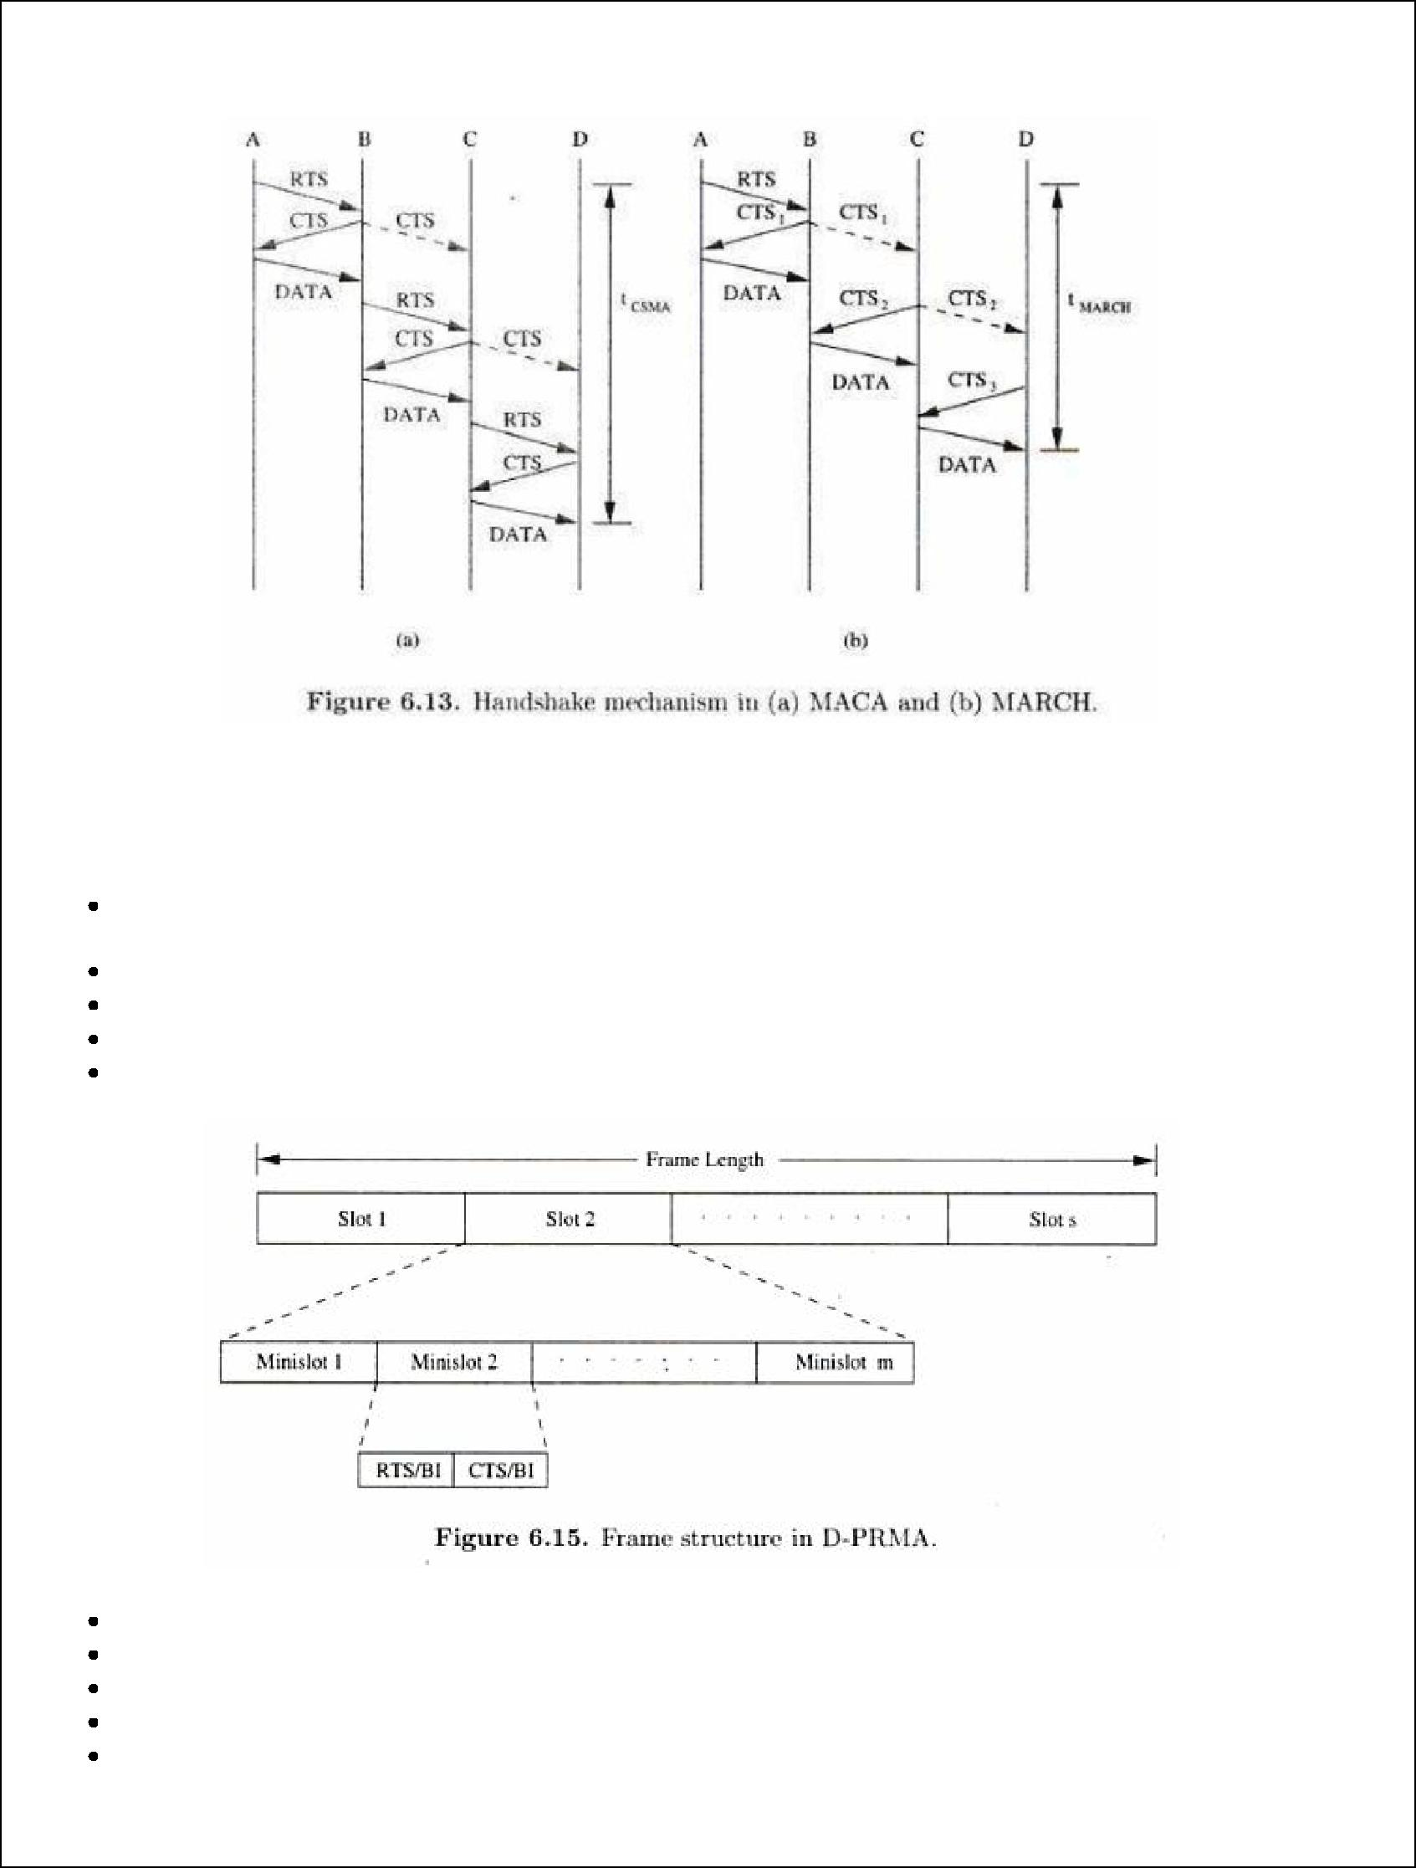

**CONTENTION BASED PROTOCOLS WITH RESERVATION MECHANISMS**

**Distributed Packet Reservation Multiple Access Protocol (D-PRMA)**

It extends the centralized packet reservation multiple access (PRMA) scheme into a distributed scheme that can be used in ad hoc wireless networks.

PRMA was designed in a wireless LAN with a base station. D-PRMA extends PRMA protocol in a wireless LAN. D-PRMA is a TDMA-based scheme.

The channel is divided into fixed- and equal-sized frames along the time axis.

Each frame is composed of s slots and each slot consists of m minislots. Each minislot is further divided into two control fields, RTS/BI and CTS/BI.

These control fields are used for slot reservation and for overcoming the hidden terminal problem. All nodes having packets ready for transmission contend for the first minislot of each slot.

The remaining (m-1) minislots are granted to the node that wins the contention.



Also, the same slot in each subsequent frame can be reserved for this winning terminal until it completes its packet transmission session.

Within a reserved slot, communication between the source and receiver nodes takes by means of either time division duplexing (TDD) or frequency division duplexing (FDD).

Any node that wants to transmit packets has to first reserve slots.

A certain period at the beginning of each minislot is reserved for carrier sensing.

In order to prioritize nodes transmitting voice traffic over nodes transmitting normal data traffic, two rules are followed in D-PRMA

**1st rule->** voice nodes are allowed to start contending from minislot 1 with probability p=1.Others with p<1 **2nd rule** -> only if the node winning the minislot contention is a voice node, it is permitted to reserve the

same slot in each subsequent frame until the end of the session

In order to avoid the hidden terminal problem, all nodes hearing the CTS sent by the receiver are not allowed to transmit during the remaining period of that same slot

In order to avoid the exposed terminal problem, a node hearing the RTS but not the CTS is still allowed to transmit

**Requirement 1 ->** when a node wins the contention in minislot 1, other terminals must be prevented fromusing any of the remaining (m-1) minislots in the same slot for contention

**Requirement 2** -> when a slot is reserved in subsequent frames, other nodes should be prevented fromcontending for those reserved slots

D-PRMA is more suited for voice traffic than for data traffic applications

**Collision Avoidance Time Allocation Protocol (CATA)**

It is based on dynamic topology-dependent transmission scheduling

Nodes contend for and reserve time slots by means of a distributed reservation and handshake mechanism.

Support broadcast, unicast, and multicast transmissions. The operation is based on two basic principles:

The receiver(s) of a flow must inform the potential source nodes about the reserved slot on which it is currently receiving packets. The source node must inform the potential destination node(s) about interferences in the slot.

Usage of negative acknowledgements for reservation requests, and control packet transmissions at the beginning of each slot, for distributing slot reservation information to senders of broadcast or multicast sessions.

Time is divided into equal-sized frames, and each frame consists of S slots. Each slot is further divided into five minislots.

The first 4 minislots are used for transmitting control packets and are called control minislots (CMS) The last minislot is called data minislot (DMS)

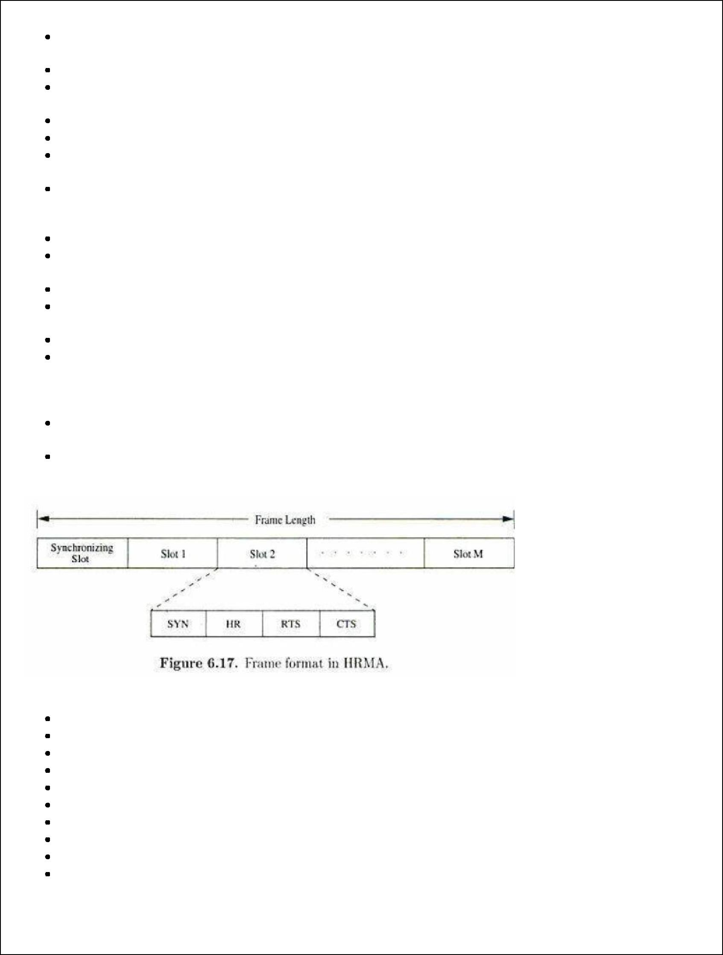

Each node that receives data during the DMS of the current slot transmits a slot reservation (SR) packet during the CMS1 of the slot

This serves to inform other neighboring potential sender nodes about the currently active reservations

The SR packet is either received without error at the neighboring nodes or causes noise at those nodes, preventing them from attempting to reserve the current slot

Every node that transmits data during the DMS of the current slot transmits a request -to-send packet The receiver node of a unicast session transmits a clear-to-send packe

On receiving this packet, the source node clearly understands that the reservation was successful and transmits data during the DMS of that slot until unicast flow gets terminated

Once the reservation has been made successfully in a slot, from the next slot onward, both the sender and receiver do not transmit anything during CMS3 and during CMS4 the sender node alone transmits a not-to-send (NTS) packet.

The not-to-send (NTS) packet serves as a negative acknowledgement

A potential multicast or broadcast source node that receives the NTS packet or that detects noise, understands that its reservation request has failed & does not transmit during DMS of current slot

The length of the frame is very important in CATA.

The worst case value of the frame-length = *Min(d2+1, N) ,* where d is the maximum degree of a node in the network and N is the total number of nodes in the network.

CATA works well with simple single-channel half-duplex radios.

It is simple and provides support for collision-free broadcast and multicast traffic

**Hop Reservation Multiple Access Protocol**

A multichannel MAC protocol which is based on half-duplex, very slow frequency-hopping spread spectrum (FHSS) radios

Uses a reservation and handshake mechanism to enable a pair of communicating nodes to reserve a frequency hop, thereby guaranteeing collision-free data transmission.

There are L frequency channels available.

HRMA uses one frequency channel, denoted by f0 as a dedicated synchronising channel The nodes exchange synchronisation information on f0

The remaining L-1 frequencies are divided into M=(L-1)/2 frequency pairs

fi is used for transmitting and receiving hop-reservation packets, RTS, CTS and data packets fi * is used for sending and receiving acknowledgement (ACK) packets

The data packets transmitted can be of any size.

Data transmission can take place through a single packet or a train of packets. In HRMA, time is slotted and each slot is assigned a separate frequency hop

Each time slot is divided into four periods, namely, synchronizing period, HR period, RTS period, and CTS period

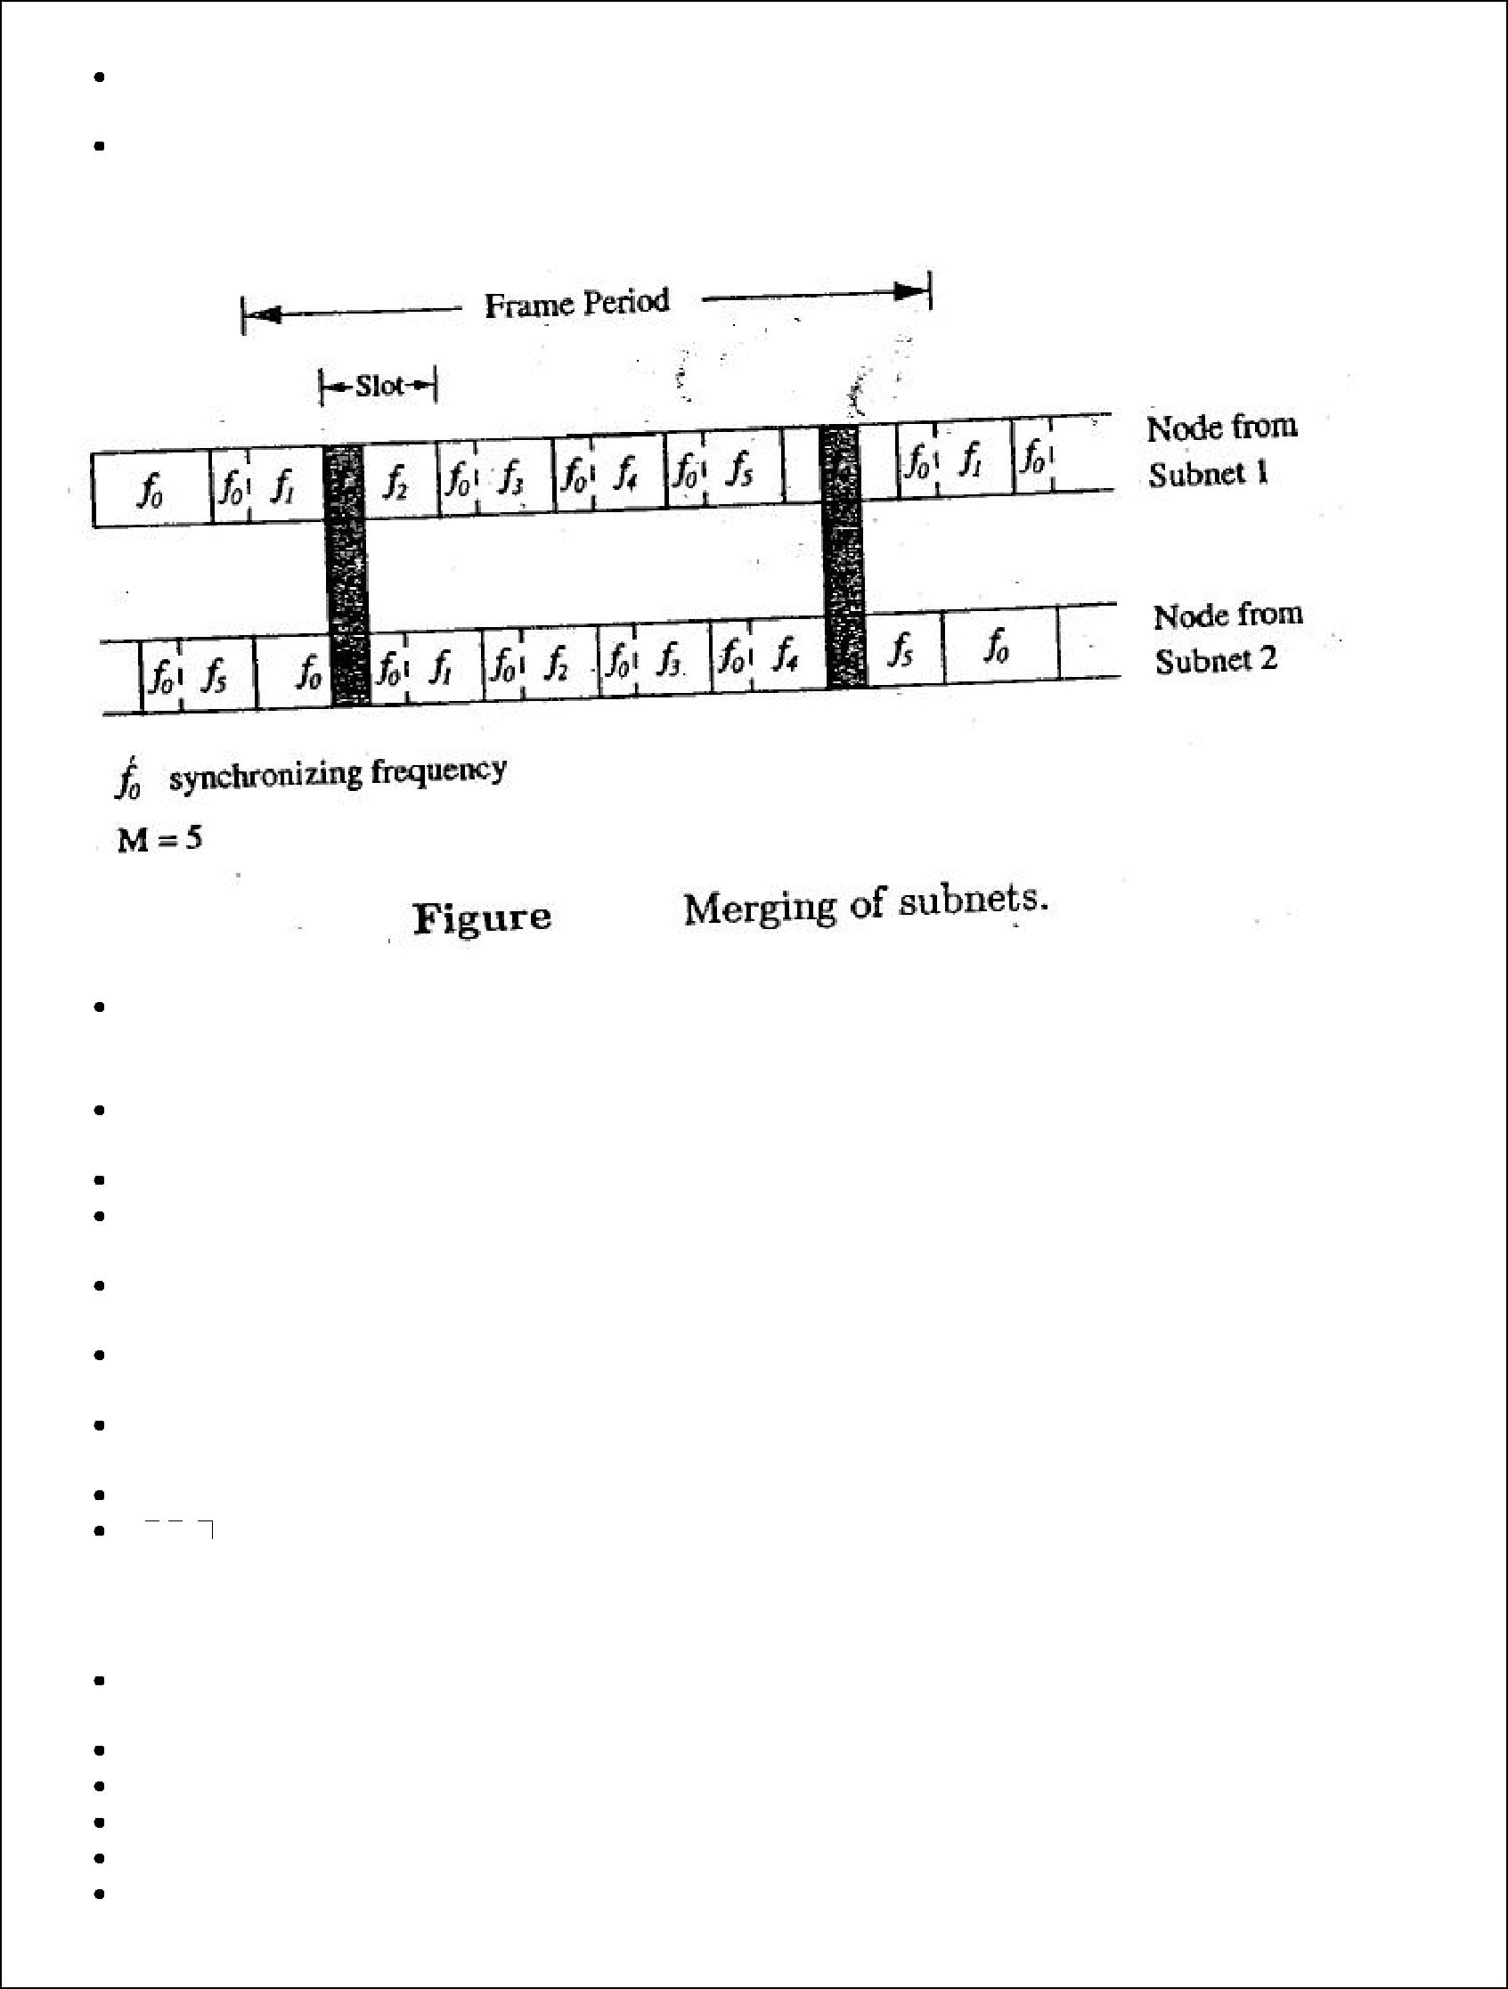

Each period meant for transmitting or receiving the synchronizing packet, FR packet, RTS packet, and CTS packet respectively.

During the synchronizing period of each slot, all idle nodes hop to the synchronizing frequency f 0 and exchange synchronization information

When a new node enters the network, it remains on the synchronizing frequency f0 for a long enough period of time so as to gather synchronization information such as the hopping pattern and the timing of the system. If it receives no information, it assumes that it is the only node in the network, broadcasts its own synchronization information and forms a one-node system.

Figure above depicts the worst-case frequency overlap scenario. When a node receives data to be transmitted, it first listens to the HR period of the immediately following slot If it finds the channel to be free during the SR period, it transmits an RTS packet to the destination during the RTS period of the slot and waits for the CTS packet On receiving the RTS, the destination node transmits the CTS packet during the CTS period of the same slot and waits for the data packet. If the source node receives the CTS packet correctly, it implies that the source and receiver nodes have successfully reserved the current hop. After transmitting each data packet, the source node hops onto this acknowledgement frequency. The receiver sends an ACK packet back to the source.

**Soft Reservation Multiple Access with Priority Assignment**

Developed with the main objective of supporting integrated services of real-time and non-real-time application in ad hoc networks, at the same time maximizing the statistical multiplexing gain. Nodes use a collision-avoidance handshake mechanism and a soft reservation mechanism Unique frame structure Soft reservation capability for distributed ad dynamic slot scheduling. Dynamic and distributed access priority assignment and update policies. Time constrained back-off algorithm

Time is divided into frames. There are two types of frames namely reservation frame and information frame. Each RF is followed by a sequence of Ifs. Each RF has N reservation slots (RS). Each IF has N information slots (IS).

In order to reserve an IS, a node needs to contend during the corresponding RS. Based on these contentions, a TDMA schedule is generated in the RF and is used in the subsequent Ifs until the next RF. Each RS is composed of M reservation cycles. During the corresponding IS, a node would be in one of the three states: transmit(T), receive(R) or blocked(B). The protocol assumes the availability of global time at all nodes. The reservation takes five phases: reservation, collision report, reservation confirmation, reservation acknowledgement, and packing and elimination phase.

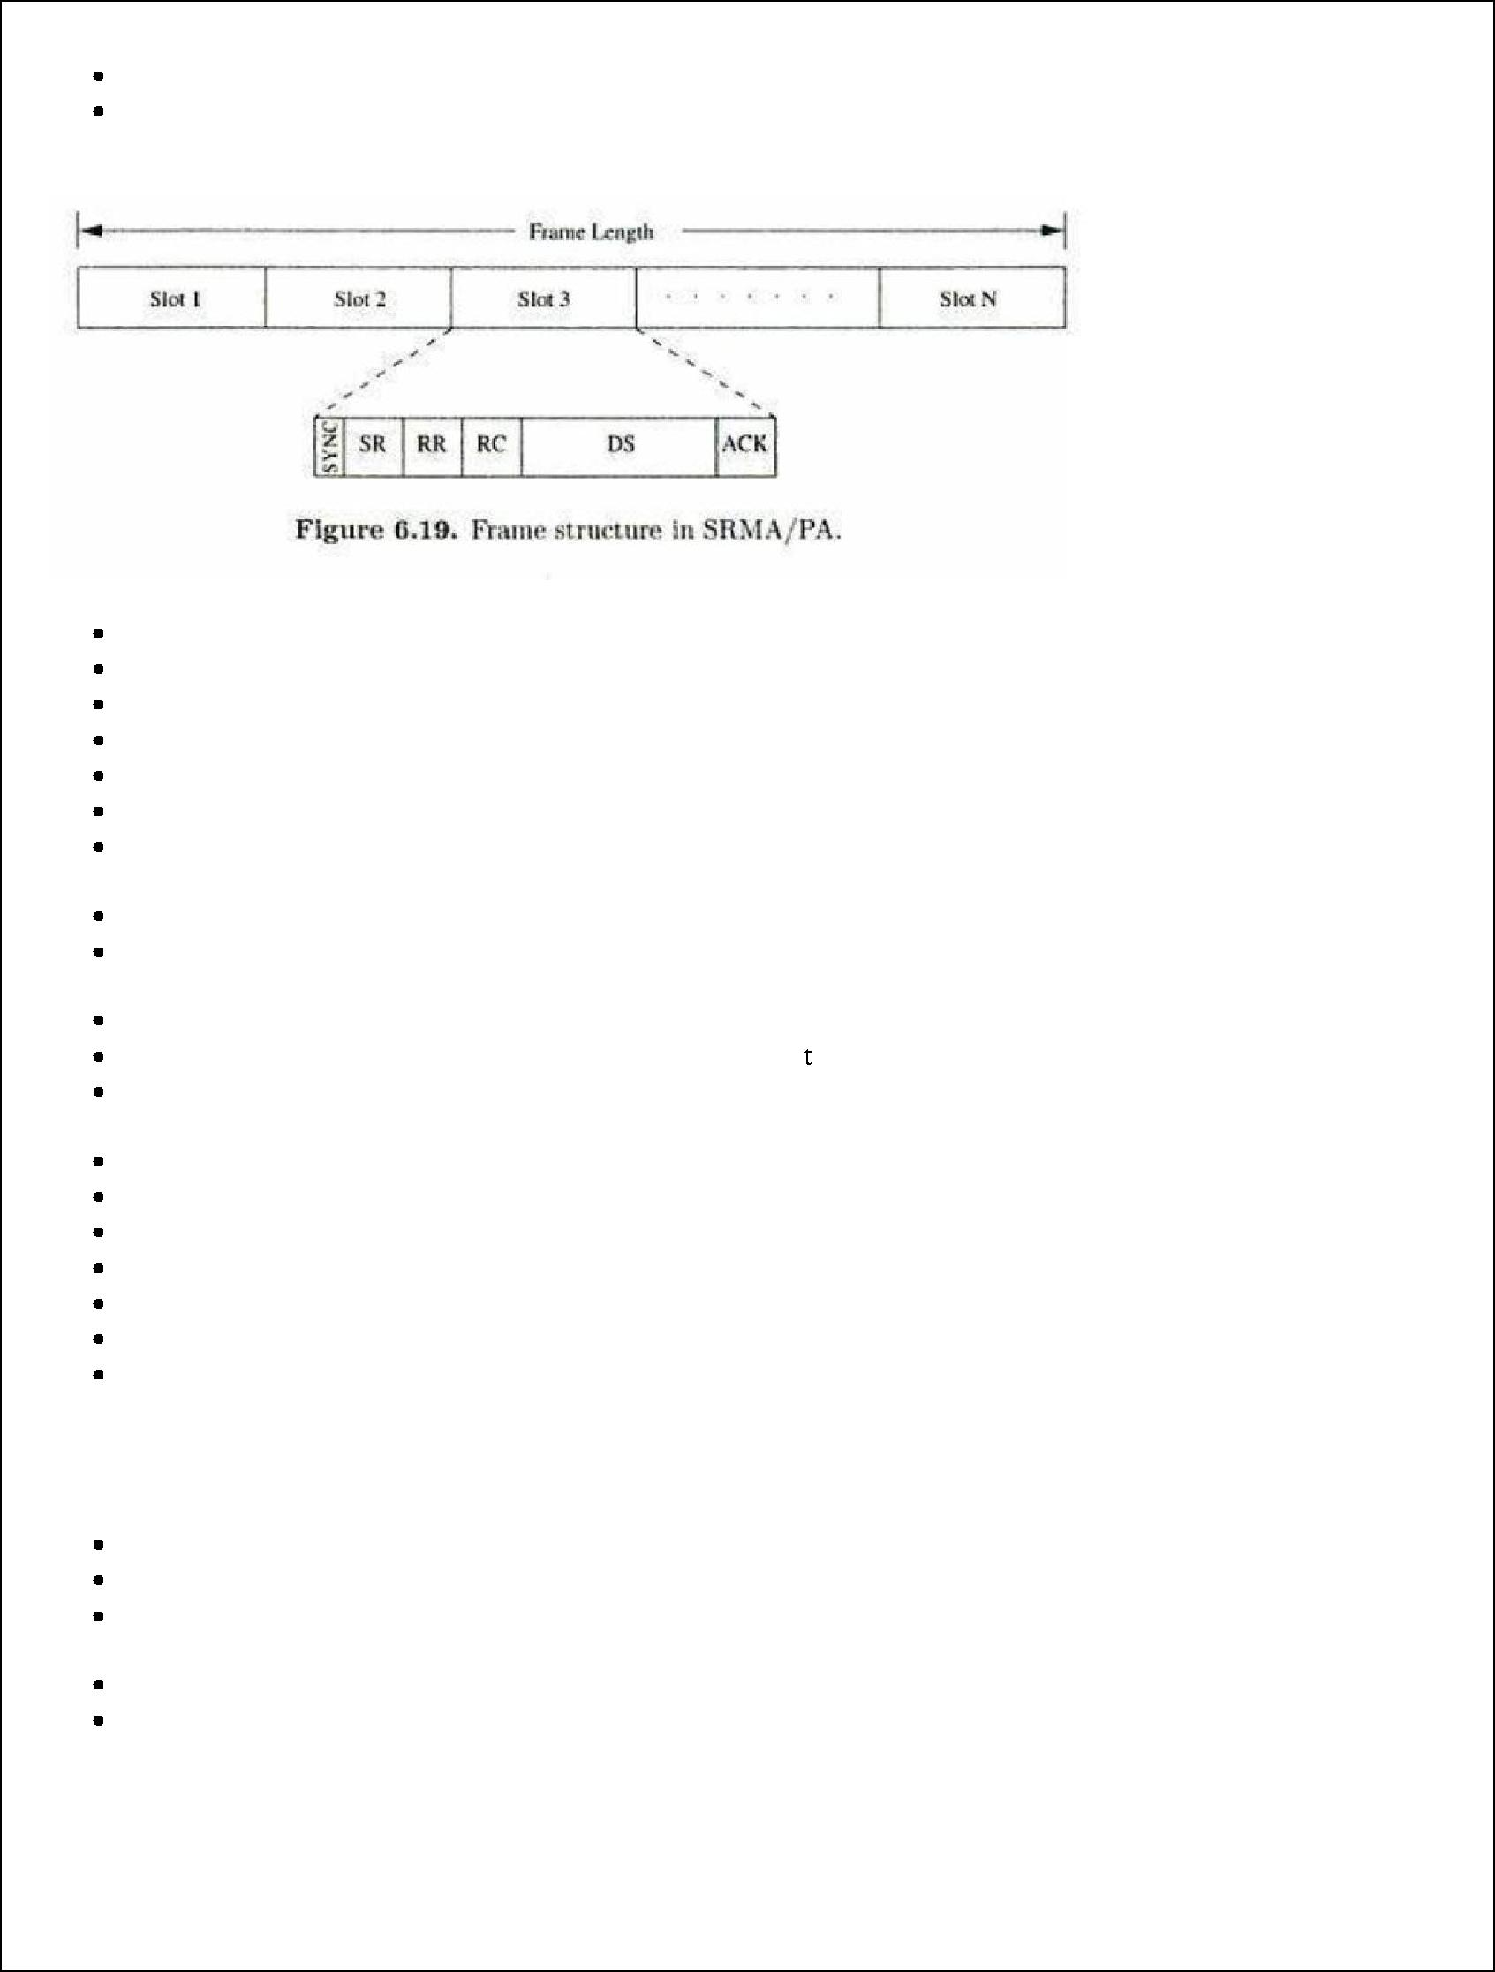

Time is divided into frames, with each frame consisting of a fixed number of slots

Each slot is further divided into 6 different fields (figure) namely SYNC, soft reservation (SR), reservation request (RR), reservation confirm (RC), data sending (DS) and acknowledgement (ACK)

The SYNC field is used for synchronisation purposes

The SR, RR, RC, and ACK fields are used for transmitting and receiving the corresponding control packets The DS field is used for data transmission

The SR packet serves as a busy tone

It informs the nodes about the reservation of the slot.

SR packet also carries the access priority value assigned to the node that has reserved the slot

When an idle node receives a data packet for transmission, the node waits for a free slot and transmits the RR packet in the RR field of that slot.

A node determines whether or not a slot is free through the SR field of that slot.

In case of a voice terminal node, the node tries to take control of the slot already reserved by a data terminal if it finds it priority level to be higher than that of the data terminal.

This process is called *soft reservation.*

 he service classes in a static manner.

It is required that priority of voice terminal pv(R) > priority of data terminal pd(R) such that delay sensitive voice applications get preference over normal data applications.

A node that is currently transmitting is said to be in active state.

A node that is said to be in the idle state if it does not have any packet to be transmitted.

In the active state itself, nodes can be in one of the two states: access state and reserved state. Access state is one in which the node is backlogged and is trying to reserve a slot for transmission. The access priorities are assigned to nodes and updated in a distributed and dynamic manner.

This allows dynamic sharing of the shared channel.

In order to avoid collisions, a binary exponential back-off algorithm is used for non-real time connections and a modified binary exponential back-off algorithm is used for real time connections

**Five-Phase Reservation Protocol**

A single-channel time division multiple access (TDMA)-based broadcast scheduling protocol. Nodes use a contention mechanism in order to acquire time slots. The protocol is fully distributed, that is, multiple reservations can be simultaneously made throughout the network. No ordering among nodes is followed.Nodes need not wait for making time slot reservations

