RAVINDRA COLLEGE OF ENGINEERING FOR WOMEN
G.PULLAIAH COLLEGE OF ENGINEERING & TECHNOLOGY
(Autonomous)
Approved by AICTE | NAAC Accreditation with ‘A’ Grade | Accredited by NBA | Permanently Affiliated to JNTUA
Training & Placement Cell
2018 – 2019 23rd April 2019
Congratulations to the following students who are placed in
with 3.38 L PA
S NO | ROLL NO | Student Name | BRANCH | COLLEGE
1 | 17AT1E0002 | PATAN ABDULLA KHAN | MBA | GPCET
2 | 17AT1E0004 | SAEED AHMED | MBA | GPCET
3 | 17AT1E0005 | V.AKHILA | MBA | GPCET
4 | 17AT1E0006 | K ANIL | MBA | GPCET
5 | 17AT1E0008 | UPPARA ANJANEYULU | MBA | GPCET
6 | 17AT1E0013 | SHAIK AZEES | MBA | GPCET
7 | 17AT1E0023 | SAJJANAM GANDLA LATHA | MBA | GPCET
8 | 17AT1E0028 | P HIMA BINDU | MBA | GPCET
9 | 17AT1E0031 | THAKKASILA KAVITHA | MBA | GPCET
10 | 17AT1E0033 | BOYANA KOMALI | MBA | GPCET
11 | 17AT1E0047 | BILLAKANTI MOHANKUMAR | MBA | GPCET
12 | 17AT1E0056 | MAMILLA PRATHAP REDDY | MBA | GPCET
13 | 17AT1E0061 | YERABHAM PRIYANKA | MBA | GPCET
14 | 17AT1E0066 | S RAKSHIT | MBA | GPCET
15 | 17AT1E0067 | YERRAGOLLA RAMAMOHAN | MBA | GPCET
16 | 17AT1E0073 | P SAI TEJASWI | MBA | GPCET
17 | 17AT1E0077 | D SANTHOSHI DEEPTHI | MBA | GPCET
18 | 17AT1E0080 | AMBARAPU SHIRISHA | MBA | GPCET
19 | 17AT1E0082 | RAMAPURAM SNEHA | MBA | GPCET
20 | 17AT1E0083 | NUNNA SOWMYA | MBA | GPCET
21 | 17AT1E0085 | TELUGU SREENIVASULU | MBA | GPCET
22 | 17AT1E0095 | E.VASAVI JYOTHI | MBA | GPCET
23 | 17AT1E0099 | E VENKATA PRASANNA | MBA | GPCET
24 | 17AT1E00A7 | S YASMEEN | MBA | GPCET
25 | 17AT1E00A8 | GUNDEPOGU NAVEENKUMAR | MBA | GPCET
26 | 17AT1E0001 | K ABDUL REHAMAN | MBA | GPCET
27 | 17AT1E0075 | K.SANDEEP | MBA | GPCET
28 | 17AT1E0025 | M HARIPRIYA | MBA | GPCET
29 | 17AT1E0055 | K.POOJITHA | MBA | GPCET
30 | 17AT1E0041 | G LAXMINARAYANA YADAV | MBA | GPCET
31 | 17AT1E0014 | Md Riyaz | MBA | GPCET
32 | 17AT1E00A2 | K Venkatesh | MBA | GPCET
33 | 17AT1E0084 | BattulaSreelakshmi | MBA | GPCET
34 | 17AT1E0060 | Malreddy Priyanka | MBA | GPCET
35 | 17AT1E00B1 | Manasa Veena N | MBA | GPCET
36 | 17AT1E00B0 | Illuru Ambica | MBA | GPCET
37 | 17AT1E0070 | K Rupa | MBA | GPCET

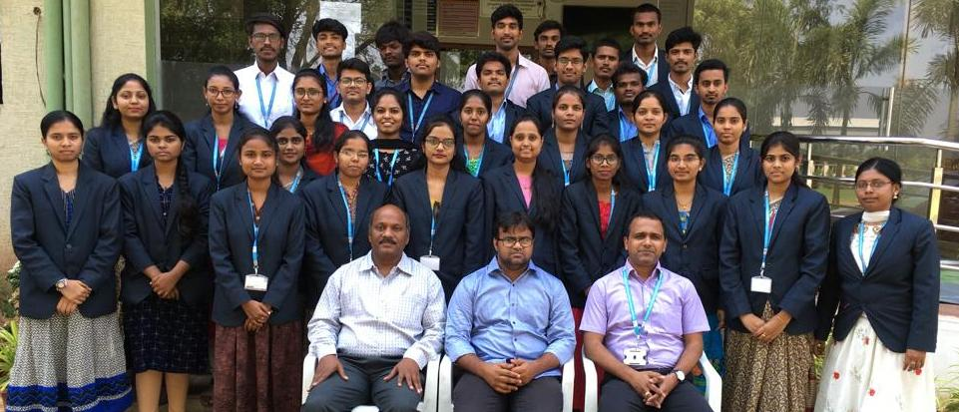

Head of Corporate Affairs
Copy to Management, Principal (GPCET), Principal (RCEW)
HOD’s of GPCET & RCEW (CSE / CIVIL / ECE / EEE / H&S / ME & MBA)
Circulation among T & P Coordinators, Staff and Students

