G.Pullaiah College of Engineering and Technology: Kurnool
(Autonomous)
Research and Development Cell
------------------------------------------------------------------------------------
Report on the release of R & D Newsletter by Prof D.M. Vinod Kumar, Professor (HAG), NIT Warangal, Warangal

The Research and Development Cell of the college organized the release of October Issue of Newsletter on 26/10/2019. The Chief guest for the was Prof. D.M. Vinod Kumar, Professor (HAG), Electrical Engineering, NIT Warangal, Warangal. A lecture on “Importance of Research” was also delivered by him in which he explained the purpose of research, goal of research, importance of research in the advancement of society. He also stressed upon the importance of research in both academics and professional growth. A total of 18 articles written by the faculty of various departments were incorporated in the Newsletter and the Chief Guest expressed happiness regarding the efforts of the college to promote and inculcate the culture of research among the faculty and students
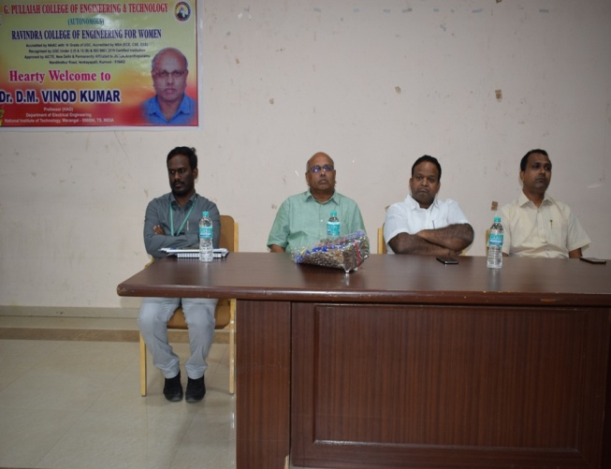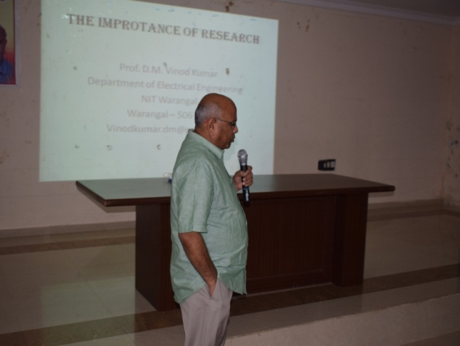

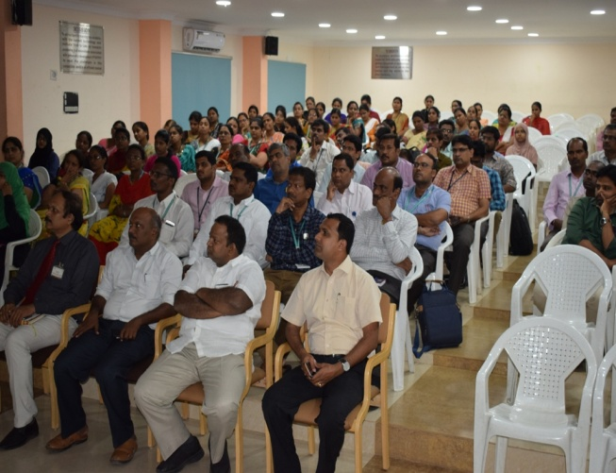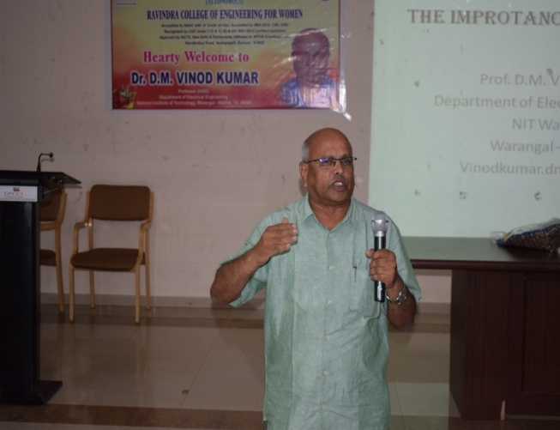

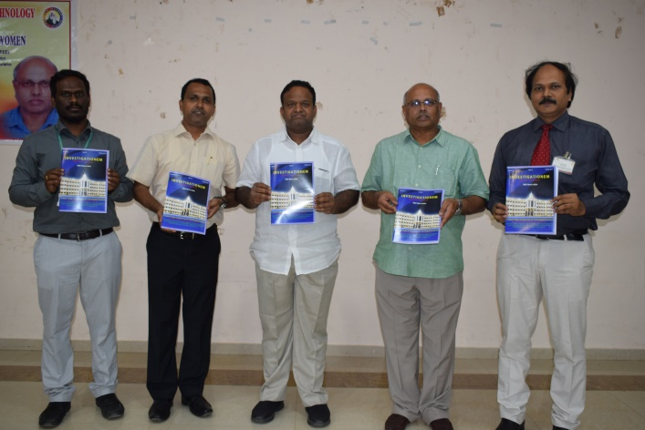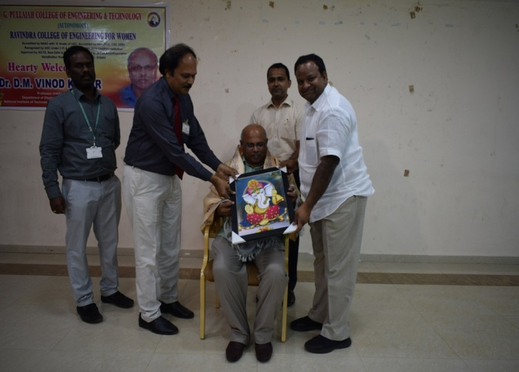

Research and Development Cell

