G. PULLAIAH COLLEGE OF ENGINEERING & TECHNOLOGY
(Autonomous)
Department of MBA
A Report on Guest lecture on
“Benchmarking in Career and Life”

A Guest lecture on “Benchmarking in career and life” was organized for I-MBA students on 26th November, 2019 at GPCET. Mr. C. Kalyan Chakravarthy, Partner- Rudragiri Associates, Hyderabad acted as a resource person. He enthralled the entire audience. It was an interactive session, hence most of the students involved in the discussion regarding career and life.
In this session, few activities were conducted for the students to explore themselves. The resource faculty has also presented few short stories that motivate to acquire a great position in career as well as life. The speaker also shed light on the importance of MBA in global scenario and need to choose a right career in a right path etc. The program ended with the quote “Success is achieved by the ordinary people with an extraordinary determination.”

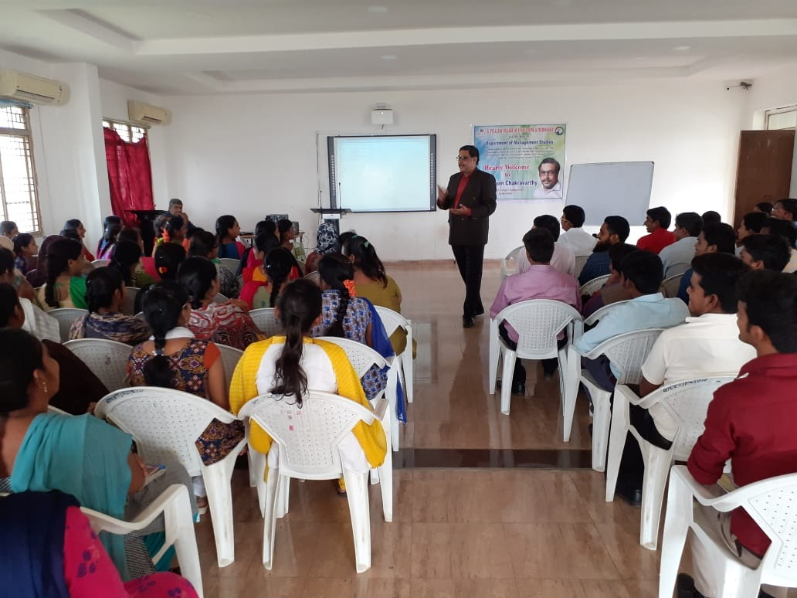
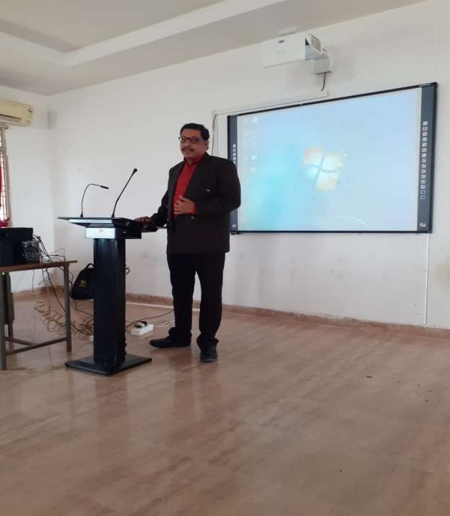

SNAPSHOTS OF THE GUEST LECTURE

