G. PULLAIAH COLLEGE OF ENGINEERING & TECHNOLOGY
(Autonomous)
Department of MBA
A Report on Two- Day Workshop on Data Science

A Two- Day workshop on Data Science was organized for the I semester MBA Students on 23rd & 24th December, 2019 at GPCET. Dr. Shaheen, Assistant Professor, Coordinator - PR, Institute of Public Enterprise, Hyderabad acted as a Resource Person.

Objective of workshop:

In this era of competition, the secret behind any business is its ability to solve problems and framing the right strategy. With Data Science, companies can predict the success rate of their strategies, solve various problems and take right decisions in right time. Data science methodologies can explore historicals, make comparisons to competition, analyze the market, and ultimately, make recommendations of when and where your product or services will sell best. Hence a two-day workshop on Data Science was organized to help the budding managers to enhance their problem solving and decision making skills.
The outcomes of the workshop are:
- Students developed relevant programming abilities.
- Students learnt statistical analysis of data.
- Students learnt data management and interpretation.
- Students will apply data science concepts and methods to solve problems in real-world contexts and will communicate these solutions effectively.
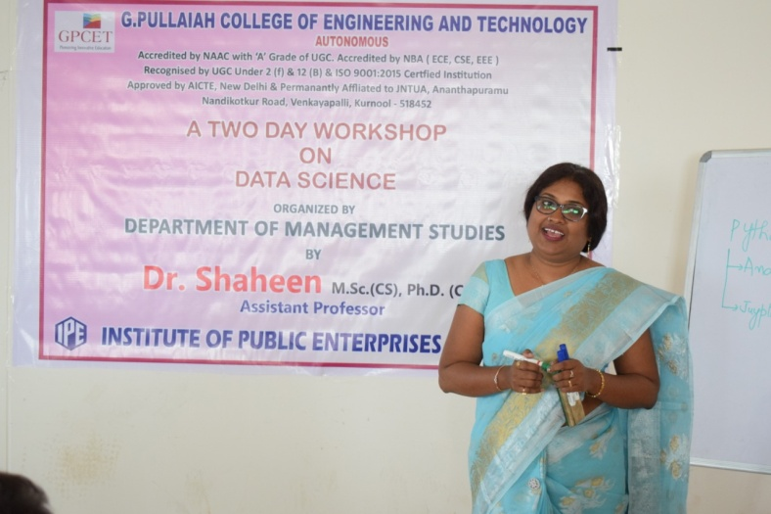
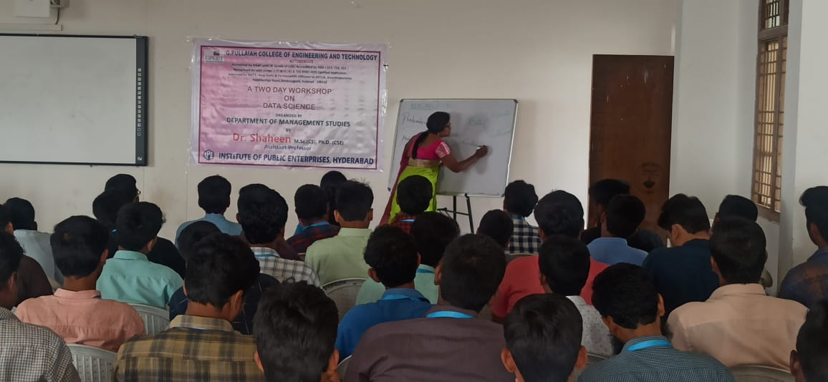

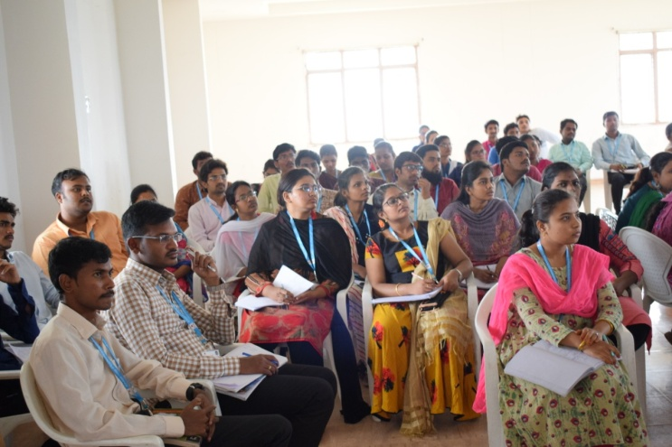
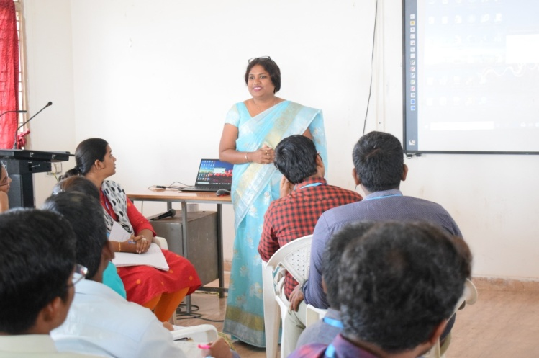

SNAPSHOTS OF THE GUEST LECTURE

